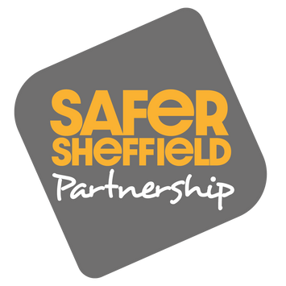

**Violence Against Women and Girls (VAWG) Glossary of Terms**

This guide has been created by Sheffield City Council’s Domestic Abuse Co-ordination Team. It is designed to give you a better understanding of the different types of domestic abuse and sexual violence. It is an easy-read glossary setting out definitions and examples of what people may experience.

Sheffield has a range of domestic abuse and sexual violence advice and support services. You can find more info here:

[Domestic abuse and sexual violence advice and support |](https://www.sheffield.gov.uk/public-health/get-help-with-domestic-abuse)

[Sheffield City Council](https://www.sheffield.gov.uk/public-health/get-help-with-domestic-abuse)

[White Ribbon and Violence Against Women and Girls |](https://www.sheffield.gov.uk/public-health/white-ribbon-and-violence-against-women-and-girls)

[Sheffield City Council](https://www.sheffield.gov.uk/public-health/white-ribbon-and-violence-against-women-and-girls)

There is also a list of signposting options on the last page. **Published 2024**

**Violence against women and girls (VAWG) is an umbrella term**

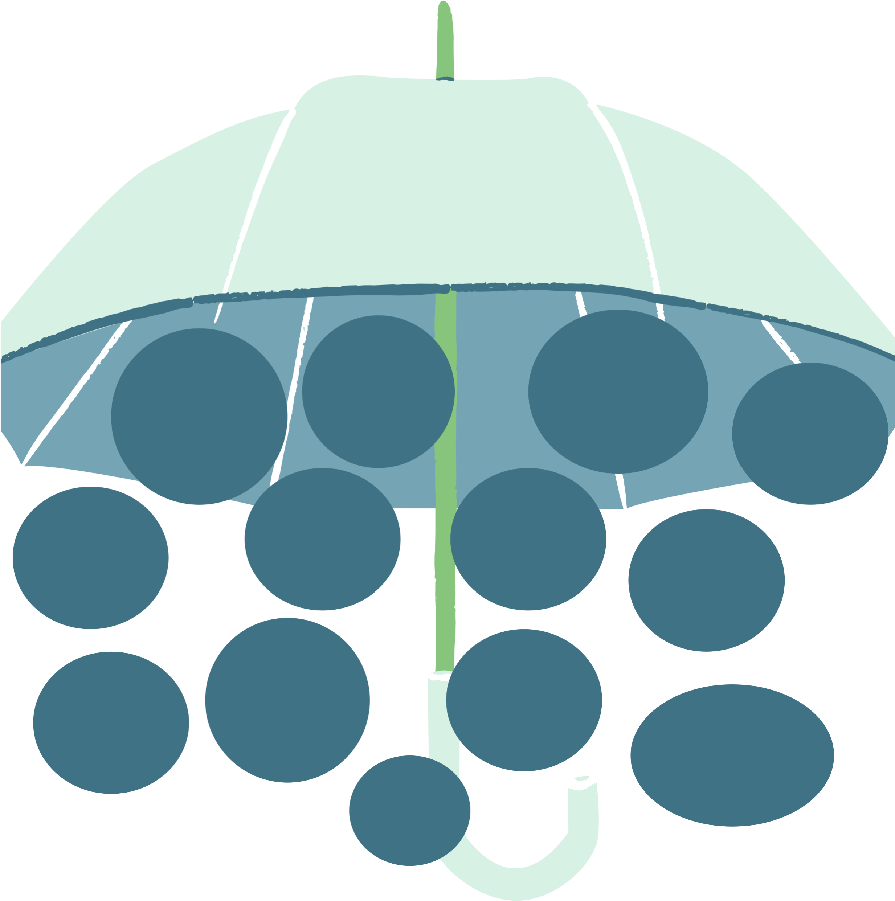

**Childhood**

**sexual**

**abuse**

**Violence**

**Against**

**Women and Girls**

**Female**

**genital**

**mutilation**

**Domestic**

**abuse**

**Spiking**

**Sexual**

**violence**

**Stalking**

**Sexual**

**harassment**

**Honour**

**based**

**abuse**

**Virginity**

**testing**

**Forced**

**marriage**

**Sexual**

**exploitation**

**Image**

**based**

**offences**

**Online**

**sexual**

**harassment**

**All these forms of harm are included under the heading VAWG.**

**Violence against Women and Girls (VAWG)**

Violence can happen to anyone. **But women and girls are more at risk of certain forms of violence.**These are usually committed by men towards women.

All the forms of harm listed under the umbrella are more likely to be experienced by women and girls. They are defined in this glossary.

Men and boys can still be victims/survivors of these harms.

The United Nations defines violence against women and girls as ‘any act of

gender-based violence that results in, or is likely to result in, physical, sexual or psychological harm’.

# Domestic Abuse

Domestic abuse is when you are harmed by:

* Someone you have a close relationship with, like a partner or ex-partner.
* A family member.

Domestic abuse happens in different ways like when a partner or family member:

* Attacks you or is violent towards you.
* Controls how you behave or the choices you make.
* Humiliates, insults or intimidates you.
* Stops you from being able to spend or earn money.
* Uses technology, like computers or the internet, to control you or make you feel scared.
* Makes you do sexual things that you don’t want to do.

# Forced marriage

Forced marriage is when one or both people getting married are made to do it. They may be threatened with violence if they do not agree. It is illegal in the UK.

# Female genital mutilation (FGM)

Female genital mutilation (FGM) is a form of abuse when a girl has their genitalia cut or damaged. It is illegal in the UK and illegal to organise someone getting it abroad.

# Virginity testing

Virginity testing is when female genitalia is inspected to try and tell when a female has had vaginal sex. It also includes ‘hymen repair’ surgery. It was made illegal in the UK in 2022.

# Honour Based Abuse

Honour based abuse is where you suffer abuse by someone in your family or community because they think you have brought shame to them. This can be for many reasons including how someone dresses, who someone is dating, sexuality, divorce, and pregnancy.

It is a form of domestic abuse and may also overlap with forced marriage or FGM.

This may look like:

* Pressure to move abroad
* Being locked indoors
* Threats of violence
* Forced abortion

# Safe accommodation

Safe accommodation is dedicated housing that provides a safe place to stay for victims/survivors of domestic abuse.

This may look like:

* A refuge
* A safe and secure flat or house specifically for domestic abuse victim/survivors
* A scheme helping you to make your home safer and more secure. For example, installing new locks, windows or alarms.

A range of support is provided to victim/survivors in safe accommodation.

# Sexual Violence

Sexual violence is a term that describes when you are made to do sexual things when you do not want to. You may or may not know the person. This can be in person or online.

This may look like:

* Making you have sex or do sexual things when you did not say yes or changed your mind.
* Touching your genitalia, bum or breasts when you did not say yes. Also known as groping.
* Touching themselves in their private parts in front of you in public.
* Exposing themselves in front of you.
* Threatening to show other people naked photos of you.

# Childhood sexual abuse (CSA)

Childhood sexual abuse is when someone forces, tricks, or persuades a child or young person to take part in sexual activities with or without their understanding. It is a form of sexual violence and illegal.

# Sexual exploitation

Sexual exploitation is when someone tries to pressure you to have sex or do sexual things. It is a form of sexual violence and illegal. This may look like:

* Providing gifts in return for sexual favours.
* Suggesting that sex is needed to repay a ‘debt’, this can include forcing you to sleep with other people.
* Using their power and authority to pressure you for sexual acts.

# Spiking

Spiking is giving someone alcohol or drugs without their knowledge. It is illegal.

# Image based offences

These offences are when someone takes, shares, or threatens to share sexual images or videos of a person without their knowledge or permission, and with the aim of causing them harm.

This might look like:

* Creating and sharing altered sexual images of someone e.g. deepfakes
* Taking photos down someone's shirt or up their skirt
* Sharing, or threatening to share videos of sexual acts or nude photos

# Sexual harassment

Harassment is when someone acts in an unwanted way that makes someone feel uncomfortable. Sexual harassment is when this is of a sexual nature.

This might look like:

* Sexual comments or requests
* Sexual gestures
* Sexual jokes
* Sexual comments about your appearance
* Suggestive looks or staring
* Sexual insults like ‘slut’ or ‘whore’

Sexual harassment can also overlap with racism, homophobia, transphobia, ableism, ageism and sexist views.

**Stalking and harassment**

This is when someone:

* won’t leave you alone
* doesn’t respect your privacy.

This might look like:

* Calling or messaging you constantly
* Waiting for you outside where you live or work
* Following you
* Spying on you. Including putting tags on your possessions or apps on your phone to track you
* Damaging your possessions

Stalking is when this is fixated, obsessive, repeated and unwanted.

# Online Sexual Harassment

Sexual harassment can also happen online. For example, on social media like Facebook or X, or during online socialising such as livestreams or multi-player video-gaming.

This might look like:

* Sexual requests e.g. for nude images
* Sexual insults like ‘slut’ or ‘whore’
* Sexist comments
* Being sent sexual content without consent e.g. photos of genitalia or links to pornography
* Making sexual threats

Sexual harassment can also overlap with racism, homophobia, transphobia, ableism, ageism and sexist views.

# SIGNPOSTING FOR SUPPORT

If someone has experienced domestic abuse, you can support them to call the [Independent Domestic Abuse Service](https://idas.org.uk/) (IDAS) Sheffield helpline on 0808 808 2241.

If someone has been raped or sexually assaulted, they can go to the Sexual Assault Referral Centre for South Yorkshire or known as [Hackenthorpe Lodge.](https://hackenthorpelodge.org/) They offer free, confidential healthcare and compassionate support to people. Their telephone 0330 223 0099 is open 24 hours a day, every day of the year. Call to speak with a nurse for support and to discuss your options for making an in-person appointment and/or referral.

National Helplines:

* [National Domestic Abuse Helpline](https://www.nationaldahelpline.org.uk/#:~:text=Call%20us%2024%2F7&text=Call%20for%20free%20and%20in,a%20day%3A%200808%202000%20247.) Call them 24/7 on 0808 2000 247
* [Rape Crisis England & Wales](https://rapecrisis.org.uk/get-help/want-to-talk/#:~:text=Whenever%20you%27re%20ready%20to,to%20start%20an%20online%20chat.) - Call them 24/7 on 0808 500 2222
* [Domestic Abuse Helpline for Men | Men's Advice Line UK](https://mensadviceline.org.uk/) Call them Mon–Fri 10am-5pm on 0808 8010327
* [Victim Support](https://www.victimsupport.org.uk/) offer independent, free, and confidential advice on what to do after a crime. Call them on 0808 1689 111.
* The [National Stalking Helpline](https://www.suzylamplugh.org/pages/category/national-stalking-helpline) gives practical information, support, and advice on risk, safety planning and legislation to victims of stalking, their friends, family, and professionals working with victims. Call them on 0808 802 0300.
* If you have experienced cyber-flashing or someone taking an image or video of you without your consent, call the [Revenge Porn Helpline](https://revengepornhelpline.org.uk/) on 0345 6000 459.
* If you are a member of the LGBT+ community and you've experienced any form of abuse or violence, you can contact [Galop](https://galop.org.uk/) on 0800 9995428.
* If you have experienced Honour Based Abuse, you can contact [Karma Nirvana'](https://karmanirvana.org.uk/)s Honour Based Abuse helpline on 0800 5999 247.