**DOMESTIC ABUSE AND MULTIPLE DISADVANTAGE**

## **FINDINGS FROM SHEFFIELD DOMESTIC HOMICIDE REVIEWS**

21 Domestic Homicide Reviews have been completed or started since 2011 in Sheffield.

A table showing when a Domestic Homicide Review should be undertaken. 

 In this section “domestic homicide review” means a review of the circumstances in 
which the death of a person aged 16 or over has, or appears to have, resulted from 
violence, abuse or neglect by—
(a) a person to whom he was related or with whom he was or had been in an 
intimate personal relationship, or
(b) a member of the same household as himself,
held with a view to identifying the lessons to be learnt from the death.


Between 2011 and April 2024 several cases included vulnerabilities around mental health, substance misuse, histories of offending and homelessness as illustrated below:

## **MULTIPLE DISADVANTAGE**

Multiple disadvantage can be identified in 5 DHR cases (24%) e.g. where there are 3 or more of the following in relation to the perpetrator or victim of abuse:

* + Domestic abuse
  + Offending
  + Substance misuse
  + Homelessness
  + Mental health issues

The relevant DHRs are Adult C, Adult H, Leah, Imran, and Kisten. Sheffield’s recently published DHRs can be found here [Domestic Homicide Reviews (DHRs) | Sheffield City Council](https://www.sheffield.gov.uk/public-health/domestic-homicide-reviews-dhrs). Learning Briefs for all cases can be found here [Domestic Homicide Reviews learning briefs | Sheffield City Council](https://www.sheffield.gov.uk/public-health/domestic-homicide-reviews-learning-briefs). The national DHR Library is here [Search the domestic homicide review library - GOV.UK (www.gov.uk)](https://www.gov.uk/guidance/search-the-domestic-homicide-review-library).

## **LEARNING FROM COMPLETED REVIEWS**

### **Need for trauma informed approaches**

People experiencing multiple disadvantage are likely to have experienced trauma – both when they were children (Adverse Childhood Experiences) and / or as adults e.g. in the form of abusive relationships. The impact of this trauma is evident in the experiences of victims and perpetrators in DHRs:

* *A trauma informed approach was required to better understand Leah and the perpetrator in the context of their life histories and experience. This may have changed practitioner’s attitudes towards them, built trust and engagement in support. (Leah DHR)*
* *Professionals did not use a trauma informed approach or professional curiosity with Leah. Therefore, they did not always understand the risk to her and why she distrusted children’s agencies. (Leah DHR)*
* *Consider the evidence of the links between adverse childhood experiences, family violence & youth offending & put in place interventions to mitigate the risk (Imran DHR)*

These local findings are echoed and expanded on in [Breaking_Down_the_Barriers_Report.pdf (agendaalliance.org)](https://www.agendaalliance.org/documents/11/Breaking_Down_the_Barriers_Report.pdf) which presents the findings of the Commission on women facing domestic and sexual violence and multiple disadvantage 2021.

It found that:

* The services women experiencing multiple disadvantage come in to contact with often do not have the required skills or capacity to support them. Specialisms (in terms of understanding, as well as service provision) are also lacking around supporting specific groups of minoritised or marginalised women, for example BAMER women, LGBT (Lesbian, Gay, Bisexual and Trans) women and women living with disability.
* Specific challenges reported by women included: thresholds preventing them from accessing services; inclusion criteria that may prevent certain groups accessing support, a lack of specific support for women with complex needs; limited knowledge amongst professionals about the impact of violence against women; a lack of intersectional service provision; and short-term support which fails to meet need.
* Trauma-informed practice is the most effective model of support for survivors facing multiple disadvantage.
* Despite a growing international evidence base, trauma-informed approaches are still considered to be an emerging field in the UK
* Key to effective engagement is empathy and relationship building; women prioritise staff who have the right values and competencies to work with them.
* Women place considerable value on having workers with lived experience involved in the design and delivery of services.

### **Children**

The Leah DHR found that fear of the involvement children’s services was a barrier to her disclosing abuse.

[Breaking_Down_the_Barriers_Report.pdf (agendaalliance.org)](https://www.agendaalliance.org/documents/11/Breaking_Down_the_Barriers_Report.pdf) also found the following:

* Women facing multiple disadvantage are being prevented from seeking help for fear of losing their children.
* The removal of children as a result of domestic abuse can be a major barrier to women making a meaningful recovery.
* When children are removed into care, not enough is being done to support children or consider their needs.
* Keeping children safe is essential, but more must be done to reduce the long-term harm to both mother and child from permanent separation

Sheffield City Council has invested in [the Safe and Together Model](https://safeandtogetherinstitute.com/the-sti-model/model-overview/) in recognition of the need to move away from victim blaming narratives in relation to safeguarding children in the context of domestic abuse:

A visual outline of the Safe and Together Principles. 

1. Keeping child Safe and Together with non-offending parent. 
2. Partnering with non-offending parent as default position.
3. Intervening with perpetrator to reduce risk and harm to child. 

**Need for greater awareness of the dynamics of domestic abuse**

The impact of Coercive and Controlling behaviour on the victim, particularly when it was long term, was not understood in some of the cases:

* *Leah lived in fear of her abuser. Coercive and controlling behaviour was not recognised. He would “control her” by threatening to kill himself if she left him. (Leah DHR)*
* *There was a lack of professional curiosity about the long history and the focus was on incidents, rather than understanding it as the pattern of coercive control (Kirsten DHR)*

Leah and Kirsten also both experienced post separation abuse. It is important to remember that separation does not mean that abuse ends, in fact it can often lead to heightened risk as the perpetrator fears losing control over the victim.

There were indications that both Leah and Kirsten experienced non fatal strangulation by their perpetrators. This is an extremely dangerous form of abuse and should always be treated as high risk when it is disclosed. A useful information leaflet for victims / survivors can be found [here.](https://ifas.org.uk/information-leaflet-for-victims/)

There is no such thing as a ‘perfect victim’. Victims can sometimes appear to be perpetrators if care is not taken to consider the whole story and not just focus on single incidents:

* *Had Leah’s act of self-defence / violent resistance being identified as such, then a trauma-informed approach could have been used, a safety plan agreed, and her needs considered. (Leah DHR)*

Men can be victims as well as women. 2 of the male victims of Sheffield DHRs were killed by family members:

* *Risk to Imran was not recognised – there was a lack of awareness of male victims (Imran DHR)*

It’s always important to think about any barriers to disclosing abuse or accessing support that may be related to cultural factors:

* *Imran was an Asian British male, and it is possible that the events described were a source of dishonour and shame for the family in the eyes of the community. (Imran DHR)*

Staff must be required to be fully aware of processes that are in place to safeguard domestic abuse victims / survivors. Staff also need to be confident in working with victims / survivors who are still in relationships with their perpetrator. Disclosures can and will be made to any agency or service.

* *Provide training to staff on Domestic Abuse and MARAC (Kirsten DHR)*

Other reviews have recommended staff gain awareness of the [Homicide and Suicide Timelines](https://www.homicidetimeline.co.uk/what-is-the-homicide-timeline.php).

[Breaking_Down_the_Barriers_Report.pdf (agendaalliance.org)](https://www.agendaalliance.org/documents/11/Breaking_Down_the_Barriers_Report.pdf) also references that:

* The trauma experienced by women who have survived abuse can have lifelong consequences, yet this is seldom recognised.
* The report found that in relation to domestic abuse:
* There is an inconsistency of approach and a lack of trauma-informed support for survivors.

### **Risk of Suicide**

Several of Sheffield’s DHRs have been in relation to people who took their own lives in the context of domestic abuse.

Women who have experienced domestic abuse are three times more likely to have made a suicide attempt in the past year than women who have not experienced this.  Women who have experienced sexual abuse in an intimate relationship are seven times more likely to have attempted suicide in the past year than those who had not experienced this. ([Agenda Alliance](https://www.agendaalliance.org/our-work/projects-and-campaigns/underexamined-and-underreported/)).

A Home Office report detailed 38 domestic abuse related suicides (April 2020-March 2021), a likely underestimate as only those with a **reported history** of abuse to police were included. The majority were aged under 45 and 90% were female.

* *The partnership should ‘Raise awareness of attempted suicide as a potential indicator of domestic abuse.’ (Kirsten DHR)*

Agencies tend to think children are a protective factor regarding women and suicidal thoughts – several of the cases of suicide in Sheffield have involved mothers of dependent children. Perpetrator’s tactics can include telling the woman that the children would be better off without her.

* *Agencies failed to identify and address the risk of suicide as a possible outcome of the domestic abuse she was experiencing – it was thought her children were a protective factor. (Leah DHR)*

### **Substance Misuse and Domestic Abuse**

Where people have issues with problematic substance misuse or poor mental health it is important to ask about relationships and home circumstances.

* *Specialist substance misuse services, and GPs should always ask questions about home circumstances when assessing patients who present with issues of substance misuse. (Adult C DHR)*
* *Where there are substance misuse issues and poor mental health it is important to ask about domestic abuse. (Adult H DHR and Kirsten DHR)*
* *‘there is a need to enquire about / assess domestic abuse within the wider family where individuals are presenting with alcohol misuse and mental health issues’. (Adult C DHR)*

Substance misuse may also be a consequence of living with domestic abuse:

* *It was not explored with Kirsten whether her substance misuse was a means of coping with the domestic abuse. (Kirsten DHR)*

The [Safe and Together model](https://safeandtogetherinstitute.com/the-sti-model/model-overview/) uses the term intersections to refer to how domestic abuse, mental health and substance use interact with each other and asks professionals to consider how the perpetrators pattern of abusive behaviour can:

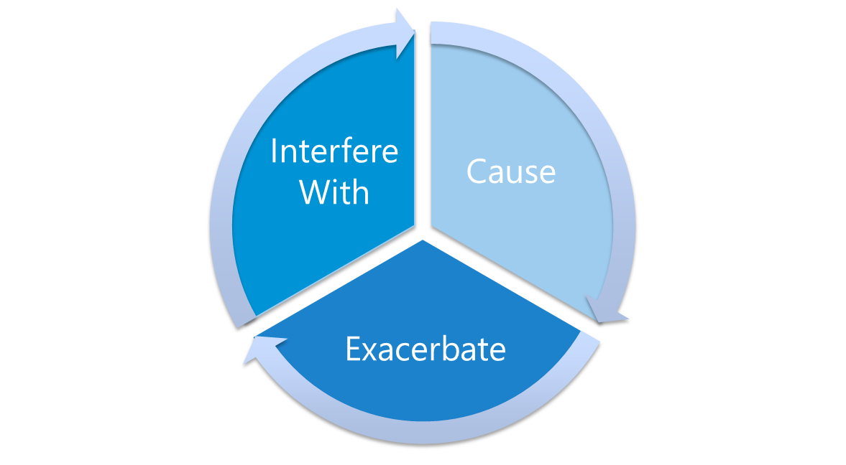

…mental health or substance misuse issues. It’s important to think about these intersections to avoid victim blaming and partner with survivors to keep them and their children, if they have them, safe.

## **Adult Family Violence**

Domestic Abuse is now defined in law as between people who are ‘personally connected’[1] and this includes family relationships, not just current or former intimate partners. None of the victims of Sheffield DHRs who were killed by family members were identified as being at risk of domestic abuse before they died:

* ‘*more could be done to raise awareness of both the issues surrounding and services to support victims of domestic abuse where the abuser is a family member rather than an intimate partner. This applies to both public and organisational awareness.’ (Adult C DHR)*
* *Professionals need to be supported to identify and support victims who may be experiencing controlling behaviour from a family member. (Imran DHR)*

## **Working with perpetrators on their abusive behaviour**

Many agencies offer support to people who are offenders, homeless, have mental health issues or misuse substances, who are also perpetrating abuse in their families and relationships. It is all of our responsibilities to challenge abusive behaviours and keep adults and children at risk of domestic abuse safe:

* *Agencies focused on the perpetrator’s mental health and self-harming and didn’t identify him as a perpetrator. (Leah DHR)*

It may be effective when trying to safeguard the victim to support the perpetrator with their needs e.g. if they are homeless, using substances or having issues with their mental health.

If they are aware that their behaviour is a problem you could signpost them to Cranstoun Inspire to Change who provide free group work programmes for men and women (and one to one support in some cases)[**Inspire to Change, South Yorkshire - Cranstoun**](https://cranstoun.org/help-and-advice/domestic-abuse/inspire-to-change/)

### **Carers**

Victims in DHRs have been acting as a carer for their perpetrator in several cases including Adult C and Kirsten.

* *Ensure referrals made to the Carer’s Centre and Carer’s assessments are undertaken. Consider the appropriateness of informal carers to fulfil this role if any element of the Trilogy of Risk is present (Kirsten DHR)*

**What can you do to support a victim / survivor who is experiencing multiple disadvantage?**

* Be empathetic and trauma informed: e.g. if the victim / survivor states that they don’t want to call the police or don’t want the perpetrator to leave. It may be that they are scared of violence escalating if they take action or separate.
* Think about the impact of coercive control – is this person feeling trapped in the abusive situation?
* Listen to what they want to do and work with them to make informed choices
* Ask what you can do to help – build trust by providing consistent support that meets the person at the stage they’re at
* Be aware of possible *unconscious bias* when working with people affected by multiple disadvantage can mean domestic abuse is not responded to effectively.
* Professional Curiosity – think beyond the presenting situation. Why is the person acting like this? Is this a trauma response? What else is going on?
* Be clear about your boundaries in terms of safeguarding and information sharing
* **Call the police if the person is in immediate danger**
* **Make safeguarding (adults and children) referrals if you are concerned**
* Offer support with a [**safety plan**](https://www.idas.org.uk/our-services/domestic-abuse/safety-plan/) , most victims / survivors have safety strategies already in place i.e. ways of managing the perpetrators behaviour – if not help them construct one. Or discuss and review the strategies they are already using.
* Use the[**DASH risk assessment**](https://www.sheffield.gov.uk/public-health/domestic-abuse-sexual-violence-resources-professionals)
* If the person is **high risk of serious harm or homicide,** then refer to MARAC (Multi agency risk assessment conference).
* You should also report disclosures of abuse to the police, particularly if this is a high risk situation and you are referring to MARAC. You can do this via 101 or [online](https://www.southyorkshire.police.uk/ro/report/domestic-abuse/a1/report-domestic-abuse/). Ask the victim / survivor what response they want or don’t want from the police, listen to their concerns and share this information when you report the disclosure.
* Refer to / signpost to servicese.g. **Sheffield Domestic Abuse Helpline 0808 808 2241** [**info@idas.org.uk**](mailto:info@idas.org.uk)[**www.idas.org.uk**](http://www.idas.org.uk/)
* Access free training:
  + [IDAS Online Training Courses](https://courses.idas.org.uk/),
  + [Sheffield Children Safeguarding Training (safeguardingsheffieldchildren.org)](https://www.safeguardingsheffieldchildren.org/events),
  + [Sheffield Adult Safeguarding Training (sheffieldasp.org.uk)](https://www.sheffieldasp.org.uk/events)

**Asking about domestic abuse**

Domestic abuse is common.

Especially if there are other vulnerabilities, think about asking about domestic abuse.

Think about how to ask the question – *Are you scared of anyone? Does anyone hurt you? What is your life like on a day to day basis? What can’t you do? Do you feel safe at home?*

**Be careful with language – don’t victim blame or let the perpetrator off the hook**

You can find out more about asking the question in our dedicated guidance on our webpage [Domestic abuse and sexual violence resources for professionals | Sheffield City Council](https://www.sheffield.gov.uk/public-health/domestic-abuse-sexual-violence-resources-professionals).

**Further reading**

[Breaking_Down_the_Barriers_Report.pdf (agendaalliance.org)](https://www.agendaalliance.org/documents/11/Breaking_Down_the_Barriers_Report.pdf) findings of the Commission on women facing domestic and sexual violence and multiple disadvantage 2021

[Responding_to_Counter_allegations_Guidence.pdf (safelives.org.uk)](https://safelives.org.uk/sites/default/files/resources/Responding_to_Counter_allegations_Guidence.pdf)

[Home | Homicide Timeline](https://homicidetimeline.co.uk/)

You can read locally produced guidance for professionals at [Domestic abuse and sexual violence resources for professionals | Sheffield City Council](https://www.sheffield.gov.uk/public-health/domestic-abuse-sexual-violence-resources-professionals)

1. [Domestic Abuse Act 2021 (legislation.gov.uk)](https://www.legislation.gov.uk/ukpga/2021/17/part/1)