LOCAL GOVERNMENT (MISCELLANEOUS PROVISIONS) ACT 1982

STREET TRADING CONSENTS

FOOTBALL STREET TRADING - RENEWAL

APPLICATION FORM AND GUIDANCE

Licensing Service
Place Portfolio
Business Strategy and Regulation
Block C, Staniforth Road Depot
Staniforth Road
Sheffield
S9 3HD

Telephone Number: 0114 273 4264

Or visit our website: www.sheffield.gov.uk/licensing
Or email us at: licensingservice@sheffield.gov.uk

Opening Times

Monday to Friday 10am to 4pm

GUIDANCE FOR A
STATIC STREET TRADING APPLICATION
NOTES FOR APPLICANTS

The purpose of the Street Trading process is to allow the selling or exposing or offering for sale of any article (including a living thing) in a street, under the Local Government (Miscellaneous Provisions Act 1982
The Council passed a resolution under Schedule 4 of the above Act designating all streets (which includes roads, footway, forecourts, or other areas to which the public have access) within the Sheffield City Boundary as consent streets.

This designation took effect from the 1st April 2002. The effect of the above resolution is that from the aforementioned date, it is an offence to engage in street trading in any street or other place identified in the above resolution without being authorised to do so by consent from the City Council.

If you wish to street trade in Sheffield, you must apply to the Licensing Authority. Please ensure you fully read our Street Trading Policy before making an application to us. This can be viewed at www.sheffield.gov.uk/licensing.

Any street trading consent granted under the Local Government (Miscellaneous Provisions) Act 1982 will generally remain in force for one year or for such shorter period as the licensing authority thinks fit.

Street trading is restricted around Sheffield’s football grounds and any trader wishing to trade within an 800 metre radius of both grounds on match days will be required to apply for a football street trading consent.

A plan indicating the radius of Sheffield Wednesday Football Club and Sheffield United Football Club is attached.

Those granted football consents will be permitted to trade at all 1st Team Home Fixtures, Friendly’s & Internationals for four hours prior, during and up to one hour after each fixture for that particular ground (this does not include beam back or similar events, 1 day consents must be applied for in this instance).

Restrictions have been placed on the number of consents that can be issued at each stadium in order to avoid over-crowding, congestion and conflict between traders.

The following indicates the maximum consents permitted around both grounds:

Sheffield Wednesday Football Ground - 19 consents

Sheffield United Football Ground - 15 consents

Any applications for new consents beyond the restricted numbers referred to above shall be placed before the Licensing Committee for determination.

Additional consents are only likely to be granted by the Licensing Committee if the applicant can demonstrate to the Committee that the unit will be a minimum of 25 metres away from any other current consent holder and that the consent site applied for does not cause any obstruction, block footpaths or exit routes from the stadia.

1. Eligibility Criteria

An applicant:
- Must be at least 17 years old

2. Fee
- £521 (on application) - for hot and cold food and drinks
- £211 (on application) - for memorabilia
(The Licensing Service no longer accepts cash or cheque payments);

3. Application

All questions on the application form must be answered unless otherwise stated. If relevant questions are not answered, the application will be deemed incomplete and returned to the applicant. Application forms are available from www.sheffield.gov.uk/licensing

To apply for the grant of a Football Street Trading Consent an applicant must produce to the Council:-

a) A completed application form.
b) The relevant fee.
c) A certificate of insurance in respect of the vehicle or tow vehicle you propose to use.
d) An appropriate vehicle test certificate.
e) A certificate of public liability insurance (the level of cover shall be a minimum of £2,000,000).
f) Waste management contract

- Consultation

Once an application is received, it will be circulated to:

South Yorkshire Police 0114 220 2020 www.southyorks.police.uk

South Yorkshire Fire & Rescue 0114 272 7202 www.syfire.gov.uk

Planning 0114 203 9183 planningdc@sheffield.gov.uk

Highways 0114 273 6677 highways@sheffield.gov.uk

Where applicable local residents, shop owners and any other person which may be affected by your application.

Twenty-eight days will be given to the above consultees to make comments on your application.

If you do not contact Highways and Planning prior to making an application and there is a problem with the site you have identified, your application will be delayed.

- Traffic Regulation Orders

You will need to be aware of any parking restrictions (yellow lines) and other traffic restrictions on the highway when deciding where to site your vehicle.

If you think there is a traffic regulation order that might affect your consent, you must contact the traffic regulations section on (0114) 273 6178 or email Traffic_Regs@sheffield.gov.uk before you submit your application.

6. Objections

Any person objecting to an application for a consent shall give notice of their objection in writing not later than 28 days after the date of the application.

In any cases where an objection is received the application will be referred to Members of the Licensing Committee for their consideration. The applicant and objectors will be notified of the hearing and will be invited to attend.

7. Grant of a Licence

The Council may grant to any applicant a consent to trade in the terms and conditions as specified by the Council.

Granted football consents will be permitted to trade at all 1st Team Home Fixtures, Friendly’s & Internationals for four hours prior, during and up to one hour after each fixture for that particular ground (this does not include beam back or similar events).

Consents will last for the season applied for and applicants must renew prior to the following season should they wish to continue.

8. Offences

It is an offence for any person to engage in street trading in a consent street without being authorised to do so except under and in accordance with the terms and conditions of a consent granted by the appropriate Authority.

The maximum penalty on summary conviction is £1000 for each offence (each individual sale would constitute a separate offence).

Any person who, in connection with an application for the grant or renewal of a consent, makes a false statement which he knows to be false in any material respect or which he does not believe to be true shall be guilty of an offence.

9. Other Legislation to be Aware of

Food Establishments

Food establishments must be registered with Environmental Health (contact (0114) 273 5774 / 273 4415 or email: healthprotection@sheffield.gov.uk).

It is a criminal offence to operate a food business without registering.

There is no charge for registering with Environmental Health.

Trade Waste Disposal

You have a legal responsibility under the Environmental Protection Act 1990 and other related legislation to safely contain and legally dispose of any waste produced from your business. If you don’t, you may be prosecuted.

For further information on this, please contact Environmental Protection on 0114 2037411 or visit www.netregs.gov.uk.

Identification of Consent Holders and Assistants

Consent holders must ensure that any person who is working on the site has obtained the relevant authorisation in the form of an identification badge from the Licensing Service.

Application forms for assistant identification badges can be collected from the Licensing Service.

Along with the form, the consent holder and any assistants must submit two (recent and identical) passport size photographs signed and dated on the reverse as a true likeness. These will be used to issue an identification badge.

Assistant badges will be at a cost of £32 each.

Lost or replacement badges will be at a cost of £22 for consent holders and assistants.

The identification badge must be worn by the person(s) working at all times.

Consent holders must ensure that the Licensing Service are immediately informed of any new assistants that are employed to work. Assistants may not commence work until being issued with the appropriate identification badge.

The consent holder must not allow anybody under the age of 17 to work on the pitch.

Applications must be submitted to:

Licensing Service,
Block C, Staniforth Road Depot
Staniforth Road
Sheffield S9 3HD

The Service is open by appointment booking only, from 10am to 4pm, Monday to Friday. Telephone (0114) 2734264

SHEFFIELD CITY COUNCIL
Licensing Service

PLEASE NOTE:

DISCLAIMER

The information / guidance supplied in this pack by Sheffield City Council, Licensing Service, is offered purely as a basic guide for your assistance.

Sheffield City Council can take no responsibility or liability for the completion of your application form.

We will however endeavour to offer basic information / guidance.

Should you require any legal assistance you must seek your own legal advice.

Stephen Lonnia

Head of Licensing
Sheffield City Council

Local Government (Miscellaneous Provisions) Act 1982

Application for a
FOOTBALL Street Trading Consent

Notes to Applicant
All questions must be answered unless otherwise stated.
If relevant questions are not answered, the application will be deemed incomplete and returned to the Applicant.

*I / *WE HEREBY APPLY to the Sheffield City Council for the grant of a football street trading consent (*delete as appropriate).

A. THE APPLICANT(S)

 |  | 1st Applicant  (Mr/Mrs/Miss/other) | 2nd Applicant  (Mr/Mrs/Miss/other)
Q1 | Full name(s)of the applicant
Q2 | Applicant(s) permanent private address
Q3 | Date of birth
Q4 | Nationality and place of birth
Q5 | National Insurance No.
Q6 | Do you have the legal right to work and live in the UK? | YES / NO  Details: | YES / NO  Details:
Q7 | Have you ever been refused a street trading consent in this or any other area? | YES / NO  Details: | YES / NO  Details:
Q8 | Telephone No
Q9 | Email address

B. COMPANY DETAILS (if applying as a Corporate body)

Q10 | Name
Q11 | Registered address
Q12 | Registered number
Q13 | Telephone number
Q14 | Email address
Q15 | Please provide details of all Directors (names, addresses, dates of birth and details of any convictions). A separate sheet may be used.

C. THE UNIT / VEHICLE

Q16 | Consent Number
Q17 | Description of unit / vehicle to be used
Q18 | Registration number  (if applicable)
Q19 | Date of first registration  (If applicable)
Q20 | Last MOT and service  (if applicable)
Q21 | Size of vehicle | Height:  Width:  Length:
Q22 | Does the vehicle meet the qualitative criteria?  Your vehicle will be inspected prior to granting a consent.

D. TRADING DETAILS

Q23 | Details of stadia applying for.  Tick as appropriate: | [ ] Sheffield United Football Club  or  [ ] Sheffield Wednesday Football Club
Q24 | Location / details of pitch:  (include site plan to scale)
Q25 | Is this private land?
Q26 | If private, who owns the land and have you obtained consent from them to use the land to trade?
Q27 | Type of application | [ ] Hot and cold food and drinks  or  [ ] Memorabilia
Q28 | Specify items to be sold
Q29 | Highways comments attached?
Q30 | Planning comments attached?

E. CONVICTIONS / CAUTIONS

Q31 | Have any of the applicants ever been convicted of a criminal offence, whether in the United Kingdom or elsewhere?  If the answer is Yes please give full details below: |  |  | Applicant 1  Yes [ ] No [ ]  Applicant 2  Yes [ ] No [ ]
 | Details of previous convictions and/or cautions
 | Date of Conviction | Court of Conviction | Nature of Offence |  | Sentence
Applicant 1

Applicant 2

F. CHECK LIST

The following documents must be attached with this application: (tick)

The appropriate fee
Certificate of insurance in respect of the vehicle / unit
Appropriate vehicle test
Public liability insurance (minimum of £2,000,000)
Waste Management Contract

G. DECLARATION
WARNING

Paragraph 10(3) of Schedule 4 to the Local Government (Miscellaneous Provisions) Act 1982 gives the following warning:-

“Any person who, in connection with an application ….for a street trading consent, makes a false statement which he knows to be false, in any material respect, or which he does not believe to be true, shall be guilty of an offence.”

I / We,
- declare that all the information I have given in this application is complete and correct:
- declare that I am over 17 years of age (in cases of individual applicants)
- declare I understand and will comply with the Sheffield City Council Street Trading Consent Conditions;
- undertake to pay Sheffield City Council the relevant consent fee in advance whether demanded or not;
- understand that consents are not transferable;
- understand that the Local Authority reserve the right to make further enquiries with South Yorkshire Police as a result of this application as they may consider desirable; and
- understand that giving false information is an offence and may result in prosecution and / or a street trading consent being refused or revoked:

Applicant 1

Signature: ……………………………………………………………………………...

Print name: ……………………………………………………………………………..

Date: ……………………………………………………………………………...

Capacity: ……………………………………………………………………………...

Applicant 2

Signature: ……………………………………………………………………………...

Print name: ……………………………………………………………………………..

Date: ……………………………………………………………………………...

Capacity: ……………………………………………………………………………...

Please read these notes before completing the application form.

- If there is insufficient room on this form to fully answer the questions; or if you wish to make any further statement in support of your application, please do so on a separate sheet of paper attached to this form.

- None of the information which you supply on (or with) this form will be treated as confidential except where it relates to convictions.

- The Council is under no obligation whatsoever to grant a consent to any person; you will be notified of the result of this application, as soon as possible.

Please return the fully completed form and all attachments to:

Licensing Service,
Block C, Staniforth Road Depot
Staniforth Road
Sheffield
S9 3HD

The Service is open from 10am to 4pm, Monday to Friday. Telephone (0114) 2734274

Privacy Notice – Street Trading
How we will use your information
The information provided to us will be used to help us process your application.

Your personal data is processed under a contract to which you are party to through your application for a licence (as per Article 6(1)(b) of the General Data Protection Regulation). In terms of special category data, your information is processed as it is necessary for the performance of a task carried out in the public interest (as per Article 9(2)(g) of the General Data Protection Regulation).

Your application will be processed in line with the following pieces of legislation:

• Local Government (Miscellaneous Provisions) Act 1982

Who we will share your information with
We may share your information with the following third parties in order to inform decision making:

• South Yorkshire Police
• South Yorkshire Fire and Rescue
• Sheffield City Council Planning Department
• Sheffield City Council City Centre Management Team
• Sheffield City Council Highways Department
• Sheffield City Council Safety Advisory Group (SAG)
• Sheffield City Council Food Hygiene Department
• Sheffield City Council Health Protection
• Sheffield City Council Park and Countryside Service
• Other Local Authorities relevant to your application
• Other Council Services

How long we will keep your information
The information you provide will be kept for the duration of your licence, plus six years, after which time it will be deleted.

The information will be stored either in paper form and/or electronically on a secure council database.

What are your rights
You have rights under Data Protection law. For further details about your rights, the contact details of our Data Protection Officer and your rights to make a complaint please see our Data Protection web page:

https://www.sheffield.gov.uk/privacy

If you do not have access to the internet, please contact us and we will be able to provide paper versions of the information you require.

I have read and understood the information provided in this form and understand my personal information will be used in the processing of my application and/or request.

Name: _____________________________________________________________

Signature:__________________________________________________________

Date: ______________________________________________________________

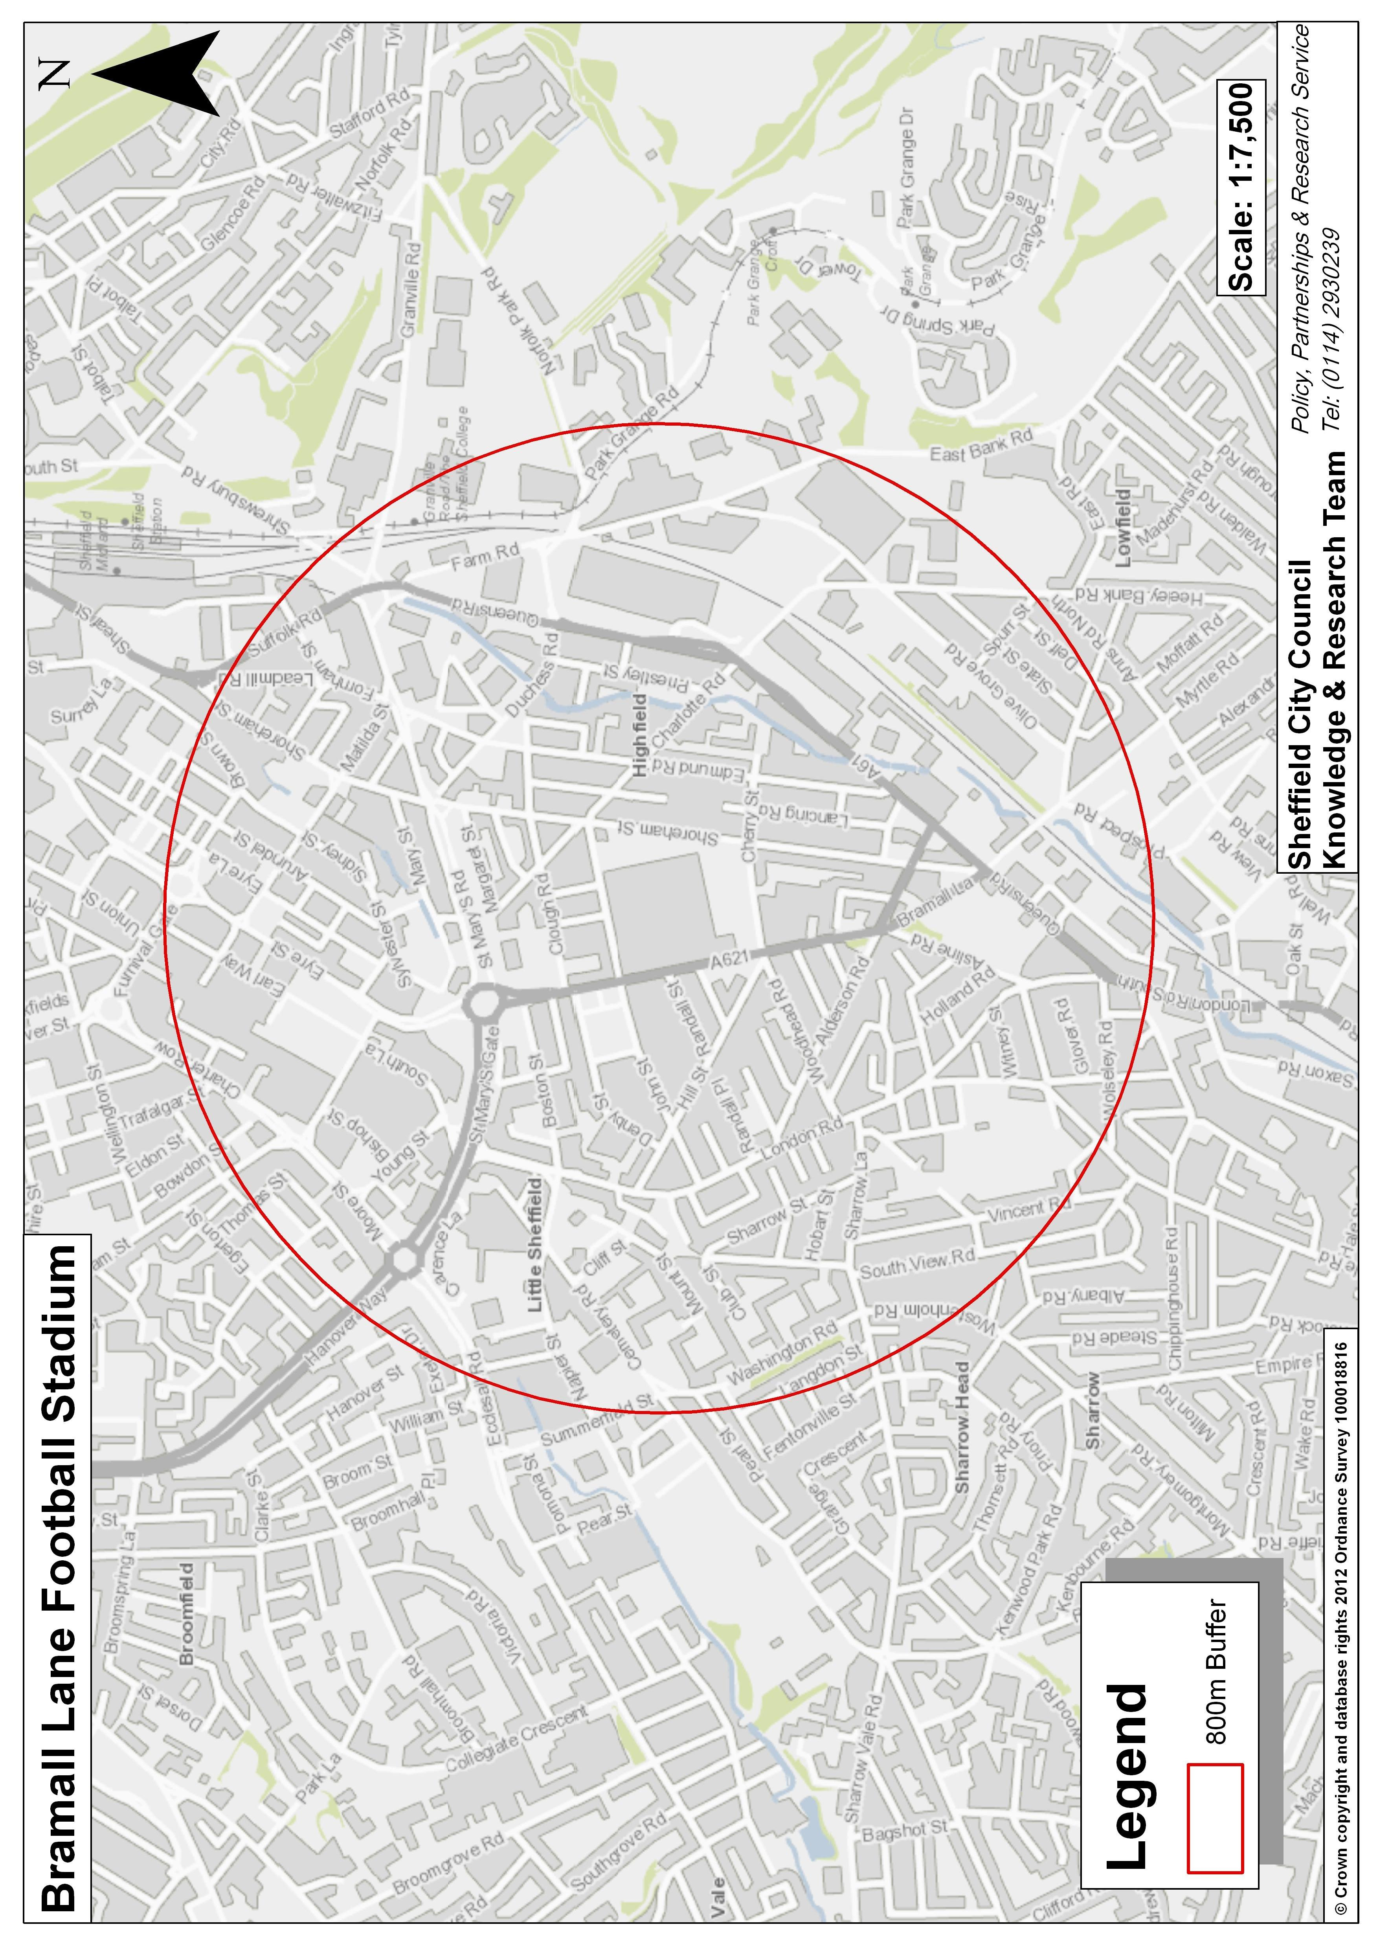
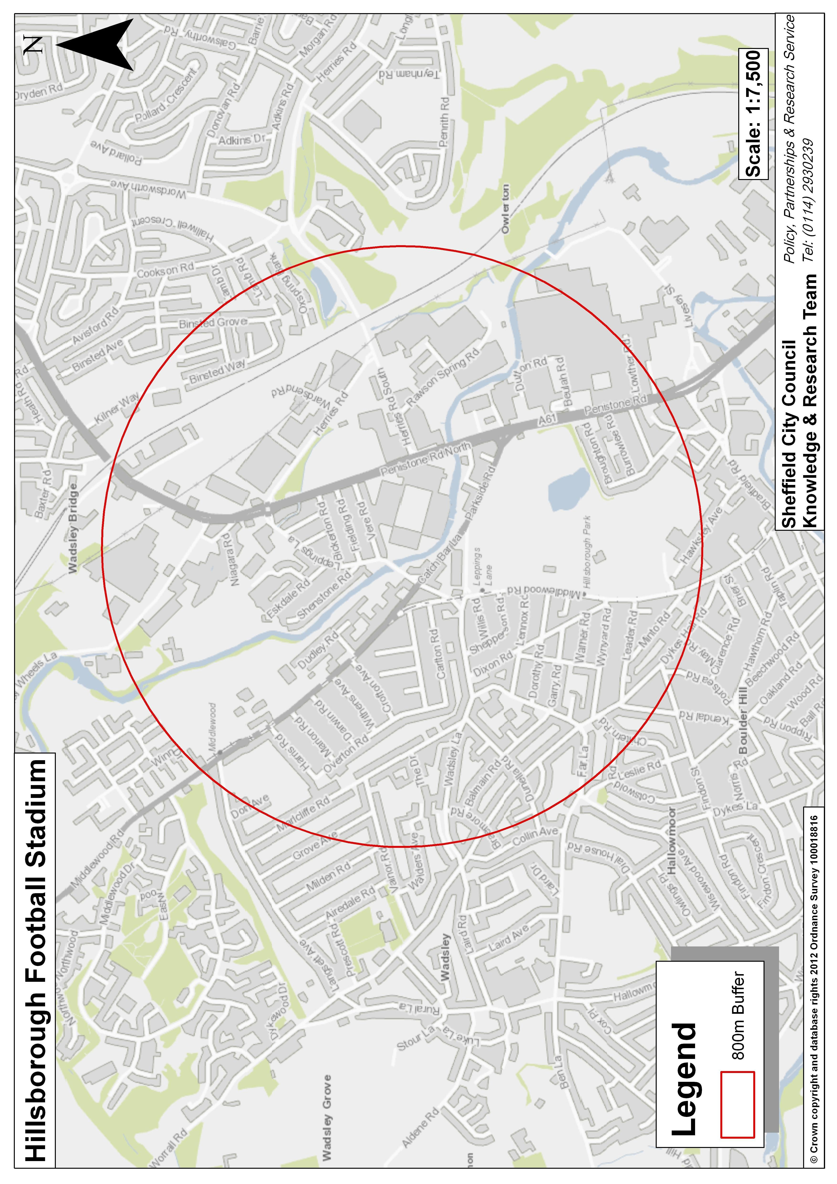

CITY WIDE STREET TRADING

QUALITY SPECIFICATION
(This specification does not include the city centre)

UNIT DESIGN
- Good display is an important part of the selling process and top quality presentation encourages purchase and benefits the retailers’ reputation.

- It is in the best interest of traders to produce a high quality design both internally and externally in their unit.

- The function of the unit is to identify the trader and add vitality and colour to the immediate area, and reflect the quality, cleanliness in their operation. The unit must contribute to the appearance of the area for good or bad, so design matters to everyone who uses the street, as well as the operator.

- Stalls must enhance the visual appearance of the street rather than detract from it and be constructed in a suitable style and of appropriate materials.

Examples of acceptable designs include:

- Modern, simple, functional stalls with umbrellas, canopies or striped awnings.
- Traditional or ‘period’ type handcarts, barrows or tricycles.

- The stall design should be fully accessible for all customers.

- The outside of the unit will be limited to the name of the stall, the type of product sold and a simple price list. Ad hoc pictures and advertiser’s slogans should be avoided, as should untidy handwritten signs.

- Advertisements on stalls will not be permitted except by permission of the Council in writing and subject to further conditions. The Council shall be the sole judge of what is an acceptable advertisement.

- Sign writing and scrollwork must be finished to a standard acceptable to the City Council.

- The unit must be visually acceptable to the City Council.

- The general design of the unit must meet the requirements of the Council for the location and proposed hours or days of trading. A photograph of the actual unit or proposed model must be submitted on application.

- Bright colours and a sense of fun are encouraged.

- Pitched and curved roofs are encouraged.

- Canopies must be maintained and cleaned.

- No expenditure on units or equipment should be made until the Council has granted consent and the unit design has been approved.

- The internal layout of the unit must be clean and to a high standard.

- Non-motorised vehicles (ie carts/barrows) are encouraged in pedestrian areas. For example shopping areas like Woodseats, Hillsborough, etc.

- Motorised vehicles should not be of an age of 5 years or over.

- Mobile trading vans must have a side hatch to serve customers.

- The unit / vehicle must be clearly identifiable as a trader.

Environmental Health considerations of the unit design:

For Enclosed Food units:

- The internal arrangements must be such that:

  - There is suitable and sufficient hand washing facilities with hot water;

  - The work surfaces are impervious to water and readily cleansable;

  - There is sufficient compliant temperature controlled food storage facilities appropriate to the business;

  - The gas and electrical installations are certificated and deemed to be safe by a competent and suitably qualified engineer; any gas store cupboard should be outside of the food area;

    - The external arrangements must be that the mobile is sufficiently weather and pest proof so as to not risk the contamination of the food.

For Market-Stall or Street-Barrow type food units:

- The stall must be covered to prevent the risk of matter falling on to the food;

- The work surfaces likely to be in contact with the food must be impervious to water and readily cleansable;

- Any intrinsic storage food area must be able to be secured against the intrusion by pests;

- If temperature controlled food is to be stored on the mobile, the storage facility shall be capable of maintaining the food in a legally compliant manner;

- That there are adequate hand washing facilities.

Food Hygiene record (for all food stalls) - all food regulations have been adhered to:

- The applicant will need to demonstrate that:

- they have registered with their home Local Authority;

- all food handlers have received adequate food safety training appropriate to their job role;

- the food business has a legally compliant Food Safety Management System (e.g. Safer Food, Better Business);

- if there is a history of non-compliance, it has been addressed and accepted by the Food Safety Enforcing Officer, or that the food business is in the process of addressing the issues and the Food Safety Officer does not consider the defect too severe so as to prohibit the food business from trading; and

- their business has a food hygiene rating score of at least 3.

DRESS

- Trader and their assistants must be identifiable (i.e wear a uniform).

- The style of dress worn by stall operators should be chosen to complement the style and period of the unit.

- Over clothing must always be smart and clean. Operators of food stalls should ensure that sufficient changes of clothes are provided so as to enable personnel to always wear over clothing, which is clean.

- Personal cleanliness is also important and persons employed at food stalls are required to have good personal hygiene.

GENERAL

- Vehicles used to tow trailers must be parked legally at all times.

- The Council will reserve the right to not renew any consent where it considers the product/s offered by the operator are not in keeping with the requirements of the site.

- The goods complement and do not conflict with the goods sold by other retailers within their proposed area(s).

The criteria above are intended to guide applicants for street trading consents as to the type of stall and dress, which the Council is looking to promote as a means of regulating the street trading.

It is not intended to exclude any design that does not fall within the examples given.



