**JOINT REGIONAL STATEMENT OF COMMON GROUND**

**FINAL DRAFT**

**MAY 2023**

*[Nb. Some signatories below still to formally confirm]*



**Contents**

|  |  |
| --- | --- |
| 1. **Introduction** | 3 |
|  |  |
| 1. **Signatories** | 6 |
|  |  |
| 1. **Strategic Geography** | 8 |
|  |  |
| 1. **Key Strategic Matters** | 11 |
|  |  |
| * 1. Planning for Energy and Climate Change | 12 |
|  |  |
| * 1. Planning for Housing | 15 |
|  |  |
| * 1. Planning for Employment | 19 |
|  |  |
| * 1. Planning for Transport | 25 |
|  |  |
| * 1. Planning for the Natural Environment | 30 |
|  |  |
| * 1. Planning for Waste | 33 |
|  |  |
| * 1. Planning for Digital Connectivity | 37 |
|  |  |
| * 1. Planning for other Strategic Matters | 40 |
|  |  |
| 1. **Governance Arrangements** | 41 |
|  |  |
| **Annex** | 42 |
|  |  |
| **Glossary of abbreviations** | 58 |

**1. Introduction**

1. This Statement of Common Ground provides a record of agreement on cross boundary, strategic planning matters and has been produced by the signatory authorities to demonstrate how Local Plans are prepared on the basis of an agreed understanding of the issues facing the Region (as outlined in Chapter 3, for the purposes of this Statement ‘Region’ refers to the former Sheffield City Region area).
2. The local authorities directly engaged in the Statement are:

* Bassetlaw DC
* Barnsley MBC
* Bolsover DC
* Chesterfield BC
* Derbyshire Dales DC
* City of Doncaster Council
* North East Derbyshire DC
* Rotherham MBC
* Sheffield City Council
  1. Other key stakeholders and signatories to the Statement are:
* South Yorkshire Mayoral Combined Authority
* Nottinghamshire County Council
* Derbyshire County Council
* Peak District National Park Authority
  1. This Statement fulfils the requirements of the National Planning Policy Framework (NPPF) and has been developed in accordance with the Government’s Planning Policy Guidance. It updates and replaces the previous Joint Statement of Common Ground agreed in October 2020, which covered the former Sheffield City Region (SCR) geography.
  2. An explanation of the key strategic matters and where we agree on these is set out in the following sections, with more detailed information in the Annex along with technical issues and links to the evidence base we have developed and continue to maintain.
  3. Other Statements of Common Ground have also been agreed, or are being prepared, by authorities in the former SCR Region[1]. This includes Statements of Common Ground for:
* The Doncaster Local Plan (March 2020) covering several strategic matters relating to the Local Plan.
* North East Derbyshire District Council, Bolsover District Council, Chesterfield Borough Council, Bassetlaw District Council, Derbyshire County Council and Highways England (Oct 2018) covering M1 J30 & Treble Bob Roundabout.
* Bolsover and Mansfield District Councils (August 2018) covering Gypsy and Traveller unmet need, housing needs, Junction 28 and 28 and development in Pleasley.
* North Derbyshire and Bassetlaw (May 2018) on the Housing Market Area.
* Sheffield and North East Derbyshire (May 2018) on Green Belt.
* Bolsover and North East Derbyshire (May 2018) on the former Coalite Works.
* Bassetlaw and Mansfield (December 2018) covering Gypsy and Traveller unmet need, housing need and distribution, Welbeck Colliery site and A60 corridor.
* Derbyshire Dales District Council is preparing an updated SOCG as part of the review of the Local Plan.
* Nottinghamshire and Bassetlaw, Sheffield, Rotherham, and Doncaster in respect of Waste Planning issues related to the Nottinghamshire and Nottingham Waste Local Plan (2024, forthcoming).
* Bassetlaw and others (November 2022) on the A1 corridor logistics assessment property market area.
* Bassetlaw and Rotherham (November 2022) on the Bassetlaw Local Plan.
* Sheffield Local Plan – in preparation – to be completed prior to Local Plan being submitted for examination.
  1. In addition, the Peak District National Park Management Plan 2023-2028[2] has high level buy in from Sheffield City Council and all constituent authorities across the National Park area. The Management Plan sets out an ambitious 20 year vision for the Peak District National Park and provides principles and priorities for partnership action working through its vision, aims, objectives and delivery plan.
  2. This Region-wide Statement of Common Ground has been prepared in light of existing work, in order to avoid duplication or conflict, and enable a more streamlined approach for the planning authorities in South Yorkshire and the former SCR area in the future. It will be reviewed annually by the signatories involved. This process will also allow other signatories and strategic matters to be added as appropriate.
  3. Throughout this Statement the wider regional context is recognised where appropriate (for example, the two Strategic Economic Plans prepared by SYMCA and D2N2); however, there is an emphasis on South Yorkshire for some issues where this reflects the core of activity or co-operation.

**2. Key Signatories**

|  |  |
| --- | --- |
| ...................................................................  **for and behalf of Bassetlaw District Council** | ....................................................................  Signature  .....................................................................  Title |
| ...................................................................  **for and behalf of Barnsley Metropolitan Borough Council** | ....................................................................  Signature  .....................................................................  Title |
| ...................................................................  **for and behalf of Bolsover District Council** | ....................................................................  Signature  .....................................................................  Title |
| ...................................................................  **for and behalf of Chesterfield Borough Council** | ....................................................................  Signature  .....................................................................  Title |
| ...................................................................  **for and behalf of Derbyshire Dales District Council** | ....................................................................  Signature  .....................................................................  Title |
| ...................................................................  **for and behalf of City of Doncaster Council** | ....................................................................  Signature  .....................................................................  Title |
| ...................................................................  **for and behalf of North East Derbyshire District Council** | ....................................................................  Signature  .....................................................................  Title |
| ...................................................................  **for and behalf of Rotherham Metropolitan Borough Council** | ....................................................................  Signature  .....................................................................  Title |
| ...................................................................  **for and behalf of Sheffield City Council** | ....................................................................  Signature  .....................................................................  Title |
| ...................................................................  **for and behalf of Derbyshire County Council** | ....................................................................  Signature  .....................................................................  Title |
| ...................................................................  **for and behalf of Nottinghamshire County Council** | ....................................................................  Signature  .....................................................................  Title |
| ...................................................................  **for and behalf of Peak District National Park Authority** | ....................................................................  Signature  .....................................................................  Title |
| ...................................................................  **for and behalf of South Yorkshire Mayoral Combined Authority** | ....................................................................  Signature  Mayor.........................  Title |

**3. Strategic Geography**

1. This Statement of Common Ground covers the former Sheffield City Region area. In 2021 the Combined Authority changed its name from “Sheffield City Region” to the “South Yorkshire Mayoral Combined Authority” to better reflect the organisation and the communities it serves. This also recognised Government’s decision to change the geographies of Local Economic Partnerships and the agreement of a Devolution Deal and funding to SYMCA only covering South Yorkshire. However, the constituent and non-constituent members of SYMCA remain unchanged[3], and the former SCR area continues to be an appropriate strategic level for co-operation for spatial planning. For the purposes of this Statement references to ‘the Region’ refer to the former SCR area.
2. The Region covers two cities, several large towns, thriving smaller towns, other semi-urban areas and a rural surrounding area. Ten local authorities are responsible for preparing Local Plans (see Figure 1, page 8) - four metropolitan districts of Barnsley, Doncaster, Rotherham and Sheffield; five district councils of Bassetlaw, Bolsover, Chesterfield, Derbyshire Dales; and North East Derbyshire. An area of the Peak District National Park also falls within the western area of the Region and is a planning authority in its own right. Derbyshire County Council and Nottinghamshire County Council are responsible for preparing minerals and waste local plans for their areas.
3. The National Park plays a key role in the Region, but also much more widely with special qualities that reflect the importance of its landscapes, wildlife and cultural heritage[4].
4. Research conducted by the OECD[5] in 2012 (updated 2019) into functional urban areas highlights the limitations of existing administrative boundaries and strong relationships among several urban cores within the UK. The work concludes that most of the former Sheffield City Region is a functional urban area, with a rural fringe which is also important to its economic, social, cultural and environmental functioning. This is further supported by the ONS[6] which highlights five main travel-to-work areas within the Region as well as overlaps with five others.

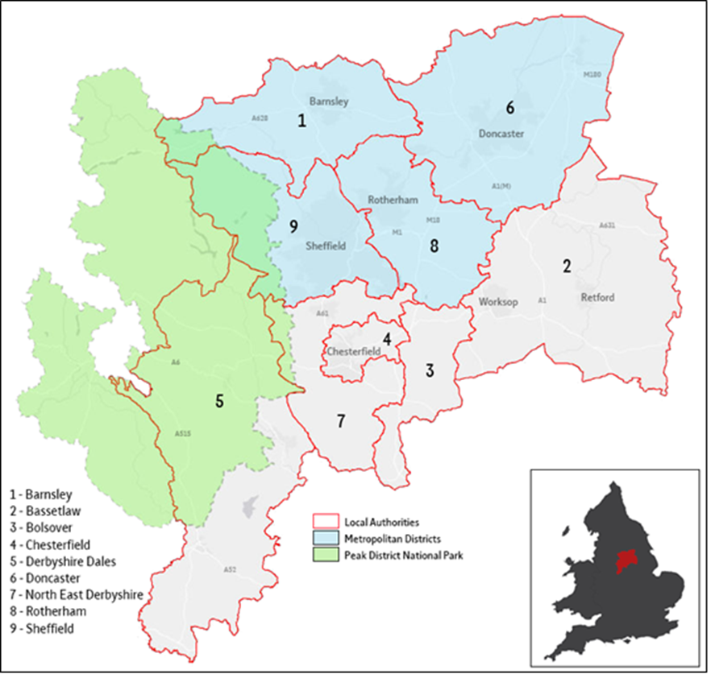

Figure 1: The Statement of Common Ground area

3.5 These relationships are also reflected in the retail, housing, transport and cultural linkages across the Region[7]. For example:

* There is overlap between retail catchments with joint working on retail important in ensuring appropriate land/property provision and retail/leisure demand relative to transport networks.
* Housing markets across the Region share some commonalities with most areas being more affordable than the national average, although this can mask areas of real need, especially for households with the lowest incomes.
* The proximity of major urban areas and the relative ease of commuting between them for work (as demonstrated by travel-to-work flows and journey times) demonstrate strong linkages within the Region.
* Administrative boundaries that cover the Region demonstrate the complexity of geography but also the commonalities. The NHS has several Integrated Care Partnerships and Boards within the Region demonstrating historical but also demographic commonalities. Other Government Agencies work across a broader geography (e.g. Homes England covers the North East, Yorkshire and The Humber as well the East Midlands).
* The Region’s cultural geography and green and blue infrastructure has never been assessed in its totality but there are clear linkages. These include the Peak District National Park, the West and South Yorkshire Green Belt and the canal and river networks as well as several historic and cultural assets, and some significant areas with high biodiversity value.

3.6 However, relationships between areas don’t stop at the Region’s boundary and we are committed to working with all neighbouring areas. For example, the area is closely related to the West Yorkshire region (particularly Barnsley) and also overlaps with the D2N2 LEP[8] (in Bassetlaw, Bolsover, Chesterfield, NE Derbyshire and Derbyshire Dales). These relationships have fostered close partnership working, producing some innovative projects on shared priorities as well as wider collaboration with other areas through the initiatives like Northern Powerhouse[9].

**4. Key Strategic Matters**

4.1 The local authorities of Bassetlaw; Barnsley; Bolsover; Chesterfield; Derbyshire Dales; Doncaster; North East Derbyshire; Rotherham and Sheffield together with the upper tier authorities of Derbyshire and Nottinghamshire County Councils, the Peak District National Park Authority and SYMCA work together at a regional scale on planning matters of shared strategic significance.

4.2 Together, we have agreed that this Statement of Common Ground should focus primarily on the following strategic matters:

1. Energy and Climate Change.
2. Housing.
3. Employment.
4. Transport.
5. Natural Environment.
6. Waste; and
7. Digital Connectivity.

4.3 Spatial planning has a vital role to play in enabling and encouraging the transition to a competitive and resilient low-carbon society that also supports the environment and human health and wellbeing[10]. This Statement acknowledges, as an overarching imperative, the role of the planning system in responding to the challenges of the climate change crisis and the need to reduce carbon emissions in order to meet national, regional and local net zero carbon targets. It recognises that tackling the climate emergency, supporting sustainable development and transport solutions and delivering environmental improvements and a net gain in biodiversity are cross-cutting and cross-boundary in nature.

4.4 In addition, current working arrangements on several other strategic matters are summarised in this Statement in order to illustrate the range of shared interests being progressed. These are developing and will continue to be reviewed in future updates of this Statement. They include:

* Green Belt.
* Minerals Planning.
* Peak District National Park; and
* Health.

**4.1**  **Planning for Energy and Climate Change**

4.1.1 In June 2019, The Climate Change Act 2008 (2050 Target Amendment) Order 2019 was signed into force by the UK Government committing by law to achieve 100% (net zero carbon) reduction in emissions by 2050.

4.1.2 Climate change is a cross cutting topic and strategic planning has a key role to play in achieving sustainable development and tackling and adapting to climate change. A number of the topics covered in this Statement are instrumental in reducing and mitigating the effects of climate change, in particular biodiversity and natural environment and transport. This includes influencing where new housing, employment and other development is located which in turn affects the need to travel and access to more sustainable travel modes. As such, as well as the agreements set out below, there will be agreed actions in other chapters in this document which will contribute to climate change mitigation and adaptation.

4.1.3 SYMCA and 8 out of the 12 authorities which signed up to the existing Joint Statement of Common Ground have declared a climate emergency and established targets for reducing carbon emissions. The Peak District National Park also has a high priority towards carbon reduction in its National Park Management Plan.

|  |  |  |  |
| --- | --- | --- | --- |
| **Authority** | **Date Climate Emergency Declared** | **Target date** Council activities where applicab**l**e | **Target date**  Whole area |
| **SYMCA** | November 2019 |  | 2040 |
| **Barnsley** | September 2019 | 2040 | 2045 |
| **Chesterfield** | July 2019 | 2030 | 2050 |
| **Derbyshire Dales** | May 2019 | 2030 | 2050 |
| **Doncaster** | September 2019 | None | 2040 |
| **North East Derbyshire** | July 2019 | 2030 |  |
| **Rotherham** | October 2019 | 2030 | 2040 |
| **Sheffield** | February 2019 | 2030 | 2030 |
| **Nottinghamshire** | May 2021 | 2030 |  |

**Energy**

4.1.4 As above, SYMCA and the four South Yorkshire local authorities have all declared climate emergencies and put in place targets for reducing carbon emissions.

4.1.5 SYMCA’s Energy Strategy[11] outlines how the region could achieve its ambition to be at net-zero carbon emissions by 2040, ten years before the goal set by Government. The target was set following the declaration of a Climate Emergency in South Yorkshire in November 2019[12].

4.1.6 The zero carbon and energy strategies of the four South Yorkshire authorities are summarised at Table 10 in the Annex.

**Whole Life Carbon**

4.1.7 Whole life carbon emissions relate to the carbon emissions associated with a building over its entire lifetime arising from materials, its construction and its use. Traditionally it has mainly been operational emissions that have been assessed. In order to be able to monitor and assess whether we are meeting our net zero targets, we will work towards securing the assessment of whole life carbon emissions for major developments.

**Future Homes Standard**

4.1.8 The Government has brought in the Future Homes Standard, which from 2025 will require co2 emissions produced by new homes to be 75-80% lower than homes that are built to the 2023 Building Regulations standards. Homes will need to be zero carbon ready with no retrofit work required to benefit from the decarbonisation of the electricity grid and the electrification of heating. The intention is to future proof new homes for low carbon heating systems and meet higher standards of energy efficiency.

4.1.9 The Government has also set higher performance targets for non-domestic buildings (Future Building Standard), which will have to be ‘zero carbon ready’ by 2025. This involves uplifting minimum energy efficiency standards, uplifting minimum standards for new and replacement thermal elements (i.e. walls, floors, roofs) and controlled fittings (e.g. windows, roof-lights and doors).

4.1.10 The existing Building Regulations and future revisions are a crucial element in achieving zero carbon development. Local authorities will ensure new development meets these standards as a minimum and encourage higher standards where possible.

**Flood Risk in South Yorkshire**

4.1.11 Since the devastating flooding in November 2019 across South Yorkshire, SYMCA and the four local authorities have worked with partner organisations to respond to the flood risk and climate emergency in South Yorkshire on a catchment scale.

4.1.12 The Connected by Water Action Plan[13] is a vital part of this response, setting out the actions SYMCA, South Yorkshire local authorities and our partners are developing and delivering now and in the coming years. It strengthens our capacity to plan and act together to ensure we are building a climate resilient future for the communities of South Yorkshire.

***Based on the above, the current position is that we:***

* Work towards contributing to the national target of being net zero by 2050 alongside local targets and targets in SYMCA and local climate emergency declarations.
* Collaborate where appropriate to accelerate progress towards a carbon neutral Region, reflecting in local plans or supplementary planning documents such as the SYMCA energy strategy and renewal plan, where appropriate.
* Liaise with neighbouring authorities regarding cross boundary impacts of specific sites, to identify and agree appropriate mitigation measures where required.
* Local planning authorities will seek to encourage higher standards than the Building Regulations in force at the time of the development, where practicable and economically viable to do so.
* Local planning authorities will work towards seeking whole life carbon assessments (covering both operational and embodied carbon) where appropriate.
* Local Planning Authorities in South Yorkshire have agreed to work together on a catchment wide basis to reflect the natural geography of the region and seek consistency in respect of permitted run off rates for greenfield and brownfield developments.
* Partners in South Yorkshire will work together to develop and deliver flood risk benefits through the planning system on a catchment scale, consistent with the Connected by Water Action Plan.
* Local Planning Authorities in South Yorkshire have agreed to work together to develop and support the implementation of the Energy Strategy and Delivery Plan.

**4.2**  **Planning for Housing**

**The Collective Housing Needs of the Region**

4.2.1 All Local Planning Authorities in the Region are planning to ensure that their own housing needs are met within their Local Authority boundaries, where this is consistent with national planning policy. Based on adopted annual Local Plan targets, emerging Local Plan targets and local housing need figures, there is no significant shortfall in housing supply and no re-distribution of unmet need required in the Region. The overall level of housing growth being planned for is enabling economic growth targets in existing and emerging Local Plans to be delivered, supporting the aspirations of the SYMCA Strategic Economic Plan.

4.2.2 Using the Government’s standard methodology, the assessment of Local Housing Need (LHN) across the Region would be 6,200 (net) new homes per annum[14], which informs developing Local Plans or plans being reviewed. Housing requirement targets in adopted and emerging Local Plans currently total 6,466 new homes per year. This means the Region are currently planning for around 266 homes per year more than the standard housing need figure.

4.2.3 Rotherham’s Core Strategy is subject to a partial update, which is programmed for consultation in late 2023 (Reg 18). If LHN is used to inform Rotherham’s target the figure will be 566 homes per year. In addition, the draft Sheffield Local Plan (Reg 19 stage) sets a housing target of 2,040 homes per year, which is 978 below the LHN figure for Sheffield of 3,018. This reflects the additional 35% urban uplift as applied to Sheffield’s Local Housing Need figure by Government, which has a significant impact on the regional figure. This uplift is catering for household growth arising from people moving to Sheffield from elsewhere in the UK or from abroad (i.e., it is not locally generated). Taken together, these changes mean that the Region would be planning for around 6,072 homes per year, which is 128 homes less than the standard housing need figure. This represents a change since the previous Statement of Common Ground, being slightly below the Government’s LHN requirements[15].

4.2.4 Table 1 in the Annex provides a local authority breakdown of local housing need figures and Local Plan housing requirement targets.

**Housing Delivery**

4.2.5 All Local Planning Authorities are currently working to maximise the delivery of new homes in their area and across the Region.

4.2.6 The number of new homes completed in the Region has risen steadily over recent years, rising from 5,350 in 2015/16 to a high of 8,212 in 2019/20, albeit with a dip during 2020/21 as a result of the Covid-19 pandemic. However, completion of 7,143 new homes in 2021/22 shows how the Region has recovered to reach the second highest level of completions since 2015/16. Table 2 in the Annex provides a local authority breakdown of net housing completions, which represents the total of all new homes added to the housing stock in the Region, including conversions and change of use. For accuracy and consistency, this is based on figures provided annually by local authorities to Government through the Housing Flows Reconciliation returns[16], which are used to calculate performance against the Housing Delivery Test (HDT) - a key feature of the Government’s push to increase housing delivery.

4.2.7 Overall, annual housing delivery in the Region is now broadly in line with Local Plan targets and local planning authorities will continue to monitor the rate of new housing completions within the Region.

4.2.8 Monitoring of completions by house type and size is not available consistently across all the Region’s authorities and is therefore not included in this Statement of Common Ground. Similarly, other housing issues such as tenure and provision for specific groups like Gypsies and Travellers, students or armed forces personnel are better addressed at the Local Planning Authority level and so are not covered within this Statement.

**Housing Land Supply**

4.2.9 All Local Planning Authorities in the Region are currently working to ensure that a housing land supply of at least five years is available within each local authority area, which in turn will result in a 5-year supply across the Region as a whole. The most recent monitoring suggests that there is in excess of a 5-year deliverable housing land supply across the Region, rising to a supply in excess of 8 years if compared to the combined Local Housing Need figure.

4.2.10 Table 3 in the Annex provides details of the full local authority published 5-year housing land supply position and publication dates of data. Due to the variation in publication dates, some positions will have since changed. We will continue to monitor land supply in relation to Local Plan requirements.

4.2.11 We will work collaboratively to anticipate and respond to long term requirements and opportunities, including exploring sustainable housing growth opportunities arising from proposed major improvements to strategic transport infrastructure.

**Housing Market Areas**

4.2.12 Figure 2 below shows the extent of different Housing Market Areas defined across the Region and used to understand housing needs and demands at a local level. It illustrates the complexity of our housing market geography as well as the close relationships between areas, particularly in the south of the region. It is recognised that Housing Market Areas can operate differently for different groups, and that there is some overlap. These more complex relationships will be addressed through local assessments and discussions between neighbouring districts wherever necessary.

4.2.13 In some cases, where Local Plans are adopted with housing requirements above the Local Housing Need assessment figure, this may contribute towards wider regional growth ambitions. This would require separate agreements between individual authorities (there are no such agreements in place at present within the Region) and would only apply in situations where new homes and areas of jobs growth do not result in unsustainable commuting patterns and where the new homes are not required to balance the jobs growth in an individual local authority area.

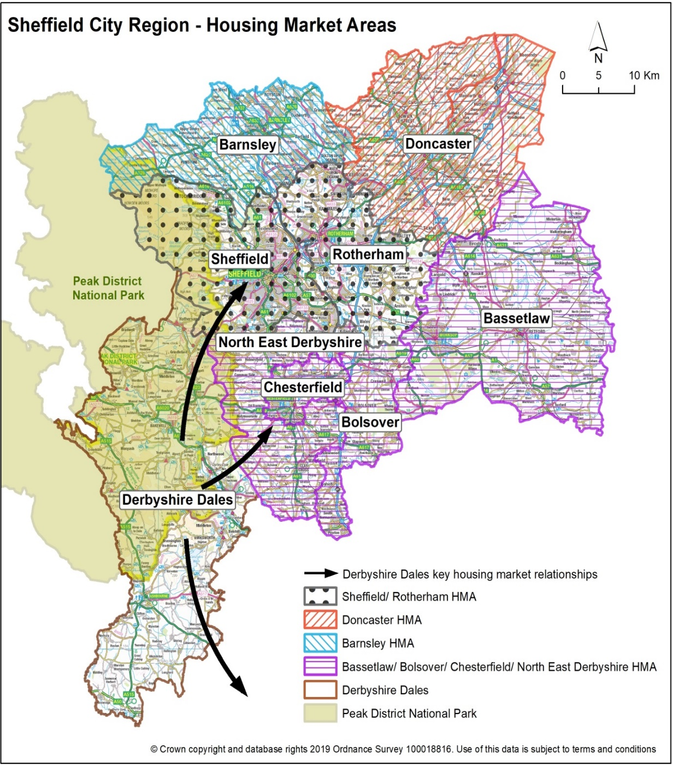

**Housing Market Areas**

Figure 2: Housing Market Areas

***Based on the above, the current position is that:***

* Each Local Planning Authority plans for their own housing need within their own Local Authority boundaries, taking account of national planning policy, housing market geographies, individual local authority economic growth targets and agreements between individual authorities as necessary.
* Through Local Plans, we ensure that the quantum of housing required to deliver growth ambitions across the Region is being met.
* Through Local Plans, agree Housing Market Areas in the Region and understand the relationships between these.
* We will use the plan making system to maximise delivery of sustainable housing development.
* Monitor housing delivery on an annual basis, as a minimum, to ensure that housing growth continues to meet identified local need and support growth ambitions across the Region.

**4.3 Planning for Employment**

**Employment Targets**

4.3.1 The SCR Strategic Economic Plan (SEP) agreed in 2014, sought to create 70,000 new jobs and 6,000 new businesses across the former City Region (between 2015 and 2025). This informed preparation of Local Plans across the region.

4.3.2 Following the refocusing of the Mayoral Combined Authority on South Yorkshire the latest SEP, agreed in 2021, provides a strategy to 2041. This aims to deliver 33,000 extra people in higher level jobs across South Yorkshire, although it moves away from specific job targets for individual districts. Its vision is to grow an economy that works for everyone; developing inclusive and sustainable approaches that build on our innovation strengths and embrace the UK’s 4th Industrial Revolution to contribute more to UK prosperity and enhance quality of life for all.

4.3.3 The strategy for Derbyshire and Nottinghamshire to 2030 is set out in ‘Vision 30’, the D2N2 Local Enterprise Partnership’s SEP. This seeks to deliver a high-value economy, prosperous, healthy and inclusive, and one of the most productive in Europe. The D2N2 Recovery and Growth Strategy 2021 seeks to support low carbon growth; promote productivity, particularly around employment and skills; business growth and innovation; and endorse connectivity and inclusion, including integrated infrastructure and place shaping.

4.3.4 Local Plans in the Region are at different stages of preparation and cover differing plan periods. They are being, or have been, prepared drawing on relevant and robust evidence to accommodate jobs growth. Table 4 in the Annex sets out the headline jobs figures being planned for in the adopted or emerging Local Plans.

**Employment Land Supply and Major Growth Areas**

4.3.5 Each place within the region plays an important role in the economy and contributes to our economic ambitions. The roles of different places and their contribution to the regional economy are defined in each Local Plan. Key points from these plans are summarised in Table 7 in the Annex to this Statement.

4.3.6 Working across these places and the different roles they fulfil, key locations have been identified where growth will be supported through investment and infrastructure measures.

4.3.7 In South Yorkshire the SEP identifies eight Major Growth Areas which are:

* Sheffield and Doncaster City Centres and the town centres of Barnsley and Rotherham
* Gateway East[17]
* Advanced Manufacturing Innovation District (AMID)
* Doncaster Unity
* Goldthorpe in the Dearne Valley

4.3.8 In Derbyshire and Nottinghamshire, the Local Industrial Strategy supports the growth of cities, towns and economic corridors to improve quality of place and economic prosperity in the wider region. Key locations are:

* Chesterfield and Worksop town centres
* Markham Vale
* A61 Corridor

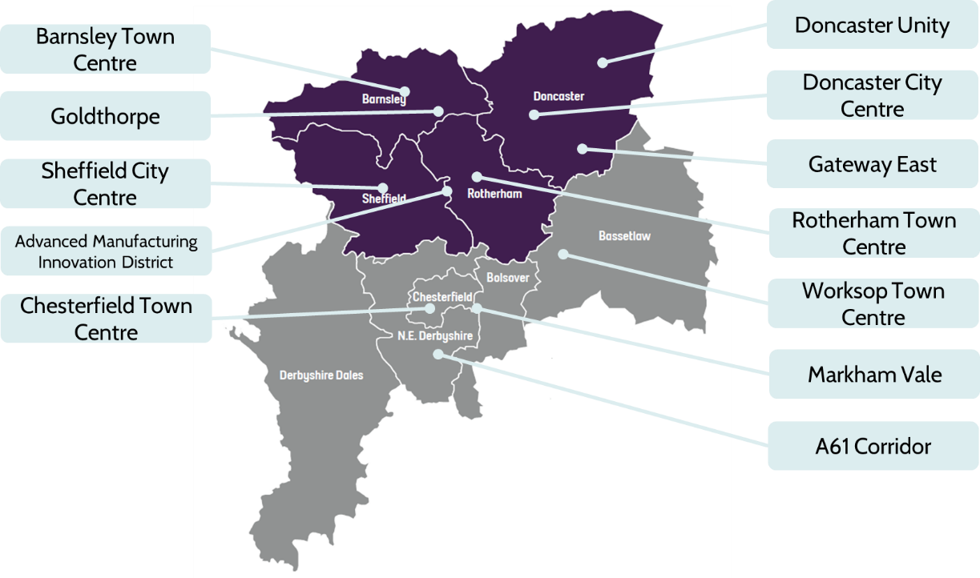

Figure 3: Indicative location of Key Urban Centres and Major Growth Areas

4.3.9 Local Plans will help to drive employment in these urban centres and growth locations, ensuring that an appropriate supply of employment land is available for economic growth and that the infrastructure needed to deliver this is recognised and capable of being funded.

4.3.10 Table 6 in the Annex summarises the employment land requirements from each of the Local Plans in the region.

4.3.11 A high-level appraisal of strategic employment sites across the former Sheffield City Region was undertaken in 2020, with a particular focus on strategic sites of 5 ha or more. It provides a coherent, joined up understanding of current employment land across all nine districts which will inform the decisions of individual planning authorities.

**Functional Economic Market Areas and Travel to Work Areas**

4.3.12 The geography of commercial and industrial property markets needs to be understood in terms of the requirements of the market, location of premises, and the spatial factors used in analysing demand and supply – often referred to as the Functional Economic Market Area (FEMA).

4.3.13 However, patterns of economic activity vary from place to place and there is no standard approach to defining a FEMA. Instead, the extent of a FEMA needs to be defined on the basis of a number of factors such as travel to work pattern; flows of goods, services and information; service markets for consumers; administrative boundaries; catchment areas for cultural facilities; and the transport network.

4.3.14 Based on this approach, Local Planning Authorities across the region define a FEMA for their own local plans, which are summarised at Table 8 in the Annex. Each Local Planning Authority is individually responsible for identifying employment needs and employment land supply in their local plans to meet their District’s economic needs and growth priorities.

4.3.15 The definition of the FEMAs is not always straightforward and there can often be overlaps. At the regional scale there are strong links between the different market areas and travel to work patterns. The previously adopted regional Statement of Common Ground recognised that it is reasonable to consider the whole of the former Sheffield City Region as a Strategic FEMA; which would sit above the local FEMAs defined in Local Plans. We continue to adopt this position in this updated Statement.

4.3.16 We acknowledge, however, that logistics including large scale warehouse and distribution (logistics) uses over 100,000sq ft have a larger than local property market area[18] which may not align with the boundary of the Region and the strategic FEMA. Considering opportunities for large scale logistics would require separate agreements between individual authorities within an evidenced property market area.

4.3.17 Considering the Region as a strategic FEMA within the boundary of the Region will ensure that together we can offer the optimum supply of land to address large scale strategic or inward investment growth requirements that would otherwise be above and beyond the indigenous needs of any one district. This approach will provide further assistance to work already undertaken to plan infrastructure and help support closer integration between policy areas such as planning and transport. It would not prejudice the work done by any individual district in developing their Local Plans.

4.3.18 Pre-coronavirus (COVID-19) pandemic data indicates that in total, 88% of the working people who live in the Region also work within the Region; looking at this pattern from the other perspective, nearly 9 in 10 people whose job is in the Region also live here[19]. In short, the great majority of residents work locally or commute between districts within the Region for work. These internal commuting flows are set out in Figure 4.

4.3.19 At the same time, there are also important links between the region and employment opportunities in Leeds, Wakefield, Derby and the Amber Valley-Ashfield-Mansfield corridor. The extent of these external commuting flows is illustrated in Figure 5.

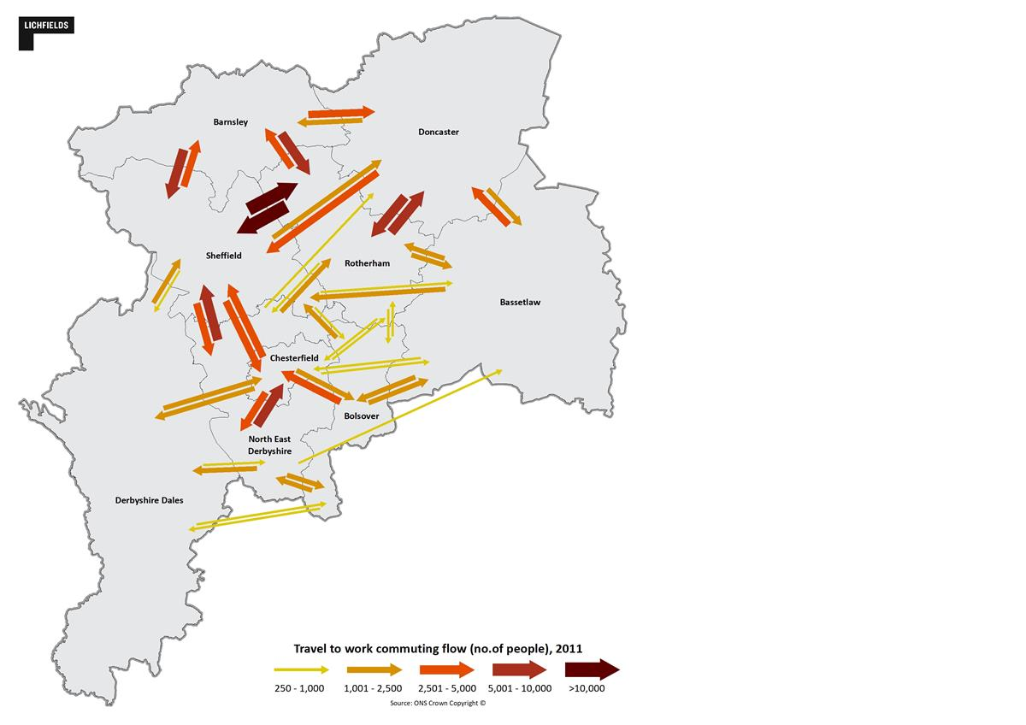

Figure 4: Travel to work commuting flows**[20]**

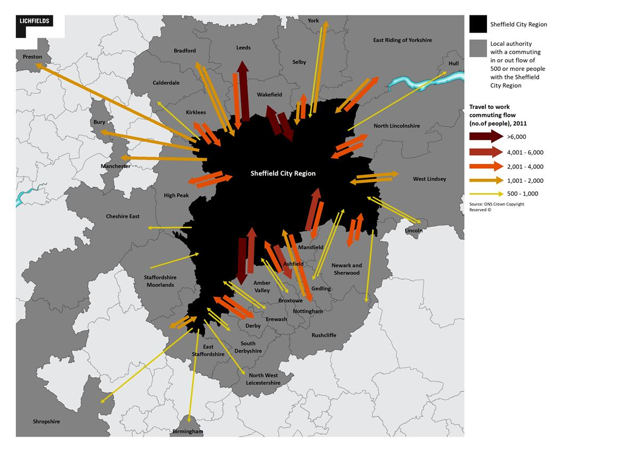

**Former Sheffield City Region**

Former Sheffield City Region

Figure 5: Travel to work commuting flows between the former Sheffield City Region and neighbouring areas

4.3.20 The coronavirus (COVID-19) pandemic led to major changes in commuter travel patterns. Travel to workplaces declined sharply due to a shift to working from home, being furloughed or in some cases because of job losses. Research suggests that latent demand for permanent flexible working arrangements, including working from home and hybrid office-home working, have been unlocked by the pandemic[21]. Understanding the long-term impacts of changing working and commuting patterns on local and regional economies will be important; particularly in respect of office floorspace supply and demand, impacts on city and town centres and other major growth areas.

***Based on the above, the current position is that:***

* Local planning authorities will plan for their own employment land needs within their own Local Authority boundaries, taking account of alignment with housing growth proposals, Functional Economic Market Areas and agreements between individual authorities as necessary.
* Employment growth in the Key Urban Centres and Major Growth Areas will be supported.
* The delivery of employment land will be monitored, and Local Planning Authorities will ensure an appropriate supply of land in line with growth ambitions.
* The loss of employment land to other uses, in particular residential use, will be monitored.
* We will share local evidence as appropriate and strengthen our collective evidence base, particularly in respect of changing working and commuting patterns.
* We will continue to work collaboratively to achieve the economic ambitions of the SYMCA and D2N2 SEPs and other growth strategies within the Region, developing our evidence and understanding the operation of a strategic FEMA at the regional scale.
* Local Planning Authorities will seek to maintain an adequate supply of land for logistics uses across the Region as a whole (recognising the larger than local property market area)

**4.4 Planning for Transport**

**Transport Strategy**

4.4.1 The SCR Transport Strategy[22] sets goals and policies for South Yorkshire but recognises the importance of the wider regional economic geography. It was adopted by SYMCA in January 2019 as a basis for supporting the economic aspirations of the Region. Importantly, the Strategy also looks beyond the immediate boundaries of the region to include interventions that benefit the wider Northern Powerhouse and Midlands Connect sub-national areas, as well as the rest of the UK.

4.4.2 Further detail is set out in the following plans, supporting the Transport Strategy:

* SYMCA Bus Service Improvement Plan[23] (2021)
* SCR Integrated Rail Plan (2019)
* SCR Active Travel Implementation Plan (2020)

4.4.3 Taken together, the Strategy is intended to ensure all parts of the Region are well-connected, with journey times that connect every neighbourhood to a regional hub in 15 minutes; a regional hub to another regional hub in 30 minutes; and all regional hubs to a major centre in 75 minutes[24].

4.4.4 As separate Local Transport Authorities, both Derbyshire and Nottinghamshire have their own Local Transport Plans, covering parts of the region outside of South Yorkshire. These both emphasise the importance of cross boundary working, and have objectives aligned with the SCR Transport Strategy as set out in the table below.

| **SCR Transport Strategy goals** | **Derbyshire LTP3 objectives** | **Nottinghamshire LTP goals** |
| --- | --- | --- |
| *Residents and businesses connected to economic opportunity* | *Supporting a resilient local economy.*  *Promoting equality of opportunity.* | *Improve access to key services, particularly enabling employment and training opportunities* |
| *A cleaner and greener Sheffield City Region* | *Tackling climate change.*  *Improving quality of life and promoting a healthy natural environment.* | *Minimise the impacts of transport on people’s lives, maximise opportunities to improve the environment and help tackle carbon emissions* |
| *Safe, reliable and accessible transport network* | *Contributing to better safety, security, and health* | *Provide a reliable, resilient transport system which supports a thriving economy and growth whilst encouraging sustainable and healthy travel* |

4.4.5 Since the development of the SCR Transport Strategy and its supporting plans, a number of significant changes in national and regional transport policy have taken place, including:

* New national strategies in respect of active travel[25] and buses[26];
* The national Transport Decarbonisation Plan[27] and Net Zero Strategy[28];
* The updated regional Strategic Economic Plan[29] and Renewal Action Plan[30];
* The Integrated Rail Plan for the North[31], and the South Yorkshire Post-IRP Positioning Plan;
* The recently agreed East Midlands Devolution Deal; and
* A new national Park management Plan seeking low carbon sustainable visits to the National Park.

4.4.6 The changes will be reflected in in the preparation of the new South Yorkshire Local Transport Plan, to be in place for Spring 2024. A new Local Transport Plan will also be prepared for the new East Midlands Mayoral Combined Authority. These changes are also likely to require the renewal of the implementation plans set out at paragraph 4.3.2 above.

4.4.7 We will work closely together on all relevant aspects of the SCR Transport Strategy, transport strategies in Nottinghamshire and Derbyshire, and with Local Plans where relevant and planning decisions particularly helping to deliver priorities around economic growth, housing, health, air quality and decarbonisation:

* Growth: improved transport network connectivity and greater capacity are vital in enabling economic growth, both in the region and across the wider North of England.
* Housing: transport contributes to meeting our housing targets by helping to unlock new development sites and provide more sustainable modes of travel for residents.
* Decarbonisation: transport accounts for 38% of territorial emissions in the region, and prompt, well targeted action will be required to reduce carbon emissions as fast as possible in the lead-up to achieving Net Zero at 2040 – in particular for the most significant contributors in respect of medium- and long distance car travel and freight (see paragraph 4.3.12).
* Health and Air Quality: provision for more active travel like walking and cycling as well as public transport alongside development enables more sustainable choices to be made, benefitting health and air quality

**National and pan-northern interventions**

4.4.8 The SCR Transport Strategy, and subsequent documents, define a number of transport interventions that will have a national and pan-northern impact as they are progressed by SYMCA and partners such as Transport for the North, neighbouring authorities, the National Highways, Network Rail, public transport operators, businesses and Government.

4.4.9 Local Plans in the SCR Transport Strategy area will seek to support the following:

* Maintenance and improvement of bus services in the region, including working with LTAs in Nottinghamshire and Derbyshire in respect of services running across Local Transport Authority boundaries.
* Major rail improvements: including faster and more frequent services to Leeds and Manchester.
* Local rail improvements, such as new stations at Rotherham Mainline, and accessibility improvements at local railway stations.
* Securing the long-term future of the tram / tram-train network: including the enhancement of services and supporting infrastructure and improving connectivity to and the accessibility of tram stops.
* Integrated and smart travel programme: with multi-modal, integrated ticketing and real time information.
* Strategic Road Network improvements: which will increase connectivity between the region and neighbouring regions as well as movements within the region itself.

4.4.10 Information in Table 9 of the Annex lists these national and pan-northern interventions. Together they will improve the region’s links other Northern towns and cities as well as with the East Midlands region. It will, therefore, be particularly important to work closely with bodies such as Transport for the North, Midlands Connect, Network Rail and National Highways so that people can commute between city regions more quickly and easily, ensuring the right people have access to the right jobs in as sustainable a manner as possible.

**Local Interventions**

4.4.11 Each part of the Region has its own transport priorities and several local transport authorities have (or are developing) their own Local Transport Strategies, aligned to regional strategies, which are also used to inform Local Plans. At the Regional scale, the SCR Transport Strategy identifies 11 key regional economic centres that need reinforcing with transport infrastructure and 20 priority transport corridors.

4.4.12 We will work together and with SYMCA and other partners to seek to deliver improvements to transport corridors and enhance the strategic transport network with a combination of walking, cycling, bus, tram, bus rapid transit, heavy rail and tram-train.

**Transport and climate change**

4.4.13 Transport, and in particular road transport, is a major driver of carbon emissions – accounting for 39% of territorial emissions in the Region in 2019. Road transport was responsible for 97% of these emissions. Initial baselining work reveals, within the Region:

* 50% of transport emissions come from cars, 23% from heavy goods vehicles, and 16% from vans;
* 78% of car emissions result from trips exceeding 10 km (6 miles) length, despite only accounting for 45% of trips;
* 55% of car emissions, and 65% of road transport emissions, result from trips to or from destinations outside of the region. 26% of car emissions, and 32% of road transport emissions, have no origin or destination in the region at all i.e. are simply passing through. (There will be a similar effect for other regions, where trips to or from our region pass through others without stopping).
* Only 22% of car emissions, and only 16% of road transport emissions, relate to trips where both origin and destination lie within the same district.
* Around 90% of trips to the National Park take place by private vehicle.

4.4.14 The above baseline position highlights the importance of working with regional and national partners to tackle the medium- and long-distance trips that are disproportionately responsible for carbon emissions – likely through a combination of travel demand reduction, destination shift, mode shift and shift to zero emission vehicles.

**Strategic Testing Tools**

4.4.15 Since 2017, authorities across the Region have been assessing transport proposals using a region-wide computerised model of transport networks and demand (SCRTM1). This model is due to be updated in the coming years, to reflect changed travel patterns following the Coronavirus pandemic; this process will also see a review of how the model is used to ensure scheme appraisal reflects latest policy.

4.4.16 We will use these Region wide models alongside local transport models, including in Nottinghamshire and Derbyshire, to ensure a complementary hierarchy of modelling is applied. Working at different scales, from strategic interventions of major schemes to micro-simulation of individual sites or junctions, this will ensure the impacts and value for money of projects are understood in a clear, consistent way.

***Based on the above, the current position is that we:***

* Acknowledge carbon emissions are predominantly driven by medium- and long distance transport, both passenger and freight, and so development and transport impacts may not be fully accounted for in an individual area’s territorial emissions – and agree to ensure cross-boundary impacts of development and transport interventions are fully considered and mitigated for.
* Support the development and adoption of new Local Transport Plans for South Yorkshire and the East Midlands by Spring of 2024.
* In South Yorkshire, the development and adoption of new implementation plans to reflect the new Local Transport Plan, covering bus, rail, tram, walking, cycling and private traffic (including freight and shift to zero emission vehicles) in an holistic and co-ordinated manner.
* Support, in the interim, the implementation of policies in the SCR Transport Strategy, but being flexible to adapt to shifts in national, regional policy since that strategy was drafted.
* Help to bring forward the national and pan-northern interventions agreed through the SCR Transport Strategy where remaining relevant or consistent with policy.
* Work together to improve connectivity, particularly within and around the 20 regional transport corridors defined in the Transport Strategy.
* Support the safeguarding and delivery of critical transport routes (both existing and new) and collaborate across boundaries to make the best use of inter-regional rail, tram, road and water transport networks.
* Secure financial contributions (for example, through S106 obligations, Community Infrastructure Levy, or Land Value Capture) wherever appropriate to help leverage funding for relevant transport interventions, particularly for public transport and active travel measures.
* Apply a complementary hierarchy of transport models to understand and assess the impact of local plans, projects and proposals on the transport network at appropriate scales.

**4.5** **Planning for the Natural Environment**

4.5.1 All authorities within the Region recognise the importance of conserving and enhancing the natural environment and are taking a range of actions as a result, both within and outside of the sphere of influence of the planning system. In addition, Doncaster, Rotherham and Sheffield Councils have declared nature or biodiversity emergencies which are complementary to climate emergency declarations, and which point towards the development of further actions and activities.

**Local Nature Recovery Strategies**

4.5.2 The Environment Act 2021 sets out the requirement for the preparation of Local Nature Recovery Strategies (LNRS). A LNRS is a tool that is designed to drive more coordinated action to help nature and establish a Nature Recovery Network. As identified in the Government’s 25 Year Environment Plan, the Nature Recovery Network will be a national network of wildlife rich places. The aim is to expand, improve and connect wildlife rich areas across our towns, cities and countryside, to help deal with the challenges of biodiversity loss, climate change and wellbeing. The LNRS will map the most valuable existing habitats for nature, map specific proposals for creating or improving habitats for nature and environmental goals as well as agreeing priorities for nature’s recovery.

4.5.3 Within the Region:

* SYMCA has provisionally[32] been appointed to be the Responsible Authority for the development of South Yorkshire's Local Nature Recovery Strategy.
* Nottinghamshire County Council has provisionally been appointed to be the Responsible Authority for the development of Nottinghamshire’s Local Nature Recovery Strategy.
* Derbyshire County Council has provisionally been appointed to be the Responsible Authority for the development of Derbyshire’s Local Nature Recovery Strategy.
* The Peak District National Park is also producing a single plan for Nature Recovery to cover the whole of its statutory geography which overlaps these areas.

4.5.4 The Responsible Authorities, supported by partners, including local authorities and Local Nature Partnerships will develop the LNRS, including setting targets for nature recovery in the region. The delivery of the LNRS will then be monitored and reported as a requirement of the Environment Act.

**Natural Capital**

4.5.5 Natural capital can be defined as the world's stocks of natural assets which include geology, soil, air, water and all living things. It has been shown that the loss of biodiversity and the degradation of natural capital has consequences for the long-term welfare of people and the sustainability of economic systems[33]. It is therefore vital that an understanding of natural capital plays a role in shaping planning policy and decision making.

4.5.6 A natural capital assessment for the whole of South Yorkshire was commissioned by the SYMCA in 2021. The assessment identifies the existing natural capital assets, the baseline habitat level biodiversity, the flow of ecosystem services they provide, the monetary value of the resulting benefits – currently estimated at £550million per year and the opportunities to restore existing habitats and to create new ones to enhance biodiversity and deliver greater multiple benefits.

4.5.7 The evidence from the natural capital assessment will be used to help inform the development of the Local Nature Recovery Strategy for South Yorkshire. It can also be used to inform many other cross cutting policy areas within the planning service, including issues such as open space provision, enhancing health and wellbeing, improving air quality, delivering flood alleviation, improving water quality and reduction of greenhouse gas emissions.

**Biodiversity Net Gain**

4.5.8 The Environment Act 2021 also means that from around November 2023 most new developments will be legally required to demonstrate a minimum 10% net gain in biodiversity and achieve those gains for 30 years post development. By November 2023, all Local Planning Authorities will need to be able to assess Biodiversity Net Gain Plans submitted with planning applications and determine if they are legally compliant.

4.5.9 Authorities can help prepare for mandatory biodiversity net gain by setting locally-specific planning policy and guidance, such as within Local Plans or Supplementary Planning Documents (SPD), that provides additional direction on how development should approach biodiversity net gain. While each of the authorities is at a different stage in preparing for mandatory Biodiversity Net Gain and in plan-making, there are benefits to authorities in coordinating their approaches to Biodiversity Net Gain. Rotherham has consulted on a draft Biodiversity Net Gain SPD and intends to bring this forward in 2023. Doncaster already has a Local Plan Policy requiring a minimum of 10% biodiversity gains from development. It has also recently adopted a Supplementary Planning Document on Biodiversity Net Gain that sets out guidance for developers on the standards of information that need to be provided to support planning applications and includes a biodiversity offsetting compensation payment that can be used in certain circumstances. The calculation of such offsetting contributions may need to be different in other areas, but a consistent approach to data requirements and the % net gain requirements could potentially be developed.

4.5.10 Biodiversity Net Gain will be an important mechanism for delivering opportunities identified in the Local Nature Recovery Strategy. The wording of new planning policy should require offsite BNG delivery to use identified strategies, including the Local Nature Recovery Strategy to determine the ‘strategic significance’ score that is part of the Biodiversity Metric. This will help to ensure that BNG contributes to wider nature recovery plans and to ensure that the correct habitats will be delivered in the most strategic places.

***Based on the above, the current position is that we:***

* Will work together to develop and agree Local Nature Recovery Strategies for South Yorkshire, Derbyshire and Nottinghamshire, including those parts of the Peak District National Park, and to drive their delivery.
* Will use the maps, priorities and targets within the agreed Local Nature Recovery Strategies to inform any reviews of Development Plan documents, policies, guidance and site allocations in order to maximise opportunities for nature recovery.
* Continue to share learning on Biodiversity Net Gain across the Region and aim to develop locally-specific planning policy, either within Local Plans, Supplementary Planning Guidance or advice notes that:
  + Sets a consistent net gain % requirement for all of South Yorkshire.
  + Ensures data submitted to assess biodiversity net gain is of a consistently high standard across the region and that the necessary ecological expertise is available to each authority for net gain assessments to be verified.
  + Encourages the use of the LNRS in determining strategic significance in the Biodiversity Metric, in order to incentivise delivery of opportunities identified in the LNRS.
* Use the findings of the South Yorkshire Natural Capital Assessment to help shape new development plans, including planning polices and site allocations.
* Support the necessary collection and management of data on biodiversity net gain and nature recovery delivered through planning, by ensuring Local Records Centres are adequately equipped to be able to monitor and facilitate the reporting of habitat changes, as well as meet the increasing demand for data to support planning services and users.
* Undertake a review of the South Yorkshire Natural Capital Assessment at a future point in time (approx. 5-10 years) to update ecosystem service flow (physical and monetary) modelling, based on an updated habitat baseline.

**4.6** **Planning for waste**

**Current Position**

4.6.1 Waste management is a cross boundary strategic planning matter requiring coordination and cooperation between waste planning authorities. Government guidance stipulates that planning authorities should work jointly and collaboratively to collect and share data and information on waste arisings. This reflects the ‘duty-to- co-operate’ requirement set out in the Localism Act 2011.

4.6.2 Waste Planning policies for Barnsley, Doncaster and Rotherham are currently contained within the Barnsley, Doncaster and Rotherham (BDR) Joint Waste Plan (Adopted 2012). Waste Policies for Sheffield are contained within the Sheffield City Council’s 2009 adopted Core Strategy. Waste policies in both these plans are in need of a review to take account of amendments in national policy and the government’s changing approach to waste, which is diverging away from a linear model to a circular economy model. The waste needs evidence in the BDR Plan is also very out of date, however an updated WNA has been produced for South Yorkshire (see paragraph 4.6.5).

4.6.3 Waste planning policies for other districts in the Region are set out in:

* Saved policies contained within the Derby and Derbyshire Waste Local Plan (adopted 2005).
* The Nottinghamshire and Nottingham Waste Core Strategy (Adopted 2013) and saved policies within the Nottinghamshire and Nottingham Waste Local Plan (adopted 2002).
* The Peak District National Park Core Strategy (adopted 2011) and Development Management Policies (adopted 2019).

4.6.4 Districts in Nottinghamshire and Derbyshire are working with their respective County Councils to prepare or update county wide waste plans, ensuring these coordinate with plans in South Yorkshire. Work is progressing to prepare new Waste Local Plans in Derby and Derbyshire (to guide development until 2038) and Nottinghamshire and Nottingham (to guide development until 2038). In the Peak District National Park, a new Local Plan is being prepared which will guide development to 2044.

**South Yorkshire Waste Needs Assessment (June 2022)**

4.6.5 Barnsley, Doncaster, Rotherham and Sheffield agreed to produce a Joint Waste Needs Assessment which was completed in June 2022. It identifies each authority’s waste facilities, and requirements, both separately and as a whole. The Waste Needs Assessment identifies where South Yorkshire’s waste capacity gaps are, which means we now have a starting point to determine what facilities are needed moving forward.

4.6.6 Jointly, the Waste Planning Authorities of South Yorkshire produce just under 3 million tonnes per annum (Mtpa) of various types of waste as set out in figure 7 below. Forecasts indicate that waste arisings could increase to just over 3.5 Mtpa by 2041.



Figure 6: Estimated waste arisings for South Yorkshire

4.6.7 Non-hazardous waste produced in South Yorkshire is currently managed via a range of management methods, achieving a total recovery rate of around 93%. Forecasts indicate that South Yorkshire could achieve a total recovery rate of over 95% by 2030.

4.6.8 A significant amount of residues from treatment processes are also produced from facilities located within South Yorkshire, from treatment of waste arising from both South Yorkshire and from waste imported into South Yorkshire (estimated at just over 0.300 Mt and 0.400 Mt respectively for 2020).

4.6.9 South Yorkshire does not produce low-level radioactive waste from the nuclear industry. A very small amount of low-level radioactive waste is produced from the non-nuclear industry from South Yorkshire[34]. In addition, agricultural waste and wastewater are also produced.

4.6.10 Of total waste arising attributed to South Yorkshire, around a third was exported to other Waste Planning Authorities. The majority of which was received at facilities for treatment and recovery, disposal (mainly non-hazardous (including stable non-reactive hazardous waste landfill), and processing in preparation for reuse and recycling (including composting and inert recycling).

4.6.11 Waste management facilities within South Yorkshire reported receiving a significant amount of waste imported from other Waste Planning Authorities; around three times that exported from South Yorkshire, meaning that the South Yorkshire Waste Planning Authorities are a net importer of waste. Not all waste can be managed within the boundary of the Waste Planning Authority from within which it arises due to contractual arrangements and other factors such as the need for specific treatment processes (e.g. hazardous wastes). There will normally be some movement of waste into and out of Waste Planning Authorities; this is reflected by the position of seeking net self-sufficiency. With a broader movement of Waste Planning Authorities also seeking to increase their waste management capacity in line with net self-sufficiency movements are expected to reduce in the future, although some movements will still occur.

4.6.12 Waste arisings forecast up to 2041 and future needs (incorporating relevant targets) are summarised in Table 6 and Figure 8 in the Annex. In addition, some residual waste will be produced as an output from waste treatment processes. This means that there may be a need for additional capacity to push these residual wastes up the waste management hierarchy, but also a need for some disposal to landfill (albeit the least preferred option) where further recovery of such residues is not possible.

4.6.13 Overall, South Yorkshire is making good progress towards achieving net self-sufficiency for waste management. Existing facilities provide for more than sufficient capacity with regards to net self-sufficiency for preparation for reuse and recycling, treatment and energy recovery, and soil treatment over the reporting period, and inert recycling up to 2025. When viewed in terms of total arisings and existing capacity South Yorkshire currently provides waste management capacity that exceeds total arisings; the majority of this capacity is associated with facilities for preparation for reuse and recycling, treatment and energy recovery.

4.6.14 Capacity gaps have been identified for composting, inert recycling, inert recovery, and non-hazardous (including stable non-reactive hazardous wastes) landfill, as well as hazardous recovery and treatment and hazardous landfill.

4.6.15 There is potential, dependant on the scale of the individual facilities and processes employed, for the following facilities to be provided within the South Yorkshire area: composting (or other biological treatment processes), inert recycling, and inert recovery associated with restoration (e.g. colliery or mineral extraction sites). In addition, given the significant amounts of residues arising from treatment processes (from facilities located within South Yorkshire), facilities for further recovery and treatment of residues may support the waste management hierarchy and further diversion of waste from landfill.

4.6.16 The appropriateness of South Yorkshire to accommodate extensions to existing non-hazardous landfill or additional capacity for hazardous recovery and treatment would need to be determined on a site-by-site basis and in compliance with adopted development management policies. Some of the future needs for such capacity is likely to continue to be met at facilities outside of the South Yorkshire area. No strategic or Duty to Co-operate matters have been identified in relation to the principle or continuation of such movements. Ongoing monitoring of waste movements and continued working with relevant Waste Planning Authorities regarding strategic waste planning matters will be necessary to ensure that wastes are managed, and that any necessary capacity planned for, appropriately. Table 7 in the Annex provides a summary of South Yorkshire waste arisings and future needs up to 2041.

***Based on the above, the current position is that:***

* We will share and monitor cross boundary waste planning information.
* We will seek to achieve the maximum degree of self-sufficiency possible in net waste movements.
* The South Yorkshire authorities will aim to:
  + Plan jointly to meet South Yorkshire’s Waste Needs.
  + Work collaboratively to produce a Joint South Yorkshire Waste Local Plan (JWLP) and prepare a joint/individual Local Development Scheme(s) (LDS) to reflect agreed timescales in individual authority LDS updates.
  + Prepare a JWLP Memorandum of Understanding.
  + Review policies in both the BDR Waste Plan and Sheffield Core Strategy (Waste Chapter).
  + Review current waste plan site allocations and determine need.

**4.7 Planning for Digital Connectivity**

4.7.1 Fast, reliable digital connectivity can deliver economic, social and well-being benefits for communities. To deliver high quality, reliable digital infrastructure that works across the UK, Government has set a target of a minimum of 85% gigabit capable coverage by 2025 but will seek to accelerate roll-out further to get as close to 100% as possible[35].

4.7.2 Local Bodies (groups of Local Authorities) have been working to increase coverage of Superfast Broadband in their areas. The Local Bodies in the region are:

* ‘Superfast South Yorkshire[36]’ which covers Barnsley, Doncaster, Rotherham and Sheffield.
* ‘Digital Derbyshire’ which includes Chesterfield, North East Derbyshire, Bolsover, Derbyshire Dales.
* ‘Better Broadband For Nottinghamshire’ which includes Bassetlaw.

**Current generation digital connectivity technology**

4.7.3 Overall, large parts of the Region are well served by current generation digital connectivity technology such as superfast broadband (fixed line broadband that is capable of download speeds of 30Mbps) and 4G (cellular broadband with average download speeds from 16 to 33Mbps). This is not the case in more rural parts such as Derbyshire Dales where 4% of premises receive less than 10Mbps.

4.7.4 The take-up of superfast broadband in areas where the Superfast South Yorkshire programme has invested has increased from 18% to 75%, Enterprise Zones and business parks in South Yorkshire were amongst the first in the country to access wholesale full fibre broadband; and business development programmes have helped local SMEs understand how digital can sustain and grow their business as well as enabling them to access support for connection charges and innovation projects. At the same time, Sheffield City Centre now benefits from one of the best public access Wi-Fi networks. Overall South Yorkshire now has 99% coverage of superfast broadband.

4.7.5 As the Region develops and grows there will be an increased demand for high speed, ubiquitous connectivity, especially in more rural areas. However, both superfast broadband and 4G technologies are incapable of meeting future demands for speed, capacity, reliability, and responsiveness.

4.7.6 Alongside increased demand by 2025, analogue telephone services accessed by the Public Switched Telephone Network (PSTN) will be switched off as telecoms infrastructure is upgraded to digital connectivity. The copper-based telecoms network, used for analogue telephone services will be retired, with digital Voice over Internet Protocol (VoIP) technology taking over and people using their broadband connections for telephone services

**Next generation digital connectivity technology**

4.7.7 The next generation of digital connectivity technology is gigabit-capable networks and 5G cellular networks. Gigabit-capable broadband provides a download speed of at least 1 gigabit per second (or 1000 megabits per second). It is at least twenty times faster than the current average broadband speed in the UK. Gigabit-capable networks are often delivered through fibre optic infrastructure – flexible glass cables, though a range of different infrastructure types can deliver broadband at this speed. 5G uses a new radio interface that enables much higher radio frequencies to be used allowing faster connections, lower latency, and greater capacity.

4.7.8 5G is being rolled out by operators across the region; however, is likely to remain a largely urban phenomenon with mobile network operators concentrating on upgrading macro sites (infrastructure covering large geographic areas such as monopoles, rooftop sites & lattice towers). Small cell deployment is anticipated in areas of high demand as the rollout progresses.

4.7.9 Coverage of gigabit broadband in South Yorkshire is 68.56% as of Q2 2022/23[37]. Coverage in Nottinghamshire stands at 76.98%[38] and in Derbyshire coverage is 45.15%[39].

4.7.10 The Government’s Project Gigabit will deliver support to hard-to-reach parts of the UK towards the cost of gigabit-capable broadband. It will bring full fibre broadband to some of the most rural parts of the region, targeting properties with the slowest speeds that would have otherwise been left behind by commercial plans.

4.7.11 BDUK conducted an Open Market Review and Public Review in 2022 to understand from suppliers if there were any current or planned investment over the next three years in broadband infrastructure across South Yorkshire. 80,777 premises were flagged as having no gigabit network infrastructure with none likely to be developed within 3 years. An intervention area will be confirmed where Project Gigabit support will be directed.

4.7.12 The South Yorkshire Digital Infrastructure Strategy (2021) sets out how we intend to accelerate the development of ‘gigabit capable’ digital infrastructure and 5G networks across the whole of South Yorkshire and includes proposals for public interventions to support achieving this strategic ambition.

4.7.13 In response to recent government consultation, building regulations have been amended to compel gigabit-capable broadband in new build home, with the new requirements being introduced in December 2022[40].

***Based on the above, the current position is that we:***

* Support the implementation of Project Gigabit and the digital infrastructure elements of adopted Local Plans.
* Help to bring forward a range of local and regional interventions to improve digital connectivity, improving speeds and addressing gaps in provision.
* Support local communities to utilise the BDUK Gigabit Voucher Scheme to accelerate the roll-out of gigabit capable infrastructure across South Yorkshire and the wider Region.
* Create a supportive planning framework for digital connectivity, including consistent planning conditions that encourage developers to provide infrastructure for at least one, but ideally multiple gigabit capable broadband providers.

**4.8 Planning for other Strategic Matters**

4.8.1 All nine Local Planning Authorities in the Region commit to work together at a regional scale on other issues where we have a common interest and cross boundary work is required. These are defined around the following areas, with further information and evidence highlighted where this is available:

* Green Belt: Local Planning Authorities in the Region have agreed a common assessment method for reviewing Green Belt and will adopt this where appropriate to ensure a consistent approach.[41]
* Minerals: Local Planning Authorities in the Region have agreed to share evidence on minerals planning, working closely together and with Derbyshire County Council who are currently updating their own Minerals Plans, and Nottinghamshire County Council who adopted a Minerals Plan in 2021. This includes evidence from Local Aggregates Assessments, exploring the benefits of undertaking joint assessments.
* Peak District National Park: Local Planning Authorities and other public bodies recognise the statutory purposes of the Peak District National Park and the special qualities which make it unique, and have regard to these purposes when undertaking their own functions. The Park’s Management Plan[42] sets out these qualities, alongside areas of focus for management, so that they can be properly respected in decision making.
* Local Planning Authorities recognise the health and wellbeing challenges facing many areas of the Region and agree to share evidence to ensure that Local Plans are effective in addressing those challenges. This will be in terms of the provision of health services as well as tackling the wider determinants of health such as sub-standard housing, air pollution, social isolation and lack of access to green space.  There will be an emphasis on creating environments that are conducive to people being able to be physically active as part of their daily life.

**5. Governance Arrangements**

5.1 This Statement of Common Ground has been prepared by the Heads of Planning Group, which brings together senior planning managers across all nine local planning authorities as well as from Nottinghamshire and Derbyshire County Councils.

5.2 The Group meets on a bi-monthly basis and has responsibility for preparing the Statement of Common Ground alongside other pieces of collaborative work including the preparation of new evidence and developing a shared planning approach on some service issues. The Heads of Planning Group will ensure that the Statement is consistent with local planning practice and is reviewed on an annual basis[43] and updated as necessary in order to reflect any changes to local practice or arrangements at the regional scale.

5.3 Progress and oversight for the Statement and other joint planning work in South Yorkshire is the responsibility of the SYMCA Housing and Infrastructure Board, which includes Cabinet Portfolio Holders from local districts as well as representatives from the South Yorkshire LEP. Derbyshire Dales, North East Derbyshire, Chesterfield, Bassetlaw and Bolsover Councils all also remain as non-constituent members. The Housing and Infrastructure Board is accountable to the MCA and LEP through wider governance arrangements established for SYMCA[44].

**Annex**

**Table 1: Regional housing needs**

|  |  |  |  |  |
| --- | --- | --- | --- | --- |
|  | **2022 Annual Local Housing Need figure (A)** | **Local Plan target (B)** | **Difference (B - A)** | **Local Plan Status** |
| Barnsley | 864 | 1,134 | +270 | Adopted January 2019 |
| Bassetlaw | 279 | 288 | +9 | Reg. 22 stage |
| Bolsover | 216 | 272 | +56 | Adopted March 2020 |
| Chesterfield | 228 | 240 | +12 | Adopted July 2020 |
| Derbyshire Dales | 230 | 284 | +54 | Adopted December 2017 |
| Doncaster | 554 | 920 | +366 | Adopted September 2021 |
| North East Derbyshire | 247 | 330 | +83 | Adopted November 2021 |
| Rotherham | 564 | 958* | +394 | Adopted 2014/2018** |
| Sheffield | 3018 | 2,040*** | -978 | Reg 19. January 2023 |
| **Region total** | **6,200** | **6,466 \*\*\*\*** | **266** |  |

* Rotherham’s Core Strategy is subject to a partial update, which is programmed for consultation in late 2023 (Reg 18).

** The Rotherham Local Plan is made up of a Core Strategy (adopted in 2014) and a Sites and Policies document (adopted 2018).

*** Net annual housing requirement set out in the Publication Draft Sheffield Plan (January 2023).

**** The Peak District National Park Local Plan does not establish a housing target for the National Park; however nominally around 40 homes per year are approved in the Peak District National Park area and these are counted as part of the delivery in constituent Council areas.

**Table 2: Regional net completions\***

|  |  |  |  |  |  |  |  |
| --- | --- | --- | --- | --- | --- | --- | --- |
|  | **2015/16** | **2016/17** | **2017/18** | **2018/19** | **2019/20** | **2020/21** | **2021/22** |
| Barnsley | 706 | 850 | 1,009 | 988 | 1052 | 590 | 594 |
| Bassetlaw | 338 | 462 | 551 | 434 | 694 | 777 | 766 |
| Bolsover | 325 | 290 | 248 | 291 | 439 | 446 | 537 |
| Chesterfield | 206 | 123 | 110 | 212 | 304 | 276 | 379 |
| Derbyshire Dales** | 157 | 281 | 308 | 411 | 435 | 423 | 258 |
| Doncaster | 1,170 | 1,057 | 1,173 | 1,327 | 1,213 | 761 | 1,190 |
| North East Derbyshire | 431 | 282 | 396 | 189 | 436 | 465 | 555 |
| Rotherham | 585 | 599 | 471 | 422 | 556 | 566 | 1,090 |
| Sheffield | 1,432 | 2,248 | 2,304 | 1,976 | 3,083 | 1,850 | 1,774 |
| **Region total** | **5,350** | **6,192** | **6,570** | **6,250** | **8,212** | **6,154** | **7,143** |

**\***All data collected directly from the Housing Flows Reconciliation figure used to calculate the Housing Delivery Test (except for Derbyshire Dales where Annual Monitoring Report data is used)[45]. Includes new build completions, change of use from non-residential to residential and conversions from one to multiple dwellings. In some instances, figures may differ from those reported independently by Districts due to further analysis.

** Note discussions with MHCLG concluded that an additional 76 completions should be included in the Derbyshire Dales Housing Delivery Test for 2015/16 and 2017/18, representing completions within the Peak District National Park area. This takes the three year total for the district to 674.

**Table 3: Regional housing land supply\***

|  |  |  |  |  |
| --- | --- | --- | --- | --- |
| **Local authority** | **Annualised (net) requirement** | **Total (net) 5-year supply** | **Supply in years** | **Date of publication** |
| Barnsley | 1,376 | 7,637 | 5.6 | Dec-21 |
| Bassetlaw | 293 | 3,962 | 13.5 | Apr-22 |
| Bolsover | 286 | 2,739 | 10.07 | Dec-20 |
| Chesterfield | 252 | 2,249 | 8.9 | Oct-21 |
| Derbyshire Dales | 316 | 1254 | 3.96 | Apr 22 |
| Doncaster | 906 | 6,342 | 7.0 | Feb-23 |
| North East Derbyshire | 347 | 2,405 | 6.94 | Jun-22 |
| Rotherham | 566 | 5,358 | 9.5 | Sept 21** |
| Sheffield | 3,169 | 11,506 | 3.63*** | Jan-23 |
| **Region total** | **7,511** | **43,452** | **5.79** |  |

* Figures taken from the most recently published 5-year supply statements, which allow for any backlog in delivery over recent years. As such annualised requirement figures may vary from Local Plan requirements set out in Table 1.

** Taken from published evidence for The Pitches Sports Club site, Rotherham appeal decision (APP/P4415/W/21/3278557).

***Does not include all proposed allocated sites in the Publication Draft Sheffield Plan (January 2023).

**Table 4: Job Figures being planned for in Local Plans**

| **Local authority** | **Job target** | **Annualised average equivalent (rounded)** |
| --- | --- | --- |
| Barnsley | 28,840 (2014-2033) | 1,518 per year |
| Bassetlaw | 9,735 (2020-2037) (Publication Local Plan, August 2021) | 573 per year |
| Bolsover | A baseline jobs growth of 3,000 used in SHMA for OAN. No specific target set in Local Plan (2014-2033) | 158 per year |
| Chesterfield | 5,200 (2018-2035) | 306 per year |
| Derbyshire Dales | A need for 1,700 additional jobs calculated in employment land availability assessment. No specific target set in Local Plan (2013-2033) | 85 per year |
| Doncaster | Growth of 27,100 jobs being planned for. No specific targets set in Local Plan (2015-2035) | 1,355 per year |
| North East Derbyshire | 3,000 (2014-2034) | 150 per year |
| Sheffield | 43,350 (2022 - 2039) based on the annual jobs growth for Sheffield set out in the previous SEP (2014) | 2,550 per year |
| Rotherham | 12,000 – 15,000 (2013-2028) | 800 – 1,000 per year |
| **Total** | **116,125 – 119,125** | **7,495 – 7,695 per year** |

**Table 5: Employment Land requirements in Local Plans**

|  |  |
| --- | --- |
| **Local authority** | **Employment Land** |
| Barnsley | 297 ha (2014-2033) |
| Bassetlaw | 63 ha minimum (2018-2035) |
| Bolsover | 92ha (2015-2033) |
| Chesterfield | At least 50ha (2018-2025)  52.3ha supply identified within the Plan Period, including 4ha of land at Staveley Works that can come forward dependent on final form of HS2 phase 2b Infrastructure Maintenance Depot (although upto 30ha of land could be available). |
| Derbyshire Dales | At least 24 ha (2013 – 2033)  Evidence to support the emerging Local Plan Review suggests that in the region of 13.7ha – 15ha of employment land may be required for the period 2017- 2040 |
| Doncaster | 481 ha (2015-2035) |
| North East Derbyshire | 43 ha (2014-2034) |
| Rotherham | 235 ha (2013-2028) |
| Sheffield | Evidence to support the emerging Local Plan suggests that around 217.6 ha of land is required to meet employment needs over the period 2022 to 2039. |

**Table 6: Summary of South Yorkshire waste arisings and future needs up to 2041 (million tonnes per annum)**

|  | | | Indicative total waste management capacity needs | | | | |
| --- | --- | --- | --- | --- | --- | --- | --- |
| 2021 | 2026 | 2031 | 2036 | 2041 |
| Total waste arisings | | | 2.890 | 3.230 | 3.375 | 3.481 | 3.592 |
| Non-hazardous waste management | | | | | | | |
| Preparing for reuse and recycling | Materials recycling | Forecast arisings | 0.785 | 0.876 | 0.933 | 0.984 | 1.026 |
| Existing capacity | 1.789 | 1.789 | 1.789 | 1.789 | 1.789 |
| Capacity gap | 1.005 | 0.913 | 0.856 | 0.805 | 0.763 |
| Composting | Forecast arisings | 0.105 | 0.109 | 0.114 | 0.119 | 0.123 |
| Existing capacity | 0.086 | 0.086 | 0.086 | 0.086 | 0.086 |
| Capacity gap | -0.019 | -0.023 | -0.028 | -0.033 | -0.037 |
| Inert recycling | Forecast arisings | 0.204 | 0.247 | 0.259 | 0.260 | 0.260 |
| Existing capacity | 0.312 | 0.188 | 0.188 | 0.158 | 0.158 |
| Capacity gap | 0.108 | -0.060 | -0.072 | -0.102 | -0.102 |
| Treatment and other forms of recovery | Treatment and energy recovery A | Forecast arisings | 0.736 | 0.775 | 0.816 | 0.862 | 0.909 |
| Existing capacity | 1.702 | 1.702 | 1.702 | 1.702 | 1.702 |
| Capacity gap | 0.966 | 0.927 | 0.886 | 0.840 | 0.793 |
| Soil treatment | Forecast arisings | 0.062 | 0.075 | 0.079 | 0.079 | 0.079 |
| Existing capacity | 0.210 | 0.210 | 0.210 | 0.128 | 0.128 |
| Capacity gap | 0.148 | 0.135 | 0.131 | 0.049 | 0.049 |
|  |  |  |  |  |  |  |  |
| Other recovery | Inert recovery B | Forecast arisings | 0.643 | 0.797 | 0.845 | 0.845 | 0.845 |
| Existing capacity | 0.449 | 0.170 | 0.045 | 0.045 | 0.045 |
| Capacity gap | -0.194 | -0.627 | -0.800 | -0.800 | -0.800 |
| Non-hazardous waste disposal | | | | | | |  |
| Disposal - Non-hazardous landfill | | Forecast arisings | 0.192 | 0.177 | 0.150 | 0.143 | 0.147 |
| Existing capacity | 0.300 | 0.200 | 0.200 | 0.000 | 0.000 |
| Capacity gap | 0.108 | 0.023 | 0.050 | -0.143 | -0.147 |
| Hazardous waste management | | | | | | |  |
| Recovery and treatment | | Forecast arisings | 0.140 | 0.152 | 0.161 | 0.172 | 0.185 |
| Existing capacity | 0.154 | 0.154 | 0.154 | 0.154 | 0.154 |
| Capacity gap | 0.014 | 0.002 | -0.007 | -0.018 | -0.031 |
| Disposal - Hazardous landfill | | Forecast arisings | 0.015 | 0.011 | 0.012 | 0.013 | 0.014 |
| Existing capacity | 0.000 | 0.000 | 0.000 | 0.000 | 0.000 |
| Capacity gap | -0.015 | -0.011 | -0.012 | -0.013 | -0.014 |

A - Treatment and energy recovery refer to Anaerobic Digestion, Energy from Waste, and other physical/chemical treatment processes.

B - Available data indicates that, within South Yorkshire, inert waste that may elsewhere be disposed of to inert landfill is recovered through deposit of inert waste to land for beneficial purposes such as restoration of mineral extraction sites with extant planning permission. In addition, inert materials will be required for engineering and restoration of non-hazardous landfill sites (estimated at 0.070 Mtpa up to 2025, 0.110 Mtpa 2025-2027, and 0.030 Mtpa 2028-2033); further reducing inert recovery capacity gaps.

A small amount of waste (<1%) is disposed of through incineration without energy recovery and at restricted landfill (associated with a specific industrial process and not receiving other waste types, located within the factory curtilage).

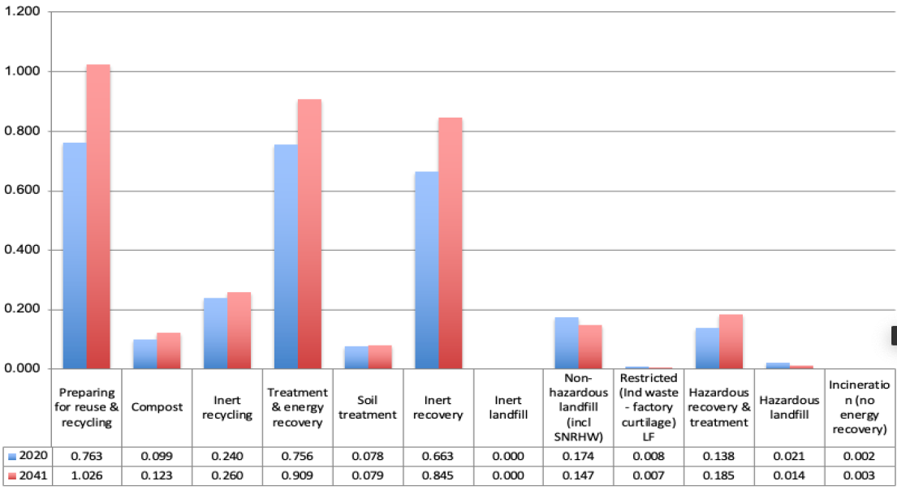

Figure 7: Comparison of management methods for waste arisings from within South Yorkshire 2020 and 2041 (million tonnes)

**Table 7: Summary of economic role of places**

Local Plans across the region describe the economic role of each area.

**Barnsley**

Barnsley has a growing economy, creating an M1 economic corridor, thriving town centre and some outstanding cultural heritage. In terms of current sectors, evidence from Mott Macdonald (2016) identified a higher proportion of employees in manufacturing and construction than comparator areas including the national average. In contrast, Barnsley has lower proportions of IT and finance professionals and a higher proportion of jobs in public administration, health and education (29% compared to a national average of 26%).

**Bassetlaw**

Bassetlaw’s accessibility is the basis for an expanding economy, with a growing economic corridor stretching along the A1, direct access to the East Coast Main Line and close proximity to the M1 attracting business and investment.

The evidence and the D2N2 LEP recognise the role the District can play in developing identified growth sectors: creative and digital technologies; construction, particularly modern methods of construction; renewable energy and low carbon energy production; engineering and civil engineering; and the visitor economy. The logistics sector is also recognised as being well-positioned to integrate with other sectors. The Local Plan capitalises on the District’s locational advantage by promoting locations able to provide a continuous and diverse supply of employment land within proximity to the Main Towns and local labour supply. This includes land accessible to the A1/A57, which also provide strategic connectivity to the M1, the wider East Midlands region and South Yorkshire.

**Doncaster**

Doncaster has a high quality urban centre with attractive retail opportunities within an expanding mixed-use offer. Doncaster’s multi-modal connectivity offers access to major conurbations and coastal ports whilst the Doncaster-Sheffield Airport (should it re-open) and iPort areas provide an international gateway with growing engineering and logistics business base. The National College for Advanced Transport and Infrastructure and the new University Technical College are part of a growing vocational education offer.

Doncaster’s Economic Strategy 2030 seeks to create a regenerative and inclusive economy for thriving people, places and the planet. By 2030 the aspiration is to have an economy which improves the living standards for all with a more resilient and productive economy, which is also green and regenerative. There are four Sectors of Opportunity: health and care; engineering and manufacturing; creative and digital; and culture. Four ‘niches’ are also included which will help provide highly productive and innovation-led growth: rail; green technology; future mobility; and advanced materials.

**Rotherham**

Rotherham has developing strengths in new economic sectors, as part of the region’s wider regeneration agenda, with a particular specialism in manufacturing. The adopted Core Strategy identifies the priority of safeguarding this manufacturing base and targeting several priority sectors including Creative and Digital Industries; Advanced Manufacturing and Materials; Environmental and Energy Technologies; Construction Industries; Business, Professional and Financial Services; and Low Carbon Industries. The Advanced Manufacturing Park (AMP) in the Advanced Manufacturing Innovation District lies in Rotherham.

**Bolsover**

Bolsover is a rural area, with the need and ability to accommodate significant economic growth in key settlements, taking advantage of access to the M1. In the Bolsover Economic Development Needs Assessment (2015) competitive sectors identified were: Wholesale and Retail; Manufacturing; Transport & Storage; Construction; Information & Communication (knowledge-based activity); and Energy & Water.

**North East Derbyshire**

North East Derbyshire is a predominately rural area with the population concentrated in four towns, and the potential for growth along the A61. It has close links with Sheffield and Chesterfield. Key sectors are Digital and Creative Industries; Advanced Manufacturing; Food and Drink; Construction and Environmental Industries; and Health and Care.

**Derbyshire Dales**

The Derbyshire Dales economy is based on thriving micro businesses and SMEs with manufacturing the largest employment sector. Pay in the Derbyshire Dales is amongst the lowest in the former Sheffield City Region and England. Businesses in the Dales want to grow but can’t find the space locally, and provision of new employment space in the district is the highest priority.

**Chesterfield**

Chesterfield is a key market town and the sub-regional economic centre for Northern Derbyshire, with a high quality urban core and opportunities for further growth in the Staveley and A61 corridors. Along the M1, Markham Valeis an area recently developed with plans to establish itself as a major employment hub, supporting activity elsewhere in the City Region. The area includes Enterprise Zone sites.

Chesterfield’s key sectors are Public administration ; Wholesale/retail; Financial and business services and Manufacturing.

**Sheffield**

Sheffield is the fourth largest city in England and a major centre of engineering, creative and digital industries, with a wide range of culture and retail facilities. Sheffield City Centre will be the primary office location in the region, providing a high proportion of the region’s jobs in business, financial and professional services, higher education and health and wellbeing services.  The retail and leisure offer in the City Centre is expected to grow through the Heart of the City 2 development but will be complemented by that provided at Meadowhall and by other built leisure facilities in the Lower Don Valley.

The Lower Don Valley and Advanced Manufacturing Research Centre (in the Advanced Manufacturing Innovation District) areimportant employment areas, focused on advanced manufacturing. The area includes an Enterprise Zone at Sheffield Business Park.

Sheffield’s key sectors are Advanced Manufacturing and Health.

**Peak District National Park**

Quarrying, agriculture, and tourism are the mainstays of the Peak District National Park economy. Agricultural businesses account for a third of businesses, with over 87% of the Peak District being farmed. The DEFRA agricultural census indicates that there are over 3,000 farm businesses in the Peak District.

Market towns and local businesses benefit from the National Park’s strong rural and visitor economies; tourism alone generates over £1.5 billion for the economy each year. One in five jobs (3,944) within the Peak District National Park are within accommodation and food services.

Between 2016 and 2020 employment in the arts, entertainment, recreation and other services industry grew by nearly a quarter (24%), providing an extra 747 jobs.

The majority of local business units within the Peak District are classified as micro-businesses (employing fewer than 10 people). The rural economy is interdependent with the urban employment centres nearby. About half of the working population travels to jobs outside the National Park, and non-residents fill about 4 out of 10 jobs in the National Park.

**Table 8: Summary of Functional Economic Market Areas within the Region**

Local Plans across the Region define their Functional Economic Market Areas in line with national planning guidelines.

|  |  |
| --- | --- |
| **Barnsley** | Part of a wider area of a single Sheffield and Leeds City Region FEMA. |
| **Bassetlaw** | The general FEMA is broadly self-contained, with links to the former Sheffield City Region and north Nottinghamshire and north east Derbyshire. |
| **Bolsover** | A wide FEMA made up of Amber Valley; Ashfield; Bassetlaw; Chesterfield; Mansfield; and North East Derbyshire DC authority areas. |
| **Doncaster** | Defines a standalone FEMA along its own administrative boundary. |
| **Derbyshire Dales** | Is divided between surrounding areas, with the southern part of the District in a wider Derby focused FEMA; the Northern area in a Sheffield focused FEMA; and the central part of the district falling in an overlap with influences from Sheffield, Chesterfield and Derby. |
| **NE Derbyshire and Chesterfield** | Share an employment market and FEMA. |
| **Sheffield and Rotherham** | Share a single FEMA, consistent with a single travel to work area. |

It is recognised that large scale warehouse and distribution (logistics) uses over 100,000sq ft have a wide property market area covering the whole of the Region[46].

**Table 9: SCR Transport Strategy: national and pan-northern interventions**

The following schemes are being progressed by our partners or are included in Transport for the North’s initial investment programme for a start by 2027. As such they form a baseline for the Region’s interventions.

**MAJOR RAIL IMPROVEMENTS**

* HS2 – the Region supports the principles of high speed rail services across the North to the rest of the UK, radically reducing journey times and providing enhanced connectivity beyond the HS2 network. The Government’s Integrated Rail Plan (IRP) in November 2021, is committed to deliver two HS2 trains per hour between London and Sheffield in 87 minutes. SYMCA wants these trains extended to Leeds.
* Hope Valley line capacity improvements – initial capacity improvements are underway to allow a frequency of three fast trains in addition to one stopping train per hour and freight trains. Currently the third fast train is not committed.
* Sheffield to Leeds – improvements to Sheffield station and the Dearne Valley Line towards Leeds to allow the extension of the HS2 trains, including two new stations in South Yorkshire at Rotherham and Dearne Valley, along with journey time and reliability improvements on the Hallam line via Barnsley.
* Doncaster to Leeds – capacity, journey time and reliability enhancements, including capacity enhancements at Doncaster station.
* South Trans Pennine Line – capacity and journey time improvements between Doncaster and Cleethorpes
* East Coast Main Line power upgrade and capacity improvements to allow 140mph running and improve journey times between Doncaster and London.
* Improvements to allow wider/higher freight trains on the Doncaster to Immingham route
* Electrification of the Midland Mainline to Sheffield to support other major rail investment programmes, as committed to in the Government’s Integrated Rail Plan for the North and Midlands.
* Barrow Hill Line – potential reopening of existing freight line for passenger use under the Restoring Your Railways programme, providing direct passenger services between Clay Cross, Chesterfield, North East Derbyshire and Sheffield.

**INTEGRATED AND SMART TRAVEL PROGRAMME**

* Multi-modal, integrated, contactless ticketing
* Enhanced real time customer information
* Smart ticketing on rail

**STRATEGIC ROAD NETWORK IMPROVEMENTS**

* Trans Pennine upgrade programme – a package of improvements including –
  + Mottram Moor link road granted a Development Consent Order by the Secretary of State on 16th November 2022 and is due to commence in 2023; and,
  + the A616/A61 Westwood roundabout (completed)
* A1 Redhouse to Darrington – upgrade to motorway standard
* A1(M) Doncaster bypass – widening to a three-lane motorway
* Hollingworth to Tintwistle bypass and capacity improvements on the M67, M60 and M56, which are both outside of the Region but included due to the benefits they can bring to the Region.
* A1 junction improvements with A46 in Bassetlaw.
* Chesterfield Staveley Regeneration Route (CSRR), providing bypass to north of A619 in Chesterfield, linking A61 and M1 Junction 29a.

**Table 10: Summary of South Yorkshire authorities’ zero carbon and energy strategies**

**Barnsley**

In October 2020 the Council approved a Strategic Energy Action Plan, which identifies four Zero Carbon Community Aims. These will be delivered via five themes and it will align with the 17 United Nations’ Development Goals.

Community Goals will be delivered by focusing on delivering projects based on the following Five Themes:

1. Energy Efficiency: To reduce the overall demand for energy in Barnsley across residential, commercial and industrial sectors and improve public health outcomes.
2. Renewable energy: To generate and/or source local energy needs from zero carbon and renewable sources by around 2045.
3. Sustainable Transport: A complete transition to fossil fuel free local travel by around 2030.
4. Resource Efficiency: Use resources; materials, land and food in a sustainable way.
5. Decentralised Heating: In order to provide local resilience and empower communities too heat and light homes through local zero or low carbon generation rather than by centralised natural gas supply.

In July 2022 the Council approved an urban design and sustainability strategy for Barnsley Town Centre prepared by Urbed. This strategy considers urban design issues and also looks how the town centre can move towards being zero carbon. The overarching theme of ‘Sustainability Interventions’ sits above six other themes: Retail; Culture; Work; Housing; Greenspace and Connections. These are then followed through into a proposed spatial strategy and a list of suggested interventions.

**Doncaster**

The Doncaster Local Plan was adopted in September 2021 and has a suite of climate change related policies. In 2012 Aecom carried out a Renewable and Low Carbon energy study on behalf of Doncaster. This provides evidence to support Local Plan policy 58 Renewable and Low Carbon Energy.

The study looked to see how policies could be delivered in a sustainable, carbon efficient way and that site allocations and detailed policies incorporate appropriate requirements for carbon reduction through energy efficiency and renewable and low carbon energy generation associated with development. The study:

* Examined the current and future energy demand from the existing housing and non-domestic building stock, as well as the energy requirements from new build delivered through the growth strategy set out in the Core Strategy.
* Provided an updated audit of the current renewable energy provision in Doncaster.
* Built on the Yorkshire and Humber Low Carbon and Renewable Energy Study (2010) to assess the potential technical capacity of renewable and low carbon energy in Doncaster.
* Balanced technical potential with delivery appetite.
* Provided policy recommendations.

**Rotherham**

Rotherham has developed an annual climate change action plan with actions identified under seven themes: Energy, housing, Transport, Waste, Built and Natural Environment, Influence and engagement.

This action plan supports the Council’s established targets of:

* The Council’s carbon emissions to be at net zero by 2030 (NZ30)
* Borough-wide carbon emissions to be at net zero by 2040 (NZ40)

Annual targets have also been set based on the Tyndall Centre for Climate Change Research’s carbon budget calculations. The aim is to develop a portfolio of realistic actions based on scientific evidence, as well as reflecting local political, economic and social priorities. Wherever possible, actions will be drawn from examples of best practice both nationally and internationally. The Council will endeavour to address both mitigation actions (which will address the causes of climate change) and adaptation actions (which will address the impact of climate change).

This programme also aims to work in a complementary way with the declared nature crisis and will be expanded to include actions for recovery and enhancement of Rotherham’s biodiversity.

**Sheffield**

The Tyndall Centre for Climate Change Research has written a report that establishes a ‘carbon budget’ for the city (updated October 2022). It recommends that Sheffield must not exceed a budget of 15.2 million tonnes of carbon emissions over the next 20 years.

At current rates of energy consumption we will use this budget in less than 5 years from 2022.

The Council has a ten point plan which sets the framework for action for the transition to Net Zero. It is based on the evidence in the Pathways to Zero reports developed for the city by consultants Arup and Ricardo which identify the actions that needs to be taken for the city to become carbon neutral by 2030. As well as taking immediate action, Sheffield is in the process of developing route maps on the key areas for decarbonisation.

The ten point plan for climate action is to:

1. put climate at the centre of our decision-making
2. be proactive in finding ways to resource the action that is needed
3. act in a way which supports social justice
4. work towards reducing Council emissions to net zero by 2030
5. work to bring the city together to make the changes we need
6. work with the city to develop route maps for the areas where change needs to happen
7. work with and support people, businesses and organisations to take the action that is needed
8. work to build the skills and economy we need for the future
9. work to ensure we have the planning and infrastructure we need for the future
10. prepare the city to adapt for a changing climate

**Peak District National Park**

Climate Change aims and objectives are set out in the Peak District National Park Management Plan.

The overarching aim is that the Peak District National Park is more resilient and net-zero by 2040 through its exemplary response to climate change. Supporting objectives relate to lowering greenhouse gasses significantly, sequestering and storing substantially more carbon and reversing damage to nature, biodiversity and cultural heritage.

Headline targets are that:

* By 2028 there will be a 25% reduction in total greenhouse emissions in the Peak District National Park.
* By 2028 there will be a 2,878 tonnes net decrease in carbon emissions from moorlands.
* By 2028 we will secure funding for four measures that increase the resilience of existing habitats and species, cultural heritage and the built environment.

**Glossary of abbreviations**

4G - Fourth generation wireless mobile telecommunications technology with average download speeds from 16 to 33Mbps

5G - Fifth generation wireless mobile telecommunications technology which delivers higher peak data speeds, ultra-low latency, greater connectivity and increased network capacity.

BDUK – Building Digital UK, the Government programme to deliver superfast broadband and local full fibre networks.

BNG – Biodiversity Net Gain. Under the Environment Act 2021, all planning permissions granted in England (with a few exemptions) will have to deliver at least 10% biodiversity net gain from November 2023.

D2N2 – the Local Enterprise Partnership for the Derby, Derbyshire, Nottingham and Nottinghamshire area.

FEMA – Functional Economic Market Area, the spatial level at which economies and markets operate.

FLUTE – Forecasting Land Use, Transport and Economy, a forecasting model used across South Yorkshire.

HDT – Housing Delivery Test, an annual measurement of housing delivery across relevant plan making authorities.

HS2 – High Speed 2, the new rail line proposed between the south and north of England.

LEP – Local Enterprise Partnership, a partnership between local authorities and businesses to set economic priorities for an area and negotiate growth deals with Government.

LIS – Local Industrial Strategy, strategy to promote the coordination of local economic policy and national funding streams and establish new ways of working between national and local government, the public and private sectors.

LNRS – Local Nature Recovery Strategy, which will establish priorities and map proposals for specific actions to drive nature’s recovery and provide wider environmental benefits.

LTA – Local Transport Authorities

MCA – Mayoral Combined Authority, a corporate body enabling two or more local councils to collaborate and take collective decisions, established with a directly elected Mayor.

MHCLG – the former Ministry of Housing, Communities & Local Government which is now called Department for Levelling Up, Housing and Communities

NHS – National Health Service

NPPF – National Planning Policy Framework, sets out the Government’s planning policies and how these are expected to be applied.

OECD – Organisation for Economic Collaboration and Development, an international organisation set up to promote world trade and stimulate economic progress.

ONS – Office for National Statistics, executive office of the UK Statistical Authority responsible for collecting and publishing statistics related to the economy, population and society of the UK

PSTN - Public Switched Telephone Network, closing on 31 December 2025 as part of a switch to a fully digital network

S106 - Section 106 legal agreements between Local Authorities and developers; which are linked to planning permissions

SCR – the former Sheffield City Region geography and Partnership

SCRTM1 – Sheffield City Region Transport Model version 1, a model of transport networks and demand across for the SCR area.

SEP – Strategic Economic Plan, setting out the LEP/MCA plan to transform the economy, create jobs and encourage new businesses.

SYMCA – the South Yorkshire Mayoral Combined Authority

TTWA – Travel to Work Area, a geography created by the ONS to approximate labour market areas.

VoIP - a system that uses an internet connection to make and receive calls.

1. Not all signatories to this regional Statement of Common Ground are party to or signatories of the other Statements of Common Ground listed.
2. https://www.peakdistrict.gov.uk/looking-after/strategies-and-policies/national-park-management-plan
3. Constituent members of SYMCA are Sheffield, Barnsley, Doncaster and Rotherham Councils. Non-constituent members are Derbyshire Dales, North East Derbyshire, Chesterfield, Bassetlaw and Bolsover Councils.
4. The Environment Act 1995 sets out the purposes of National Parks and commitment to their special qualities https://www.legislation.gov.uk/ukpga/1995/25/contents/enacted
5. See OECD’s Functional Urban Area Definitions here: <http://www.oecd.org/cfe/regional-policy/functionalurbanareasbycountry.htm>
6. See ONS’s Travel-to-Work Areas: <https://www.ons.gov.uk/employmentandlabourmarket/peopleinwork/employmentandemployeetypes/articles/traveltoworkareaanalysisingreatbritain/2016>
7. Further evidence was collated in the SCR LEP Review Geography Proposal (September 2018) which is available on request from SYMCA
8. Following the Government’s review of Local Enterprise Partnerships and the removal of overlapping geographies, a joint statement was prepared outlining the intended collaboration between the Sheffield City Region (as it was known at the time) and D2N2 LEPs across the shared Functional Economic Area. The purpose of the collaboration was to develop shared approaches where there is a clear rationale to do so, and where the impact of doing the activity will exceed the economic benefits of separate endeavours. A number of areas of activity were specified where there would be ‘Strategic Collaboration’. This included Spatial Planning, although there were no specific actions defined.
9. For example, through the Department for International Trade’s Northern Powerhouse trade missions
10. The Climate Crisis: A Guide for Local Authorities on Planning for Climate Change. TCPA & RTPI. January 2023.
11. <https://southyorkshire-ca.gov.uk/getmedia/423b1606-ad2b-4261-93b0-f712b7fef6e8/SCR-Energy-Strategy.pdf>
12. SCR Mayoral Combined Authority Board meeting. 18 November 2019. Minute item 15.

    <https://governance.southyorkshire-ca.gov.uk/ieListDocuments.aspx?CId=137&MId=173&Ver=4>
13. <https://southyorkshire-ca.gov.uk/Connected-by-water>
14. Correct as at 1. April 2022. Based on increase household projections for 2022-20232 and affordability ratio for 2021. Full guidance at <https://www.gov.uk/guidance/housing-and-economic-development-needs-assessments>
15. The previous 2019-based calculations identified that Local Plans were planning for 6,311 – 6,659 homes pear year, equating to 922 – 1,270 homes per year above a combined regional Local Housing Need of 5,389 homes per year.
16. See fuller explanation at <https://www.gov.uk/guidance/dwelling-stock-data-notes-and-definitions-includes-hfr-full-guidance-notes-and-returns-form>
17. The owners of Doncaster Sheffield Airport began winding down aviation services in October 2022 arguing that its operation was commercially unviable. The City of Doncaster Council and SYMCA continue to explore all appropriate legal remedies in order to secure aviation operations at Doncaster Sheffield Airport.
18. It is also recognised that logistics uses may have larger market areas which extend beyond the boundaries of the Region as defined for the purposes of this Statement, and which individual authorities will need to take into account.
19. Based on 2011 TTWA data (published by ONS in 2015), analysed by Lichfields (2019)
20. Based on 2011 TTWA data (published by ONS in 2015), analysed by Lichfields (2019)
21. <https://post.parliament.uk/the-impact-of-remote-and-flexible-working-arrangements/>
22. See full strategy on the SYMCA website at <https://southyorkshire-ca.gov.uk/explore/transport>
23. On-line at <https://southyorkshire-ca.gov.uk/SheffieldCityRegion/media/PDF-library/Transport%20pdfs/37770_Bus-Service-Improvement-Plan_FINAL.pdf>
24. The Transport Strategy defines a neighbourhood as the closest built up area to your home; it defines 11 regional hubs in SCR which are economic centres that people need to access quickly and easily for work, health services, education, shopping and leisure.
25. Gear Change, Department for Transport (2020)
26. Bus Back Better Department for Transport (2021)
27. Transport decarbonisation plan (DfT, 2021)
28. Net Zero Strategy: Build Back Greener DfT, 2021
29. [SCR_SEP_Full_Draft_Jan_21-(accesssible).pdf (southyorkshire-ca.gov.uk)](https://southyorkshire-ca.gov.uk/getmedia/4256c890-d568-42c8-8aa5-c8232a5d1bfd/SCR_SEP_Full_Draft_Jan_21-(accesssible).pdf)
30. <https://southyorkshire-ca.gov.uk/getmedia/bf2c27b2-a5c7-4ac5-ac64-b4f8798df095/Sheffield-City-Region-Renewal-Action-Plan-Document-Final.pdf>
31. Integrated Rail Plan for the North and Midlands, DfT, 2021
32. Subject to the cost of the responsibility being met by Government funds
33. Dasgupta, P. (2021) The economics of Biodiversity: The Dasgupta Review. (London: HM Treasury).
34. A survey undertaken by the Department of Energy and Climate Change (DECC) in 2008, Data Collection on Solid Low Level Radioactive Waste from the Non-nuclear Sector, indicated that South Yorkshire produced 31.33m3 of low activity low level radioactive waste from the nonnuclear industry.
35. National Infrastructure Strategy. 2020. HM Treasury.
36. Superfast South Yorkshire is transitioning to become the team which delivers the South Yorkshire Digital Infrastructure Strategy
37. See current coverage at <https://labs.thinkbroadband.com/local/south-yorkshire>
38. https://labs.thinkbroadband.com/local/E10000024
39. https://labs.thinkbroadband.com/local/E10000007
40. Section1 (page 2) of " Approved Document R Volume1: Physical infrastructure and network connection for new dwellings"
41. See detailed explanation at <https://www.sheffield.gov.uk/sites/default/files/docs/planning-and-development/sheffield-plan/Proposed%20Sheffield%20City%20Region%20Combined%20Green%20Belt%20Review.pdf>
42. See <https://www.peakdistrict.gov.uk/looking-after/strategies-and-policies/national-park-management-plan>
43. The next review of the Statement of Common Ground will be within one year of the date of adoption, or earlier should the Heads of Planning group identify the need for this.
44. A full account of SYMCA Governance arrangements is available in the Assurance Framework at https://southyorkshire-ca.gov.uk/mayoral-combined-authority-procedures
45. See <https://www.gov.uk/government/collections/housing-delivery-test>
46. It is also recognised that logistics uses may have larger market areas which extend beyond the boundaries of the Region as defined for the purposes of this Statement, and which individual authorities will need to take into account.