**Sheffield Gypsy and Traveller Accommodation Assessment**

**2019 – 2024**

Final Report

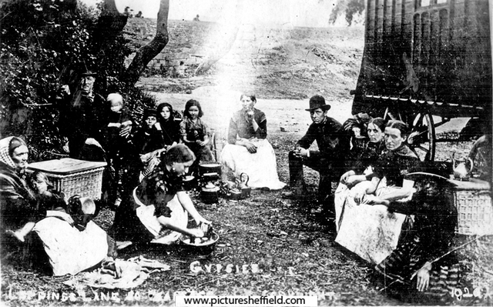

Strategic Housing and Regeneration

Sheffield City Council

**Acknowledgements**

Without the time, expertise and contributions of a number of individuals and organisations this study could not have been completed. Officers from within Sheffield City Council, the Multi Agency Group and the Showmen’s Guild have provided guidance and assistance throughout the project.

Special thanks also to the Centre for Regional Economic and Social Research at Sheffield Hallam University who acted as critical friend throughout the assessment.

Finally a particular thank you to the Gypsies and Travellers that have taken part in the study and provided a valuable insight into their current and future accommodation needs.

Contents

|  |  |
| --- | --- |
| **Chapter** | **Page** |
| Executive Summary | 4 |
| 1. Introduction | 7 |
| 1. National Policy | 8 |
| 1. Methodology | 12 |
| 1. Sheffield Gypsy and Traveller Population | 14 |
| 1. Supply of Gypsy and Traveller Sites in Sheffield | 18 |
| 1. Need Arising from Authorised Council Sites | 21 |
| 1. Need Arising from Unauthorised Developments and Encampments | 25 |
| 1. Need Arising from Bricks and Mortar Accommodation | 29 |
| 1. Stakeholder Consultation | 34 |
| 1. Assessment of Accommodation Need for Gypsies and Travellers | 38 |
| 1. Travelling Showpeople | 45 |
| 1. Assessment of Transit and Stopping Place Provision | 49 |
| 1. Houseboat Dwellers | 50 |
| 1. Conclusion and Recommendations | 52 |
| Glossary | 54 |

Executive Summary

**The study**

From July 2018 to August 2019 Sheffield City Council undertook a new assessment to consider the need for Gypsy and Traveller accommodation in Sheffield and provide an evidence base to inform the Draft Sheffield Plan. This assessment analyses the current need for pitches and projects the need for the next 10 and 15 years, as follows:

* 2019 – 2024 – next 5 years
* 2025 – 2029 – next 10 years
* 2030 – 2034 – next 15 years

The assessment was undertaken by conducting a review of the following data sources:

* The previous Gypsy and Traveller Accommodation Assessments in Sheffield
* The national policy and guidance
* The bi-annual Caravan Count
* 2011 Census data
* Information from the Sheffield City Region local authorities and the Multi Agency Group
* Surveys of 54 Gypsies and Travellerscurrently living in Sheffield, covering a range of accommodation types
* A survey of 4 houseboat dwellings
* Consultation with the Showmen’s Guild
* Consultation with New Age Travellers

**Defining Gypsies and Travellers**

The study considers the accommodation needs of Gypsies (including English, Scottish, Welsh and Romany Gypsies), Irish Travellers, New Age (or New) Travellers and Travelling Showpeople, and the need of houseboat dwellers.

This GTAA therefore assesses the pitch requirements for all Gypsies, Travellers and Travelling Showpeople in Sheffield.

**Local accommodation provision**

There is no single source of information about the size of the Gypsy, Traveller and Travelling Showpeople population in Sheffield. An official estimate is taken from 2011 Census which found that there are 340 individuals or 131 households.

The known population of Gypsies and Travellers in Sheffield live across the following accommodation types:

* Two council rented Gypsy and Traveller sites with 31 pitches
* One privately owned Travelling Showpeople’s site with eight yards
* Bricks and mortar accommodation (living in traditional housing)
* One unauthorised New Age Traveller encampment with around 16 households.

**Characteristics of local Gypsies and Travellers**

The secondary data and survey of Gypsies and Travellers identified some important characteristics about the local population.

* The average Gypsy and Traveller household in Sheffield is larger than the overall household size in the city. The 2011 Census estimates the household size is 2.7 people compared to 2.4 people for all other household types. The site and council housing data indicates that the average household size for Gypsy and Traveller council tenants living in houses (5.8) is higher than for those on a council pitch (3).
* The majority of Gypsies and Travellers on all site types have a longstanding local connection to Sheffield. This is particularly true of those living in on the council sites.
* The Gypsies and Travellers that live on the council sites generally do not travel or only travel for holiday purposes once or twice a year and therefore do not meet the planning definition of Traveller.
* The majority of Travelling Showpeople do travel for work purposes and therefore do meet the planning definition.
* The survey suggested that most of the Gypsies and Travellers would not have the resources to develop their own private site as when asked they said they could not afford to.

**Accommodation need and supply**

This study has undertaken a thorough assessment of the need arising from all Gypsies, Travellers and Showpeople present within Sheffield at the time of the study. As such this assessment of need should be regarded as a reasonable and robust assessment of need upon which to base planning decisions going forward.

The total need for Gypsies, Travellers, and Travelling Showpeople pitches is presented in Table A: Total pitches required for 2019 - 2034 and Table B: Summary of the Gypsies and Travellers and Travelling Showpeople pitch requirements.

**Table A: Total pitches required for 2019 - 2034**

|  |  |
| --- | --- |
| **Pitches for Gypsies, Travellers and Showpeople** | **No. of pitches required** |
| Pitches needed 2019 – 2024 | 44 |
| Pitches needed 2025 – 2029 | 47 |
| Pitches needed 2030 – 2034 | 50 |

**\***Based on a household growth rate of 1.98%

The figures in Table B are presented for those that meet the planning definition in the Planning Policy for Traveller Sites and those that do not meet the definition and fall within the Housing and Planning Act 2016 (see pages 9 & 10). This is to ensure that the needs of all Travellers in the city are accounted for and considered in the Sheffield Plan.

**Table B: Summary of the Gypsies, Travellers and Travelling Showpeople pitch requirements**

|  |  |  |  |
| --- | --- | --- | --- |
| **Pitches needed 2018** | **Planning Definition** | **Do not meet the Planning Definition** | **TOTAL No. of pitches required** |
| Gypsies and Travellers (excl. New Travellers | 1 | 15 | 16 |
| Travelling Showpeople | 12 | 0 | 12 |
| New Age Travellers | 2 | 14 | 16 |
| **Pitch requirements for all Travellers** | **15** | **29** | **44** |

The New Age Travellers are represented separately as the need from this community is different to other Gypsy and Traveller groups because of the alternative lifestyles they lead.

The accommodation needs of the Travelling Showpeople is assessed separately as this community has different characteristics when compared to the Gypsy and Traveller population which incur different needs due to their frequency of travel for work and their requirement for larger yards to store vehicles and equipment.

**Changes since 2015/16**

The total number of pitches required, regardless of meeting the planning definition, has reduced since the 2015/16 GTAA when 57 pitches were needed. This is due to a number of factors:

* A reduction in the number of concealed and newly forming households on the council sites as some have moved off the sites or secured a pitch.
* A reduction in the need from Travellers in bricks and mortar this is partly due to the lower numbers that have taken part in the study (5) when compared to 2015/16 (11).
* A reduction in the need from the New Age Travellers from 33 pitches in 2015/16 to 16 pitches.
* An increase in yard requirements from the Travelling Showpeople from 3 yards in 2015/16 to 12 yards in this study. This is due to overcrowding on the existing site and the identification of five families by the Showmen’s Guild which have not previously been disclosed.

## Introduction

The main purpose of the Gypsy and Traveller Accommodation Assessment (GTAA) is to provide a robust assessment of the current and future need for Gypsy, Traveller and Travelling Showpeople accommodation in Sheffield.

Assessing the accommodation needs of Gypsies and Travellers is essential for local authorities to positively plan to meet their local population needs, and ensure that suitable land is identified in the right location near to local services and the surrounding infrastructure.

Providing the right accommodation for Gypsies and Travellers will help to address the inequalities that these communities face with respect to health and education, such as a much shorter life expectancy, lower education attainment and the lower levels of income and access to finance. A comprehensive accommodation assessment enables local authorities to identify sufficient sites to meet the need and reduce the likeliness of unauthorised encampments.

A total of three GTAAs have been undertaken in Sheffield over the past 12 years. The assessments in 2006 and 2011 were across South Yorkshire due to the regional spatial planning that existed at the time. The last assessment was in 2015/16 and covered only Sheffield.

The 2015/16 assessment followed ‘best practice’ at the time and assessed the accommodation needs of the Gypsies and Travellers on the two Council owned sites, the privately owned Travelling Showpeople site, the unauthorised encampment of New Age Travellers (NATs), and Travellers living in bricks and mortar.

Since the 2015/16 GTAA was completed there have been a number of changes to national legislation that have altered the duty placed on local authorities to undertake a GTAA, and the planning definition of Gypsies, Travellers, and Travelling Showpeople.

The main purpose of this assessment is to update the 2015/16 GTAA to take into account these changes, and to provide a robust evidence base to aid the implementation of the Draft Sheffield Plan.

The study considers the accommodation needs of Gypsies (including English, Scottish, Welsh and Romany Gypsies), Irish Travellers, New Age Travellers and Travelling Showpeople, and supersedes the previous GTAA’s completed in Sheffield. It also considers the need of houseboat dwellers to meet the requirement of the Housing and Planning Act 2016.

## National Policy

This section discusses the national housing and planning legislation and the guidance framework for Traveller provision. The study should be viewed in the context of the following:

* Equality Act 2010
* National Planning Policy Framework 2012 & 2018
* Planning Policy for Traveller Sites 2015
* Housing and Planning Act 2016
* Draft guidance to local housing authorities on the periodical review of housing needs – caravans and houseboats 2016
* Homelessness Reduction Act 2017 and Code of Guidance for Local Authorities 2018
  1. **Equality Act 2010**

The Equality Act 2010 prohibits discrimination, harassment and victimisation against persons with “protected characteristics”. Race is a protected characteristic and Romany Gypsies, Scottish Travellers and Irish Travellers have been declared by the courts to be protected as “races” under the Act.[1] However, at least two Traveller groups fall outside of these definitions; Travelling Showpeople and New Age (or New) Travellers and may therefore not be protected by the Act.

In addition to the Act’s prohibition of discrimination, Section 149 of the Act provides that public authorities are, in the exercise of their functions, required to have due regard to the need to:

(a) eliminate discrimination, harassment, victimisation and any other conduct that is prohibited by or under this Act;

(b) advance equality of opportunity between persons who share a relevant protected characteristic and persons who do not share it;

(c) foster good relations between persons who share a relevant protected characteristic and persons who do not share it.

As such, where exercising relevant functions (e.g. planning decisions), public authorities are required to have due regard to this duty, and consider how they are making provision for culturally appropriate accommodation for these groups.

* 1. **National Planning Policy Framework (NPPF) 2018**

In July 2018 the Ministry of Housing, Communities and Local Government published the revised National Planning Policy Framework. The NPPF sets out the role of the planning system in significantly boosting the supply of homes, and ensuring land can come forward, to meet the needs of groups with specific housing requirements.

Local Planning authorities are directed to plan positively to meet the housing needs of an area, assessing and planning for the different size, type and tenure of housing needed for different groups in the community (including Travellers).

* 1. **Planning Policy for Traveller Sites (PPTS) 2015**

In March 2012 the Government published the PPTS in conjunction with the NPPF. The overarching aim of this policy was to ensure fair and equal treatment for Travellers that facilitates the traditional way of life and encourages local authorities to take the lead on plans and decision making for Traveller sites.

A revision to the PPTS was published in August 2015. The policy states that local authorities’ should formulate their own evidence base for Gypsy and Traveller needs and set their own targets for pitches in order to identify a suitable five-year supply of sites.

It stresses the importance of working collaboratively with neighbouring planning authorities as well as the need to carry out effective consultation and engagement with Travellers, their representative bodies and the settled community when identifying sites.

*“In assembling the evidence base necessary to support their planning approach, local planning authorities should;*

1. *Pay particular attention to early and effective community engagement with both settled and traveller communities (including discussing travellers’ accommodation needs with travellers themselves, their representative bodies and local support groups).”[2]*

**Planning definition -** The main revision to the policy was the change in the definition of Gypsies and Travellers, and Travelling Showpeople under planning law. This is set out in Annex 1 of the PPTS and states that:

*“For the purposes of planning policy “gypsies and travellers” means:*

*“Persons of nomadic habit of life whatever their race or origin, including such persons who on grounds only of they own or their family’s or dependant’s education or health needs or old age have ceased to travel temporarily, but excluding members of an organised group of travelling showpeople or circus people travelling together as such”[3]*

*In determining whether persons are “gypsies and travellers” for the purposes of this planning policy, consideration should be given to the following issues amongst other relevant matters:*

1. *Whether they previously led a nomadic habit of life.*
2. *The reasons for ceasing their nomadic habit of life.*
3. *Whether there is an intention of living a nomadic habit of life in the future, and if so, how soon and in what circumstances.*

*For the purposes of planning policy, “travelling showpeople” means:*

*Members of a group organised for the purposes of holding fairs, circuses or shows (whether or not travelling together as such). This includes such persons who on the grounds of their own or their family’s or dependants’ more localised pattern of trading, educational or health needs or old age have ceased to travel temporarily, but excludes Gypsies and Travellers as defined above.*

The main change to both definitions was the removal of the terms ‘*persons…who have ceased to travel permanently’,* meaning that those who have ceased to travel permanently will no longer fall under the planning definition.

The implication of applying the planning definition means that it will only include those who travel (or have ceased to travel temporarily) for work purposes and in doing so stay away from their usual place of residence. Members of the household that stay at home to look after children or other dependents will be regarded as travelling, for planning purposes, if someone in the household is travelling. It can include those who have a permanent site or place of residence, but it does not include those who travel for purposes other than work – such as attending horse fairs or visiting friends and family. It also does not cover those who commute to work daily from a permanent place of residence.

The revised PPTS included further amendments to greater protect the Green Belt, and address the problems of the unauthorised occupation of land.

**Protecting the Green Belt –** The new policy strengthens the protection of the Green Belt and sensitive areas by stating that Gypsy and Traveller sites (temporary or permanent) are inappropriate in these areas. Therefore the absence of a five year supply of sites, or the unmet need and personal circumstances of the Travellers are unlikely to outweigh the harm that a development would have in the Green Belt. This change applies to the settled and travelling community.

**Assessing unauthorised occupation of land –** The new policy states thatintentional unauthorised developments should be regarded by decision makers as material consideration that weighs against granting planning permission. Changes have also been made in order to address large scale unauthorised developments, such as Dale Farm. This means that there is now no assumption that the local authority should meet the Traveller site needs in full if the site presents a burden to the authority and the area is subject to strict and special planning constraints.

**2.4 Housing and Planning Act 2016**

Section 8 of the Housing Act 1985 placed a statutory duty on local authorities to undertake a periodical review of the housing needs of people residing or resorting to their district. This is commonly known as a Strategic Housing Market Assessment (SHMA) and it is usually undertaken every five years.

Section 225 of the Housing Act 2004took this further and introduced a specific duty on local authorities to carry out an assessment of the accommodation needs of Gypsies and Travellers when carrying out a SHMA.

In July 2016 the Housing and Planning Act revoked Section 225 of the Housing Act 2004 and removed the duty on local authorities to assess the accommodation needs of Gypsies and Travellers. Instead local authorities should now ‘consider’ the needs of people residing in, or resorting to the district with respect to the provision of sites on which caravans can be stationed, or places on inland waterways where houseboats can be moored.

The implication of the Act is that the housing needs of Gypsy and Traveller households that do not meet the new ‘planning’ definition of a Traveller will need to be assessed as part of the SHMA, and will form a subset of the wider need arising from households residing in caravans or houseboats.

Draft guidance[4] on how to assess this need was published by the Government in 2016. The guidance noted that this assessment should not be restricted to people of any particular race or origin, but did highlight bargees, Romany Gypsies, Irish and Scottish Travellers, New Age Travellers and Travelling Showpeople as groups to consider.

The guidance stated that it is important to understand the need for caravans and moorings to properly plan provision (and avoid unauthorised developments) and that local authorities need to consider the circumstances of a range of residents including: those with no authorised site, those whose site is overcrowded or unsuitable, households containing ‘suppressed’ households and those unable to access an authorised site (or afford land to develop on).

The guide also highlighted households in bricks-and-mortar accommodation, particularly noting that such accommodation could be considered unsuitable if a person has a preference not to live in bricks and mortar. Although the guidance has yet to be confirmed as final it has been taken into account in the undertaking of this GTAA, and the accommodation needs of Gypsies and Travellers that fall within and outside of the planning definition have been assessed.

**2.5 Homelessness Reduction Act 2017**

*Part 7 of the Housing Act 1996* (as amended) provides the statutory under-pinning for action to tackle homelessness. Local authorities have a duty under the legislation to secure accommodation for unintentionally homeless households who fall into a ‘priority need’ category. The *Homelessness Reduction Act 2017* places new duties on local authorities to intervene at earlier stages to prevent homelessness in their areas. It also requires authorities to provide homelessness services to all those affected, not just those who have ‘priority need’. The statutory *Homelessness Code of Guidance for Local Authorities* (2018) further states that:

*“Housing authorities are reminded that when drawing up their homelessness strategies for preventing and reducing homelessness, they must consider the needs of all groups of people in their district who are homeless or likely to become homeless, including Gypsies and Travellers”*

Consideration has been given to homeless Gypsies and Travellers and those threatened with homelessness within this assessment.

## Methodology

This GTAA has been led by Sheffield City Council’s Strategic Housing and Regeneration Team alongside the Forward and Area Planning Team. The study has utilised information and input from other partners, such as Environment Protection Services, Council Housing Services and the Sheffield Gypsy and Traveller Multi Agency Group.

The Centre for Regional Economic and Social Research (CRESR) at Sheffield Hallam University has acted as a critical friend for the assessment offering guidance on the methodology and commentary on the report.

The GTAA requirements have been incorporated into a wider update of the Sheffield Strategic Housing Market Assessment. The GTAA follows the PPTS and the draft guidance on reviewing the housing needs of caravans and houseboats. It utilises and brings together various existing data sources, the knowledge of stakeholders working with the community and the views of Gypsies and Travellers living in Sheffield. The following methods were used in the assessment.

**Desk- Based Review -** Information on Gypsies and Travellers in Sheffield was gathered from existing secondary data sources including the 2011 Census, Caravan Counts, records of unauthorised encampments, planning information and site information. A literature review of the relevant legalisation and policy was also undertaken.

**Stakeholder Engagement –** Stakeholders working with Gypsies and Travellers in Sheffield were invited to take part in the study. This involved sharing information that they have about the community, assisting with the consultation and giving their views on the need for Gypsy and Traveller accommodation in Sheffield. The stakeholders included the Gypsy and Traveller Multi Agency Group, the Showmen’s Guild (Yorkshire), and the following organisations representing Travellers:

* Traveller Movement
* Derbyshire Gypsy Liaison Group
* National Federation of Gypsy and Traveller Liaison groups
* Lincolnshire Gypsy Liaison Group
* Leeds GATE
* Friends, Families, Travellers
* Proud Gypsy Traveller Project – Doncaster
* York Travellers Trust

**Neighbouring authorities -** All the local authorities in the Sheffield City Region (SCR) were contacted to provide information on the movement of Travellers across the region e.g. Travellers from outside the area that wish to move to Sheffield. The GTAAs undertaken by these authorities were also reviewed to identify links with Sheffield.

**Consultation with Gypsies and Travellers –** Surveys were undertaken either face to face or through the post with Gypsies and Travellers living on sites and in bricks and mortar accommodation in Sheffield. The aim of the survey was to gain a thorough understanding of their current and future accommodation needs, their travelling patterns in order to determine if they meet the planning definition, and their views on future site provision such as the types of sites needed, the facilities on the site, the appetite for developing private sites and any contact with the planning service.

**Houseboats and caravan dwellings -** Letters and surveys were sent to 23 houseboat addresses and the 6 caravan dwelling addresses on the Local Land Property Gazetteer. Four surveys were returned from houseboat dwellers but no surveys were returned from those living in the caravans (not on known Traveller sites).

* 1. **Assessing current and future need**

To meet the requirements of the PPTS only Gypsies and Travellers that meet the planning definition have to be formally considered as need arising from the GTAA, and this need should subsequently be addressed through site allocations in the Draft Sheffield Plan. The surveys with the Gypsies and Travellers have been used to determine if they meet the planning definition. In order to do this, the survey included a number of questions about travelling patterns. Households that need to be considered (under the PPTS) fall into one of three categories:

* Households that travel under the planning definition
* Households that have ceased to travel temporarily under the planning definition
* Households where a survey was not possible but *may* fall under the planning definition

The remaining need from Gypsies and Travellers that do not meet the planning definition fall under the Housing and Planning Act (2016) legislation that states that local authorities should consider the needs of people residing in or resorting to caravans or houseboats when reviewing housing needs in the area.

This study therefore assesses the pitch requirements for **all Travellers** in the city and presents the pitch numbers for those that do and do not meet the planning definition as well as an overall total.

This is to ensure that the needs of all Travellers in the city are accounted for and considered in the Sheffield Plan.

The pitch requirements of Travelling Showpeople have also been assessed separately as their site requirements differ to other Gypsies and Travellers. They usually require larger sites with mixed use plots for accommodation and equipment storage, which are referred to as yards.

## Sheffield’s Gypsy and Traveller Population

This section provides an overview of the size of the Gypsy and Traveller population living in Sheffield, the characteristics of this community, and the numbers of caravans recorded in the bi-annual Caravan Count.

**4.1 Size of the Gypsy and Traveller population in Sheffield**

The earliest known reference of Gypsies in Sheffield was in 1595 when the Town Trustees paid the town’s watchmen 2 shillings ‘when the gipsees were in the towne’[5]. In 1816 a Sheffield Quaker John Hoyland also published a survey of Gypsies in the country in the hope that their living conditions and their acceptance in society would be improved[6].

Presently, for the first time in its history the 2011 Census recorded Gypsy and Traveller as an ethnic group. The Census estimated that there were 358 individual Gypsies and Travellers living in Sheffield making up 0.1% of the city’s population, which is slightly higher than nationally. When compared to the Sheffield City Region authorities, Sheffield has the second largest population after Doncaster with Chesterfield having the least.

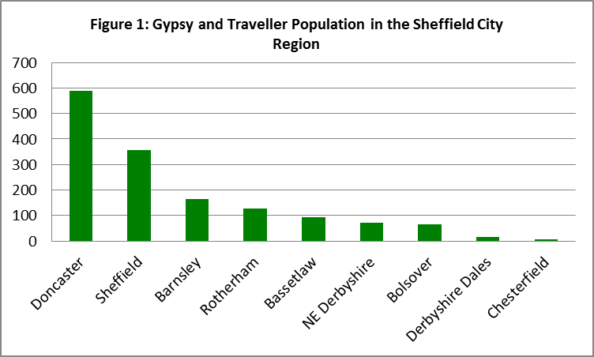

Source: Census 2011

It is worth noting that the Census information is now 7 years old and is likely to have under estimated the total population of Gypsies and Travellers living in Sheffield and the city region, for instance Doncaster[7] estimates that their Traveller population is around 4,000. This under counting is for a number of reasons such as subsequent household growth since the Census, the reluctance of some Travellers to reveal their ethnicity due to a fear of discrimination, and the non-recording of those living on unauthorised encampments.

Drawing on the Census, Map 1 shows that in 2011 Sheffield’s Gypsy and Traveller population were concentrated to the east of the city, mainly in the Burngreave (67), Park and Arbourthorne (40), and Darnall (40) wards. As there are no Traveller sites in these wards it is likely that these households lived in bricks and mortar accommodation.

**Map 1: Gypsies and Travellers by Sheffield Wards**

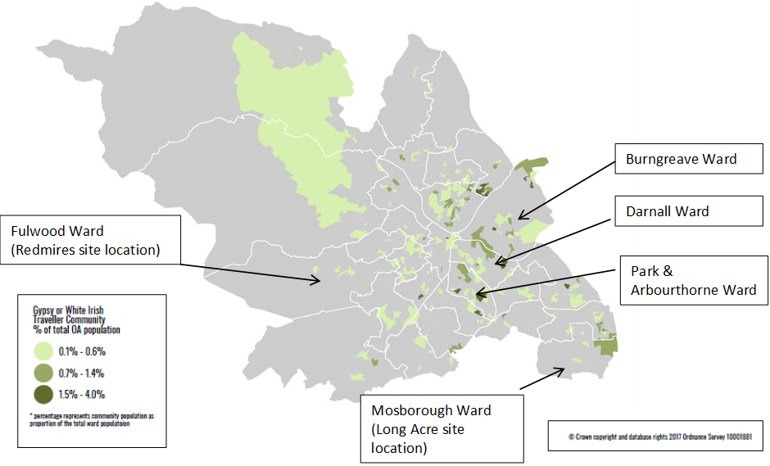

**4.2 Gypsy and Traveller Profile**

Gypsies and Travellers in Sheffield tend to be younger and live in larger households than the settled community. The Census estimated that the population equated to 131 Gypsy and Traveller households with an average household size of 2.7 people compared to 2.4 persons for the city’s total population.

The Census found that 66% of the Gypsy and Traveller households lived in a house, while 34% lived in a flat, maisonette or apartment, or mobile/temporary accommodation e.g. caravan.

Figure 2 shows that at the time of the Census over a third of the population were children aged 0-14 years which was double the proportion of Sheffield’s overall population. This reflects the tendency for Gypsies and Travellers to marry young and have larger families as well as the lower life expectancy of this population resulting in a smaller population aged 65 years and over.

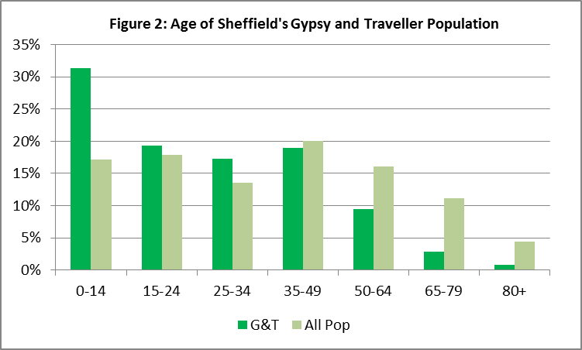

Census 2011

Compared with the general population, Gypsies and Travellers are more likely to suffer bad health. In the 2011 Census 13% of Gypsies and Travellers in Sheffield rated their health as bad or very bad compared to 6% of the general population.

A 2004 report[8] by The University of Sheffield, which included consultation with Gypsies and Travellers in Sheffield, identified higher rates of long-term illnesses, mobility problems, arthritis, diabetes and chest conditions amongst the community. It concluded that the life expectancy of Gypsies and Travellers is between 10-12 years lower than the settled population. Improved life expectancy of Gypsy and Traveller communities appears to be associated with the availability of established site provision and access to medical care. A recent report for the Department of Health noted that accommodation insecurity; the conditions of Gypsies and Travellers living environment, low community participation, and discrimination all play key roles in exacerbating these poor health outcomes[9].

Gypsies and Travellers living in Sheffield experience greater inequality than the wider population. Two fifths (41%) of the city’s Gypsies and Travellers live in areas that are amongst the 10% most deprived in the country compared to the Sheffield average of 23%. At the time of the Census, 45% of males and 58% of females from the Gypsy and Traveller community were economically inactive compared to 30% of all males and 38% of all females in Sheffield.

It is widely recognised that Gypsies and Travellers have higher levels of illiteracy and lower education levels than the wider population. This is partly due to the reluctance of the community to send their children to secondary school due to worries around the dilution of their culture, the fear of bullying or the limited access to special educational support[10]. The number of Traveller pupils aged 0-14 years in Sheffield has grown by 59% in the last 8 years with 48 pupils recorded in 2016/17.

**4.3 Caravan Count**

The bi-annual Count of Gypsy and Traveller Caravans is the only national information collected on Gypsy and Traveller encampments and it provides a snapshot on the number of caravans in the country. Local authorities carry out a count of caravans on Gypsy and Traveller sites twice a year, in January and July, and submit the information to Government.

Information is collected about caravans on authorised socially-rented sites, authorised privately-funded sites, unauthorised developments (sites on land owned by Gypsies or Travellers without planning permission) and unauthorised encampments (on land not owned by Gypsies or Travellers and which do not have planning permission).

Figure 3 shows the Caravan Counts for Sheffield over the past four years compared to nearby local authorities. Doncaster and Barnsley have the largest number of caravans, but this has fluctuated over the years. Sheffield’s caravan count is similar to NE Derbyshire at around 40 caravans.

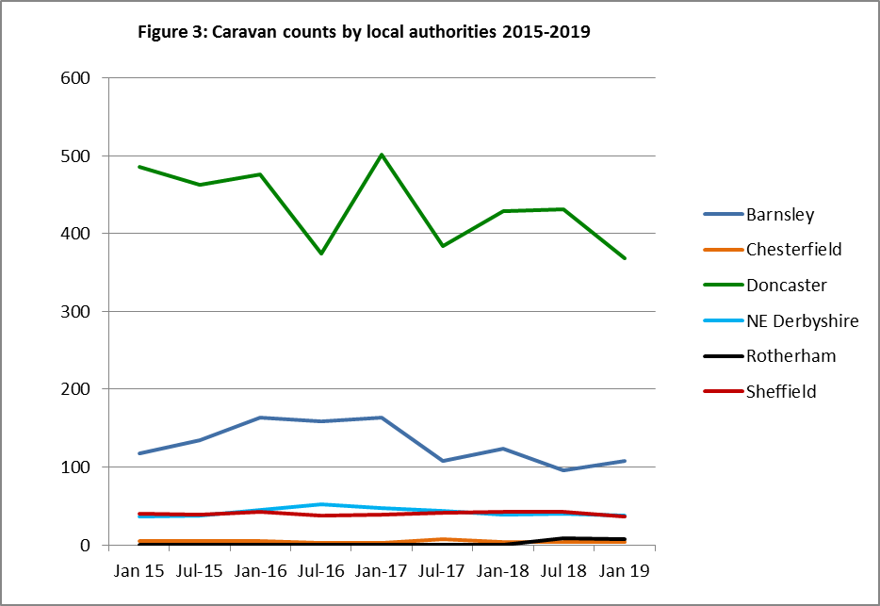

The robustness of this national count has been criticised due to the snapshot nature of the data collection, the non-involvement of Gypsies and Travellers, the exclusion of Travelling Showpeople in the July count, and the recording of caravans rather than households.

Furthermore, the information collected in Sheffield only applies to the caravans on the two council owned sites. Caravans on the Showpeople site and unauthorised encampments are not captured. Other data sources have therefore been used in this assessment to further understand the number of caravans in the city.

## Supply of Gypsy and Traveller Sites in Sheffield

There are two authorised Gypsy and Traveller sites in Sheffield which are owned and managed by the Council Housing Service. These are the Long Acre (Mosborough ward) and Redmires (Fulwood ward) sites which have a total of 31 pitches. (There is also a privately owned Showpeople site in Chapeltown which is discussed separately in section 11).

The pitches on the sites are let under the *Housing Regeneration Act 2008* agreement, which made provision for local authority Gypsy and Travellers sites to be included within the *Mobile Homes Act* 1983 and came into effect on the 30 April 2011. This gave the residents on the site improved security of tenure, and tenancy rights and responsibilities.

The pitches have a hard-standing, a garden, a pitch boundary fence and space to accommodate a trailer and static chalet or caravan. They also have a brick built amenity block which is let to the resident. The day room comprises of a bathroom and/or shower facilities, a WC, a kitchen sink, space for kitchen equipment and limited electric or solid fuel heating. Residents must provide their own privately owned or rented caravan to place on the pitch.

Both the sites have been refurbished, Redmires in 2007 and Long Acre in 2011. This involved replacing the amenity block and the fencing around each pitch. Both the sites have a community room to provide opportunities for adult and child learning, health visits and community lead activities.

Residents are permitted to travel for up to four weeks at a time for a maximum of 12 weeks in the year. Visitors can stay on their pitch, with written permission, for a maximum of 4 weeks in a year. Visitors to the pitch pay the weekly rent. The pitch rent is around £92 (per week) which is considerably higher than the average rent for a council property at £74. The majority of residents receive Housing Benefit payments to help with rent costs.

* 1. **Redmires**

Redmires was opened on the 15th May 1980 and was the first permanent Gypsy and Traveller site in Sheffield. The site proved to be a popular location for the Gypsy and Traveller community, and it has remained in virtual full occupation since it was opened.

The site is 1 hectare and it is situated on Green Belt land within the Fulwood Ward, as shown in Map 2.

The rural location is desirable but there few local facilities and services and the nearest bus stop is a 10 minute walk away. This can be a problem for those without access to a car as well as elderly residents and those with small children.

**Map 2: Redmires Gypsy and Traveller Site**

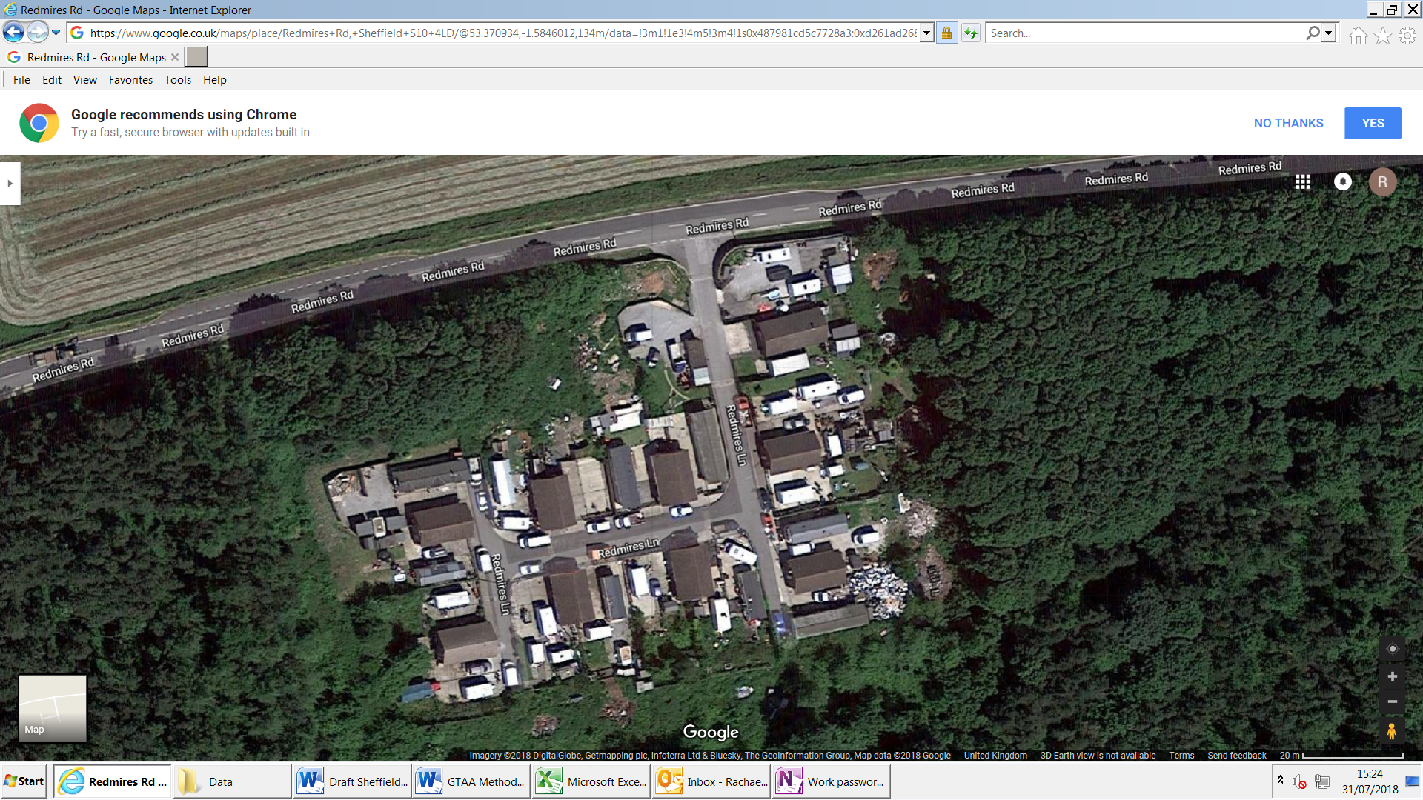

* 1. **Long Acre**

Long Acre was originally given temporary permission for use as a Traveller site in 1980 with full permission granted in 1992. The site is 0.486 hectares and it is located within the Holbrook Industrial estate in the Mosborough Ward, as shown in Map 3.

Although the site is not located on land that would now be deemed as appropriate for accommodation under planning law it is situated close to wide range of facilities such as shopping centres, the Sheffield Supertram terminus at Halfway and the Rother Valley Country Park.

**Map 3: Long Acre Gypsy and Traveller Site**

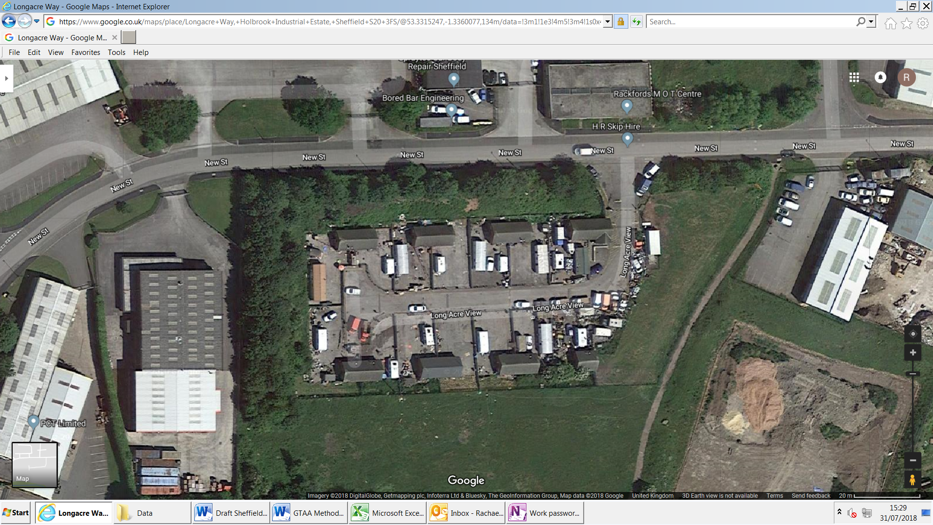

**5.3 Turnover of pitches**

Over the past five years 14 pitches have become available for re-let across the two sites, with the majority (10) at Long Acre. The reasons for quitting the pitches varied and included moves to other pitches on the sites, moves to bricks and mortar accommodation and the death of tenants.

**Table 1: Pitches becoming vacant in the past 5 years**

|  |  |  |
| --- | --- | --- |
| **Year** | **Redmires** | **Long Acre** |
| **2014/15** | 1 | 0 |
| **2015/16** | 0 | 5 |
| **2016/17** | 0 | 4 |
| **2017/18** | 1 | 1 |
| **2018/19** | 2 | 0 |
| **Total** | 4 | 10 |

*The average tenancy length for Sheffield City Council tenants in 2018/19 was 8 years, 8 months

The vacant pitches were allocated to people on the waiting list with the majority going to concealed households already living on the sites (8) as well as to Travellers from bricks and mortar and outside of Sheffield (Chesterfield).

**5.4 Demand for pitches**

The council owned pitches are allocated via a waiting list which Gypsies and Travellers who are eligible[11] and interested in a pitch can join. The pitches are allocated to applicants with the most waiting time (subject to references). If the applicant refuses the pitch because it is not suitable for their needs they have the right to remain at the top of the list, and the pitch will be offered to the next applicant. Applicants can be on the waiting list for one or both of the sites.

As of August 2019 there are nine applicants on the waiting list which is three more than in the 2015/16 assessment. Table 2 provides a breakdown of the current applicants on the Council sites waiting list, Redmires has the largest demand.

**Table 2: Waiting list for the Council sites**

Table showing site preferences

There are no Gypsies and Travellers currently living in bricks and mortar accommodation on the waiting list. This slightly differs from 2015/16 when there were two households, both of these have now moved onto the sites.

## 6. Need Arising from Authorised Council Sites

The section discusses the likely need arising from the Gypsies and Travellers currently living on the two council sites. It considers the site’s occupancy list and the findings from the survey.

**6.1 Site occupancy**

The site’s occupancy lists provide information on the population on both the Council sites and the ages of each member of the household. This helps to give an indication of the possible concealed households’ e.g. adults living with parents that need their own accommodation or pitch, and also newly forming households; children that will turn 18 within the next 5 years.

In August 2019, all the pitches on both the Council sites were fully occupied. There were 44 people living on Redmires, 33 adults and 11 children (0-17 years), and 34 people at Long Acre, 19 adults and 15 children. Table 3 gives a breakdown of the types of households on the pitches across the two sites.

**Table 3: Household types on the sites**

|  |  |  |
| --- | --- | --- |
| **Household type per pitch** | **Redmires Pitches** | **Long Acre Pitches** |
| Pitches containing a single adult (18+) | 6 | 5 |
| Pitches with 2 or more adults (18+) | 5 | 0 |
| Pitches with adult (s) & children aged 0-12 years | 1 | 3 |
| Pitches with adult (s) & children aged 13-17 years | 6 | 7 |

*One pitche at Redmires and 1 pitch at Long Acre have children aged 0-12 and 13-17 years.

One pitch at Long Acre is due to come vacant as the occupier has priority to move into bricks and mortar accommodation.

Table 4 breaks this down further to estimate the potential number of people that are concealed e.g. adults living with parents (18 and over), and the potential newly forming households e.g. those aged 13 – 17 years that will turn 18 years within the next 5 years and therefore be eligible for pitch if required.

**Table 4: Potential concealed and newly forming households**

|  |  |  |
| --- | --- | --- |
| **Number of people** | **Redmires** | **Long Acre** |
| Concealed households (adults) | 5 | 0 |
| Newly forming households (children aged 13-17) | 1 | 3 |

The occupancy list therefore suggests that there are **five** concealed households who are all living at Redmires and potentially **four** newly forming households.

The number of concealed households is a little lower than 2015/16 when there was 7. Since the 2015/16 assessment three of these have secured pitches on the sites and the other two are still living on the sites and have been included in the new concealed need count and two have left the site.

The number of newly forming households on the sites has decreased since 2015/16 when 6 were identified. Four of these have since left the sites and two are now concealed adults.

**6.2 Survey Findings**

A survey of households on each site was conducted over two separate visits to the sites in July and August 2018. At the time of the survey all the 31 pitches were occupied and a total of 20 surveys were completed, 9 on Redmires and 11 on Long Acre, which is a 65% response rate. This is same response rate as in the 2015/16 GTAA.

**6.2.1 Current accommodation**

All of the Travellers living on the Redmires site are Romany, while the occupants on Long Acre are a mix of Romany, Irish, Scottish and Welsh Travellers. Most of the respondents have lived on the site for over 10 years (17).

The Redmires respondents were generally happier with the site than those at Long Acre, with 6 respondents saying that they were very happy with their home. However, respondents on both sites raised issues and concerns about the site.

Residents at Redmires were particularly concerned about the condition of the amenity blocks stating that they were in disrepair and contained mould. They also commented on the infrequency of repairs and the length of time it takes for them to be completed. The Site Support Officers have also flagged this as a problem at Redmires, with reports that repairs are not being carried out in a timely manner. There is also currently a drain problem on this site which is causing them to overflow in wet conditions.

Residents at Long Acre commented on the poor appearance of the site because of fly tipping and the volume of dogs living on the site, which is causing problems with waste and the occurrence of vermin such as rats.

The respondents on both sites would like improvements to the fencing around the pitches.

**6.2.2 Future accommodation need**

Only two existing households said that they may move within the next 5 years and these both live on Long Acre. One said they need a permanent local authority pitch and the other a temporary or transit pitch. They were unsure where they might move to as it depends on the accommodation that becomes available. Both the households said that they would want to live with other households that are on their current site.

One respondent at Long Acre said that they have two adults (concealed) living on their pitch that require their own pitches on a permanent local authority site in Sheffield within the next 5 years. The same household had three teenage children (newly forming households) that could need pitches in the future.

**6.2.3 Travelling patterns**

Seven households said that they still travel and two households have stopped travelling temporarily. Only two of these households travel for work purposes and therefore meet the planning definition of Traveller. The others travel to visit family/friends, go on holiday, to attend horse fairs or religious retreats.

The households generally travel in the summer for up to two months and stay in various places, such as on private transit sites, on the roadside or with family and friends. Four of the households intend to continue to travel in the future for holidays and to visit family, only one household said that they will travel for work in the future.

Four respondents have stopped travelling permanently the reasons given were: children in school, ill health and feeling settled in their current home.

The respondent from Long Acre that had the adults and older children living with them that need pitches has permanently stopped travelling because of having nowhere to stay, children being in school and ill health. The respondent and their family members do not intend to travel again in the future and therefore do not meet the planning definition of Traveller.

**6.2.4 Future sites**

Nine respondents felt that Sheffield needs more new permanent sites and five respondents said that they would like a transit site or temporary stopping places provided in Sheffield. All of the respondents said that new sites should have 13 or more pitches. The sites are needed to accommodate household growth, to improve living conditions by reducing overcrowding on the existing pitches and to accommodate those travelling through the city.

Respondents were asked about the facilities that are needed on new sites from a list of 22 multiple choice options. Respondents placed the most importance on a children’s play area, visitor car parking, individual amenity blocks, an office for a site manager, recycling facilities and fencing around pitches. Respondents would not like sites with communal bathing or laundry facilities and placed less importance on meeting space facilities, CCTV and horse grazing space.

Three respondents said that they would potentially be interested in developing their own site, but they do not currently have the funds to allow them to pursue this. None of the Travellers have had contact with the Council’s Planning department.

**6.3** **Accommodation needs summary**

* There are **nine** people on the waiting list, 3 of these currently live on the Council sites, 3 are from outside of Sheffield and three are from unknown addresses although one is believed to be travelling.
* The occupancy lists suggest that there are **5** adults (concealed households) that may need their own pitches and these all live on the Redmires site, but only one of these adults is currently on the waiting list for a pitch. Only one concealed household was recorded in the survey in August 2018 and this was not the person on the waiting list.
* The occupancy lists suggests that there are four newly forming households (children aged 13-17 years that may need their own pitch in the next 5 years). One of these children was identified in the survey, but the others were not. An additional older child was also highlighted as in need by a survey respondent. In order to take account of future demand and mitigate overcrowding on the sites, all **5** children have been included in the calculation of need for newly forming households.
* Two existing households on the Long Acre site said that they may move in the next five years, but were unsure if this would be in Sheffield. One said that they would like to move to a permanent local authority site if more places became available, and the other said that they would move to authorised temporary stopping places or transit sites, suggesting that they could go travelling. One household at Long Acre is currently a priority on the Council’s waiting list to move into bricks and mortar housing.
* There was little demand from the Travellers to develop their own sites with only three people saying that they would potentially be interested if they had the funds. This suggests that any new sites in Sheffield will need to be provided in the social sector, either by the Council or Registered Providers.
* Only two of the seven existing households that said they travel do so for work purposes, the other five households travel for holidays, to visit family/friends, to attend horse fairs or religious retreats.
* None of the households living on the pitches with concealed households and newly forming households said that they travel for work purposes and they do not intend to travel for this purpose in the future. Therefore these households do not meet the planning definition of a Traveller.

## Need Arising from Unauthorised Developments and Encampments

In order to assess the need for pitches it is importance to understand the volume and frequency of unauthorised developments and encampments by Gypsies and Travellers. A high number can indicate that there is an insufficient supply of authorised provision in the area meaning that Travellers have to resort to unauthorised developments and encampments. There occurrence and frequency can also give an indication of the travelling patterns and the need for temporary sites, for instance are there more encampments in certain areas or at certain times in the year when more provision might be necessary.

Unauthorised developments and encampments are often a source of tension between the travelling and settled communities, and addressing this issue through the provision of more permanent or temporary provision can help to alleviate the disruption both for the settled and Traveller communities.

* 1. **Unauthorised encampments in Sheffield**

There have been no unauthorised Gypsy and Traveller developments (developing a site without planning permission) in Sheffield since the last assessment, but there have been incidences of unauthorised encampments. These encampments are unpredictable making it difficult to assess the level of pitch requirements from these Travellers. Nevertheless, they do offer an insight into the transient need of Gypsies and Travellers and the likely areas these encampments may occur.

Although the bi-annual Caravan Count for Sheffield has not recorded any unauthorised encampments in the last four years, the number of unauthorised encampments is officially logged by the Council’s Environment Protection Service (EPS) that has responsibility for dealing with unauthorised encampments in the city.

The approach to dealing with unauthorised encampments is set out in the Council’s 2001 policy *‘In Respect of Gypsy and Traveller Unauthorised Encampments’*. This involves visiting the site and negotiating with the Travellers to move on as soon as possible. Depending on the circumstances (location and impact on community, reports of anti-social behaviour and waste etc.) this can be from a few days to two weeks. If the agreed timescales are breached formal repossession procedures will normally be undertaken if the land is owned by the Council or belongs to others where it is inappropriate to require the owners to undertake their own action to gain possession.

* + 1. **Number of unauthorised encampments in Sheffield**

Since 2015 there have been 33 unauthorised encampments in Sheffield (excluding the long standing New Age Traveller unauthorised encampment which is discussed further in Section 7.2).

Figure 4 below shows that the number of encampments has reduced in recent years following a peak of 10 in 2015.

The encampments had an average of 6 caravans, with the largest having 18 caravans, and these generally latest for no more than a week once being asked to move on. There was a seasonal pattern to the travelling with all the encampments occurring in the months from March to September.

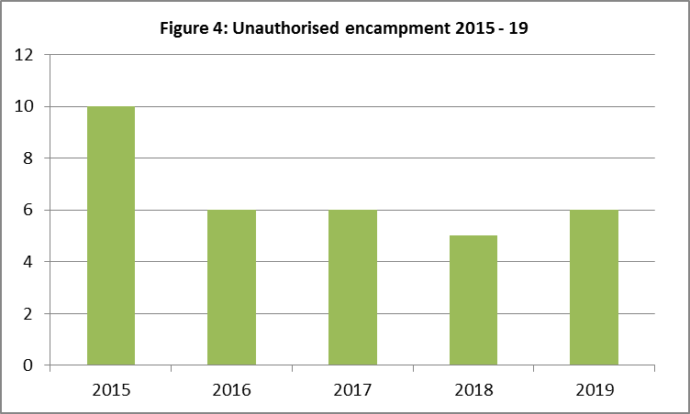

*2019 January to August

The unauthorised encampments were mainly deemed to be ‘in transit’ generally visiting Sheffield for a short period of time to see family, attend events or travelling through to other locations in the country. Most of the encampments (13) were located in the east and south east of the city close to main routes through the city, such as the Sheffield Parkway, A57 and the M1 motorway.

**7.2 New Age Traveller unauthorised encampment**

New Age (or New) Travellers (NATs) are a diverse group of people originating mainly from the settled British population in the early 1970s, although some New Travellers are now 2nd or 3rd generation. NATs come from varied backgrounds, and choose, or end up, living as a Traveller for different reasons such as wanting to live an alternative more sustainable lifestyle or having strong personal or political convictions.

There have been historic problems of unauthorised occupation on a site in Sheffield by different members of the NATs community dating back to 1999. The site in question is on council owned industrial land which is not suitable for residential accommodation. The initial occupation was concluded in 2006 when a family lost a high court appeal and left the site. However, in 2010 local businesses in the area reported that the land had become illegally occupied once more.

Since the site was re-established Environment Protection Service (EPS) have visited the occupants on a regular basis to provide health and safety advice on caravan separation distances to reduce the risk of fires, provided trade waste bins, and have acted as chaperones for other council services such as housing, planning, children’s services and social care. At its peak the site had around 45 caravans with an estimated 30 households.

**7.2.1 Regaining possession**

In 2015 the Council agreed to look to reclaim the land to enable the regeneration of the site into an outdoor leisure attraction for the city. Notice to quit was therefore served to the occupants in May 2017.

The Council has a duty to support any vulnerable person that could be at risk of homelessness as a result of this action. Since the notice was served EPS have been working closely with the Housing Solutions service to offer support and advice to the occupants, as well as offer alternative accommodation such as bricks and mortar housing. From December 2017 to summer 2019 Housing Solutions visited the site 16 times to speak with the occupants about their housing needs and other care or support they might require. Over the course of these visitors 10 occupants asked for rehousing advice and 3 housing offers were made. However none of the occupants on the site have moved into bricks and mortar housing. Most of the occupants wanted the Council to find an alternative site.

The court hearing commenced in September 2018 and the Council was granted the right to possession of the land in March 2019. The eviction of the site took place in July 2019.

**7.2.2 Need since the eviction**

At the time of the eviction there were 7 occupied caravans on the site and 19 left abandoned. Some of the NAT’s have since left Sheffield, but 16 households have gone on to occupy council land on another unauthorised encampment in the Hillsborough ward.

Most of the people on the site are single, but there are two known families with 3 children between them. The Council has formally written to the occupants and asked them to vacant the land. They were also asked if any occupants have health or social care needs that the Council can support them with, but no occupants have requested this. The intention is to take legal action if the occupants do not vacant the land.

Following this correspondence, the 16 households have sent a letter to the Council expressing a desire for the Council to find them alternative land that could be used as a permanent NAT site. They state that bricks and mortar housing is unsuitable accommodation as living in trailers and caravans is a way of life, others travel to work at festivals and fairs, but need a base in the winter, and they wish to live together as one community. They also state an intention to relocate to other sites in the city if they are moved on.

* 1. **Accommodation needs summary**
* There have been 33 short term unauthorised encampments in Sheffield over the last 5 years, with an average of 6 caravans per encampment. These encampments usually lasted for a week and occurred in the spring and summer months.
* To represent the number of households that have moved onto the unauthorised encampment following the eviction from the previous site, and have sent the letter to the Council requesting a permanent NAT site it has been assumed that there is a need for **16** pitches from the NATs in Sheffield.
* An assumption has been made that at least 10% of the NAT households travel for work purposes. This is based on the work of Opinion Research Services (ORS) who are leading consultants on GTAA’s. They have collected data from over 1,800 surveys since the PPTS came in and have found that approximately 10% travelled for work purposes. This implies that **2** of the 16 households travel for this purpose and therefore meet the Planning definition.

## Need Arising from Bricks and Mortar Accommodation

The exact number of Gypsies and Travellers living in bricks and mortar accommodation is unknown, but it is generally agreed that there are now more Gypsies and Travellers living in conventional housing than on sites or unauthorised encampments. The *Commission for Racial Equality* suggests that the housed population is around three times the size of the trailer-based population[12].

A lack of authorised sites is often the main reason that Gypsies and Travellers move into bricks and mortar accommodation although some choose this accommodation because of the health or educational needs of family members. Despite this, many Travellers living in conventional housing say that they would prefer to live on sites due to the importance of nomadism (or a sense of nomadism) in their lives, and the need to maintain their culture which is centred on family and community links, common traditions and a shared way of life. Yet, there are not enough pitches on authorised sites to accommodate the number of Gypsies and Travellers who want to live this way.

**8.1 Estimating Sheffield’s bricks and mortar population**

It is difficult to accurately estimate the number of the Gypsies and Travellers living in bricks and mortar accommodation in Sheffield due to the reluctance of the population to disclose their ethnic identity. Nevertheless, the inclusion of Gypsies and Travellers as an ethnic group in the 2011 Census did provide some baseline information that was previously unavailable.

The 2011 Census estimated that there were 131 Gypsy and Traveller households living in Sheffield and that the majority of these households rented their accommodation (79%), with half renting in the social sector. Only a fifth of Gypsy and Travellers in Sheffield owned their home compared to 58% of households owning a property citywide.

For the purpose of this study, Gypsy and Traveller Council tenants were identified and the 13 Registered Providers (RPs) in the city were contacted to provide data on the number of Gypsy and Travellers living in their accommodation. Information about homeless Travellers was also collected and this is presented in table 6 below.

**Table 6: Sheffield Gypsy and Travellers in bricks and mortar accommodation**

|  |  |
| --- | --- |
| **Source** | **Travellers households in bricks and mortar** |
| Council tenant households | 32 |
| Registered Provider tenant households | 2 |
| Gypsy and Traveller homeless applications in the last 3 years | 15 |
| Gypsy and Traveller priority homeless cases in the last 3 years | 10 |

**Gypsy and Traveller Council Housing Tenants -** There are an estimated 32 council properties containing Gypsy and Traveller tenants, but only two Registered Provider tenancies have been identified. This section discusses the Council Gypsy and Traveller tenants. Fourteen of households have children aged 0-15 years, twelve are single people and the remainder are all adult households. The average household size is 2.8 people, which is higher than the average household size for the city overall at 2.4 people.

Almost half (15) of the Travellers have lived in their council property for less than five years and two tenants have lived in their house for over 20 years. Half of the tenants live in a flat or maisonette and 14 live in a house. The map below shows the location of the Traveller council tenants. The majority live in the Beauchief & Greenhill, and Park & Arbourthorne wards which differs slightly to the Census profile where most Travellers lived in the east of the city.

**Map 4: Location of Gypsy and Traveller Council Tenants**

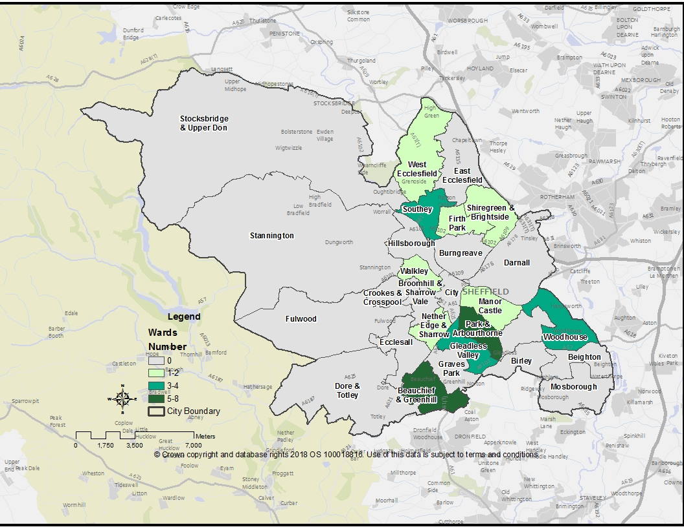

**Homeless Travellers -** Over the past three years (2015/16 - 2017/18) fifteen Gypsies and Travellers have presented to the Council as homeless and five were accepted as priority homeless cases. The majority of Travellers that presented were female (9) and eight of the households had dependent children.

The main reasons why the Travellers presented as homeless were that parents or other family members/friends were no longer able to accommodate them (8 presentations). The other reasons included: loss of rented accommodation, rent arrears, relationship breakdown and other harassment.

* 1. **Engaging with Sheffield’s bricks and mortar households**

Four methods were used to engage with the Gypsies and Travellers living in bricks and mortar accommodation in Sheffield.

* Postal surveys to the all 32 Council tenants.
* Contacting all the RPs in Sheffield asking them to distribute the survey to their Gypsy and Traveller tenants.
* Making enquiries with the Gypsies and Travellers on the council sites about family and friends they know living in bricks and mortar accommodation.
* Contacting agencies that represent Gypsies and Travellers about information they have on those living in bricks and mortar accommodation. This included the Multi-Agency Group, National Gypsy and Traveller Federation, Traveller Movement, Leeds Gate, Friends, Family and Travellers, and Derbyshire Gypsy Liaison Group.

In total five surveys were completed with Gypsy and Travellers living in bricks and mortar accommodation. This is fewer than the 11 surveys that were completed in the 2015/16 assessment but is consistent with the outcomes of many GTAAs where few households living in bricks and mortar engage in the studies. There are a number of reasons for this, such as:

* The difficulties identifying Gypsies and Travellers living in bricks and mortar accommodation especially those in privately owned properties.
* The low levels of literacy which makes postal surveys inappropriate in some instances.
* The complex needs of some of the households.
* The reluctance of some to complete surveys due to a suspicion around what the data is used for.
* Receiving no response from the national agencies despite contacting them several times. This could be because they do not work with Gypsies and Travellers in Sheffield and do not have information on the need for pitches.
  1. **Consultation findings**

Two council tenants, two RP tenants and one private rented tenant responded to the survey. Four of the surveys were through the post, and the other was undertaken face to face during the visit to the Redmires site as this respondent was visiting their family on the site.

Three of the respondents were unhappy with their current home. Two of them said this was because they feel isolated as they are not living with their own community, and the other respondent was not happy with the area they live in.

The respondents lived in bricks and mortar accommodation for different reasons, such as there not being enough sites in Sheffield, because of health reasons or to be closer to their family and friends. One respondent said that they prefer living in a house.

* + 1. **Future Accommodation**
* Four respondents said that they plan to move in the next five years, but only one wanted to move to a Gypsy and Traveller site the others wanted to remain in a house.
* Five adults (concealed households) were identified as needing to move to their own accommodation in the next 5 years, but only one said that they needed a local authority pitch in Sheffield. The others wanted to remain in bricks and mortar (3) and one wanted to move to a pitch outside of Sheffield.
* Only one household had children that might need a home of their own in the next 5 years but this person requires bricks and mortar accommodation.
  + 1. **Travelling Patterns**

Only one household said that they still travel and this was to visit family. The others said that they used to travel, but have stopped permanently. These respondents have stopped travelling because of ill health, children being at school and there being nowhere to stop when travelling. When they were travelling the respondents went all over the country for around 3-4 weeks at time and stayed with family/friends, on the roadside and on private transit sites.

**8.3.3 New Sites**

All the respondents agreed that Sheffield needs a new permanent site and two said that the city needs a transit site or stopping places. Two respondents said that they would consider developing their own site if they had the money to do so.

* 1. **Accommodation needs summary**
* To account for non-recording in the Census and household growth since 2011, it has been assumed that there are around 100 Gypsy and Traveller households in the city that live in bricks and mortar accommodation.
* If the ORS assumption is correct that 10% of households travel for work purposes then around 10 of the bricks and mortar Traveller households in Sheffield could meet the Planning definition.
* Only five Gypsies and Travellers in bricks and mortar completed a survey as part of this study compared to 11 in 2015/16. It is therefore difficult to estimate the level of demand from these households, but the lack of Travellers from bricks and mortar accommodation on the current Council sites waiting list and the survey results suggest that demand is low.
* Only **one** of the survey respondents said that they are looking to move to a local authority site in the next five years, and this household also responded to the 2015/16 survey stating that they wanted a pitch on a site. This household does not currently travel for work purposes. The current need is lower than in 2015/16 when five Gypsies and Travellers said they wanted to move onto a site (although more surveys were completed in 2015/16). Since 2015/16, two of the households have moved on to the council sites so their need has been met.
* Only **one** adult living in an existing household (concealed household) said that they need a local authority pitch in Sheffield in the next 5 years. This person lives in the existing household that wants to move to a site.
* Only one household had children that might need a home of their own in the next 5 years but this person requires bricks and mortar accommodation.

## Stakeholder Consultation

This section discusses the findings from the consultation with stakeholders to inform the GTAA, including:

* Gypsy and Traveller Multi Agency Group - to gauge an understanding of the issues from those directly working with the community.
* Sheffield City Region Authorities - to gather information on their assessments and any cross boundary issues.

**9.1 Gypsy and Traveller Multi Agency Group**

A workshop was held with the Multi Agency Group in August 2018. The group were asked their views on the existing Council sites provided in Sheffield, the current travelling patterns and the demand for new provision.

**Current site issues -** Redmires remains the most popular site and is relatively quiet. Long Acre experiences anti-social behaviour incidences, frequent fly tipping and currently has a problem with dog breeding on the site.

The condition of both the sites could be improved and the amenity blocks are in need of refurbishment. This is due to the general wear and tear of the amenity blocks and problems with getting repairs done in a timely manner. Redmires is currently experiencing drainage problems, which is partly due to the road on the site not being adopted by Highways and the moisture in the ground as there is a natural spring that runs through the site.

**Travelling Patterns -** The Multi-Agency Group is not aware of any of the Travellers on the council owned sites travelling for work. They only travel for holidays, religious retreats or to attend the Appleby horse fair.

**Demand for sites –** The site officers reported that they do receive enquiries to join the waiting list from people outside of Sheffield, and those in bricks and mortar accommodation. They have had 3 to 4 enquiries to join the waiting list from members of two Irish Traveller families living in housing over the past year. However it is often difficult to get references from them in order to include them on the waiting list.

The health representative said that they are not aware of any Travellers in houses that they visit that would prefer to live on one of the current council sites. They mostly work with Irish Traveller families who would prefer a site solely for them if one was delivered.

The residents on both the sites do not want new people moving on, so the current waiting list is made up of concealed and newly forming households of those already living on the site or extended family of the residents. The Multi Agency Group stated that community tensions can arise between different types of Travellers e.g. Romany and Irish when they live on the same site.

It was recognised that there is a need to accommodate the growing families on both sites. A preferred option would be an extension or redesign of the Redmires site to allow for more pitches which was felt would be easily filled by the members of the existing households on the site.

The group do not feel it would be beneficial to extend the Long Acre site due to its unsuitable location and the problems that occur on the site such as the dog breeding and excessive fly tipping. However there was a suggestion to provide visitor car parking and a children’s play area on the vacant land adjacent to the site.

The Multi Agency Group believes that some Travellers in Sheffield would be interested in developing and managing their own site if suitable land became available for sale.

* 1. **Sheffield City Region Authorities**

The Council did consider collaboration with Rotherham on this GTAA because of the shared housing market and the potential for cross boundary issues. A joint Strategic Housing Market Assessment with Rotherham has also been completed. However Rotherham did not need to refresh their current pitch requirements as they have already allocated a site for eight Gypsy and Traveller pitches in their adopted Sites and Policies Local Plan.

Going forward Rotherham would be supportive of undertaking an appropriate South Yorkshire-wide or Sheffield City Region-wide needs assessment to support any future review of the Rotherham Local Plan.

Joint working with the other neighbouring authorities in the Sheffield City Region was also explored but none of the authorities were looking to update their assessment as they are at different stages with their Local Plan, as described:

**Barnsley –** Consultation has been carried out on the proposed Gypsy and Traveller sites and one site has been included in the Local Plan.

**Doncaster –** They review their pitch requirements twice yearly if the evidence suggests a need to e.g. significant increase in roadside encampments/appeals. Doncaster is currently consulting on the draft policies and proposed sites for inclusion in the Local Plan.

**Bolsover, Chesterfield, Derbyshire Dales and North East Derbyshire** – The Derbyshire authorities along with East Staffordshire did a joint assessment in 2014 and will refresh this in 2019. One site was included in the Derbyshire Dales adopted Local Plan, Bolsover did a call for sites and included these in the Local Land Availability Assessment, Chesterfield have consulted on one site as part of the Local Plan, and North East Derbyshire undertook a site search through the Land Availability Assessment, but the Local Plan does not include site allocations for Gypsy & Travellers.

**Bassetlaw –** Did not respond to the survey.

Rather than delay progress on the Draft Sheffield Plan, the most appropriate way forward was for Sheffield to update its evidence base independently.

A survey was therefore sent to all City Region authorities to assess common cross boundary issues, and identify any demand for sites in Sheffield from Gypsies and Travellers living across the city region.

Table 7 shows the provision of authorised Gypsy and Traveller sites in the Sheffield City Region. Doncaster and Barnsley have the largest supply of sites and the majority of these are privately owned. Due to the large supply in Doncaster this authority currently has a surplus of pitches based on the current need. Their assessment found that there needs to be a greater supply of sites across South Yorkshire and the city region as the shortage in other areas results in Travellers focusing on Doncaster rather than there being a greater preference to live in Doncaster.

**Table 7: Current Sheffield City Region Gypsy and Traveller Provision**

|  |  |  |  |  |
| --- | --- | --- | --- | --- |
| **Local Authority** | **No. of council sites** | **No. of private sites** | **Total permanent pitches** | **5 year pitch requirements** |
| Barnsley | 1 | 7 | 53 | 15 |
| Bassetlaw | 1 | 7 | 63 | 0 |
| Bolsover | 0 | 5 | 18 | 9 |
| Chesterfield | 0 | 1 | 3 | 4 |
| Derbyshire Dales | 0 | 0 | 0 | 9 |
| Doncaster | 4 | 31 | 324 | Surplus of 16 |
| North East Derbyshire | 1 | 4 | 23 | 6 |
| Rotherham | 0 | 2 | 6 | Between 2 (based on PPTS 2015 definition) and 5 (based on ethnic identity definition) for the period 2020 to 2025. |

Generally the authorities reported little demand for pitches in their area from Gypsies and Travelling living in Sheffield. Only Barnsley has two Traveller households from Sheffield on their waiting list.

The authorities also did not report any common travelling patterns or Sheffield Travellers occupying unauthorised encampments, although this could be because they are unclear of the origin of those occupying these encampments.

Three authorities reported having unauthorised developments or encampments in their area. Doncaster has 11 unauthorised encampments containing/occupied by 19 households, and there are 36 households occupying unauthorised pitches on authorised sites due to unpermitted site extensions. Rotherham currently has one unauthorised site which they are in the process of enforcing removal. Derbyshire Dales has had 24 unauthorised encampments over the past two years, and these varied between regular encampments involving one family group with 4 caravans and transient encampments with up to 24 caravans.

Four authorities are currently developing new provision these are mainly new pitches on existing sites.

* Barnsley - Recent permissions include formalisation of temporary sites. The Council is also working with the Gypsy and Traveller community to help them develop their own sites in appropriate locations.
* Bolsover – 4 new pitches across two private sites.
* Chesterfield – A current application to extend an existing private site by 2 pitches.
* Doncaster - A longstanding site with temporary permission since 2013 did start development recently, but it is unclear whether it’s progressing.
* Rotherham - Granted a lawful development certificate on an existing site and planning permission for a further site in the borough.

## Assessment of Accommodation Need for Gypsies and Travellers

This section sets out the assessment of need for permanent residential pitches for Gypsies and Travellers in Sheffield (the pitch requirements for Showpeople are discussed separately in Section 11). The data sources and the assumptions that have been applied are explained in detail for each row.

The pitch requirements are set out in Table 8. This table details the pitch needs for Gypsies and Travellers that meet the Planning definition, those that do not and therefore fall under the Housing and Planning Act 2016, and the total number of pitches required. This is to ensure that the needs of all Travellers are accounted for.

**Table 8: Pitch requirements for Sheffield**

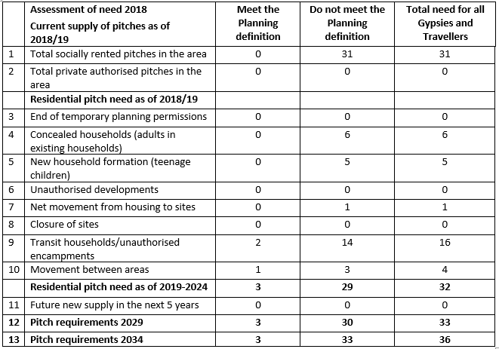

**10.1 Current supply of pitches**

**Row 1:** There are 31 pitches on the socially rented sites provided by Sheffield City Council.

**Row 2:** There are 0 pitches on private authorised sites owned by Gypsies and Travellers.

**10.2 Residential pitch need as of 2019**

**Row 3:** There are 0 pitches which have temporary planning permission due to expire within the assessment period.

**Row 4: Pitch requirements from concealed households**

This details the number of concealed households (adults over 18) occupying existing accommodation, but require independent accommodation in Sheffield.

**Findings:**

* The council sites’ occupancy list shows that there are potentially **5** concealed adults. This is lower than in 2015/16 when there were 7 concealed adults.
* **1** of these households are the waiting list, but 4 are not.
* There are currently no vacant pitches on either of the council owned sites.
* One concealed adult was recorded in the survey but this person is not on the waiting list.
* **1** concealed household was identified within bricks and mortar accommodation as needing a pitch in the next 5 years. This differs to 2015/16 when no concealed adults in housing were identified.
* None of the households said that they travel for work purposes.

**Assumptions:**

* To take account for possible overcrowding it is assumed that all the **5** concealed adults on the existing pitches on the council sites will need their own pitch in the next 5 years.
* It assumed that none of these concealed households fall within the Planning definition of Traveller.
* The **1** concealed household found in the survey living in bricks and mortar has been included in the need, but as the survey response from those in bricks and mortar was low it is possible that this is an under estimation of need.

**Calculation:** Need for pitches from concealed households = **6**

**Row 5: Pitch requirements from new household formation**

This is the number of pitches required from newly forming households e.g. secondary school aged children likely to need their own accommodation in the next 5 years.

**Findings:**

* The council sites’ occupancy list suggests that there are potentially **4** older children (13-17) that may need their own pitch in the next 5 years. This is lower than in 2015/16 when 6 newly forming households were identified.
* The survey revealed **1** more child that may be in need of a pitch.
* These households **do not** travel for work purposes and do not intend to in the future.
* Only 1 household from bricks and mortar accommodation said that they have a child that will need their own accommodation in the next 5 years, but this new household will require bricks and mortar accommodation. This is considerably lower than in 2015/16 when 6 newly forming households in bricks and mortar were identified and it is unknown whether these households still require a pitch.

**Assumptions:**

* In order to not under estimate the future need and account for possible overcrowding on the council sites the occupancy list data has been used to assess the need for pitches from newly forming households.
* No data was collected on likely newly forming households from bricks and mortar due to the small survey response. It therefore possible that some of the need has not been captured.

**Calculation:** Need for pitches from newly forming households = **5**

**Row 6:** There are 0 unauthorised developments in Sheffield.

**Row 7: Pitch requirements from movement between sites and houses (bricks and mortar)**

This is the estimated flow from sites to houses and vice versa

**Findings:**

* No households surveyed on the Council sites said that they want to move to a house in the next 5 years, but one household at Long Acre is currently on a priority for rehousing on the council waiting list.
* A total of 5 existing households in bricks and mortar accommodation were surveyed and of these **1** wanted to move onto a pitch in Sheffield. This household is not on the waiting list, but they did complete the 2015/16 survey and said that they wanted a pitch. The main reason that they have not joined the waiting list is because they would prefer to live on a site solely occupied by Irish Travellers.
* The current waiting list for the Council sites contains no households from bricks and mortar.
* The Council site management service receives 3-4 enquiries a year from households in bricks and mortar looking to move to the site, but they do not join the waiting list.
* In the past 3 years two households have quit the council sites to move into bricks and mortar and two households have moved from houses onto the sites (these were on the waiting list in 2015/16).

**Assumptions:**

Only the need from the surveyed households has been used to assess the pitch requirements. This is because only 5% of the estimated population in bricks and mortar were surveyed in this assessment. This under-representative sample reflects the hidden population in Sheffield and the difficulties experienced in engaging with the Gypsies and Travellers in bricks and mortar, as explained in Section 7.2.

It is likely that the views from the Gypsies and Travellers that were consulted do not represent theviews of the whole population and if the need was scaled up to the total population it would skew the pitch requirements.

Having said this, the two households in bricks and mortar that were on the waiting list in 2015/16 have now moved onto the council sites and their need has been met.

The need from the population in bricks and mortar will be monitored on an annual basis via the waiting list and new pitch allocations, and amended accordingly if necessary.

**Calculation:** Need for pitches from movement between houses and sites = **1**

**Row 8:** There are no planned closures of the authorised sites, but an eviction of the longstanding unauthorised site is planned.

**Row 9: Pitch requirements households on unauthorised encampments**

This provides an estimate of the need arising from households on the unauthorised encampment that will require a residential pitch in Sheffield.

**Findings:**

* The long standing unauthorised encampment in Sheffield which was occupied by around 30 New Age Travellers was evicted in July 2019.
* The Council’s Housing Solutions visited the site 16 times but none of the NATs took up bricks and mortar housing.
* 16 NAT’s are now living on another unauthorised site in the Hillsborough ward.
* It is estimated that around 2 of NATs travel for work purposes.

**Assumptions:**

* To represent the number of households that have moved to another unauthorised encampment following the eviction and sent the letter to the Council requesting a permanent site it has been assumed that there is a need for 16 pitches from the NATs, but only 2 meet the planning definition.

**Calculation:** Need for pitches from unauthorised encampments = **16**

**Row 10: Pitch requirements households moving between areas**

This is the level of movement of households between areas outside of Sheffield.

**Findings:**

* There are three households on Council’s waiting list from outside Sheffield, these are living in York, Newark and Mansfield
* There is one household on the Council’s waiting list that is travelling outside of Sheffield.
* There are two households from Sheffield on Barnsley’s council site waiting list.
* One household from Chesterfield has moved on to the Long Acre site in the last 3 years.
* One household in the survey on the Council housing site said that they might move in the next 5 years to a transit site or stopping place outside Sheffield.

**Assumptions:**

* It is assumed that the four households on the Council’s waiting list require pitches in Sheffield, one of which is currently travelling.

**Calculation:** The movement of households between areas = **4**

**10.3 Residential pitch need as of 2019 – 2024**

**Row 11:** There is no estimated new supply of pitches likely to become available in Sheffield over the next 5 years. The future turnover on the Council sites has not been included as part of the supply because the net vacancies cannot be assured and quantified. This is because there is not robust evidence available on the likely occurrence of pitches becoming vacant due to the death of the occupant, the occupant moving to bricks and mortar or leaving the area. In addition, a GTAA Best Practice Guide was produced in June 2016 by a number of organisations including Friends, Families and Travellers, the London Gypsy and Traveller Unit, the York Travellers Trust, the Derbyshire Gypsy Liaison Group, Garden Court Chambers and Leeds Gate which concluded that:

*“Assessments involving any form of pitch turnover in their supply relies upon making assumptions; a practice best avoided. Turnover is naturally very difficult to assess accurately and in practice does not do contribute meaningfully to additional supply so should be very carefully assessed in line with local treads.”[13]*

**Rows 12 and 13:** This is the estimated pitches required over the next 10 and 15 years due to household growth amongst the Gypsy and Traveller population.

**10.4 Household growth**

The growth rate for new household formation takes into account trend-based projections of natural change (births and deaths), marital composition and ‘settled community’ migration.

Gypsy and Traveller family norms facilitate household formation at a faster rate than the settled community as people marry younger (often 16-18) and obtain their own accommodation separate to their parents. The current shortage of sites and pitches in the country and limited data available on the Gypsy and Traveller population makes it difficult to estimate the future household growth and pitch requirements.

The South Yorkshire 2011 GTAA used the household growth rate of 3% per annum as applied in similar studies and recommended by Government when undertaking Regional Spatial Strategies. However, Regional Spatial Strategies are no longer required and Gypsy and Traveller consultants, such as Opinion Research Services (ORS)[14] are now questioning the justification for using a 3% household growth rate in Gypsy and Traveller Accommodation Assessments.

ORS argue that no statistical evidence exists to support the 3% growth rate and that the Caravan Count data has shown that the on-site number of caravans growing at less than 2.5% per annum, while the Gypsy and Traveller population growth may be as low as 1.25% per annum. In practice, the evidence from ORS supports using a formation rate of between 1.5% and 2.5% depending on the local data and the age of the Gypsy and Traveller population.

A local household growth rate has therefore been developed for Sheffield utilising information gathered from the population on the Council sites and in bricks and mortar accommodation. The New Age Travellers are not included in this calculation as the future of the encampment is uncertain and it is unclear how many will remain living in Sheffield long term. The household growth rate for Sheffield has been calculated as follows:

* There are 4 new households forming within the area on the Council sites (on a base of 31 households[15]) which equates to a growth rate of 2.6% compound over the five-year period.
* There are 5 concealed households on the Council sites this equates to 3.2% over 5 years.
* Only one household has been recorded as likely to move from bricks and mortar to a site and one concealed household. Over the past 5 years two households have also moved onto the site from bricks and mortar, combined this makes 4 households, which equates to a growth rate of 1% compound over the five-year period (on a base of 100 households).
* When combined this provides a **1.98% per annum compound household growth rate**.
* To take account of pitch sharing an assumption is made that 1.5 households need one pitch.

However it should be noted that the current rate of household growth in Sheffield is constrained by the lack of supply and an increase in the provision of permanent or transit sites could increase the household growth rate further.

## Travelling Showpeople

Travelling Showpeople are defined as members of a group organised for the purposes of holding fairs, circuses or shows (whether or not travelling together as such). This includes people who, on the grounds of their family’s or dependent's more localised pattern of trading, educational or health needs or old age, have ceased to travel temporarily, but excludes Gypsies and Travellers.

Although their work is of a mobile nature, Showpeople require secure, permanent bases for the storage and repair of their equipment and to live when not on the road.

Many Showpeople are members of the Showmen's Guild of Great Britain which aims to protect the interests of travelling showmen working on funfairs. It does this in two ways; by its code of rules for members and through the legal and constitutional processes of the land. The rules, which are enforced by the Guild's own disciplinary tribunals, cover such matters as the orderly running of the fairs and the conduct of members, both on and off fairgrounds. There are 4,000 active members of the Showmen's Guild representing 20,000 or more travelling families across the country.

**11.1 Assessing the need for Showpeople plots/yards**

The national planning policy, ‘Planning Policy for Traveller Sites’ requires local authorities to assess the accommodation needs of Travelling Showpeople and allocate land for site provision. In line with the Gypsy and Traveller definition the revised planning policy in 2015 also amended the definition of Showpeople for planning purposes to remove the words “or permanently”. The majority of Showpeople (ORS estimate 70%) will meet this new definition as they travel for work purposes.

The needs of Travelling Showpeople are assessed separately as their site requirements differ to other Gypsies and Travellers. Showpeople are not usually travelling or stopping on unauthorised sites as they are going to licensed fairgrounds. They normally require larger sites with mixed used plots for accommodation and the storage of equipment; these are referred to as yards.

The traditional lifestyle of Travelling Showpeople has been of peripatetic nature, with Showpeople travelling from fair to fair predominantly through the summer months, and settling on permanent sites known as "winter quarters" during the winter months where they can live when they are not working.

Increasingly, however, sites are being occupied all year round by other family members, such as older people and families with children at school. A reduction in the number of large scale fairs has also led to more localised travelling with a need for more permanent bases.

**11.2 Showpeople in Sheffield**

There is one privately owned Showpeople site in Sheffield which was first developed over 50 years ago. This site has 8 yards at around 100ft to 200ft to accommodate one or two caravans/trailers and space to store fairground equipment.

The site is located within the established neighbourhood of Chapeltown which is close to the local school, shops and services, and Junction 35 of the M1.

The need for additional Showpeople provision to accommodate the growing families on the site has been an issue since the 2006 GTAA and was expressed in the subsequent 2011 and 2015 assessments. Although the Showpeople have not submitted a planning application for a new site in Sheffield, they have been interested in two sites in the city over the last nine years. One to the south east of Sheffield in 2009, which was deemed unsuitable because of the risk of flooding, and the other in east Sheffield in 2015 but this had access issues and was deemed too expensive by the Showpeople.

A new Showpeople site with eight yards was also developed in North Anston Rotherham in 2013 by a former resident of the Chapeltown site as they could not find suitable land within Sheffield.

Doncaster has the largest provision for Travelling Showpeople in the region with nine sites accommodating 72 yards. Their GTAA suggested that this is an oversupply. Bolsover also has a Showpeople site with a further two sites granted planning permission in the area, these sites can accommodate a total of 22 yards. It is unclear if Showpeople from Sheffield would be interested in living on these sites.

**11.3 Engaging with Sheffield’s Showpeople**

All the Showpeople’s yards on the site were sent letters informing them of the study and were asked to complete a survey asking them about their accommodation needs. These were mailed to the site on two occasions, but no responses were received.

The Showmen’s Guild for Yorkshire was therefore contacted to ask for their assistance in engaging with the community, and for information about yard requirements in the city.

A subsequent telephone interview was conducted with the Planning representative for the Showmen’s Guild Yorkshire, who also took part in the 2015/16 study, and a further follow up meeting was held with this rep and the Chair of Showmen’s Guild for Yorkshire. The Showmen’s Guild said that the community feel frustrated that they have not been able to acquire land in Sheffield and were unlikely to take part in the study because of this. The Showmen’s Guild has therefore acted as a spokesperson for the community in this study due to their close ties with the Showpeople in Sheffield.

It is hoped that once sites for Showpeople are identified in the Sheffield Draft Plan the community will be open to consultation and the Showmen’s Guild will encourage them to take part.

**11.4 Consultation findings**

* All the households at Chapeltown travel for work purposes, apart from one older person that has retired. The older person is not looking to move in the future.
* Seven out of the eight yards on the Chapeltown site are occupied. The vacant yard is owned by the resident who has developed the site in Rotherham and this is let on an informal basis to Showpeople travelling to the city for fairs. The Showmen’s Guild is aware that the owner is looking to sell this vacant yard and it will likely be sold to a concealed household on Chapeltown.
* The majority of the yards (at least 6) are overcrowded because of the size of the equipment being stored and the fact that they are not big enough to accommodate the concealed and newly forming households sharing the yards. Most of the yards have three or four trailers accommodating the owner’s household and their extended family e.g. grown up children with families.
* One of the concealed households has recently left the family yard at Chapeltown and bought a yard in Hatfield (Hertfordshire) because they couldn’t find anything local to Sheffield, but there is still a sibling living on their family yard that needs their own accommodation.
* Although the Showmen’s Guild could not give exact numbers of the concealed/newly forming household on Chapeltown they estimate that the provision of seven extra yards in Sheffield could accommodate the concealed/newly forming households at Chapeltown and alleviate the overcrowding.
* In addition to the need on the Chapeltown site, the Showmen Guild is in contact with five Showpeople families in Sheffield that are currently renting private land on two sites. One of the sites has 3 families with 10 people and the other has two families with 7 people. These households do not have planning permission to be on the site and want to move onto secure permanent provision, but cannot afford to buy their own land.
* The Showmen’s Guild would like to develop and manage a permanent site in Sheffield to meet the needs of Sheffield’s Showpeople living in the city. The yards would be let at a rent set by the Guild and allocated based on need and connection to the city.
* Ideally the site would need to be 3 to 4 acres (1 acre for accommodation and 2 acres for equipment) with yards of around 150ft -150ft. These yards would accommodate caravans/trailers to live in and space to store and maintain equipment. As well as some permanent yards the site could also have some visitor yards (transit) for Showpeople working in the city.
* The cost of land is the biggest barrier for Showpeople developing a site, particularly if the site requires access and the installation of water and electricity. The Showmen’s Guild would ideally like to lease Council land on a long lease of around 150 years at a peppercorn rent. This would allow them to use their funds for the development of the site rather than the purchase of the land.
* However they have not ruled out purchasing land if it is affordable to them and a brownfield site would be preferred.
* The Showmen’s Guild currently operates a similar site in Dewsbury. The land is on a long lease from Kirklees Council and the yards are rented to the Showpeople for £30 per week, plus an additional charge per vehicle.
* Another approach that some Showpeople have taken to develop sites is to enter into a co-operative. The Showmen Guild’s planning representative is currently developing a site in Wakefield with 5 other Showmen where they are all sharing the costs of the development equally.
* Other developments are by single Showpeople who develop a site and then sell the individual yards on to Showpeople however because of the demand and lack of supply they are often overpriced. For example, Showpeople can often pay £140k-£160k for a yard which only has a land value of £30k this can make securing finance difficult.

**11.5 Assessment of need summary**

* An estimated seven yards are needed from households on the Chapeltown site to alleviate the overcrowding and accommodate concealed/newly forming households.
* There are five households living on two other sites in the city that require a yard each.
* Overall this suggests a total need of 12 yards from the Showpeople which is an increase from the 2015 GTAA when only 3 yards were needed. The Showmen’s Guild suggested that this need could be met over one or two sites.
* The Showmen’s Guild would like to develop a permanent site in Sheffield to meet the needs of local Showpeople, particularly those that cannot afford to develop their own site.
* The Showmen’s Guild will work with the Council to consult with the Showpeople when new sites are identified.

## Assessment of Transit and Stopping Places Provision

National policy is clear that there should be provision for Gypsies and Travellers who choose to travel to do so without resorting to stopping illegally or inappropriately. The change to the definition of the Gypsy and Traveller in Planning Policy to remove the words *“or permanently”* when they have ceased to travel also implies that the Government expects Gypsies and Travellers to travel at some point in the year. Transit sites or temporary stopping places can therefore help to facilitate this travelling and reduce the number of unauthorised encampments.

Aside from the Showmen’s Guild that said they would like to develop a permanent site containing some transit yards, this assessment has not demonstrated a significant demand for transit and stopping place provision in Sheffield. Across all the 25 surveys with the Gypsies and Travellers (on council sites or in bricks and mortar) only 5 respondents said that they would like this provision in the city.

The Multi – Agency Group did not particularly see the need for this provision, which is in contrast to the last study in 2015 when it was supported. The Group were of the opinion that there is not sufficient demand for a transit site to offset the costs of developing this new provision and the associated running costs. There were concerns that temporary stopping places could be difficult to manage in terms of the impact to the surrounding community and the clearance costs, as well as the potential for the Travellers to remain on the site for longer than the agreed timeframe.

Generally the city region authorities did not see a particular need for this provision. Doncaster sold their transit site due to a lack of demand and their surveys with the community have found that visitors tend to double up on pitches visiting family rather than staying on a specific transit site. This is also the case on Sheffield’s council sites, where visitors park their caravan on their friends/relatives pitch.

North East Derbyshire has four transit pitches attached to their council site, and said that their assessment has found some value in having this provision.

Suggested travelling routes that could benefit from transit provision were the M1, M6, M42, A61, A38, A52, and the A6 north to south, and the A50 east to west. Rotherham also noted that there are regular unauthorised stops along the Dearne Express Parkway/Manvers Way from those travelling between Barnsley and Doncaster.

Taking all this into account, at this time there is not sufficient demand for transit or stopping provision in Sheffield and the focus should be on permanent site provision.

## Houseboat dwellers

Those residing in boats have been considered as part of this study following the introduction, in the Housing and Planning Act 2016, of a requirement to consider the needs of people residing in houseboats.

As with Gypsies and Travellers who do not meet the planning definition of Travellers, houseboat residents form part of the Overall Assessment of Need in the Strategic Housing Market Assessment.

Given that the requirement to determine the accommodation needs of boat dwellers was only recently introduced by the DCLG Draft Guidance on Housing Needs (Caravans and Houseboats) (March 2016), there is no established method to determine need. The Housing and Planning Act 2016 definition of a ‘houseboat’ also conflicts with waterways legalisation. The Act defines a ‘houseboat’ as a boat or similar structure designed or adapted for use as a place to live, while the British Waterways Act 1971 suggests that a houseboat is a static vessel not used for navigation, as opposed to more mobile boat dwellers that do travel either from permanent moorings or as continual cruisers.

**13.1 Sheffield’s houseboat dwellers**

There are two moorings on the Sheffield and Tinsley Canal:

**Victoria Quays** – This is the Sheffield Canal Basin at the head of the Sheffield and Tinsley Canal, close to Sheffield City Centre. The Quays offer eight moorings which are managed by Calder Valley Marine who plan to turn the Quays into a bustling marina providing diesel gas and chandlery facilities, and new and pre-owned boats for sale.

**Tinsley Marina** – This is situated two miles to the north east of Sheffield City Centre, within easy reach of the M1, and Meadowhall Shopping Centre. The moorings are managed by the Canal and Rivers Trust and can accommodate up to 33 boats accessed from a mixture of fixed pontoons, in the main, and two hard standing. 12 of the berths have full residential planning consent, and are located on the top pond which is accessible by berth holders only.

In order to understand the demand for moorings in Sheffield a postal survey was sent to all the known mooring addresses. This survey asked about the occupants’ experiences of living in a houseboat, the current mooring provision, the households moving intentions, and the future need for mooring in Sheffield. Four responses were received.

The survey found that:

* All the respondents lived at the Tinsley Marina as their main residence, 3 of them in Narrow Boats and 1 in a Cruiser.
* All but one were single people, the other was a couple.
* Two have lived there over 3 years, one 1-3 years and the other for 6-12 months.
* All owned the boat but rented the mooring from the Canal and Rivers Trust.
* They chose to live on a houseboat as a lifestyle choice because of the freedom it gives and the supportive boating community.
* Two respondents believe that the condition of the moorings is good and the others said they are adequate or poor. It is felt that the toilets and showers need replacing and improvements need to be made to the pontoon surfaces.
* The location of the marina is popular because of the services nearby and the access to the trams.
* All of them are planning to stay living in their houseboat at Tinsley Marina over the next 5 years. Two of the households have travelled on their boat in the last 12 months to visit family/friends and go on holiday.
* All of them said that there is a need for more moorings in Sheffield as there are only 12 residential moorings in the city and they are popular. These should be at Tinsley, at Victoria Quays or anywhere along the canal in the city boundary.

**13.2 Summary of need**

Evidence would indicate a limited need from houseboat families and no recommendation to seek additional moorings based on the evidence available. The findings from the survey will be passed on to the Canal and Rivers Trust.

It should be noted that the analysis is based upon those houseboats that it was possible to survey. It is possible that additional boats are being used as dwellings (either authorised or unauthorised), and that there may therefore be additional need arising from these.

## Conclusions and Recommendations

The section provides some concluding comments in relation to the assessment of accommodation needs for Gypsies, Travellers and Showpeople living in Sheffield and recommendations going forward.

There is a clear need in Sheffield for an increase in Gypsy, Traveller and Travelling Showpeople pitch provision, with a total of 44 pitches (32 for Gypsies and Travellers and 12 for Travelling Showpeople) required over the following periods:

• 2019 - 2024 = 44 pitches

• 2025 – 2029 = 47 pitches

• 2030 – 2034 = 50 pitches

Of the 47 pitches required only 15 pitches fall within the Planning definition of Traveller i.e. they meet the need of those travelling for work, and the majority of these are Showpeople.

However, it is recommended that the total pitch requirements for all Travellers in the city, regardless of whether they meet the planning definition, is considered when identifying land for sites in the Sheffield Plan. This is to enable the Council to meet the Equality Act duties, allow for household growth on the sites and help prevent the occurrence of unauthorised encampments.

The pitch requirements for 2019 are lower than what was needed in 2015/16. This is due to the reduce need amongst New Age Travellers following the eviction of the long standing site, and the slight decrease in the numbers of concealed and newly forming households on the Council Traveller sites. However there are still 16 New Age Traveller households living on a new unauthorised encampment that wish to live on a site in Sheffield and stated an intention to remain on unauthorised encampments until a permanent authorised site is found.

The growth in yard requirements, from 3 in the 2015/16 to 12 in this study, is a result of unmet need over the past 12 years as the Showpeople have needed a new site in the city since the first Gypsy and Traveller Accommodation Assessment in 2006. It is also due to the identification of five additional Showpeople families living in the city that require permanent yards. Unlike Gypsies and Travellers in Sheffield that are likely to require social rented sites provided by the Council or Housing Registered Providers, the Showpeople wish to develop their own site either through the Showmen’s Guild or as a private site. The Showmen’s Guild is particularly interested in leasing council land to develop a site that will enable them to rent yards to Showpeople living in Sheffield.

The long term accommodation needs arising from Gypsy and Traveller households in bricks and mortar accommodation continue to be largely unknown. Although some need has been identified in the assessment only five households in this accommodation were consulted, which could suggest some hidden need from the group. Having said this, there are currently no Gypsies and Travellers in bricks and mortar on the waiting list for a council site and those that were on the waiting list in 2015/16 have now been accommodated on a site indicating that some need has been met. The need from the population living in bricks and mortar will therefore be monitored on an annual basis via the waiting list and new pitch allocations, and the pitch requirements will be amended accordingly if necessary.

* 1. **Recommendations**

The following recommendations are made to the local authority in order to measure and address the needs of Gypsies and Travellers living in Sheffield:

* The pitch requirements over the 2019 to 2024 period should be regarded as a reasonable and robust assessment of need; the pitch requirements for the 2025 to 2034 period should be seen as indicative due to the reliance on the housing growth figures. It is therefore recommended that the Gypsy and Traveller Accommodation Needs Assessment should be updated in due course at around every five years.
* To ensure that the needs of all Travellers in the city are accounted for, the total pitch requirements should be considered when determining the site requirements in the Sheffield Plan.
* Consultation should be undertaken with Gypsies and Travellers and the settled community on the proposed site allocations for Gypsy and Traveller sites in the Draft Sheffield Plan.
* Consultation should be undertaken with the Showmen’s Guild and Showpeople living in Sheffield to identify suitable sites to meet their requirements, and the possibility of leasing council land could be explored.
* Suitable sites for Gypsies, Travellers and Showpeople should be identified for inclusion in the Draft Sheffield Plan.
* Continue to consider the accommodation needs of the New Age Travellers as part of the site identification process.
* Continue to consider the accommodation needs of Gypsies and Travellers in bricks and mortar through the waiting list and site allocations.

**Glossary**

The following terms are used in this report and are used in conjunction with planning for Gypsy, Traveller and Showpeople accommodation. As such these terms may need some clarification. In the case of those terms which are related to Gypsy and Traveller accommodation and culture, it is noted that a number of these terms are often contested and debated. It is not the intention to present these terms as absolute definitions; rather the explanations provided are those used in this assessment as their frames of reference:

| Term | Explanation |
| --- | --- |
| **Amenity block/shed** | On most residential Gypsy/Travellers sites these are buildings where basic plumbing amenities (bath/shower, WC and sink) are provided at the rate of one building per pitch. |
| **Authorised social site** | An authorised site owned by either the local authority or a Registered Provider. |
| **Authorised private site** | An authorised site owned by a private individual (who may or may not be a Gypsy or a Traveller). These sites can be owner-occupied, rented or a mixture of owner-occupied and rented pitches. They may also have either permanent or temporary planning permission. |
| **Bricks and mortar** | Permanent housing of all tenure types. |
| **Caravan** | Defined by Section 29 (1) of the Caravan Sites and Control of Development Act 1960 a caravan as:  "... any structure designed or adapted for human habitation which is capable of being moved from one place to another (whether by being towed, or by being transported on a motor vehicle or trailer) and any motor vehicle so designed or adapted.” |
| **Caravan Count** | Bi-annual count of Gypsy and Traveller caravans conducted every January and July by local authorities published by the CLG. |
| **Concealed household** | Families living as part of another family unit of which they are neither the head nor the partner of the head and who need to live in their own separate accommodation, and/or are intending to move to separate accommodation, rather than continuing to live with their ‘host’ family unit. |
| **Draft Sheffield Plan** | The second stage in producing a new Sheffield Plan, which will become the statutory Local Plan for the city. It provides strategy and development management policies and area policies and sites, all of which are part of public consultation. |
| **Green Belt** | A policy or land use designation used to retain areas of largely undeveloped, wild or agricultural land surrounding or neighbouring urban areas. |
| **Gypsy** | Members of Gypsy or Traveller communities. Usually used to describe Romany (English) Gypsies originating from India. This term is not acceptable to all Travellers. |
| **Gypsies and Travellers** (as used in this report) | Is an inclusive term for Gypsies, Irish Travellers and New Age (or New) Travellers. |
| **Gypsy and Traveller Accommodation Needs Assessment (GTAA)** | The main document that identifies the accommodation requirements of Gypsies and Travellers. |
| **Ministry of Housing, Communities & Local Government** | The main government department responsible for Gypsy and Traveller accommodation issues. |
| **Mobile home** | Legally classified as a caravan but not usually moveable without dismantling or using a lorry. |
| **New Age (or New) Traveller** | Members of the settled community who have chosen a nomadic or semi-nomadic lifestyle. The first wave of New Age Travellers began in the 1970s and was associated with youth culture and ‘new age’ ideals. They now comprise a diverse range of people who seek an alternative lifestyle for differing reasons including personal or political convictions. Economic activities include making hand-made goods that are sold at fairs. | |
| **Newly forming households** | An individual or household that currently lives within another household but has a preference to live independently and is unable to access appropriate accommodation (on sites or in housing) e.g. older child wanting to leave their parents to live independently. | |
| **Pitch/plot** | Area of land on a site/development generally home to one licensee household. Can be varying sizes and have varying caravan occupancy levels. Often also referred to as a plot, particularly in relation to Travelling Showpeople. There is no agreed definition as to the size of a pitch. | |
| **Static caravan** | Larger caravan than the ‘tourer’ type. Can be moved but only with the use of a large vehicle. Often referred to simply as a trailer. | |
| **Stopping place** | Locations frequented by Gypsies and Travellers, usually for short periods of time. These can be identified pieces of land by the authority where the Travellers can stay while travelling through. Normally basic waste facilities are provided. | |
| **Temporary stopping place** | A piece of land that with negotiated arrangements which allow caravans to be sited on suitable specific pieces of ground for an agreed and limited period of time, with the provision of limited services such as water, waste disposal and toilets. The arrangement is between the local authority and the (temporary) residents. | |
| **Tourer/trailer** | Term commonly used by Gypsies and Travellers to refer to a moveable caravan. | |
| **Transit site** | Site intended for short stays. Such sites are usually permanent with pitches, but there is a limit on the length of time residents can stay around 4 weeks. | |
| **Travelling Showpeople** | People who organise circuses and fairgrounds and who live on yards when not travelling between locations. Most Travelling Showpeople are members of the Showmen’s Guild of Great Britain. | |
| **Unauthorised development** | This refers to a caravan/trailer or group of caravans/trailers on land owned (possibly developed) by Gypsies and Travellers without planning permission. | |
| **Unauthorised encampment** | Residing in caravans/trailers on private/public land without the landowner’s permission (for example, at the side of the road, on a car park or on a piece of undeveloped land). | |
| **Yard** | Term used by Travelling Showpeople to refer to a pitch. | |

1. This was evidenced by two key legal cases: i) In Commission for Racial Equality v Dutton [1989] Q.B. 783, CA the Court of Appeal found that Romani Gypsies were an ethnic minority with a long, shared history, a common geographical origin and a cultural tradition of their own. ii) In P. O'Leary and others v Allied Domecq and others (unreported) 29 August 2000 (Case No CL 950275-79), H.H.J. Goldstein reached a similar decision in respect of Irish Travellers.
2. CLG: Para 9, Planning policy for traveller sites (August 2015)
3. CLG: Annex 1, Planning policy for traveller sites (August 2015)
4. CLG: Draft Guidance to local housing authorities on the periodical review of housing needs – Caravans and Houseboats (March 2016)
5. Sheffield Archives TT4/1/1
6. Sheffield Local Studies 397 SST
7. Doncaster Gypsy and Traveller Accommodation Assessment March 2016
8. The University of Sheffield: The Health Status of Gypsies & Travellers in England (October 2004)
9. The Traveller Movement: Impact of insecure accommodation and the living environment on Gypsies’ and Travellers’ health (2016)
10. LKMco: The underrepresentation of Gypsy, Roma and Traveller pupils in higher education (July 2017)
11. Applicants need to be over 18, have proof of identity and provide two references which include: details on rent payments, declare previous evictions from council sites or bricks and mortar accommodation, and site compliance.
12. CRE: Common Ground: Equality, good race relations and sites for Gypsies and Irish Travellers (2006)
13. Various Authors: Best Practice for assessing the accommodation needs of Gypsies and Travellers (June 2016)
14. ORS: Housing Formation Rates for Gypsies and Travellers – A Technical Note (November 2013)
15. This is the identified households in the accommodation