Sheffield Plan:
Our City, Our Future
Publication (Pre-Submission) Draft

PART 1: Vision, Spatial Strategy, Sub-Area Policies and Site Allocations

Tracked Changes post Public Consultation

Approved by Full Council, 6th September 2023

Planning Service
City Futures
Sheffield City Council

FOREWORD: A new vision for Sheffield

This is a Plan for the people of Sheffield. It sets out how and where the city will develop over the next 15-20 years and ensure that the benefits of development are felt across all communities.
A key priority for this Council is delivering secure, connected, respected neighbourhoods – providing affordable homes in the right locations.
Housing is often at the root of inequality, and we remain steadfast in our commitment to truly tackling this and providing a high standard for all our neighbourhoods, whilst ensuring that the city’s green spaces are protected.
We, as a Council, across all the political groups, have listened carefully to what you told us during the public consultation on how the Sheffield Plan should be shaped in autumn 2020. You told us about the importance you attach to protection of the Green Belt and open spaces; how this is vital to the city’s character and to our reputation as the ‘Outdoor City’. Many of you told us about your concerns relating to climate change, about the impact of development on biodiversity and about the need for a better mix of homes and more affordable, good quality housing. You told us about the need for better public transport and to prioritise cycling and walking, about the need for a more vibrant, dynamic City Centre and there was widespread support for the reuse of vacant and underused previously developed (brownfield) sites across the city. The Plan reflects these priorities.
The new plan is ambitious but realistic. It is a plan that will enable 35,530 homes to be built and 43,000 new jobs to be created.
Crucially this is a plan that ensures homes are built in the right places and delivers on our ambitions with respect to affordability and sustainability, with the right supporting infrastructure. I am pleased that, through this Plan, we are able to do this without undermining the green character of the city.
The Climate Emergency has played a key role in shaping our overall approach. Sheffield, along with other cities and regions around the world, will need to play its part in responding to one the biggest challenges of our time. The Plan will focus future growth in the existing built-up areas and raise overall densities. It will help to make neighbourhoods better places to live, reduce the need to travel and help us to improve public transport, shops and local facilities.
The Plan takes forward the ambitions for the City Centre that we set out in the City Centre Vision in 2022. It includes proposals for a series of vibrant new neighbourhoods providing homes, new public spaces and local services and facilities. We will work with the people of Sheffield, landowners, developers and other partners to deliver those new neighbourhoods over the coming years. These new city centre neighbourhoods will have clear identities, offering a variety of places and experiences. They will be designed to be inclusive and play a significant role in sustaining existing and future businesses across the central area.
The Plan will play a vital role in helping us to drive up the overall quality of new developments. Amongst other things, it sets improved space standards for new homes, will deliver more accessible and adaptable housing and requires new development to cut carbon emissions, supporting the council’s clear objective to be net zero carbon by 2030.
By allocating land for development, the new Plan will enable the Council, utility companies and other service providers to plan new infrastructure more effectively. This includes the provision of new education and health facilities, as well as other vitally important improvements to public transport. Indeed, better transport infrastructure is crucial to delivering the new development proposed in the Plan, with many of the policies designed to support the creation of neighbourhoods where everyday needs can be met within a short walk or cycle ride, without always needing to use a car. A shift to more sustainable ways of travelling will be essential, not only to cut carbon emissions, but also to create safer, people friendly neighbourhoods and reduce congestion. But we cannot do this alone, we need significantly more support from government to deliver a public transport fit for Sheffield.
We have developed an ambitious Sheffield Plan that is for today but also the future - playing a significant role in creating a truly sustainable city.

The new Plan sets out how we will provide new homes, new jobs and new opportunities to help us realise our potential and become a more sustainable city. The right housing, jobs and infrastructure will help to achieve that while also helping to tackle profound inequalities in our city and tackle the climate emergency. The Plan sets out how we will do that and ensure that Sheffield becomes an even better city to live and work in.

Councillor Tom Hunt
Leader, Sheffield City Council

Contents
 | Page
Foreword
- Introduction to the Draft Sheffield Plan | 1
- Vision, Aims and Objectives | 14
- Growth Plan and Spatial Strategy | 19
Policy SP1: Overall Growth Plan ▲ | 23
Policy SP2: Spatial Strategy ▲ | 26
Policy SP3: The Hierarchy of Centres ▲ | 28
- Sheffield Sub-Area Strategy | 31
Central Sub-Area | 33
Policy SA1: Central Sub-Area ▲ | 34
Character Area One: Kelham Island, Neepsend, Philadelphia, Woodside | 37
Policy CA1: Kelham Island, Neepsend, Philadelphia, Woodside ▲ | 38
Policy CA1A: Priority Location in Neepsend | 40
Policy CA1B: Catalyst Site Between Penistone Road, the River Don, and Rutland Road | 41
Character Area Two: Castlegate, West Bar, The Wicker, and Victoria | 42
Policy CA2: Castlegate, West Bar, The Wicker, and Victoria ▲ | 43
Policy CA2A: Priority Location in Castlegate | 45
Policy CA2B: Priority Location in Wicker Riverside | 47
Character Area Three: St Vincent’s, Cathedral, St George’s and University of Sheffield | 48
Policy CA3: St Vincent’s, Cathedral, St George’s and University of Sheffield ▲ | 49
Policy CA3A: Priority Location in Furnace Hill | 51
Policy CA3B: Catalyst Site at the Gateway between Scotland Street, Smithfield, and Snow Lane | 53
Character Area Four: City Arrival, Cultural Industries Quarter, Sheaf Valley | 54
Policy CA4: City Arrival, Cultural Industries Quarter, Sheaf Valley ▲ | 55
Policy CA4A: Part of Priority Location and Catalyst Site at Moorfoot - Land between Eyre Street, St Mary’s Road, and Jessop Street | 57
Character Area Five: Heart of the City, Division Street, The Moor, Milton Street, Springfield, Hanover Street | 58
Policy CA5: Heart of the City, Division Street, The Moor, Milton Street, Springfield, Hanover Street ▲ | 60
Policy CA5A: Priority Location in Moorfoot | 62
Policy CA5B: Catalyst Site at the Junction between St Mary’s Gateway, The Moor Street, and London Road | 63
Character Area Six: London Road and Queens Road | 65
Policy CA6: London Road and Queens Road ▲ | 66
Northwest Sheffield Sub-Area | 68
Policy SA2: Northwest Sheffield ▲ | 69
Northeast Sheffield Sub-Area | 71
Policy SA3: Northeast Sheffield ▲ | 72
East Sheffield Sub-Area | 74
Policy SA4: East Sheffield ▲ | 78
Southeast Sheffield Sub-Area | 80
Policy SA5: Southeast Sheffield ▲ | 81
South Sheffield Sub-Area | 83
Policy SA6: South Sheffield ▲ | 84
Southwest Sheffield Sub-Area | 86
Policy SA7: Southwest Sheffield ▲ | 87
Stocksbridge/Deepcar Sub-Area | 90
Policy SA8: Stocksbridge/Deepcar ▲ | 91
Chapeltown/High Green Sub-Area | 93
Policy SA9: Chapeltown/High Green ▲ | 94
- Topic Policies | 96
Housing | 96
Policy H1: Scale and Supply of New Housing ▲ | 98
Enabling Sustainable Travel | 101
Policy T1: Enabling Sustainable Travel ▲ | 103
Blue & Green Infrastructure | 108
Policy BG1: Blue & Green Infrastructure ▲ | 109
Design Principles and Priorities | 111
Policy D1: Design Principles and Priorities ▲ | 111
Infrastructure Provision | 114
Policy IN1: Infrastructure Provision▲ | 115
Appendix 1: LIST OF SITE ALLOCATIONS | 117
▲ Denote a strategic policy (see paragraph 21 of the National Planning Policy Framework (2021))

List of Maps
Map Number | Map Title
1 | Geographical Area covered by the Sheffield Plan
2 | South Yorkshire Mayoral Combined Authority and Sheffield City Region
3 | Settlement Hierarchy and Hierarchy of Centres
4 | City Centre and City Centre Primary Shopping Area
5 | Sheffield Plan Sub-Areas
6 | Central Sub-Area – Spatial Diagram
7 | Northwest Sub-Area
8 | Northeast Sub-Area
9 | East Sub-Area
10 | Southeast Sub-Area
11 | South Sub-Area
12 | Southwest Sub-Area
13 | Stocksbridge/Deepcar
14 | Chapeltown/High Green Sub-Area
15 | Existing Transport Infrastructure
16 | Transport Opportunities
17 | Blue and Green Infrastructure and the Green Network

List of Tables
Table Number | Table Title
1 | Housing Supply 2022-2039
2 | Distribution of Housing Supply by Sub-Area 2022-2039

Introduction

What is the Sheffield Plan?
  - The Sheffield Plan sets out a strategy for future growth and change through to 2039, and will help to deliver Sheffield City Council’s objectives for creating a fairer city for everyone.
  - The plan addresses needs and opportunities for housing, jobs, and important infrastructure. It provides the basis for safeguarding the environment, adapting to climate change, and securing good design. It is one of the most important tools in enabling development and guiding decisions on the future of Sheffield.
  - Sheffield, like other major cities, is facing a number of challenges but it also has the opportunity to grasp hold of unique opportunities. In order to positively meet needs and responsibly address problems, the city needs a policy framework that can provide certainty and guidance to its residents, businesses, visitors, investors, and partners.
  - It is vital that the Sheffield Plan reflects the needs and aspirations of every person in the city, no matter who they are, where they live, or what stage they are at in their life. Changes to the places where we live and work can sometimes be challenging and can cause concerns over how existing places will cope with pressures. To address these concerns, the Sheffield Plan sets out policies and guidance for how and where growth will take place, and how we will use growth to improve the quality of life and provide opportunity for everyone.
  - Once finalised, the Sheffield Plan will become the ‘Local Plan’ for Sheffield. It will form part of the statutory ‘Development Plan’, which is made up of the local plan and any neighbourhood plans prepared by communities. The development plan has legal status and future development applications will have to be in accordance with the development plan, unless material considerations indicate otherwise.

What is the scope of the documents?
  - The Sheffield Plan represents proposals for how we think Sheffield should develop in the period up to 2039. It comprises the following documents:
- Part 1: Vision, Spatial Strategy, Sub-Area Policies and Site Allocations (this document)
- Part 2: Development Management Policies and Implementation
- Annex A: Site Allocations
- Annex B: Parking Guidelines
- Key Diagram
- Policies Map
- A Glossary
  - Together these documents form the ‘Publication (Pre-Submission) Draft’ version of the Sheffield Plan. The plan has been prepared in accordance with the Planning and Compulsory Purchase Act (2004) (as amended) and Regulation 19 of the Town and Country Planning (Local Planning) (England) Regulations 2012 (as amended).
  - Throughout this document, the Publication (Pre-Submission) Draft Sheffield Plan is referred to as the ‘Sheffield Plan’ or simply ‘the Plan’. It has been approved by Sheffield City Council for public consultation. However, it remains a draft plan until it has been formally adopted by the Council (expected to be towards the end of 2024).
Part 1: Vision, Spatial Strategy, Sub-Area Policies, and Site Allocations
  - Part 1 is this document – it includes the introduction to the plan and sets out the Council’s vision, overall aims, and objectives.
  - It establishes the overall growth plan for Sheffield, giving a complete picture on the scale of growth proposed over the period to 2039. It explains how the chosen spatial strategy affects different parts of Sheffield (the plan divides Sheffield into nine sub-areas); and each sub-area section includes a policy which describes the proposed scale and location of growth.
  - This part of the plan also lists the sites that have been allocated for future development – the ‘Site Allocations’. Some of the sites already have planning permission but because development has not started or has not been completed, they are included here because they will contribute to future growth. More details, including specific conditions that apply to the Site Allocations are set out in Annex A: Site Schedule (see below).
  - Part 1 also includes several ‘topic’ policies covering housing, transport, blue & green infrastructure, design principles & priorities, and infrastructure delivery. These policies deal with important strategic issues affecting the future development of the city.
Part 2: Development Management Policies and Implementation
  - This part of the plan helps to answer the questions: ‘What do I need to do to get planning permission’ and ‘how will the plan be implemented?’
  - Whilst Part 1 sets out the strategic overview of how Sheffield will change, Part 2 sets out how we will achieve high quality development. The development management policies set out criteria that provide certainty and consistency in decisions about planning applications. The policies enable developers to be clear about what is expected and provide guidance on what is needed to make development economically, socially, and environmentally sustainable.
  - This part of the plan includes policies that guide the mix of uses in a series of geographical ‘Policy Zones’, most of which have ‘preferred’, ‘acceptable’, and ‘unacceptable’ uses that reflect the vision, objectives, and spatial priorities. The Zones cover the whole geographical area of Sheffield and are shown on the Policies Map.
Annex A: Site Schedule
  - This provides more details on the mix of uses that are required on the Site Allocations listed in Part 1 of the Plan. It sets out any conditions that will apply to development of the sites; for example, limits that will apply to the developable area in order to protect biodiversity on parts of the site.
Annex B: Parking Guidelines
  - This Annex supplements Policy CO2 in Part 2 of the Plan. It sets out the levels and type of parking that should be provided for different types of development in different locations. It covers car parking, cycle parking, parking for disabled people and provision of Electric Vehicle (EV) charging points.
The Key Diagram
  - This is used to illustrate the main components of the spatial strategy, including the main locations for site allocation and the main broad locations for longer term growth. It also shows the main elements of the transport network.
The Policies Map
  - The Policies Map is available online. It shows where the policies would apply and the location of the site allocations.
  - As well as showing the Policy Zones, the Policies Map shows a range of other designations and proposals that are referred to in the policies in Parts 1 and Part 2 of the Plan. The various layers of information on the Policies Map can be turned on and off as needed by clicking on the key.
Glossary
  - This explains the technical terms that are used in the Sheffield Plan.

What geographical area does the Sheffield Plan cover?
  - The Sheffield Plan covers the whole of Sheffield, except for the part lying in the Peak District National Park. Map 1 below shows the geographical area covered by the Sheffield Plan.

Map 1: Geographical area covered by the Sheffield Plan
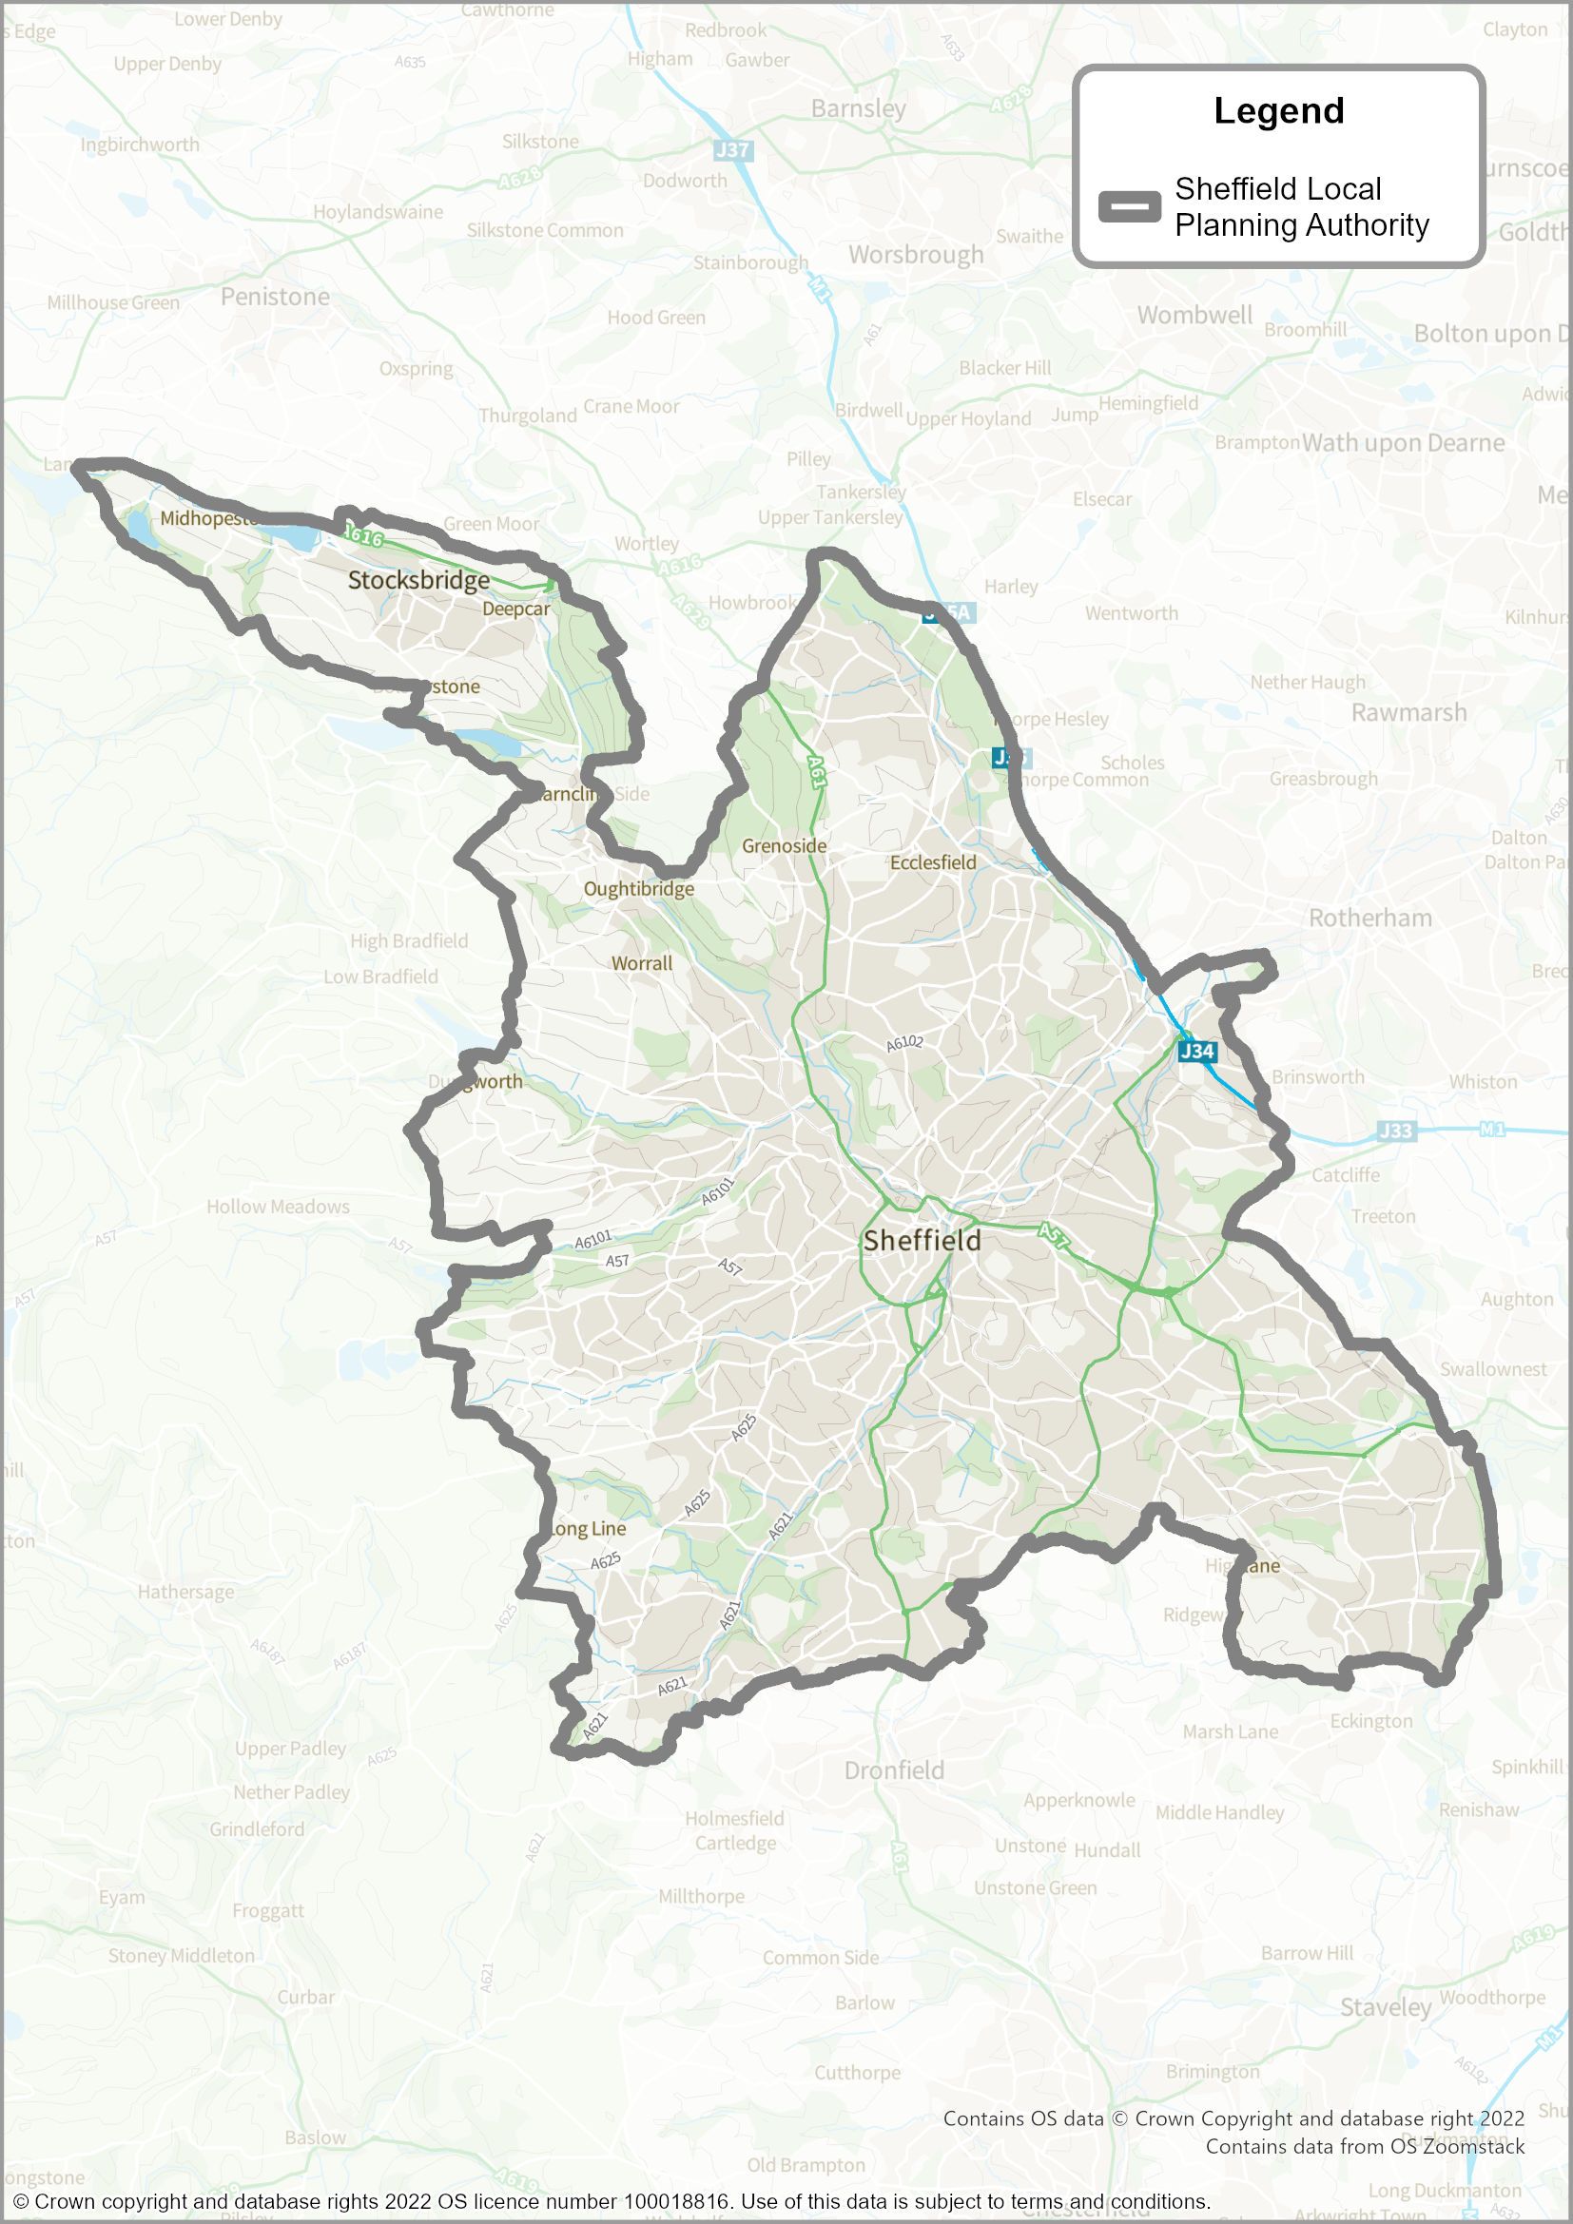

Why do we need a new Sheffield Plan?
  - At a national level, Government has set out legislation and policy that requires Councils to meet the needs of its residents, businesses, visitors, and partners. As noted, one mechanism to help meet these needs is to create a statutory development plan. Government requires that development plans are reviewed regularly and kept up-to-date.
  - The current local plan for Sheffield is the Sheffield Core Strategy (adopted in 2009) and a number of ‘saved’ policies from the Unitary Development Plan (adopted in 1998). The Core Strategy replaced many of the policies in the UDP, but is itself now over 13 years old, and does not provide an up-to-date policy approach for how Sheffield should meet its needs in the future. It does not respond as effectively to help tackle the challenges facing the city.
  - In July 2013, the Council published a draft ‘City Policies and Sites’ document, which would have set out new development management policies and site allocations (linking to the Core Strategy). However, whilst this new document was subject to public consultation, in December 2013 the Council decided not to submit it to the Government.
  - As such, there is a pressing need to produce a new development plan for Sheffield, one that positively plans for inclusive growth and change and allows the Council and all those interested in the future of Sheffield to look forward.

How does the Sheffield Plan affect the existing local plan?
  - Once adopted, the Sheffield Plan will replace both the Core Strategy and the UDP, except for three policies in the Core Strategy relating to waste management. Sheffield’s current waste management policies are set out in the Sheffield Core Strategy and the intention is to ‘save’ these policies until a new joint waste management plan is prepared with the other South Yorkshire local authorities. All four authorities have started work on this by commissioning the evidence base needed to produce the plan. This involves reviewing waste arising, capacities required, and availability within neighbouring authorities across the City Region. The authorities have agreed, in principle, to start preparation of the plan itself during 2022. The current Barnsley, Doncaster and Rotherham Joint Waste Plan was adopted in 2012 and runs to 2026.

How does the Sheffield Plan relate to Neighburhood Plans?
  - As noted above, neighbourhood plans form part of the Development Plan for the area. They are plans prepared by a Parish Council or Neighbourhood Forum for a particular local area (referred to as the ‘neighbourhood area’). They are intended to give direct power to communities to develop a shared vision for their neighbourhood and deliver the sustainable development they need. Under national planning regulations, neighbourhood plans must be in general conformity with the strategic policies contained in any development plans that cover their area. They should not promote less development than set out in strategic policies in the Local Plan. The strategic policies in the Sheffield Plan are identified on the contents page.

Previous consultation on the Sheffield Plan
  - Previously, the Council consulted on the Sheffield Plan ‘Issues and Options’, between 1 September 2020 and 13 October 2020. This consultation was carried out in accordance with the Council’s Statement of Community Involvement (SCI).
  - Prior to that, the Council had also consulted on an issues and options document in 2015 (‘Citywide Options for Growth to 2034’) but analysis of the responses to that consultation highlighted that many people were concerned about how much housing development was proposed on Green Belt land.
  - The more recent Issues and Options document identified the challenges and opportunities facing the city and importantly, set out a fresh approach for how and where future development could take place in Sheffield.
  - The comments made on the Issues and Options document have informed the Publication Draft version of the Sheffield Plan. The main issues raised are covered under the following broad themes:
  - The Climate Emergency - how the plan should respond to, and mitigate, climate change and how it should help the Council meet its target for the city to be net zero carbon by 2030;
  - Housing supply – how much and what type of housing, including affordable housing, family-sized housing, homes for older and disabled people, and students – improving choice, quality and affordability;
  - Housing space standards and the design of new homes;
  - Green Belt - the need to minimise the impact of housing growth and other development on the Green Belt and Sheffield’s ‘green frame’;
  - The City Centre – its future role, taking into account changing shopping patterns and the impact of the global pandemic;
  - Sheffield’s role within the wider City Region – take this into account when making provision for housing;
  - Better and more sustainable travel – promotion of walking and cycling and improvements to public transport services and connectivity;
  - Job opportunities – create new businesses and provide more highly skilled jobs, particularly in the Innovation District;
  - Sheffield’s heritage, landmarks, buildings of genuine character and culture – need to be preserved;
  - Open space – protection of valuable open spaces and improvements to low quality spaces;
  - Biodiversity – how to deliver a net gain in biodiversity and protect and enhance the city’s network of green spaces and countryside;
  - Reuse of previously-developed sites and buildings – this should be prioritised and the plan should be flexible about reuse and use land efficiently; and
  - Health & social care, equality and quality of life – all require improvement.
  - A summary of the comments made on the Issues and Options document, and the responses to them, is set out in a separate Consultation Report.

How long will the Sheffield Plan last?
  - The strategic policies in the Sheffield Plan are required to look 15 years ahead from adoption and will therefore cover the period to 2039 (assuming the Plan is adopted in 2024). As with any longer term planning document, it is important to review regularly to reflect changing circumstances, so the Plan will be reviewed at least every five years. At each review it will be updated and rolled forward for the next 15-year period.

Evidence base and supporting documents
  - The new Sheffield Plan takes account of national and international legislation and other statutory requirements. It has also been prepared in accordance with Government’s National Planning Policy Framework (NPPF) which sets out a framework in which locally-prepared plans (such as the Sheffield Plan) can be produced. The NPPF places a strong emphasis on economic growth and on delivering the housing that is required to support that growth. It promotes development that delivers economic, social and environmental benefits and it covers a wide range of planning issues, including ensuring the vitality of town centres, delivering a wide choice of high-quality homes and conserving the natural environment.
  - The Council has prepared a series of other documents to provide evidence and analysis that demonstrates the Sheffield Plan is sound and is based on a proportionate and appropriate evidence base. A full list of the Council’s evidence base can be found on the Council’s website.
  - Certain documents are legal compliance reports that demonstrate how the preparation of the Publication Draft version of the Sheffield Plan complies with legislation, national policy, and other planning regulations. These are:
- Sheffield Plan Integrated Impact Assessment (IIA) (2022); and
- Sheffield Plan Habitat Regulations Assessment (HRA) (2022)
  - The purpose of each of these documents is briefly described below.

Integrated Impact Assessment (IIA)
  - The Sheffield Plan has been the subject of an IIA that covers:
- Sustainability Appraisal (incorporating Strategic Environmental Assessment);
- An Equalities Impact Assessment; and
- A Health Impact Assessment.
  - A draft IIA was published alongside the Issues and Options document in September 2020. This included a Scoping Report, which highlighted the main social and economic challenges and opportunities. It also outlined the current environmental conditions in Sheffield and provided the latest baseline evidence and relevant plans and programmes that have informed preparation of the Sheffield Plan. The draft IIA also set out the approach being used to predict, appraise and monitor the effects of the Sheffield Plan on all aspects of sustainability.
  - The IIA that accompanies the Sheffield Plan updates the Scoping Report, and confirms the indicators being used to carry out the Sustainability Appraisal. It also sets out the strategic spatial alternatives that were considered and identifies the economic, social and environmental impacts of the strategic policies, development management policies, and site allocations. The work on the IIA has ensured that the Council is complying with the regulations on Strategic Environmental Assessment.
  - The Equality Impact Assessment and Health Impact Assessment enables us to understand any equality impacts arising from the Sheffield Plan and helps us ensure that Sheffield is, and will be, a fair and equal city.

Habitats Regulations Assessment
  - Habitats Regulations Assessment (HRA) is the assessment of the potential impacts of implementing a plan or policy on a European Site and is required by law. European Sites are those of exceptional importance for rare, endangered or vulnerable natural habitats and species within the European Community. They are designated as either Special Protection Areas (SPAs), or Special Areas of Conservation (SACs). A Habitat Regulations Assessment for the Sheffield Plan has been undertaken with guidance from Natural England.

The Duty to Cooperate
  - The Planning and Compulsory Purchase Act 2004 (as amended) introduced a legal ‘duty to co-operate’ in relation to the planning of sustainable development. This requires the Council to co-operate with other local planning authorities and public bodies to maximise the effectiveness of the preparation of the Sheffield Plan and supporting activities where it relates to a strategic or cross-boundary matter.
  - The Council has also had regard to the activities of the South Yorkshire Mayoral Combined Authority (SYMCA), and the Local Enterprise Partnership (LEP) as they relate to the Sheffield Plan and supporting activities. Sheffield is part of the Combined Authority (CA), which covers the four South Yorkshire districts of Barnsley, Doncaster, Rotherham and Sheffield. The local authorities of North East Derbyshire, Derbyshire Dales, Chesterfield, Bolsover, and Bassetlaw form part of the wider Sheffield City Region (see Map 2).
  - The CA local authorities have identified a number of strategic cross boundary issues with cross-boundary implications. These are:
- Economic growth and employment
- Housing requirement and land supply
- Green Belt
- Transport
- Waste management
- Minerals
- Natural resources and green infrastructure
- Gypsies, Travellers, and Travelling Showpeople
  - The local authorities have agreed to work together to produce a series of ‘Statements of Common Ground’ covering these issues. These statements will set out how the duty to cooperate has been met and will provide part of the evidence to support emerging local plans within SYMCA.
  - The Council continues to engage with the other local planning authorities and statutory bodies as part of the preparation of the Sheffield Plan. A final Duty to Cooperate Statement will be available alongside the Sheffield Plan when this is submitted to Government, which will set out the joint working and co-operation that has taken place to date.

MAP 2: South Yorkshire Mayoral Combined Authority and Sheffield City Region
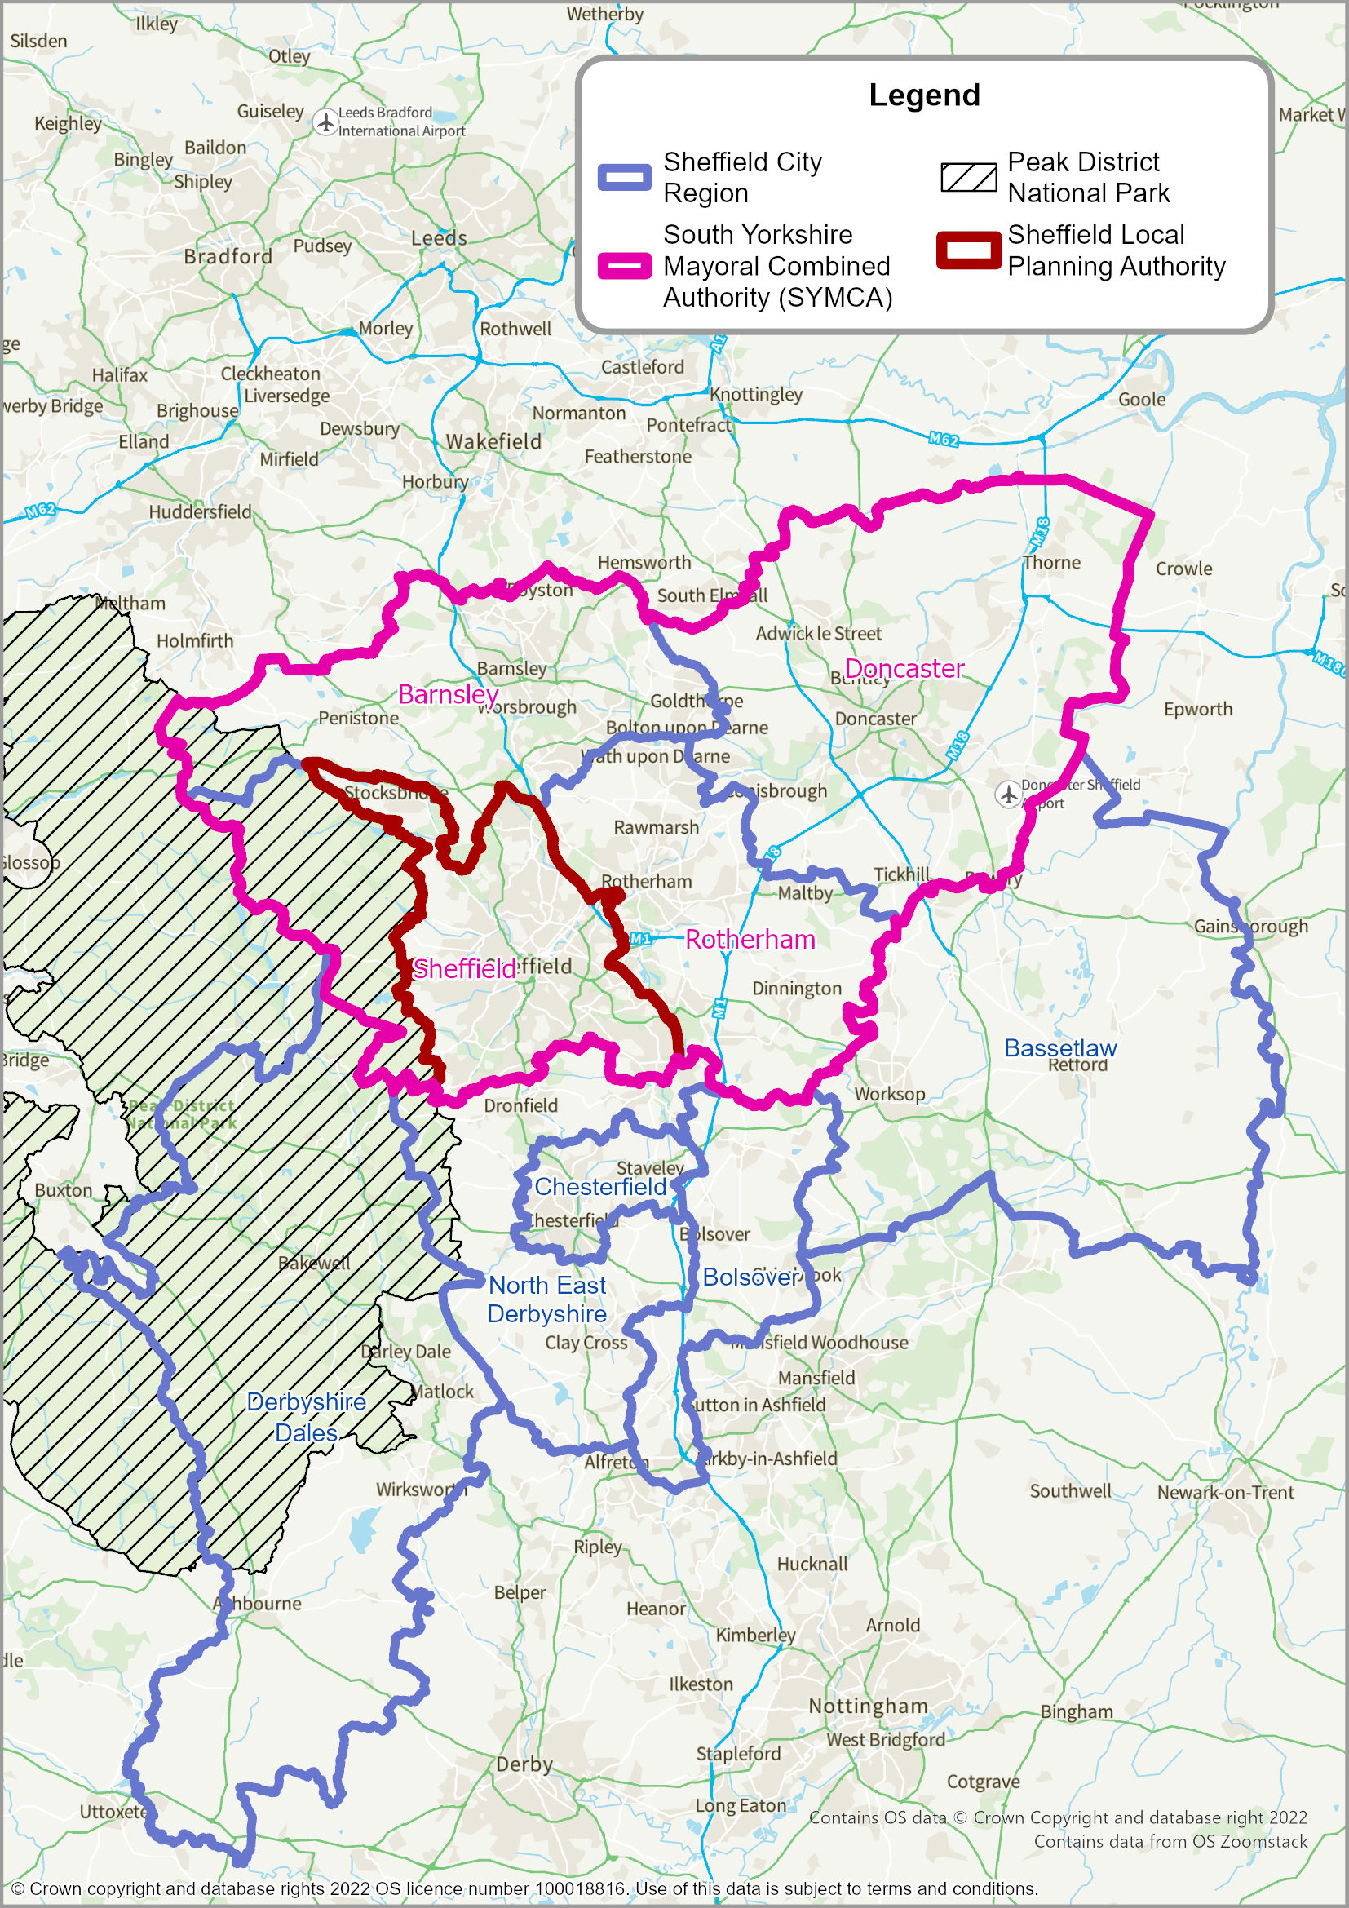

What happens to this version of the Sheffield Plan after public consultation?
  - Following public consultation, the Sheffield Plan will be submitted to Government for public examination by a Planning Inspector.
  - The process for taking the Sheffield Plan through to adoption is expected to be:
- Sheffield Plan is submitted to the Government: July 2023
- Public Hearing Sessions during the Independent Examination: December 2023
- Preliminary Inspector’s Report: March 2024
- Consult on any Main Modifications: May to June 2024
- Final Inspector’s Report: September 2024
- Adoption: December 2024

Vision, Aims, and Objectives
  - The Sheffield Plan’s ‘Vision, Aims, and Objectives’ are a response to the challenges and opportunities facing the city. Many of these challenges and opportunities were highlighted in the Sheffield Plan Issues and Options document. Responses to the consultation have been used to help refine the wording of the vision, aims, and objectives set out below.

The Vision – Our City in 2039
  - Our vision is that, by 2039, Sheffield will be an economically stronger, fairer, more inclusive and sustainable city. It will be playing a nationally significant economic role at the heart of its region, with thriving neighbourhoods and communities, and have a distinct urban and rural identity.
  - It will be known as a city that increases the skills of its people and the productivity of its businesses, enabling everyone to reach their full potential, regardless of their background or where they live.
  - Income and health inequalities will be significantly reduced and we will already have achieved net zero carbon status by 2030.
  - The city will be known worldwide as a ‘city of makers’: recognised for advanced manufacturing, specialist steels, forged products and digital innovation, award winning theatre, international art and design, ground-breaking research and world class talent.
  - It will be the destination city, major employment centre and academic and cultural heart of the city region.
  - Its reputation as the ‘Outdoor City’ will have nurtured an unparalleled quality of life for existing and new residents, retaining talent and attracting investors.
  - The city’s prosperity will be underpinned by a strong, integrated and sustainable transport system, with most shorter trips carried out by bicycle or on foot.
  - The city will provide a good quality housing offer meeting the needs of different household types and sizes.

Sheffield Plan Aims and Objectives
  - Eight aims flow from the Vision, summarised in the diagram opposite and explained in more detail in the paragraphs that follow.
  - There are significant connections and overlaps between the aims. The first two aims have a strong relationship between each other – for example, adapting to climate changes will have positive benefits for health. But they are also heavily dependent on the other six which is why we have shown them in the diagram as ‘wrapped around’ the Vision. For example, a strong economy will help to raise average incomes and enable more people to access the housing market, more efficient public transport should reduce car use which will reduce carbon emissions and improve air quality. Meeting all of the aims will contribute to creating a healthy city and ensure that the Plan makes the maximum possible contribution to the overall social value of the city.
  - For each aim, we also identify a number of more specific objectives for the Sheffield Plan.
Figure 1: Sheffield Plan- Vision and Aims
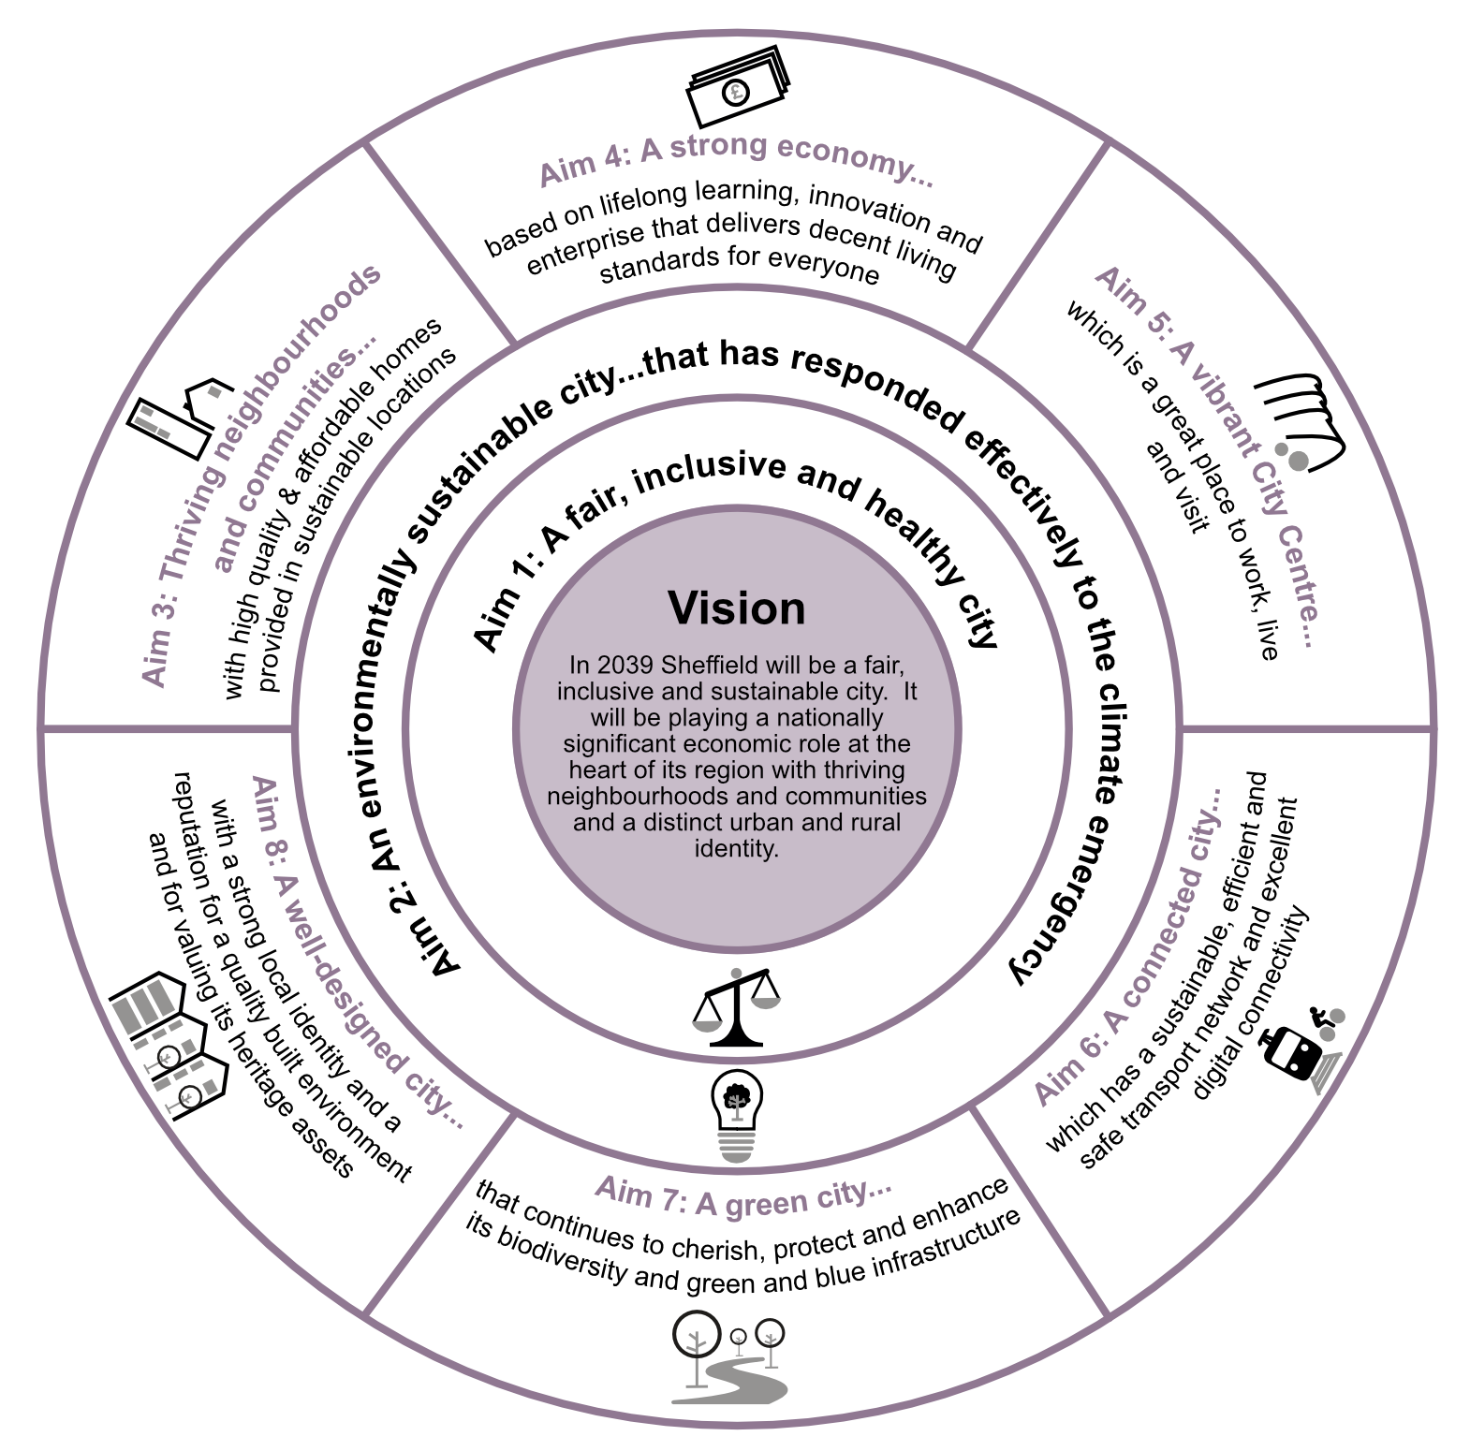

Objectives for a fair, inclusive and healthy city
- To develop and grow the city in a way which is fair and inclusive, maximising the benefits for disadvantaged communities and vulnerable people and recognising the role of a healthy population in supporting a strong economy – meaning the gap is closed between the wealthiest and poorest areas of the city.
- To develop the city in ways which improve the health and wellbeing of all Sheffield’s residents and which reduce health inequalities.
- To provide places that meet the needs of people with protected characteristics.

Objectives for an environmentally sustainable city
- To make Sheffield net zero carbon by 2030.
- To create a city that makes efficient use of natural resources, mitigates climate change, and is resilient to likely future changes to our climate (including increased risk of flooding).
- To protect and enhance Sheffield’s water resources, and minimise the pollution of water, air and soil.

Objectives for thriving neighbourhoods and communities
- To create a housing market that works for everyone and which provides quality, choice and affordability.
- To ensure Sheffield has an adequate supply of residential development land so the city can meet its requirement for new housing.
- To significantly increase the supply of affordable housing, accessible market housing and specialist housing for older people, disabled people and other vulnerable groups, particularly in places of greatest need.
- To provide sites for Gypsies and Travellers in appropriate locations to meet the current needs and to guide the provision of additional pitches if further need arises.
- To create neighbourhoods that work for everyone, with a mix of housing and access to a range of local facilities, services and open space, offering all residents the best life chances.

Objectives for a strong economy
- To enable more and, particularly, better quality jobs to be created in the city’s economy in order to raise average incomes and build a future based on Sheffield’s competitive advantages (in the areas of advanced manufacturing; education, learning and knowledge; creative and digital industries; advanced technology; research and innovation; health, wellbeing and medical technology and services; sports science and outdoor leisure).
- To ensure there is a sufficient range of locations, land and premises available for new businesses and those relocating from within the city and elsewhere that are of a high quality and suitable for the needs of modern businesses.
- To support the growth and development of the city’s universities, colleges and training providers to enable an increase in the skills and capacity of the workforce.

Objectives for a vibrant City Centre

To build a resilient City Centre that supports a strong economy and offers a diverse range of employment opportunities for all.
- To create a clear sense of place for the city by shaping distinctive and inclusive neighbourhoods in which a diverse demographic of people can live, work and play.
- To deliver enhanced connectivity and accessibility for the City Centre through integrated and sustainable transport for everyone in the community.
- To establish a sustainable and environmentally friendly City Centre.
- To bring the outdoors to the City Centre, creating attractive high-quality spaces and places that facilitate health and wellbeing for all.

Objectives for a connected city
- To create an integrated and sustainable transport network that promotes and enables walking, cycling and public transport, in order to reduce congestion, support district centres, improve air quality and safety, and enable healthier lifestyles.
- To develop excellent connections with the rest of the Combined Authority area, and national and international transport networks, including developing faster rail connections: between Sheffield and Leeds and Manchester, as well as improvements to Sheffield Midland Station.
- To locate new development where it minimises the distances that people and goods need to travel, by mixing land uses to increase opportunities for people to make single journeys that serve several purposes.
- To create a digitally connected city with comprehensive broadband coverage, including in rural areas, and to make efficient use of telecommunications infrastructure.

Objectives for a green city
- To safeguard, restore and enhance Sheffield’s unique natural landscape setting of valleys, woodlands, trees, rivers, wetlands, geological assets, urban green spaces and open countryside, in order to:
  - provide excellent opportunities for outdoor recreation;
  - improve health and well-being;
  - protect existing biodiversity and measurably contribute to nature recovery;
  - contribute to both climate change mitigation and adaptation
  - provide sufficient land to facilitate sustainable local food production
- To achieve a minimum 10% net increase in biodiversity across the city as a whole.
- To make efficient use of land by maximising the use of previously developed land and promoting higher density development in accessible locations.

Objectives for a well-designed city
- To create attractive, safe places with distinct identities, and to enhance the character of urban and rural areas in Sheffield by requiring high quality design of new neighbourhoods, buildings, public spaces, and streets.
- To achieve inclusive design of buildings, streets and public spaces so that they can be easily accessed and used by everyone.
- To protect, conserve and enhance buildings, landmarks and areas that are attractive, distinctive and/or of heritage or archaeological value.

Growth Plan and Spatial Strategy

Planning for Growth
  - Our growth plan delivers sufficient new development to meet the city’s needs to 2039. The spatial strategy for Sheffield sets out where this growth will take place, with the Plan focusing the majority of development within the existing urban areas to ensure sustainable growth, supporting economic, social and environmental objectives. In particular, this strategy helps to reduce carbon emissions. The existing urban area comprises the Main Urban Area of Sheffield, and the towns of Stocksbridge/Deepcar, and Chapeltown/High Green.
  - The spatial strategy divides Sheffield into nine sub-areas, and continues to reflect the existing settlement pattern, as well as the availability of infrastructure, and an understanding of opportunities and constraints.
  - The growth plan and spatial strategy places the Central Sub-Area at the heart of the future transformation of Sheffield. The Central Sub-Area is the most accessible location in the city and will be a key focus for new jobs associated with offices, shopping, leisure development, higher education, and cultural facilities. It has significant potential to accommodate further new housing, including higher density schemes as part of a diverse housing mix. The plan includes exciting new proposals that will create new residential neighbourhoods within the Central Sub-Area. Adopting this approach will limit outward expansion, help reduce travel by private car, and encourage active travel and improve the viability and attractiveness of public transport.
  - Sheffield’s development needs to 2039 will be met within the existing urban areas, largely without the need to remove land from the Green Belt. The proposed number of new homes will support the target for creating new jobs that is set out in the Sheffield Yorkshire Mayoral Combined Authority Strategic Economic Plan (2021 - 2041) (SYMCA SEP).
  - The priorities are to locate growth where it would:
- enable homes to be located within easy reach of the main employment areas;
- support development and increased density in the Central Sub-Area;
- match opportunity and need by concentrating new development in locations that are, or could be, well served by the tram/rail network or key bus corridors, as well as other essential infrastructure;
- support distinctive and thriving District Centres and Local Centres that act as a focus for the development of a network of ’20-minute neighbourhoods’ across the city;
- support existing public transport services, and enable the provision of new infrastructure that enables active travel;
- support service provision in the Larger Villages in the Northwest Sheffield Sub-Area;
- maximise accessibility by directing higher density developments and those that generate significant numbers of trips to the City Centre, District Centres and other locations close to railway stations, Supertram stops and high frequency bus routes;
- avoid harm to, and enhance, Sheffield’s distinctive environmental assets and green infrastructure and mitigate any adverse environmental impacts (where they are justified due to the need to meet other social or economic objectives);
- avoid development in areas with a high probability of flooding (the sequential approach) and, where necessary, apply the exception test; and
- avoiding development in areas where there would be a risk to public safety or health.

Housing Growth
  - In setting a housing requirement, the plan balances economic, social and environmental objectives; but a key priority is to maximise the reuse of brownfield sites within the existing urban areas. Releasing large amounts of Green Belt land would potentially jeopardise the regeneration of brownfield sites and would lead to higher carbon emissions due to the increased need to travel.
  - Sheffield is not relying on other local authorities in the city region to meet any of its housing needs and Sheffield does not intend to meet any housing needs arising elsewhere in the city region. Provision made for new jobs and homes in neighbouring districts provides flexibility to accommodate population and household growth arising from people moving to the region from other parts of the UK and from abroad. This helps to support the Government’s ‘levelling up’ objectives.
  - The housing growth figures set out in Policy SP1 reflect the capacity of the existing urban areas and the restrictions imposed by the Green Belt. Nevertheless, it will deliver a level of growth that will support the city’s economic growth ambitions (as evidenced by the Council’s latest Housing, Economic Growth and Demographic Modelling) . The economic growth and employment land figures in Policy SP1 are derived from evidence including the SYMCA Strategic Employment Land Appraisal, and the Council’s latest Employment Land Review, Employment Land Review Update, Logistics Study and Retail and Leisure Study.
  - Most new housing development will be located within the existing urban areas, with some limited additional development in the Larger Villages in the Northwest Sheffield Sub-Area (Oughtibridge, Worrall and Wharncliffe Side). The small villages that are washed over by the Green Belt are not sustainable locations for significant new development as they lack significant local facilities and generally have poor public transport links to the main urban areas.

Economic Growth
  - The full potential for economic development in Sheffield cannot be achieved without a supply of land that is available for commercial uses. This is recognised in the South Yorkshire Mayoral Combined Authority Strategic Economic Plan (SYMCA SEP). The plan must ensure that there is sufficient good quality land in the right locations which is available to meet the needs of new and expanding businesses. Providing sufficient high-quality land to meet the city’s employment needs will support social inclusion and promote development that will provide new jobs, particularly well-paid, skilled work for local people in locations that can be easily accessed on foot, by cycle or by public transport.
  - There are a number of important business sectors in Sheffield, particularly advanced manufacturing; creative and digital; publishing; media; business, financial and professional services; information and communications technology; utilities/environmental technologies; and healthcare and wellbeing. Many of the jobs in these growth sectors are likely to provide above average incomes. Future demand has been estimated, taking into account the city’s ambitions for new jobs and the sectors in which economic growth is expected to take place. This has determined how much land is needed.
  - In Sheffield there is significant pressure in some parts of the city for employment land to be developed for non-employment uses, especially housing. Some land that was designated for employment in the Unitary Development Plan (UDP) (1998) is now proposed for housing in order to minimise development on greenfield land or in the Green Belt. But, in allocating land and setting out options for new housing, a balance has been made with the need to safeguard land for jobs.
  - The need for high quality land that will encourage and enable businesses to develop and grow is a priority of the SEP. It aims to build on the successful Innovation District in the east of the city and to support growing sectors of the local economy.
  - Unlike housing, there is no specific requirement in national planning policy to identify a particular level of supply of employment land to meet the need over the full plan period to 2039. However, the NPPF requires strategic policies in plans to look ahead over a minimum of 15 years to anticipate and respond to long-term requirements. Existing planning permissions and proposed site allocations identified in the plan provide over 171 hectares of employment land. As land is continually being recycled, other sites are expected to come forward which will enable needs to be met up to 2039. It is anticipated that there will be sufficient ‘churn’ of economic land within the city and flexibility across the city region to ensure that demand can be met throughout the plan period.
  - Economic growth and employment land will be delivered in accordance with Policy SP1 and Policy SP2.
  - The City Centre Office Zones - within the Central Sub-Area - will be the main location for new offices but office development will also take place in other locations where it is consistent with the area policies and policies for development on allocated sites.
  - As established in Policy SA1 to Policy SA9, land required for industry will be located in the following sub-areas:
- Northwest Sheffield – the Upper Don Valley;
- Northeast Sheffield – Smithywood Industrial Estate;
- East Sheffield – the Lower Don Valley - especially the Innovation District, including the Sheffield Business Park and the Olympic Legacy Park (where health and wellbeing uses will be the preferred uses);
- Southeast Sheffield – Holbrook Industrial Estate (at Halfway/Oxclose) and land east of Eckington Way; and
  - As established in Policies SA1 to SA9, other existing employment areas will also contribute to the overall employment land supply. These will have a local economic development role in order to provide good quality local jobs and services in those areas. Specifically, these are:
- Northeast Sheffield - the Blackburn Valley and Ecclesfield Common;
- Southeast Sheffield - Dore House Industrial Estate;
- South Sheffield - the Sheaf Valley;
- Stocksbridge/Deepcar - the established Stocksbridge steel works and Wharncliffe Industrial Area, Deepcar; and
- in Chapeltown/High Green - the Thorncliffe industrial areas.
  - The overall growth plan for Sheffield is defined in Policy SP1. The proposed spatial strategy is expressed in Policy SP2, as well as through a series of Policy Zones that are defined on the Policies Map and listed in the Sheffield Plan Part 2.

POLICY SP1: OVERALL GROWTH PLAN

The Sheffield Plan will realise the vision for a ‘an economically stronger, fairer, more inclusive and sustainable city’ by promoting growth that delivers the homes, jobs, employment floorspace, infrastructure, and community facilities to meet Sheffield’s identified needs.

The Sheffield Plan will deliver:
- 35,530 new homes by 2039 (2,090 homes per annum from 2022 to 2039) (see Policy H1).
- 12.8 hectares of employment land per year, which includes 2.9 hectares for office development and 9.9 hectares for industrial development (see Policies EC1 to EC7).
- 372 Site Allocations - including 297 for housing, 52 for economic development 19 mixed use and 1 for leisure and recreation which provide a deliverable and developable supply to meet needs (see Policy SP1).
- Priority locations for economic growth within the Central Sub-Area, and the Innovation District - helping meet the objectives of the South Yorkshire Mayor Combined Authority Strategic Economic Plan (SYMCA SEP) (see Policy SA1, Policy SA4, and Policy EC1).
- Co-ordinated investment in the identified Broad Locations for Growth (within parts of the Upper Don Valley, the Lower Don Valley, and the Sheaf Valley) to enable these areas to transition from employment uses to housing, particularly after 2029 (see Policy SA2, Policy SA3, Policy SA4 and Policy SA7).
- New retail and leisure floorspace to be focused within identified town centres, which are the City Centre, along with the 17 District Centres, and all identified Local Centres (see Policy SP3 and Policy NC10).
- A total of at least 12 yards to meet the needs of Travelling Showpeople communities (see Policy H1).
- Protection for existing Green Belt boundaries around existing built-up areas, with one strategic land release on a predominantly brownfield site at the former Norton Aerodrome (for residential use) (see Policy SA6).
- Measures required to achieve net zero carbon emissions, as well as facilitate renewable energy generation, a proactive approach to the sustainable design of buildings, and the management of natural resources (see Policies ES1 to ES8).
- Major new transport infrastructure, including:
- support for strategic rail investment to unlock capacity and journey time improvements between Sheffield and London, Birmingham, Manchester, Leeds, and the East Midlands;
- support for proposals set out in the Sheffield Midland Station and Sheaf Valley Development Framework to facilitate High Speed 2 and Northern Powerhouse Rail;
- support for local rail upgrades, including to the Hope Valley Line, Barrow Hill Line, and Don Valley Line, including supporting infrastructure to deliver enhanced rail services;
- strategic highway improvements, as part of integrated, multimodal schemes, to increase connectivity between residential areas and major centres of economic activity;
- new active travel infrastructure linking new residential areas to employment opportunities, local services, and leisure facilities (see Policy T1)
- Sustainable development that promotes greater use of public transport to help secure the long-term future for the existing tram network and helps realise Connecting Sheffield’s proposals for active travel. This will include creating seven Mass Transit Corridors, enhancing the five Main Gateway Routes, and the 10 City Centre Gateway Routes (see Policy T1 and Policy DE4).
- Protection, management, enhancement and extension of blue and green infrastructure sites and assets, with a focus on the Local Nature Recovery Network (see Map 17 and Policies GS1 to GS11).
- Protection, management, and enhancement of designated and non-designated heritage sites and assets. With a focus on achieving the highest standards of new development whilst respecting the industrial and cultural significance of the existing built environment across Sheffield (see Policy D1, Policy DE1 and Policy DE9).
- Strategic flood risk management and mitigation, avoiding development in areas with a high probability of flooding, by applying the sequential approach and, where necessary, the exception test. This is of critical importance to proposals in the Central Sub-Area (see Policy GS9).

Definitions
- For ‘Central Sub-Area’, ‘Innovation District’, ‘Broad Locations for Growth’, ‘District Centres’, ‘Local Centres’, ‘pitches/plots’, ‘Mass Transit Corridors’, ‘Main Gateway Routes’, ‘City Centre Gateway Routes’, ‘Connecting Sheffield’, ‘Local Nature Recovery Network’ and ‘Urban Greenspace Zones’ - see Glossary
- For ‘blue and green infrastructure’ – see introduction to Policy BG1.
- For the ‘Green Network’ – see Map17.

POLICY SP2: SPATIAL STRATEGY

The majority of future growth will be on previously developed sites within existing urban areas. These are the Main Urban Area of Sheffield, and the two Principal Towns of Stocksbridge/Deepcar, and Chapeltown/High Green.

The spatial strategy has been defined by considering the future of the Sheffield across nine ‘sub-areas’, these are:

    - Central (including the City Centre)
    - Northwest Sheffield
    - Northeast Sheffield
    - East Sheffield
    - Southeast Sheffield
    - South Sheffield
    - Southwest Sheffield
    - Stocksbridge/Deepcar
    - Chapeltown/High Green

The spatial extent of each sub-area is shown on the Key Diagram and the Policies Map.

The sub-areas will deliver a pattern of sustainable development within the existing settlement hierarchy of Sheffield (Main Urban Area), and the identified Principal Towns, Larger Villages and Smaller Villages.

District Centres and Local Centres will act as a focus for the development of a network of ’20-minute neighbourhoods’ (see Policies NC10 and NC11).

Each sub-area has its own development strategy, these are set out in Policies SA1 to Policy SA9. Development proposals in the sub-areas will be considered alongside the various Policy Zones (as shown on the Policies Map), and all relevant policies set out in Sheffield Plan Part 2.
Definitions
- For the ‘Main Urban Area’, ‘Principal Towns’, ‘Larger Villages’, ‘Smaller Villages’, ’20-minute neighbourhoods’ and ‘Policies Map’ – see Glossary.
- For ‘Policy Zones’ – see Sheffield Plan Part 2, Section 2.
MAP 3: Settlement Hierarchy and Hierarchy of Centres

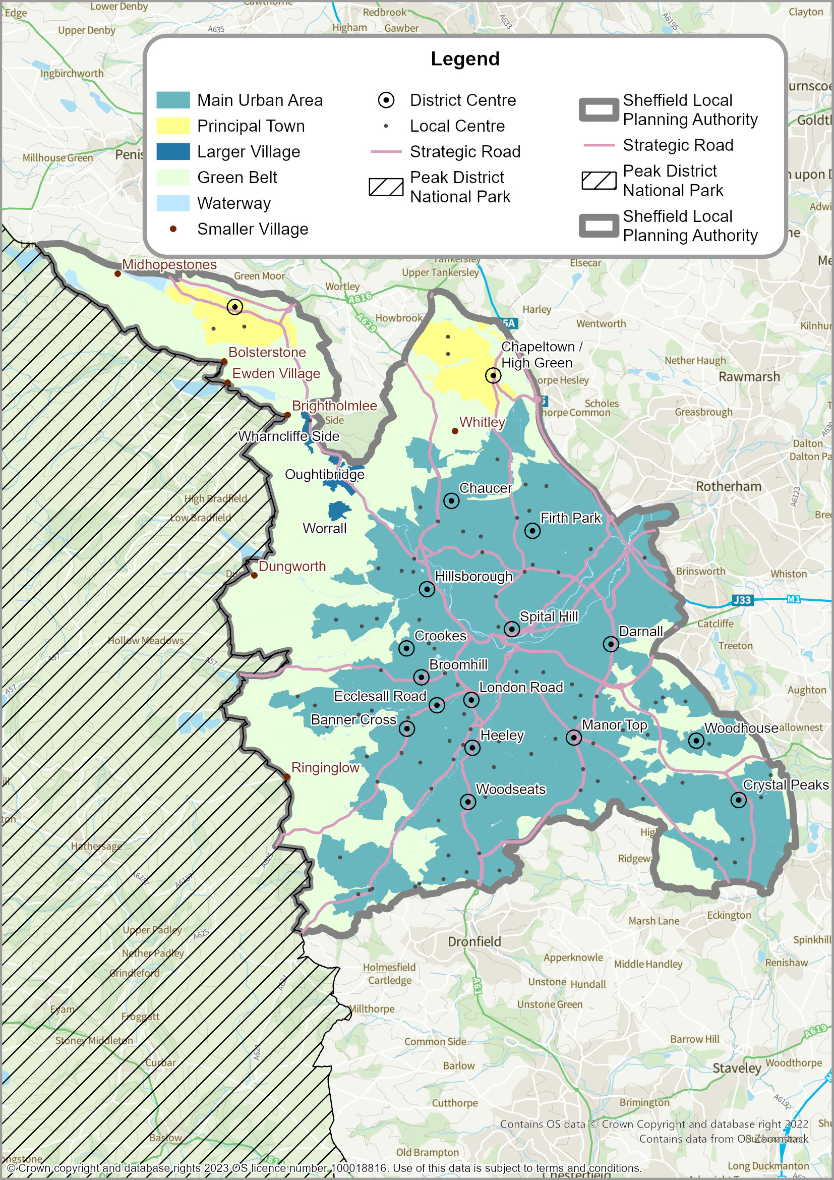

Hierarchy of Centres
  - The National Planning Policy Framework states that plans should define a network and hierarchy of town centres that should be resilient to economic changes.
  - For the purposes of the Sheffield Plan, the term ‘town centre’ refers to the defined ‘City Centre’ of Sheffield, as well as the extent of each of the 17 District Centres, and all Local Centres. The extent of the City Centre of Sheffield includes all the areas within the Inner Ring Road, as well as Kelham Island and the Sheffield Midland Railway Station (See Map 3). The extent of each of the centres is shown on the Policies Map.
  - The Council’s latest evidence indicates that the existing centres should be the focus for any future retail growth and commercial activity. Indeed, the evidence suggests it is important to direct growth towards the existing centres to ensure their long-term viability.
  - Policy SP3 defines the hierarchy and emphasises the priority for the defined City Centre to be the main retail, leisure and office destination in the region. The 17 District Centres provide a comprehensive service at a below city-wide level, while the Local Centres provide top up shopping for smaller communities, as well as community facilities close to where people live.
POLICY SP3: HIERARCHY OF CENTRES

Together, the defined City Centre, the 17 District Centres, and all Local Centres, form the hierarchy of town centres.

The City Centre includes a defined Primary Shopping Area (PSA). Both the City Centre and the PSA are located within the Central Sub-Area.

The City Centre also includes a number of City Centre Office Zones, a Cultural Zone, a University and College Zone, General Employment Zones, and Central Area Flexible Use Zones (all shown on the Policies Map).

New shops, leisure facilities, offices, and cultural and tourism development with city-wide and regional catchments will be focused in, or close to, these zones. Commercial uses will also take place in other parts of the Central Sub-Area where they are compatible with residential uses.

The specific way that town centre uses will be considered in each of the Policy Zones is set out in Sheffield Plan Part 2.

The vitality and attractiveness of all identified centres will be maintained and enhanced by promoting a mix of uses, including housing on upper floors. The centres will be the preferred locations for retail and leisure developments, and other commercial, business and service uses, and will be used to inform the application of the sequential test and/or impact test, and in accordance with relevant policies in Sheffield Plan Part 2 (see Policy NC10, Policy VC1, and Policy EC5).

District Centres will be encouraged, supported and promoted in their role of providing a broad range of shopping, leisure and community facilities to serve the various residential areas of the city. They may also include concentrations of specific shops or services in response to the local market. Smaller-scale offices and residential development on upper floors and away from street-level shop frontages will complement shops and services in District Centres.

The role of Local Centres in providing community facilities and a range of shops for day-to-day top-up shopping will be encouraged and promoted where it would help create ‘20-minute neighbourhoods’.

New Local Centres may be needed as part of the development of strategic housing sites, or in areas where a cluster of housing sites is proposed. New Local Centres will be expected to serve as ‘neighbourhood hubs’. Any new centres should not adversely affect the viability of existing centres.
Development in District Centres and Local Centres should be appropriate in scale and function to the role of that centre.
Definitions
- ‘Close to’ – within 400 metres (5-minute walk).
- For ‘Central Sub-Area’, ‘City Centre’, ‘Primary Shopping Area’, ‘City Centre Office Zones’, ‘Cultural Zone’, ‘University and College Zone’, ‘General Employment Zones’, Central Area Flexible Use Zones’, ‘District Centres’, ‘Local Centres’, ’20-minute neighbourhoods’, and ‘neighbourhood hubs’ – see Glossary.

MAP 4: City Centre and City Centre Primary Shopping Area
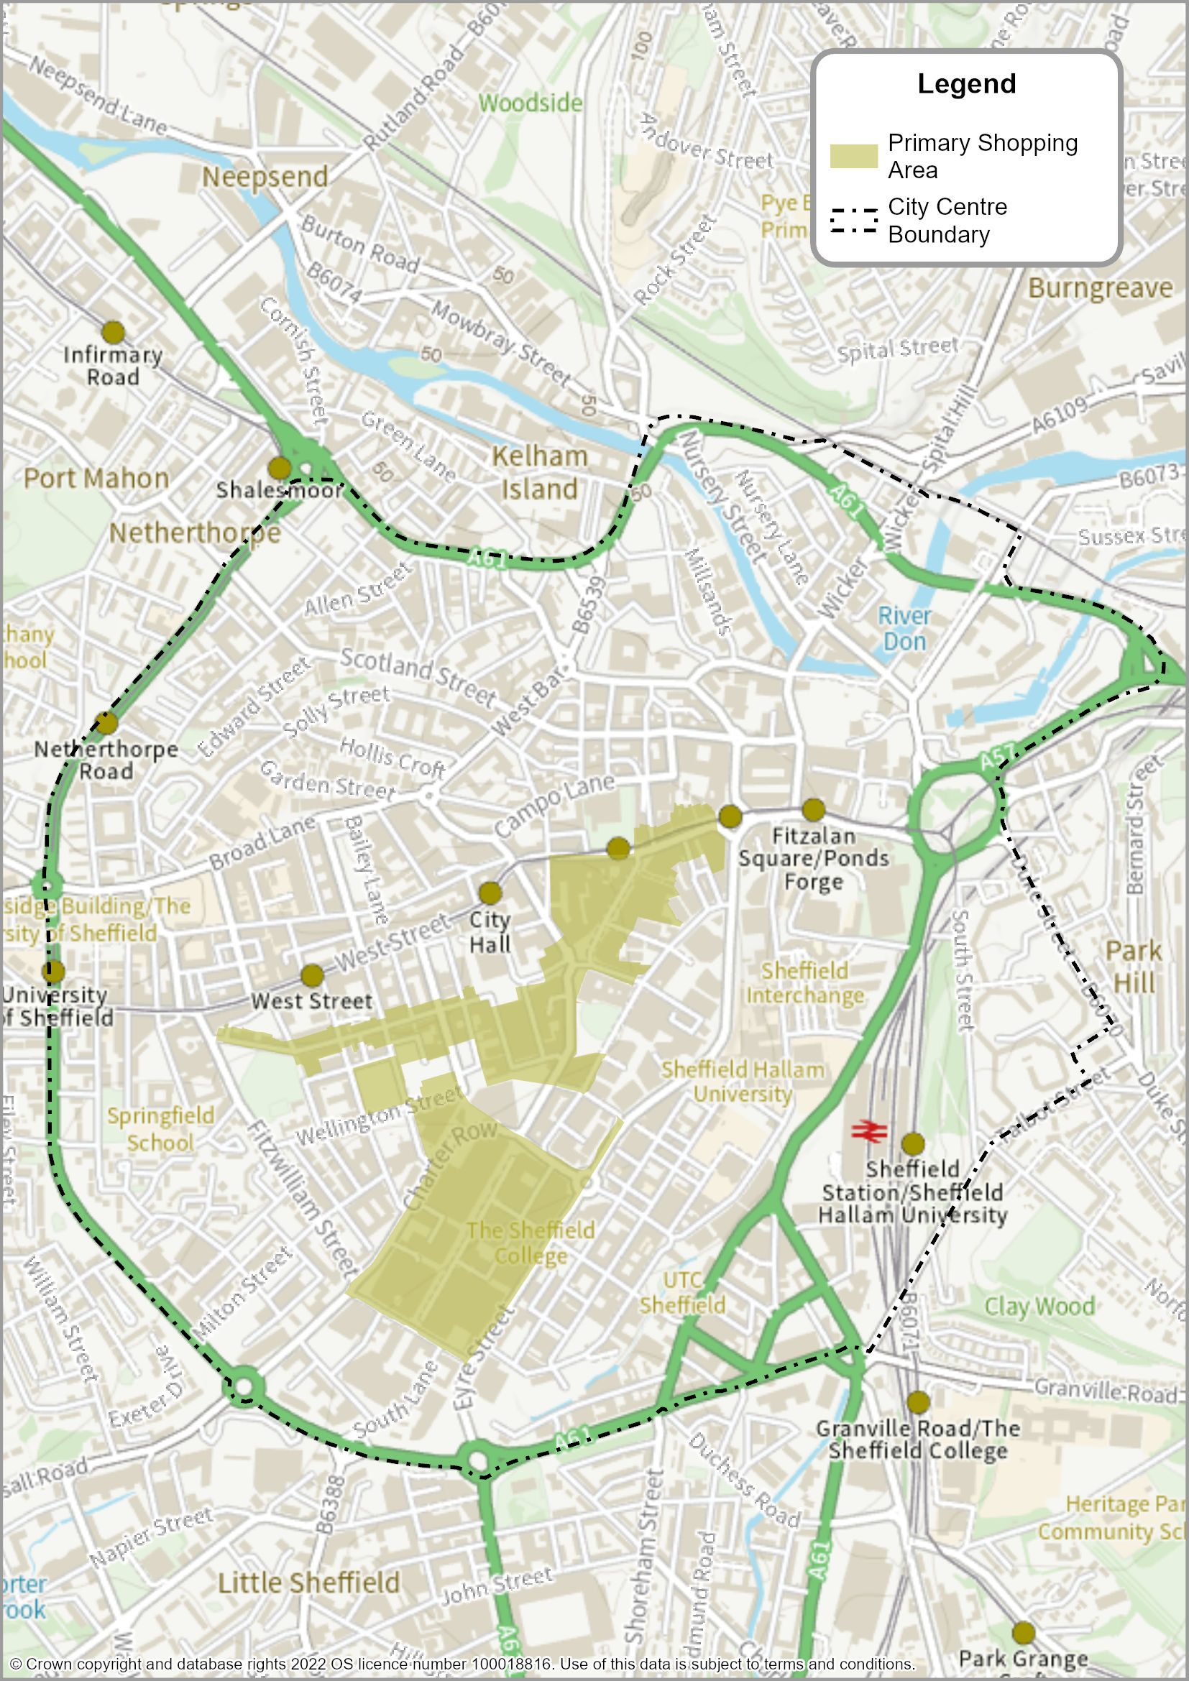

Sheffield’s Sub-Area Strategy
  - The local planning authority area of Sheffield covers more than just the Main Urban Area of Sheffield. It also includes the two towns of Stocksbridge/Deepcar and Chapeltown/High Green, as well as three larger villages within the Green Belt, and a series of smaller villages washed over by the Green Belt.
  - To assist in setting out the vision and policy approach for how Sheffield will grow and change, the plan has divided Sheffield into nine sub-areas. MAP 5 shows the geographical extent of the sub-areas.
  - The policy approach for each sub-area is set out in Policies SA1 to Policy SA9. Each sub-area policy references a series of proposed site allocations.
  - The site allocations were first considered as part of the Issues and Options consultation in September 2020, and further assessment of their suitability, availability, and achievability has taken place as part of preparing the Sheffield Plan. A full list of all site allocations can be found at Appendix 1.

MAP 5: Sheffield Plan Sub-Areas

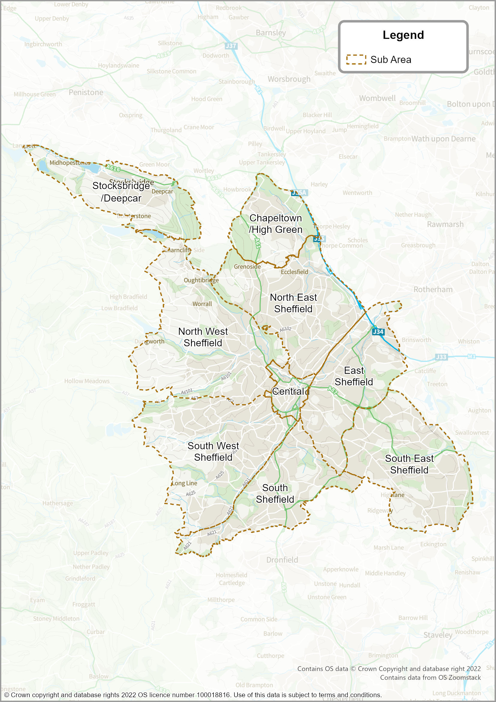

Central Sub-Area
  - The Central Sub-Area is of critical importance to the future of Sheffield. It forms the heart of the city and occupies a significant part of the Main Urban Area of Sheffield.
  - Since the late 1990s, the Central Sub-Area has been a major focus for economic regeneration, and Sheffield has flourished as an economic and cultural centre for the city region. Further growth will create a unique, thriving economic, cultural destination and a choice place to live in the UK for people of all backgrounds. Over the last decade, the population of the Central Sub-Area has grown to over 28,000, and the Sheffield Plan looks to build upon that, through sustainable, high quality development proposals.
  - The Central Sub-Area covers the defined City Centre (where main ‘town centre’ uses will be concentrated), as well as other areas outside Inner Ring Road.
  - It has been further subdivided into six Character Areas. Each Character Area is made up of recognisable sub-parts of the city. The policy approach taken to the Central Sub-Area and the Character Areas is based on evidence and analysis in the City Centre Strategic Vision, and the City Centre Priority Neighbourhood Frameworks .
  - The objective is to guide future regeneration to ensure Sheffield is an inclusive, resilient, competitive yet distinctive place, with a green agenda and its people at the heart. This will be achieved by creating new and distinctive mixed-use neighbourhoods across six Character Areas, five Priority Locations and three Catalyst Sites. The Priority Locations and Catalyst Sites have been identified because of their potential to bring about regeneration of the area and create new distinctive neighbourhoods.

POLICY SA1: CENTRAL SUB-AREA

Development proposals in the Central Sub-Area should have regard to the analysis and guiding principles set out in the City Centre Strategic Vision and the 5 City Centre Priority Neighbourhood Frameworks.

The Character Areas, Priority Locations, and Catalyst Sites to be delivered in the Central Sub-Area are set out below:

Character Area | Priority Location | Catalyst Site
1. Kelham Island, Neepsend, Philadelphia and Woodside | a. Neepsend | i. Between Penistone Road, the River Don, and Rutland Road
2. Castlegate, West Bar, The Wicker, Victoria | b. Wicker Riverside | n/a
 | c. Castlegate | n/a
3. St Vincent’s, Cathedral, St George’s and University of Sheffield | d. Furnace Hill | ii. Gateway between Scotland Street, Smithfield, and Snow Lane
4. City Arrival, Cultural Industries Quarter, Sheaf Valley | e. Moorfoot | iii. Junction between St. Mary’s Gateway, The Moor Street, and London Road
5. Heart of the City, Division Street, Springfield, Milton Street, The Moor and Hanover Street
6. London Road and Queens Road | n/a | n/a

A detailed development strategy for each Character Area is set out in Policies CA1 to CA6.

The Central Sub-Area will be the focus for residential and economic growth, as well as cultural and social activity. It will:
- Deliver approximately 18,465 new homes (through a combination of existing planning permissions and new site allocations). This includes strategic site allocations.
- Focus Purpose Built Student Accommodation in identified parts of three of the Character Areas (see Policies CA3, CA4 and CA5).
- Deliver approximately 10.1 hectares of employment land, including being the main focus for new office development through the identified City Centre Office Zones (see Policy EC2). Other forms of commercial activity and employment land/floorspace should be delivered within the identified General Employment Zones (see Policy EC3), and the Central Area Flexible Use Zones (see Policy VC3), including along the Innovation Spine running between West Bar and the University of Sheffield.
- Be the priority location for any future retail and leisure activity, helping serve a regional catchment, and be the focus for any new comparison goods retail. Town centre uses should be located within the identified Primary Shopping Area, and the defined City Centre boundary (see Policy SP3 and Policy VC1).
- Provide inclusive, thriving, diverse places for people with protected characteristics (including Sheffield’s LGBTQ+ communities).
- Be the main location for indoor cultural and tourism development, focusing development in the Primary Shopping Area (see Policy VC1), and the Cultural Zone (see Policy VC2).
- Enhance the offer at the University of Sheffield and focus associated new development within the defined University/College Zones (see Policy EC8).
- Adopt a Category ‘C’ charging Clean Air Zone within the Inner Ring Road and across the defined City Centre (see Policy CO1).
- Support the proposals in the Sheffield Midland Station and Sheaf Valley Development Framework to facilitate significant rail infrastructure improvements; as well as wider investment and development opportunities associated with an enhanced gateway into the city.
- Promote and support improved transport infrastructure; encourage greater use of public transport, cycling and walking to reduce congestion; encourage car-free development; and create a safer, cleaner, and more inclusive city. The delivery of Connecting Sheffield’s proposals will be supported;

- Extend and enhance active travel routes along one bank of the Main Rivers (River Don, River Sheaf and Porter Brook), wherever practicable and where it is consistent with biodiversity and heritage objectives
Definitions
- ‘People with protected characteristics’ – the Equality Act (2010) defines protected characteristics as age, disability, gender reassignment, marriage and civil partnership, pregnancy and maternity, race, religion or belief, sex, sexual orientation.
- For ‘Purpose-Built Student Accommodation’, Primary Shopping Area’, ‘Clean Air Zone’, ‘Sheffield Midland Station and Sheaf Valley Development Framework’, and ‘Connecting Sheffield’ – see Glossary.
Map 6: Central Sub-Area – Spatial Diagram
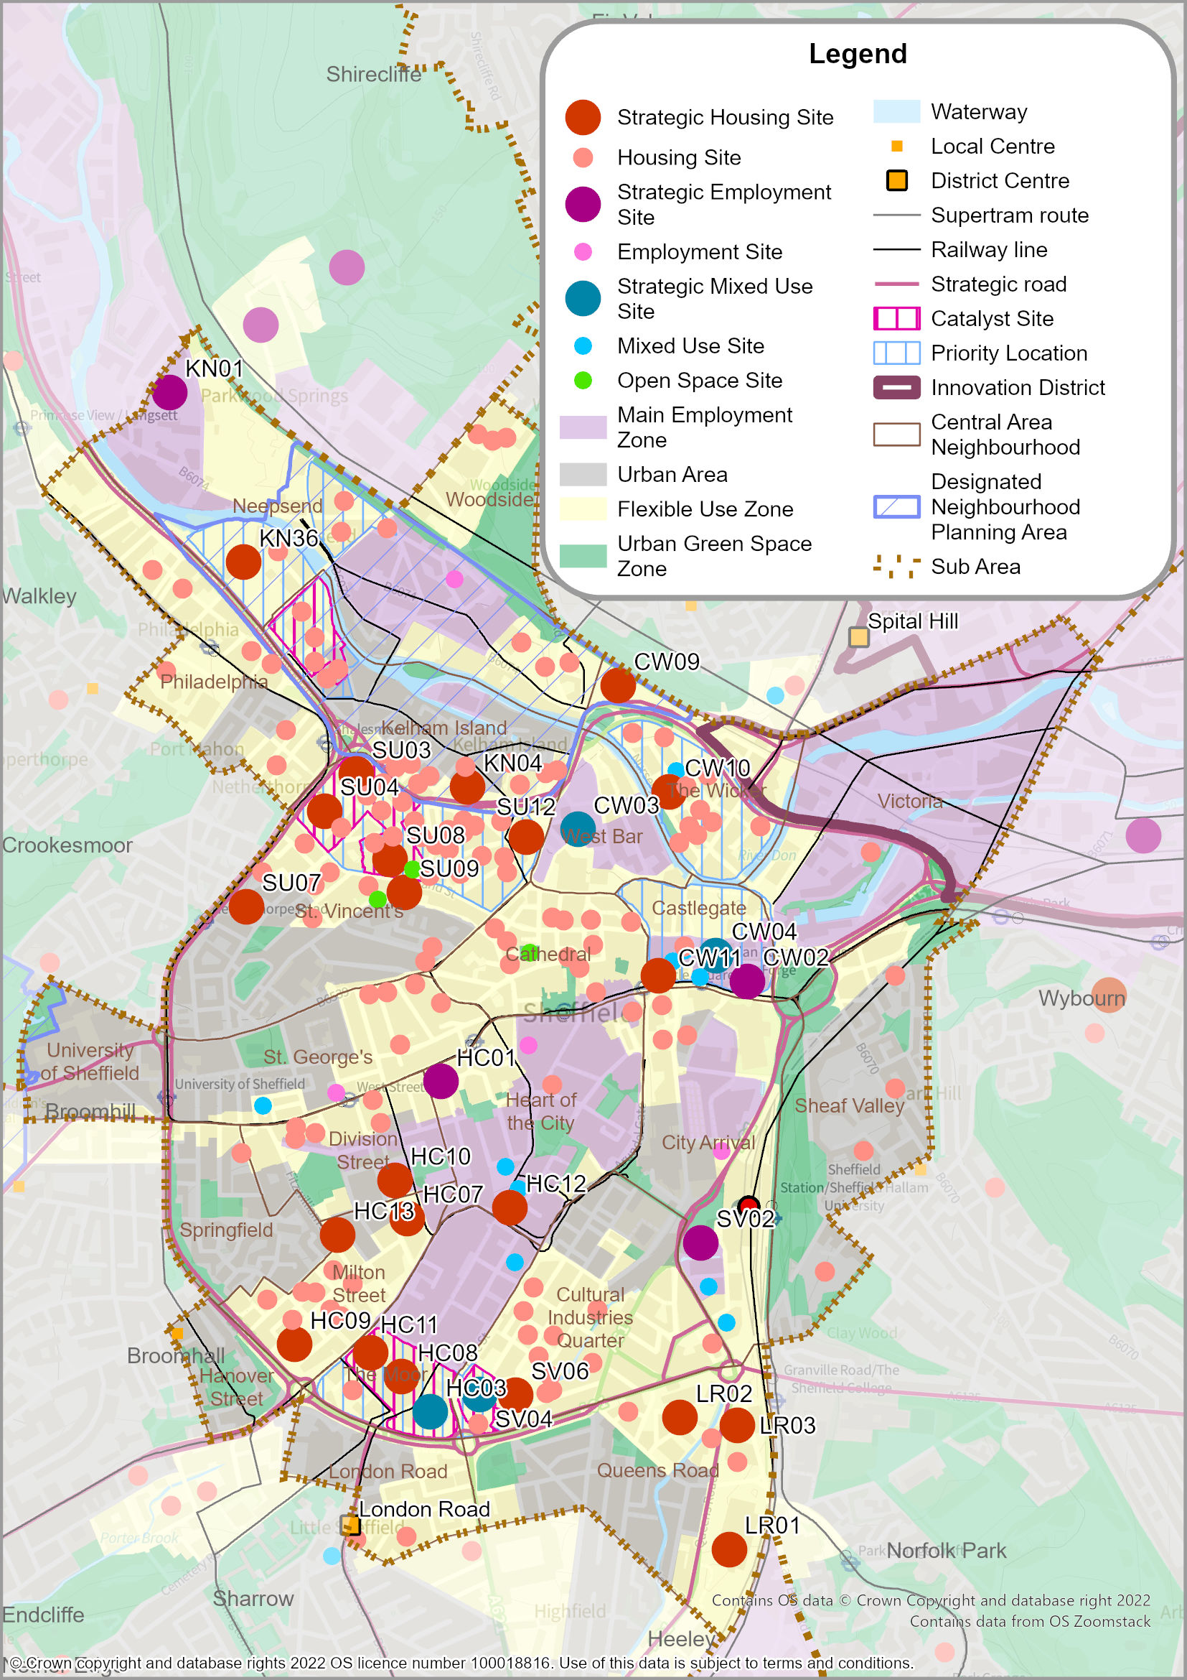

Central Sub-Area – Character Area One (Kelham Island, Neepsend, Philadelphia, Woodside)

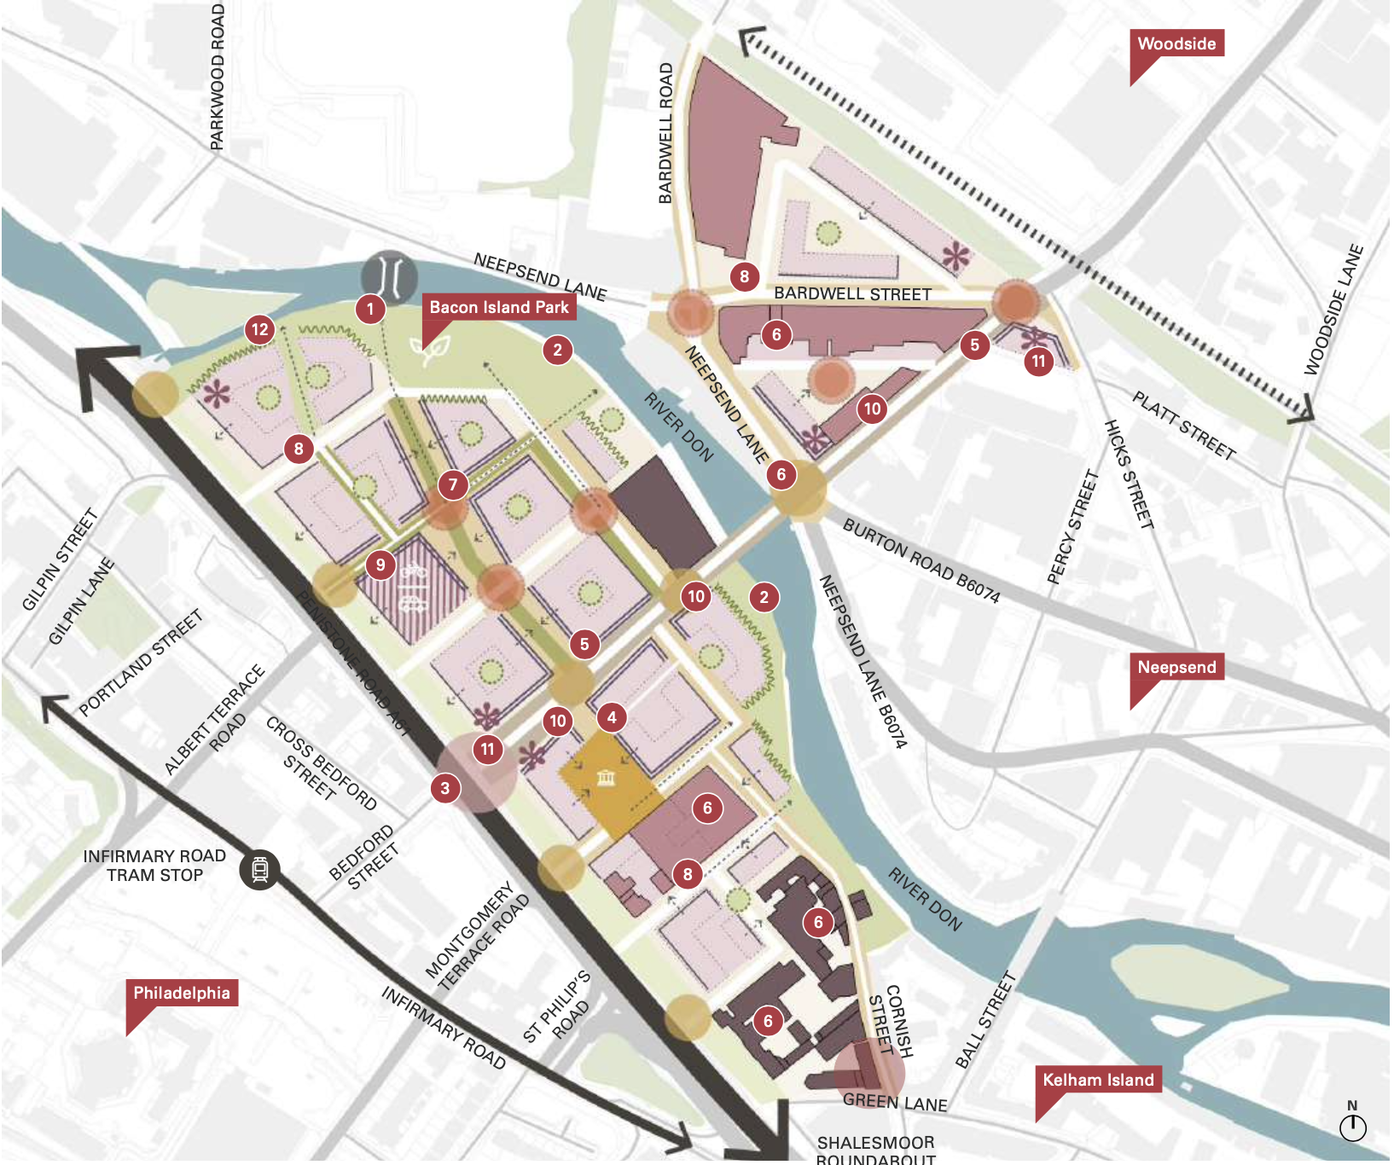
Source: Sheffield City Centre Priority Neighbourhood Frameworks – showing Priority Location 1 (Planit-IE in collaboration with Deloitte) (September 2022)

  - Character Area One is made up of the four neighbourhoods of Kelham Island, Neepsend, Philadelphia, and Woodside. The area is situated to the north-west of the City Centre and is an emerging residential area with industrial heritage and character. The role and function of the area is shaped by the River Don and important nearby green assets such as Parkwood Springs and Stanley Fields. Additionally, Kelham Island Conservation Area informs the character and gives a distinctive identity to the area.
  - Proposals will be a mix of residential types, predominantly low to mid-rise including housing for young families, apartments and townhouses. The neighbourhood will also grow as a destination for independent restaurants, cafés and shops to support the existing and future residents and attract visitors to create a vibrant daytime and early evening economy.
  - A neighbourhood area has been designated for Kelham and Neepsend, although no Neighbourhood Plan has yet been ‘made’ (adopted). It includes the areas of Kelham, Neepsend, and Philadelphia and encompasses the locations identified as a Priority Location and Catalyst Site.

POLICY CA1: Kelham Island, Neepsend, Philadelphia, Woodside
Development proposals in this Character Area will:
- Deliver approximately 2,745 homes and 1.3 hectares of employment land (through a combination of existing planning permissions and new site allocations).
- Deliver a housing requirement figure for the designated neighbourhood planning area: Kelham/Neepsend – at least 2,653 homes (including homes which already have planning permission).
- Deliver Site Allocations KN01 to KN36, with a focus on the site allocations defined within Policy CA1A – Priority Location in Neepsend, and Policy CA1B – Catalyst Site between Penistone Road, the River Don, and Rutland Road.
- Improve access and connectivity by creating a network of green north-south streets; improving the crossing environment along the Inner Ring Road; creating more accessible Supertram stops; increasing permeability to St Vincent’s and the wider City Centre; improving cycling and walking facilities; and creating linear parks to connect the neighbourhoods with existing green spaces to the north-west and south.
- Contribute towards infrastructure improvements in education and healthcare provision for Kelham-Neepsend.
- Proactively manage flood risk and drainage issues, particularly in those areas located closest to the River Don that are designated as a functional flood plain, including pockets of land with a high risk of flooding in Neepsend.
- Enable the area to become an ‘Outdoor’ Neighbourhood (epitomising the vision for Sheffield to be the ‘Outdoor City’) through the design of new development, new public realm, and an ability to accommodate outdoor events.
- Adhere to the proposed extension of the Night-Time Quiet Area covering the area from Shalesmoor to Mowbray Street/Neepsend Lane and Rutland Road (see Policy NC14).
- Enhance the local identity and character through provision of improved pathways, signage, public realm, and public art. This should complement plans to enhance amenity through improving links to nearby open spaces and greenspaces, including Parkwood Springs and Woodside.
- Conserve, enhance and capitalise on the area’s heritage, especially within the Kelham Island Conservation Area, by providing high quality development proposals.
- Deliver transport infrastructure improvements, including:
- enhancements to the highway junctions with Penistone Road;
- incorporating active travel and operational improvements to bus services, including those set out as part of the Connecting Sheffield programme;
- improved pedestrian crossings across the A61 to increase connectivity to facilities and tram stops;
- part of the Mass Transit Corridors from the City Centre.
Definitions
- ‘Supertram’, ‘Outdoor City’, ‘Night-Time Quiet Area’, ‘Connecting Sheffield’ and ‘Mass Transit Corridors’ – see Glossary.

Priority Location in Neepsend
  - Neepsend has been chosen as a Priority Location because it:
- has the capacity for volume development, facilitated by vacant sites, and large areas of land under single ownership;
- is a gateway location to the wider Neepsend area, and to encourage delivery of stalled development opportunities;
- is a distinctive neighbourhood, suitable for a mix of demographics including family housing, whilst retaining an industrial, independent heritage identity;
- has the ability to help meet targets for Biodiversity Net Gain through a comprehensive landscape strategy, and natural habitat improvement programme; and
- contains historical assets, including Cornish Works, Globe Works and Cannon Brewery which have potential to inform the character of new development.
  - Neepsend also benefits from:
- transport connections, including the Infirmary Road and Shalesmoor tram stops which connect into the City Centre; and Penistone Road which is a direct route in and out of Sheffield. The railway also runs along the northern edge of the area;
- the River Don runs through the site creating potential for green edges, access, placemaking and sustainable drainage systems (SuDS) for combating climate change;
- the existing Kelham Island community to the south of the site with established eateries and cultural assets; and
- Kelham Island Conservation Area, which informs the character and will give a distinctive identity to Neepsend.

POLICY CA1A: Priority Location in Neepsend
Development proposals will deliver Site Allocation(s) KN03, KN05, KN07, KN13, KN15, KN21, KN24, KN27, KN30, and KN36 and help realise:
- Around 1,285 new homes.
- Mixed use development that supports a proportion of non-residential uses.
- Enhanced connectivity to the River Don, including an extension of Waterloo Walk.
- A new waterside park (Bacon Island Park) along the northern edge of the River Don, helping to create a network of green spaces and connections with the Ponderosa and Parkwood.
- A new neighbourhood hub by expanding on existing amenities in Insignia Works and neighbouring Steelworks Kelham.
- A new pedestrian and cyclist priority crossing point across Penistone Road (A61), taking movement east to west along Rutland Road to Bedford Street, towards the Infirmary Road Supertram stop. Proposals for traffic calming along the A61 will also be considered.
- A new public square that complements existing heritage buildings.
- Contributions towards improvements in community infrastructure, including consideration of additional education and healthcare provision as a result of increased residential population.
- Retention and enhancement of designated and non-designated key heritage assets (including Kelham Island Conservation Area, Globe Works, Cornish Works and Cannon Brewery buildings)
- Creation of an attractive high street along Rutland Road (B6070) to provide community facilities.
- A main route through the area to include public realm, amenity and active frontages, to encourage movement towards Bacon Island Park.
- A new pedestrian bridge across the River Don which will improve connectivity to the wider Neepsend.
- New buildings set back to the Environment Agency’s recommended 8m from the River Don bank as part of future design stages.
- Increased building heights along Penistone Road, Rutland Road and the railway line edge to provide noise mitigation.

Catalyst Site between Penistone Road, the River Don, and Rutland Road
  - The Neepsend Catalyst Site lies between Penistone Road, the River Don and Rutland Road. It excludes Globe Works and Wharncliffe Works to the south. The majority of the site is within the Kelham Island Industrial Conservation Area, it consists of a mix of industrial buildings, some of which are historic, and a large footprint retail use with a large surface car park.
  - The adjacent historic buildings at Cornish Street and connection to the River Don provide a sensitive edge, as opposed to the Penistone Road frontage where the opportunity exists to explore increasing the existing height of the site.
POLICY CA1B: Catalyst Site between Penistone Road, the River Don, and Rutland Road
The Catalyst Site will be redeveloped as part of Central Sub-Area – Character Area Two, as defined on the Policies Map. Proposals will be expected to be delivered in accordance with any approved masterplan for the area to ensure the site and its infrastructure relates positively to neighbouring sites and the surrounding area. Development proposals will deliver Site Allocation(s) KN03, KN07, KN15, KN21 and KN24 and help realise:
- Around 400 new homes.
- Increased development heights along the Penistone Road frontage.
- Development proposals that are sensitive to, and positively enhance, the Kelham Island Conservation Area and nearby Listed Buildings (Cornish Works, and Globe Works) and Cannon Brewery.
- A mix of ground-floor uses to provide active frontages.
❡

Central Sub-Area – Character Area Two (Castlegate, West Bar, The Wicker, and Victoria)

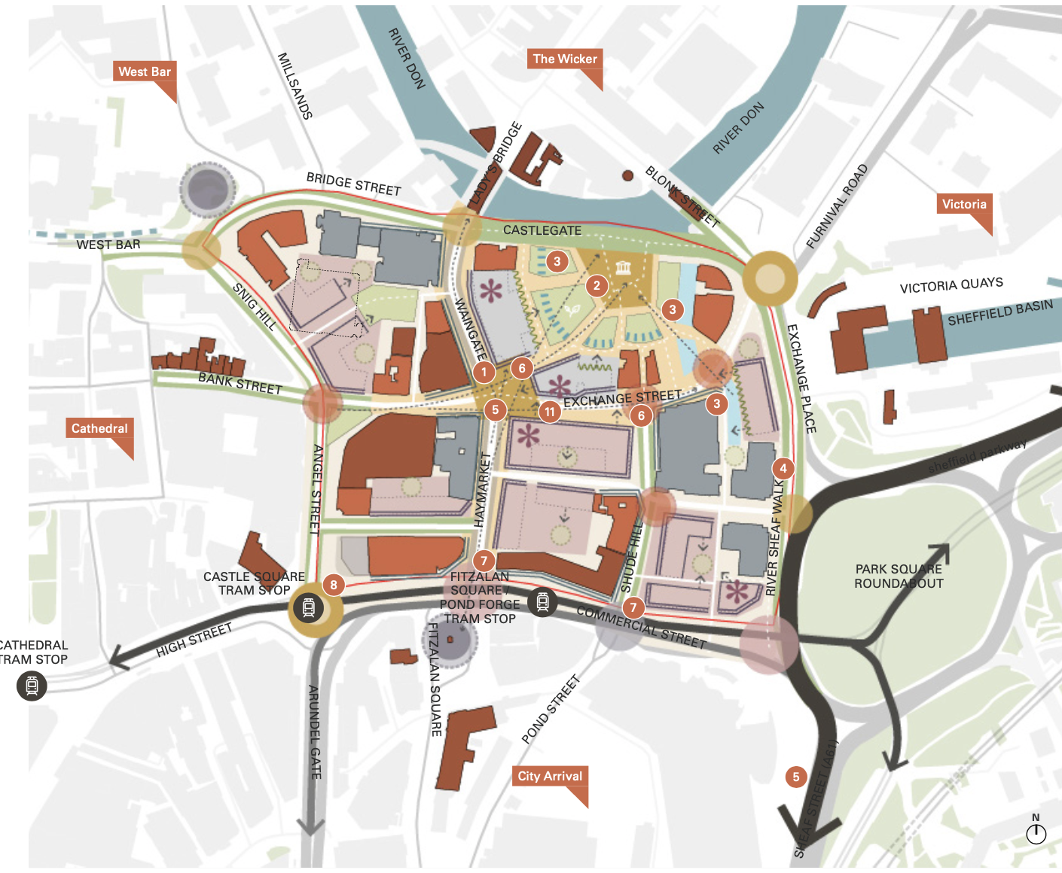

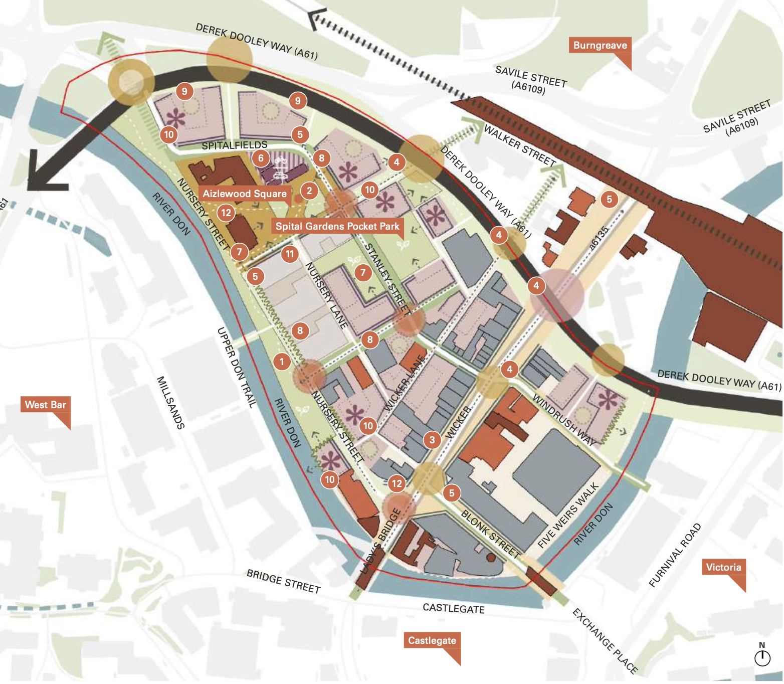
Source: Sheffield City Centre Priority Neighbourhood Frameworks – showing Priority Location 2 (Planit-IE in collaboration with Deloitte) (September 2022)

  - Character Area Two is made up of the four neighbourhood areas of Castlegate, West Bar, The Wicker, and Victoria.
  - The area is situated to the north-east of the City Centre and is currently predominantly an industrial and manufacturing area, with little residential development. The role and function of the area is shaped by the Inner Ring Road, the River Don, and the Sheffield & Tinsley Canal. Key assets include the Sheffield Canal Basin, Victoria Quays, the site of the former Sheffield Castle, and the Grey to Green route along West Bar, Bridge Street, and Castlegate.
  - The area is dominated by busy roads, including:
- the Inner Ring Road (Derek Dooley Way; Commercial Street which restricts movement to the City Centre; Snig Hill/Angel Street, Haymarket and Exchange Place (B6073) – the main routes north-south through Sheffield towards the City Centre;
- Castlegate to the north, which restricts movement towards the Wicker Arches; Wicker high street, which is a main route north-south through Sheffield; and
- The Wicker Arches where a freight railway line is located along the far northern edge of Wicker Riverside.
  - Proposals will forge a strong frontage to the Wicker (the Steel Route) and create new neighbourhoods. Proposals in Castlegate will see residential development sit alongside commercial activity as part of a vibrant, mixed-use neighbourhood. The regeneration of West Bar will create a new office-led mixed-use neighbourhood. Together, the neighbourhoods will provide for a full mix of residential types, including opportunities to deliver affordable or key working housing; as well as catering to young professionals and families.
POLICY CA2: Castlegate, West Bar, The Wicker, Victoria
Development proposals in this Character Area will:
- Deliver approximately 1,845 homes and 2.1 hectares of employment land (through a combination of existing planning permissions and new site allocations).
- Deliver Site Allocations CW01 to CW23, with a focus on the site allocations defined in Policy CA2A - Priority Location in Castlegate and Policy CA2B - Priority Location in Wicker Riverside.
- Focus office development within the two identified City Centre Office Zones at West Bar/Riverside Exchange, and Castlegate/Victoria Quays (see Policy EC2).
- Preserve and retain the area’s industrial character and street pattern, but proactively improve accessibility and connectivity. This should capitalise on the Grey to Green route from West Bar to Castlegate, and explore expanding it to other areas, where possible.
- Enhance pedestrian and cycle environments along main routes and improve the relationship with the river and canal side spaces - creating new riverside routes, supported by active building frontages, and proposals that positively interact with the river and canal side spaces.
- Improve connectivity to opportunities in the East Sheffield Sub-Area, especially key development sites in the Lower Don Valley and those related to the Innovation District.
- Deliver transport infrastructure improvements, including:
- incorporating active travel and operational improvements to bus services, including those set out as part of the Connecting Sheffield programme; and
- highway improvements at Bridgehouses on the Inner Ring Road.

Definitions
- For ‘Grey to Green’, ‘Connecting Sheffield’, ‘Lower Don Valley’, and ‘Innovation District’ - see Glossary.’

Priority Location in Castlegate
  - This area has been chosen as a Priority Location because it:
- serves as an important site that can join up the City Centre with other areas identified for future regeneration in other parts of the city;
- has the advantage of having secured initial funding to enable development on the Castle site; and
- provides an opportunity to create a fully mixed-use neighbourhood, integrating a variety of complementary uses to showcase the benefits of an integrated approach to mixed-use development.
  - Castlegate also benefits from:
- being a gateway to the City Centre from the north and east of the city;
- transport connections including: bus routes through the site connect to the City Centre, Sheffield Midland Station is within a 20-minute walk of Castlegate, and Exchange Place (B6073) which is a direct vehicular route into and out of Sheffield;
- Commercial Street, which accommodates public transport (including tram network, bus route and private vehicular movement);
- being situated in the junction of the River Don and River Sheaf, there are existing pedestrian river walks which connect into the site;
- being home to a number of key heritage assets, including the Sheffield Castle, and the historic origin of the market-town;
- being well connected to West Bar via the Grey to Green scheme along Castlegate; and
- Haymarket, which is a main north-south spinal route through the site along the Steel Route and Exchange Street, which is the main east-west route through Castlegate along the Steel Route.
POLICY CA2A: Priority Location in Castlegate
Development proposals will deliver Site Allocation(s) CW04, CW06, CW11, and CW18 and help realise:
- Around 330 new homes and approximately 1 hectare of non-residential development.
- A truly mixed-use neighbourhood, integrating a variety of complementary uses, alongside office development within the Castlegate/Victoria Quays Office Zone. Castlegate is a location where residential apartments will be the dominant type of new housing. Mixed-use and non-residential uses at ground-floor level will be supported to activate key spaces and nodes.
- A new Innovation District, expanding on the existing facilities along Haymarket, Commercial Street, and Exchange Street, and re-connecting Castlegate to the Wicker, Victoria, and into the wider City Centre. This will make Castlegate a gateway to the City Centre from the north and east.
- A new public square and riverside greenspace (Castlegate Square) to utilise and protect the heritage assets of Sheffield Castle.
- A clear north-south corridor along Haymarket, prioritising pedestrians and cyclists towards the railway station, integrating into the Steel Route and Knowledge Gateway.
- A revitalised Waingate/Haymarket High Street by developing ground-floor active uses and encouraging movement from Wicker High Street to Fitzalan Square.
- Major highway improvements to Commercial Street, Exchange Street, Castle Square, and Exchange Place/Furnival Road/Blonk Street to incorporate the Steel Route proposals, create pedestrian and cyclist priority crossing points, and improve crossing to Fitzalan Square and the underpass/overpass on Shude Hill.
- De-culverting of the River Sheaf (where possible), integrating it into the public realm and using blue and green infrastructure to enhance quality of place and amenity.
- An extension of the Grey to Green scheme into Castlegate and along the River Sheaf Walk, connecting pedestrian links along the historic watercourse of the River Sheaf, from the River Don to Sheffield Midland Station.
- Necessary community facilities and social infrastructure to support the creation of a new neighbourhood hub. This could include convenience stores, community facilities, cafés and other small-scale retail and leisure facilities to support the residential population.

Definitions
- ‘Knowledge Gateway’ – is a public realm scheme that aims to transforms the corridor running from Fitzalan Square to Brown Street.
- For ‘blue and green infrastructure’ – see introduction to Policy BG1. .For ‘Grey to Green’ and ‘Steel Route’ - see Glossary.

Priority Location in Wicker Riverside
  - Wicker Riverside has been chosen as a Priority Location because it:
- has the capacity for volume development, and for a City Centre location, much of the area is underutilised and low density;
- provides an opportunity to create a ‘live-work’ neighbourhood providing housing for a wide range of demographics, delivering a diverse identity;
- has the ability to help meet targets for Biodiversity Net Gain; and
- is a gateway into the City Centre and improvements would allow the residential populations in the north and east of Sheffield to better access the opportunities provided by City Centre.
  - It also benefits from:
- reasonable transport connections - including a bus route through the site connecting to the City Centre, Sheffield Midland Station is within a 20-minute walk of the site, and the Derek Dooley Way (A61) ring road is a direct route into and out of Sheffield;
- the Grey to Green scheme runs along Castlegate, the southern edge of the site and the River Don;
- an existing tight street network which provides opportunity for incidental spaces;
- Wicker High Street which provides existing social infrastructure for the area;
- An existing rich historical character which new development can take precedent from, including: Royal Exchange Buildings and adjoining Castle House, New Testament Church of God, and Aizlewoods Mill;
- Nursery Street Park which is an attractive green edge connecting to the River Don; and
- Kelham Island Conservation Area which is located to the northern end of the neighbourhood which gives this part a distinctive character.
POLICY CA2B - Priority Location in Wicker Riverside
Development proposals will deliver Site Allocation(s) CW05, CW10, CW12 to CW17, and CW20 to CW23 and help realise:
- Around 795 new homes and approximately 0.1 hectares of non-residential development. Wicker Riverside is a location where larger, urban family homes will be considered.
- A vibrant, mixed-use community that revitalises and diversifies Wicker High Street; and provides new community hubs (along Wicker High Street and at Aizlewood Square), and improved local community facilities.
- The opportunity for a ‘live-work’ neighbourhood providing housing for a wide range of demographics, along with active and varied street frontages that create vibrant streets and a distinctive neighbourhood.
- The retention of the fine grain street network but with improved connectivity and accessibility, including the provision of direct links to the investment proposed at Castlegate.
- New pedestrian, cyclist and vehicular connections into the site along the edge of the ring road and across Wicker High Street. Enhanced north-south connections along the Wicker (Steel Route) towards Wicker Arches and City Centre/Castlegate.
- Development that is set back from the A61 to create a green buffer and tree-planting along the A61 corridor, and creates an attractive edge to the neighbourhood.
- Contributions towards improvements in community infrastructure, including consideration of additional education and healthcare provision as a result of increased residential population.
- Enhancements to Nursery Street by defining it as ‘green street’, reducing vehicular movements, introducing street trees and capitalising on the Nursery Street Pocket Park. This will complement open space and greenspace improvements such as creating a new public square at Aizlewood Square; and a new pocket park at Spital Gardens.

Central Sub-Area - Character Area Three (St Vincent’s, Cathedral, St George’s and University of Sheffield)

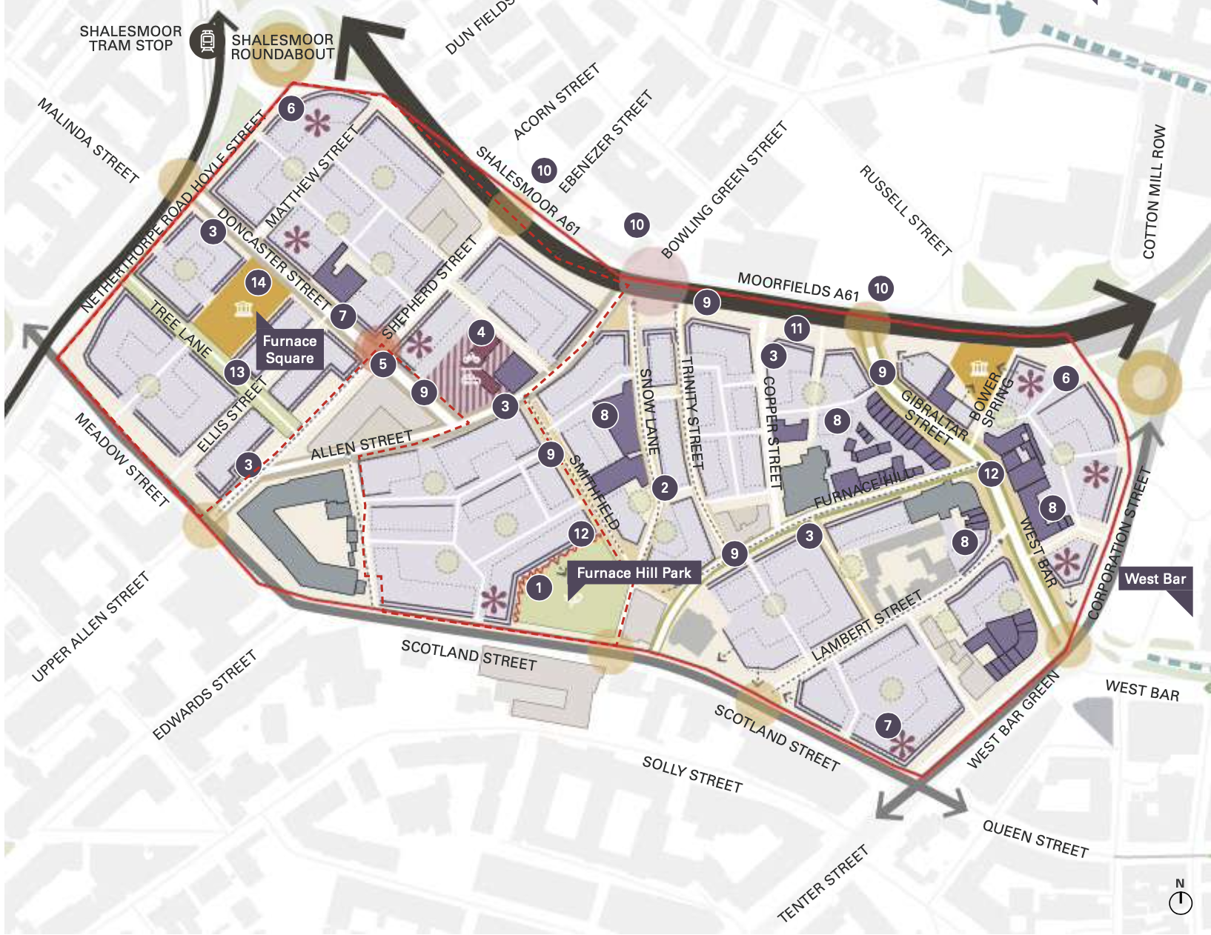
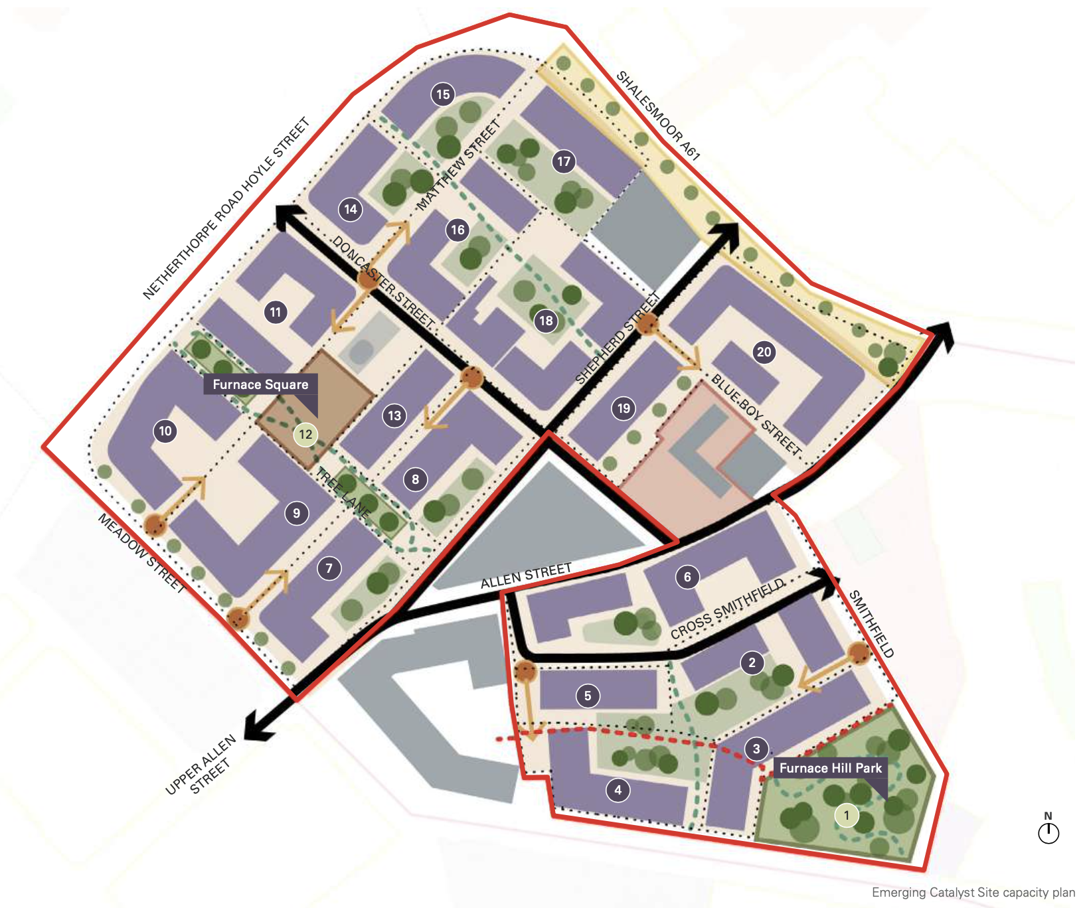
Source: Sheffield City Centre Priority Neighbourhood Frameworks – showing Priority Location 3 (Planit-IE in collaboration with Deloitte) (September 2022)

  - Character Area Three is made up of the four areas of St Vincent’s, Cathedral, St George’s and University of Sheffield. The area is situated towards the north-west of the City Centre and is a location of contrasts. There are significant areas of industry and warehousing, especially near Furnace Hill; but there are also emerging residential areas, prominent civic buildings, and a strong student presence.
  - Most of the area falls within the City Centre and has a vibrant feel through a mix of commercial, higher education, residential, civic, retail, and leisure uses. The area also features a number of Conservation Areas (Furnace Hill, City Centre, Hanover and Well Meadow) and Listed Buildings providing a built heritage context that will influence future development proposals. The role and function of the area is shaped by the existing pattern of the built environment, a challenging topography, as well as key assets such as the Grade I Listed Sheffield Cathedral, Paradise Square, and the University of Sheffield and its campus.
  - The Inner Ring Road defines the northern and western edges of the Character Area and is a significant barrier for pedestrian movement. Topography and, in places, an illegible street pattern, also serve to restrict movement through this area.
  - Proposals will seek to create active and walkable neighbourhoods, with future development schemes that encourage activity at street-level and a greater amount of ground floor uses – including retail, commercial, and leisure. Creating new neighbourhood hubs, to stimulate greater pockets of activity and movement through the area, will be vital to the future success of the area. Proposals will also enable the continuous development and expansion of existing facilities of the Sheffield Innovation Spine (see Policy SA1).

POLICY CA3: St Vincent’s, Cathedral, St George’s, University of Sheffield
Development proposals in this Character Area will:
- Deliver approximately 4,010 homes and 0.16 hectares of employment land (through a combination of existing planning permissions and new site allocations). The area will support a mix of residential typologies including student, co-living, and Build-to-Rent (BTR) accommodation, with potential for some high-end housing.
- Deliver Site Allocations SU01 to SU56, with a focus on the site allocations defined in Policy CA3A – Priority Location in Furnace Hill and Policy CA3B – Catalyst Site at the Gateway between Scotland Street, Smithfield, and Snow Lane.
- Enhance the offer at the University of Sheffield and focus associated new development within the defined University/College Zones (see Policy EC8).
- Allow for new Purpose-Built Student Accommodation in identified part(s) of the area but only where evidence demonstrates the demand for further supply in these locations (see Policy NC5 and Policy NC6).
- Focus new retail and leisure floorspace in the identified Primary Shopping Area and the wider City Centre (see Policy VC1). Deliver a new Local Centre at Scotland Street.
- Create new neighbourhood hubs that encourage sustainable movement through the areas, and also generate activity within the area. Hubs should include convenience stores, community facilities, cafes and other small-scale retail and leisure facilities, along with facilities to promote active travel to support the residential population.
- Improve the public realm to address the current lack of amenity and greenspace. Future campus investment by the University of Sheffield should continue to prioritise public realm infrastructure to improve accessibility and movement to and through the relevant neighbourhood(s).
- Conserve, enhance and capitalise on the area’s heritage within the Furnace Hill, City Centre, Hanover and Well Meadow Conservation Areas, by providing high quality development proposals.
- Adhere to the proposed extension of the Night-Time Quiet Area covering the area from Scotland Street/Meadow Street to Broad Lane and Netherthorpe Road (see Policy NC14).
- Contribute towards infrastructure improvements in education and healthcare provision
- Deliver transport infrastructure improvements, including:
- significant highway works to the Moorfields A61;
- incorporating active travel and operational improvements to bus services, including those set out as part of the Connecting Sheffield programme;
- expanding the Grey to Green route from West Bar; and
- improving north-south connections for pedestrians and cyclists.
Definitions
- For ‘Build-to-Rent’, ‘University/College Zones’, ‘Purpose-Built Student Accommodation’, ‘Primary Shopping Area’, ‘City Centre’, ‘Local Centre’, ‘Night-Time Quiet Area’, ‘Connecting Sheffield’, and ‘Grey to Green’ – see Glossary.

Priority Location in Furnace Hill
  - This area has been chosen as a Priority Location because it:
- has significant capacity for residential development, as much of the area is underutilised and low density in the context of the City Centre;
- can improve connections and legibility through the area and will benefit the overarching strategy for the city;
- has the ability to help meet targets for Biodiversity Net Gain;
- represents an opportunity to demonstrate partnership working and delivery with Homes England and public sector intervention; and
- can create a mixed-use residential neighbourhood that provides a transition in the residential offer, from being predominantly student accommodation near the University in the south of the Character Area, towards a more mixed-use residential community in the north. This will help to diversify the type of housing supply and generate a greater mixed demographic throughout the area and complement the predominantly residential uses within the adjacent Kelham Island area.
  - Furnace Hill also benefits from:
- transport connections, including the Shalesmoor tram stop which connects into the City Centre; and Shalesmoor/Moorfields (A61) ring road which is a direct route in and out of Sheffield;
- Grey to Green which is proposed to run through West Bar and Gibraltar Street;
- topography which provides significant views to the wider green landscape of Sheffield and opportunity for viewpoints within the area;
- an existing tight street network which provides opportunity for incidental spaces; and
- An existing rich historical character from which new development can take precedent.
POLICY CA3A: Priority Location in Furnace Hill
Development proposals will deliver Site Allocation(s) SU03 to SU06, SU08, SU10 to SU12, SU15, SU21, SU25, SU27 to SU30, SU34 to SU37, SU39, SU42, SU43, SU47, SU49 and SU51 and help realise:
- Around 2,290 new homes. Furnace Hill has potential to accommodate significant residential growth, and a mix of residential accommodation types, which could include family homes, apartments, duplex apartments and town houses
- New neighbourhood hubs to address a lack of existing community facilities, and to support new communities living at Furnace Hill. A hub at Gibraltar Street is a priority.
- Maximise development capacity on sites along Scotland Street and re-purpose under-utilised sites. Development proposals on existing surface car parks will help to sensitively repair the existing street pattern.
- Built form that creates mixed-use and non-residential uses at ground floor level to activate key spaces and movement routes. It will be of a scale and massing that responds to the topography and sensitive views in and out of the area, and should respect the industrial character and heritage, with new buildings that complement and enhance the finer grain street pattern.
- Furnace Hill Park (“Park on the Hill”) at, or close to, the junction of Scotland Street and Smithfield. This will be complemented by a series of other pocket parks across the Priority Location.
- Furnace Square utilising the Furnace to act as a distinctive landmark and a place-making asset within a new public space.
- Improvements to road surfaces and public realm enhancements at Snow Lane, Trinity Street, and Tree Lane. This will create a pedestrian friendly environment encouraging north-south movement.
- The reinstatement of the historical street of Tree Lane as a proposed recreational route with pedestrian and cycle priority, with potential for an exemplar Sustainable Drainage System (SuDS), including tree planting and opportunity for play.
- An extension of the Grey to Green – responding to the changing topography along the streets of Furnace Hill (including Meadow Street, Scotland Street, Shepherd Street, Tree Lane, Furnace Hill and Lambert Street).
- Contributions towards improvements in community infrastructure, including consideration of additional education and healthcare provision as a result of increased residential population.
- Highways improvements at Moorfields A61, including new pedestrian/cycling crossings to enhance the link between Furnace Hill and Kelham Island and Neepsend.
- A new Mobility Hub to encourage walking, cycling and public transport use. The location of the mobility hub will be informed by topography, as well as proximity and access to the Ring Road, and is subject to further discussion with highways authorities.
Definitions
- For ‘Grey to Green’, ‘Mobility Hub’ and ‘Sustainable Drainage Systems’ – see Glossary.

Catalyst Site at the Gateway between Scotland Street, Smithfield, and Snow Lane
  - Furnace Hill Catalyst site is situated at a key gateway between Scotland Street, Smithfield and Snow Lane. The site is located at the highest point of the Priority Location providing the opportunity for catalyst development. This site provides key frontages to Scotland Street and Smithfield.
  - This site is expected to deliver a mix of residential development types and tenures with complementary commercial and retail uses at ground floor level. The topography is a key consideration when considering building heights and should be sensitive to the Furnace Hill Conservation Area and existing heights.
  - The elevated position of the site presents a key opportunity for an elevated park providing much needed amenity space at the heart of the neighbourhood.
POLICY CA3B: Catalyst Site at the Gateway between Scotland Street, Smithfield, and Snow Lane
Development proposals will deliver Site Allocation(s) SU03 to SU05, SU08, SU15, SU21, SU25, SU29, SU39 and SU42 and help realise:
- Approximately 1,480 new homes – through a mix of residential accommodation types, including aapartments with commercial and retail uses at ground floor level.
- Building heights that respect the topography and are sensitive to the Furnace Hill Conservation Area and existing heights.
- Priority active frontages to Scotland Street and Smithfield.
- Furnace Hill Park and Furnace Square to provide necessary new amenity space at the heart of the new neighbourhood.

Central Sub-Area – Character Area Four (City Arrival, Cultural Industries Quarter, Sheaf Valley)
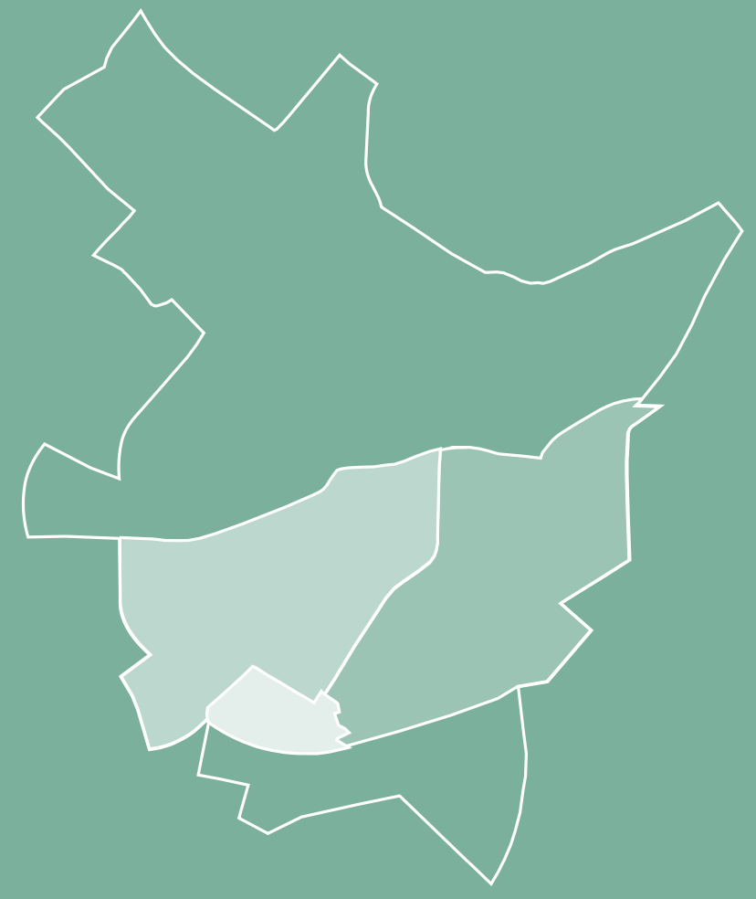
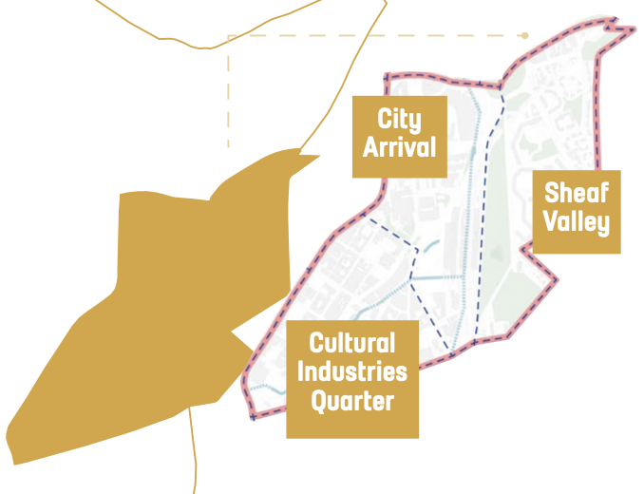

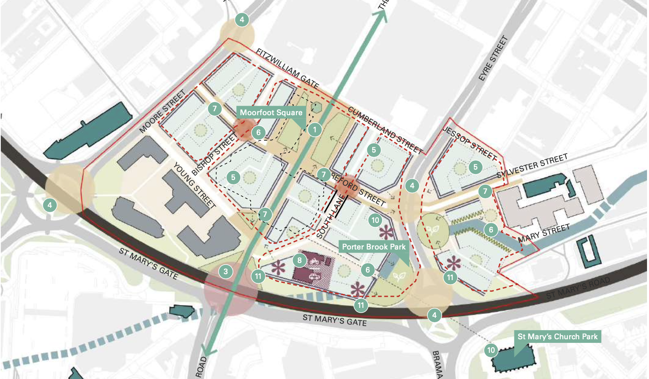
Source: Sheffield City Centre Priority Neighbourhood Frameworks – showing Priority Location 4 (Planit-IE in collaboration with Deloitte) (September 2022)

  - Character Area Four is made up of the three areas of City Arrival, Cultural Industries Quarter, Sheaf Valley. Part of the Cultural Industries Quarter sits within Character Area Five. Part of the Moorfoot Priority Location and part of the Moorfoot Catalyst Site (the majority of which are in Character Area Five) are within Character Area Four.
  - The area is situated to the south and east of the City Centre, lies within the Cultural Industries Quarter Conservation Area and has a unique identity given context by established residential areas featuring the iconic Grade II* Listed Park Hill Flats; as well as key gateways into the city at Sheffield railway station, Sheffield Interchange, and the A61 Arundel Gate. Some of Sheffield’s more recognisable landmarks including Park Hill Flats, Ponds Forge, and Sheffield Hallam University mark the area as of critical importance to the city. The role and function of the area is shaped by major road and rail infrastructure, as well as the South Street Park/Sheaf Valley Park.
  - Proposals will take advantage of the unique opportunities provided by the Sheaf Valley and Midland Station Development Framework and the Sheffield Hallam University Masterplan to re-connect this area to the City Centre. Development schemes will attract a mixed demographic through delivering a range of different residential typologies. The neighbourhoods will balance the delivery of commercial and residential uses to create a vibrant and truly mixed-use area of the city. Commercial uses will capitalise on the growth of Sheffield Hallam University and the Cultural Industries Quarter to promote the growth of knowledge and creative sectors. Further purpose-built student accommodation will be carefully managed in this area and will only be supported in certain sections of the wider area, and only where demand for additional supply can be demonstrated.
POLICY CA4: City Arrival, Cultural Industries Quarter, Sheaf Valley
Development proposals in this Character Area will:
- Deliver approximately 2,215 homes and 3.2 hectares of employment land (through a combination of existing planning permissions and new site allocations). A range of different residential types will be supported to attract a mixed demographic.
- Deliver Site Allocations SV01 to SV25, with a focus on the site allocations defined in Policy CA4A – Part of Priority Location and Catalyst Site at Moorfoot – Land between Eyre Street, St. Mary’s Road, and Jessop Street.
- Take advantage of the unique opportunity and investment as part of the Sheffield Midland Station and Sheaf Valley Development Framework to re-connect this area with the City Centre. Landmark development proposals will be promoted in the City Arrival area.
- Focus office development within two of the identified City Centre Office Zones at Sheaf Street/Pond Street, and Sheaf Street/Suffolk Road (see Policy EC2).
- Allow for new Purpose-Built Student Accommodation in identified part(s) of the area, but only where evidence demonstrates the demand for further supply in these locations (see Policy NC5 and Policy NC6).
- Support and collaborate with Sheffield Hallam University on the Sheffield Hallam University Masterplan, including supporting plans for the Sheffield Hallam University hub.
- Conserve, enhance and capitalise on the area’s industrial heritage, especially within the Cultural Industries Quarter, by providing high quality proposals.
- Deliver commercial development that complements the growth of Sheffield Hallam University and the creative uses in the Cultural Industries Quarter. This should include promoting a collaborative network in the knowledge and creative sectors using agglomeration benefits of locating in this area.
- Deliver transport infrastructure improvements, including:
- significant highway works to help overcome the challenges posed by the road network;
- incorporating active travel and operational improvements to bus services, including those set out as part of the Connecting Sheffield programme; and
- exploring opportunities to downgrade roads and create more pleasant pedestrian and cycle environments at Park Square, Arundel Gate, and Sidney Street.

Definitions
- For ‘City Centre Office Zones’, Purpose-Built Student Accommodation’, ‘Cultural Industries Quarter’, and ‘Connecting Sheffield’ - see Glossary.

Priority Location and Catalyst Site at Moorfoot - Land between Eyre Street, St Mary’s Road, and Jessop Street
  - This area has been chosen as a Priority Location because it:
- has the capacity for volume development, including opportunities for high density and landmark buildings of height;
- can provide a differentiated offer to support a community suited to the private rented sector and graduate/young professional market;
- has the ability to help meet targets for Biodiversity Net Gain; and
- represents a key site to improve the connectivity of City Centre to edge areas (e.g. Ecclesall Road/London Road and connecting the Devonshire Quarter to The Moor).
  - The part of the Moorfoot Catalyst Site, which is situated in Character Area Four, is situated on land between Eyre Street, St. Mary’s Road, and Jessop Street. The land parcels in this part of the catalyst site will deliver residential development and complementary greenspace and open space improvements and necessary enhancements to road infrastructure and the public realm.
Policy CA4A: Priority Location and Catalyst Site at Moorfoot - Land between Eyre Street, St. Mary’s Road, and Jessop Street
Development proposals will deliver Site Allocation(s) SV04, and SV16 and help realise:
- Approximately 390 new homes, and approximately 0.84 hectares of non-residential floorspace as a component part of the larger Priority Location and Catalyst Site at Moorfoot (see Policy CA5A and Policy CA5B).
- Residential courtyards in development parcels for amenity purposes, as well as other green spaces and/or public realm spaces to create new, incidental meeting places.
- De-culverting of the Porter Brook on Eyre Street/Mary Street to create a green corridor. The corridor should strengthen the connection towards the Cultural Industries Quarter and the Sheffield Midland Station, allowing for pedestrian routes to follow the Porter Brook watercourse; and for cycling routes to connect through Sylvester Street.
- Improved Ring Road connections and reduce the dominance of vehicles at St. Mary’s Gate. Improvements will also be made to the St. Mary’s Gate pedestrian crossing.
Definitions
- For ‘Cultural Industries Quarter’ – as shown on the Policies Map.

Central Sub-Area - Character Area Five (Heart of the City, Division Street, The Moor, Milton Street, Springfield, Hanover Street)
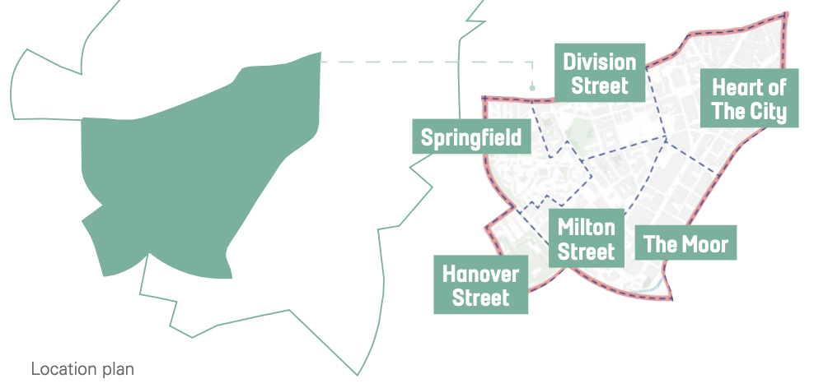

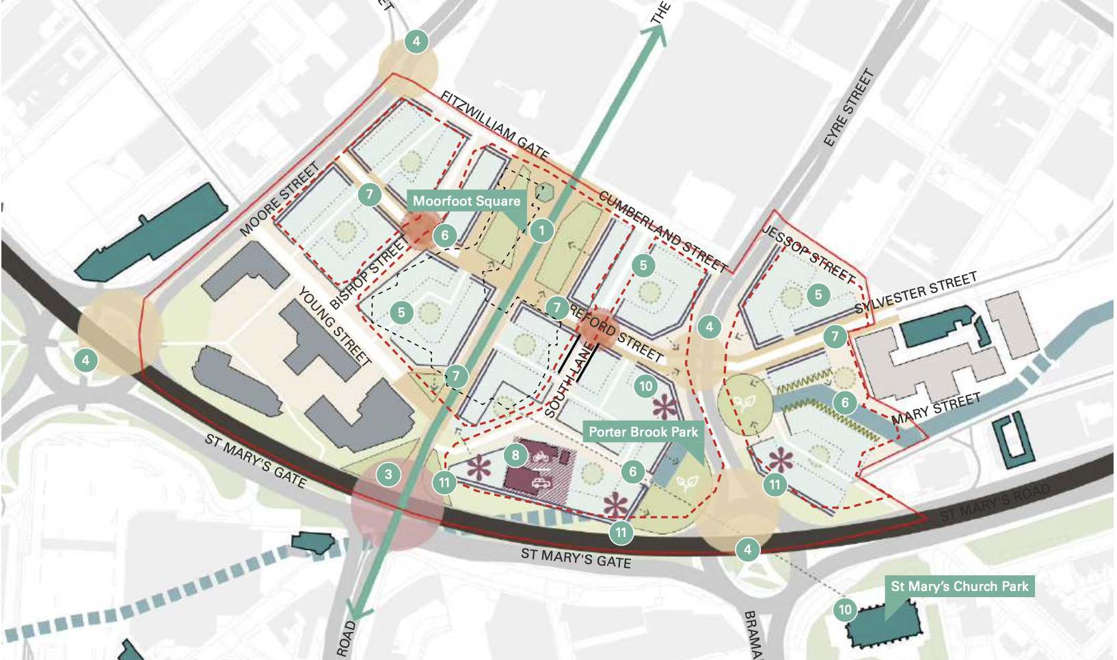
Source: Sheffield City Centre Priority Neighbourhood Frameworks – showing Priority Location 5 (Planit-IE in collaboration with Deloitte) (September 2022)

  - Character Area Five is made up of the six areas of the Heart of the City, Division Street, Springfield, Milton Street, The Moor, and Hanover Street. Part of the Moorfoot Priority Location and part of the Moorfoot Catalyst Site are within Character Area Five.
  - The area includes a core part of the City Centre, but also extends south-west towards Broomhill and the Inner Ring Road at Hanover Way/Upper Hanover Street. It is a vibrant location, featuring a wide range of all uses, from prestige retail to regionally significant sport and leisure uses, high quality offices and commercial buildings. It includes established residential estates and an increasingly strong City Centre residential offer.
  - The area provides important and well-used public greenspaces, such as Devonshire Green, the Peace Gardens and the Winter Garden. Equally, it is home to a diverse range of independent retail, and food and drink establishments, which supports a healthy night-time economy. This offer has also been recently enhanced by The Moor re-establishing itself as a shopping destination due to significant regeneration and the relocation of the Castle Market.
  - Given the area covers such a diverse range of use and places, it is unsurprising that certain locations (such as Milton Street) are evolving from their historical role as light industrial and manufacturing areas and are steadily becoming more desirable locations for residential development. At present, many of the sites within this part of the area remain under-utilised, with pockets of surface car parks and vacant land interspersed with high density residential development.
  - Equally, towards the south-west of the area, there is a noticeable change in character with established low density housing estates, community facilities, and parks and playgrounds shifting the dynamics away from those seen in the City Centre. Furthermore, locations such as Hanover Street, by virtue of its separation by the Inner Ring Road, feel somewhat cut-off from the regeneration, growth and change occurring in other parts of the city.
  - The overall street pattern remains largely Victorian and accommodates grand civic architecture and a series of important public institutions. Significant transport gateways for the tram, pedestrians, and cyclists mean this is a highly accessible and connected area. Key landmarks, such as Barkers Pool, the Town Hall, the Crucible and Winter Garden, The Moor and Moorfoot, the Peace Gardens, Fargate, and the High Street provide identifiable nodes that allow users to navigate through the core of the city.
  - The City Centre Conservation Area covers a substantial part of the area, and there are a significant number of listed buildings. These provide a context for the preservation and enhancement of the urban core of the city. But, the area also contains a mix of architectural styles, responding to modern needs and building design, with new developments providing a range of commerce, shopping, civic and leisure uses, as is typical of the City Centre.
  - Proposals will respond to the fact that this area serves as the commercial heart of the City Centre, but that there is a growing residential population catering to those who want a City Centre lifestyle. Throughout the area there is the opportunity to reduce the dominance and impact of vehicles, improve connectivity and promote active travel. The area will balance the delivery of new commercial uses (primarily focused in the Heart of the City, Division Street, and The Moor) with new residential uses (primarily focused in Milton Street, Springfield, and Hanover Street). Care will be required to ensure successful integration of commercial and residential uses to create vibrant mixed-use communities.
  - The new City Centre residential neighbourhood at Moorfoot will attract a young population, likely providing an offer for the private rented sector and may include co-living. Further purpose-built student accommodation will be carefully managed in this area and will only be supported in certain sections of the wider area, and only where demand for additional supply can be demonstrated.

POLICY CA5: Heart of the City, Division Street, Springfield, Milton Street, The Moor, and Hanover Street
Development proposals in this Character Area will:
- Deliver approximately 6,155 homes and 3.4 hectares of employment land (through a combination of existing planning permissions and new site allocations). The area represents an opportunity to attract a mixed demographic profile due to the range of built development that will occur in the City Centre.
- Deliver Site Allocations HC01 to HC30, with a focus on the site allocations identified in Policy CA5A - Priority Location in Moorfoot and Policy CA5B - Catalyst Site at the Junction between St. Mary’s Gateway, The Moor Street, and London Road. The part of the Priority Location located in Character Area Four will be delivered via Policy CA4 and Policy CA4A.
- Allow for new Purpose-Built Student Accommodation in identified parts of the area but only where evidence demonstrates the demand for further supply in these locations (see Policy NC5 and Policy NC6).
- Help realise the opportunities in the Heart of the City 2 Masterplan, and create a stronger concentration of office, commercial, retail, and leisure uses within the City Centre.
- Deliver strategic development opportunities at Fargate; reinvigorate key frontages along Pinstone Street and Cambridge Street; and realise landmark development opportunities, including at Barkers Pool, Division Street, the Devonshire Quarter, and at Wellington Street/Trafalgar Street/Rockingham Street.
- Focus office development within the identified City Centre Office Zone at the Heart of the City (see Policy EC2).
- Focus retail and leisure floorspace within the identified Primary Shopping Area, and the wider city ‘centre’ (see Policy VC1).
- Capitalise on, and enhance, the cultural offer within the city by focusing new cultural and entertainment uses within the identified Cultural Zone (see Policy VC2).
- Create a gateway and sense of arrival at Milton Street/adjacent to the Ring Road by exploring opportunities to deliver buildings of height.
- Provide major improvements to the environment by creating new green spaces alongside direct, safe and attractive walking and cycling routes. A new pocket park will also be created on the site of the Furnival Gate roundabout.
- Deliver transport infrastructure improvements, including:
  - extensions to the car free zone and additional pedestrian and cycle links proposed between the Devonshire Quarter and the Cultural Industries Quarter;
  - reinstating the historic grain of The Moor and defining the proposed Steel Route along The Moor across St Mary's Gate to London Road, with improved pedestrian connections across the A61;
  - multi-modal improvements for the roundabouts at Moor Street and Bramall Lane;
  - schemes that re-establish the historic connection from the Moor to Cemetery Road; and
  - incorporating active travel and operational improvements to bus services, including those set out as part of the Connecting Sheffield programme.
Definitions
- For the ‘Devonshire Quarter’ – see the Policies Map.
- For ‘City Centre Office Zone’, ‘Primary Shopping Area’, ‘Cultural Zone’, ‘City Centre Conservation Area’, ‘Cultural Industries Quarter’, and ‘Connecting Sheffield’ - see Glossary.

Priority Location at Moorfoot

  - This area has been chosen as a Priority Location because it:
- has the capacity for volume development, including opportunities for high density and landmark buildings of height;
- can provide a differentiated offer to support a community suited to the private rented sector and graduate/young professional market;
- has the ability to help meet targets for Biodiversity Net Gain; and
represents a key site to improve the connectivity of City Centre to edge areas e.g. Ecclesall Road/London Road, and improve connectivity of the Devonshire Quarter to The Moor.
POLICY CA5A: Priority Location in Moorfoot
Development proposals will deliver Site Allocation(s) HC03, HC08, HC11 and HC20 and help realise:
- Approximately 2,180 new homes and approximately 1.6 hectares of non-residential floorspace. Moorfoot has the potential to accommodate significant residential growth and become a new neighbourhood.
- Residential and mixed-use developments with active ground floor uses. Buildings should be of significant scale and respond to recent developments and the existing retail areas. Schemes should focus on delivering denser apartment typologies that can help create a modern gateway to the city.
- Significant highway infrastructure interventions at St Mary’s Gate and at the London Road junction. This will re-establish the historic connection between The Moor and London Road, delivering a high-quality, safe, pedestrian and cycle friendly crossing that promotes sustainable movement between the Heart of the City and the southern neighbourhoods of the city.
- A restored street pattern that responds to the historic characteristics of the area and defines the proposed Steel Route along The Moor across St Mary's Gate to London Road. Active frontages will connect to the retail area of The Moor to improve the vibrancy of streets.
- A series of public squares, courtyards and green roofs which provide new meeting places throughout the area and help interlink the various blocks. Amenity space on roof terraces of buildings and integrate green roofs and walls assist to improve air quality.
- De-culverting of Porter Brook along Eyre Street and expansion of the Grey to Green scheme to improve pedestrian links to the city, creating a stronger connection with nature for the neighbourhood, and helping define the historic route of the watercourse. This should also integrate with and enhance proposals for the Porter Brook Park and make it an important greenspace for the area.
- Moorfoot Square - a new high quality public square with integrated greenspace provision and a new multi-modal interchange - located at the intersection of the Steel Route and the east-west link from the station towards Devonshire Green.
- A mobility hub at the site of the existing electricity sub-station to encourage greater walking, cycling, and use of public transportation.
Definitions
- For ‘Grey to Green’, ‘Steel Route’, ‘Multi-Modal Interchange’, and ‘Mobility Hub’ - see Glossary.

Catalyst Site at the Junction between St. Mary’s Gateway, The Moor Street, and London Road

  - Moorfoot Catalyst Site is situated at the key junction between St. Mary’s Gateway, The Moor Street, and London Road. The entirety of the Priority Location provides opportunity for catalyst development.
POLICY CA5B: Catalyst Site at the Junction between St. Mary’s Gateway, The Moor Street, and London Road
Development proposals will deliver Site Allocation(s) HC03, HC08, and HC11 and help realise:
- Approximately 2,085 homes.
- Significant residential development to generate a new residential neighbourhood.
- Development schemes consisting primarily of apartments with active ground floor uses for community and commercial and retail uses.
- Building heights that respond to recent large-scale development and increasing build heights. New buildings of scale should help create a new gateway for the city.
- Moorfoot Square and other substantial public realm improvements, along with complementary open space and greenspace provision.
- A Mobility Hub allowing for multi-modal journeys serve as a node that helps identify the location as a key gateway to the city.
- Substantial public realm improvements, along with complementary open space and greenspace provision.
Definitions
- For ‘Mobility Hub’ - see Glossary.

Central Sub-Area - Character Area Six (London Road and Queens Road)
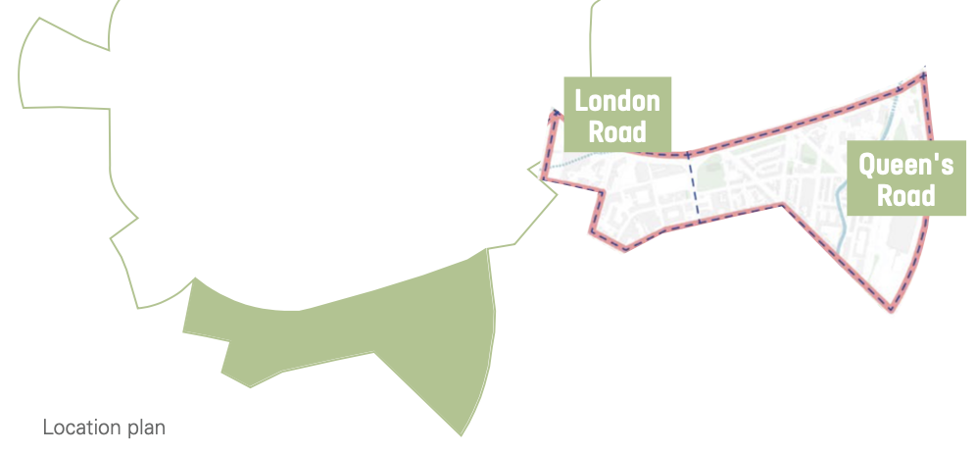
  - Character Area Six is made up of the two areas of London Road and Queens Road. The area is situated to the south of the City Centre, beyond the Inner Ring Road (St Mary’s Gate/St Mary’s Road). Due to the separation caused by the ring road, the area has historically been perceived as separate from the City Centre. The area includes a mix of residential, commercial, light industrial and warehouse development, and has previously seen some slum-clearance.
  - Parts of the area (mainly around Queens Road) still retains much of its Victorian fabric and is defined by a historic terraced street-pattern. Other parts (mainly around London Road) have long been known for its large multi-cultural and, in particular Chinese, community. Recent developments including: high density residential, Purpose-Built Student Accommodation, and large footprint big box retail and leisure has eroded some of the character in the area.
  - The River Sheaf flows through Queens Road, with Sheaf Walk located at the northern end of the neighbourhood, allowing people to enjoy the river. Duchess Road offers a sports pitch and greenspace, while Clough Road Square is the only playground in the neighbourhood. St. Mary’s Church enjoys some greenspace around it. Areas of the neighbourhood located closest to the River Sheaf are designated as a functional flood plain. Sections of the neighbourhood along the River Sheaf have a high or medium probability of flooding subject to proximity to the river.
  - Proposals in this area will focus on improving connectivity to the City Centre – at St Mary’s Road and Bramall Lane. Enhanced connections should focus on removing barriers to pedestrian and cycling movements and improving the conditions to promote active travel. The future development of this area will allow this part of the city to become a more integral part of the City Centre. The Sheffield Midland Station and Sheaf Valley Development Framework will heavily influence the future of this area and will improve connectivity to the London Road and Queens Road areas. Future development will be primarily residential with supporting commercial uses, although there will be a slightly stronger focus on delivering complementary retail, leisure, and community facilities and services in the London Road neighbourhood. New neighbourhoods will support a mixed demographic, including families. New purpose-built student accommodation will not be supported in this Character Area.
POLICY CA6: London Road and Queens Road
Development proposals in this Character Area will:
- Deliver approximately 1,495 homes (through a combination of existing planning permissions and new site allocations).
- Deliver Site Allocations LR01 to LR08, with a focus on integrating with the development proposals set out in Sheffield Midland Station and Sheaf Valley Development Framework, which will be primarily delivered in Character Area 4 (see Policy CA4 and Policy CA4A).
- Enhance Clough Road Square with high quality public realm and play provision. Improve the frontage along Clough Road overlooking St Mary’s Church to enhance its role as a key landmark.
- Proactively manage flood risk, particularly in those areas located closest to the designated functional floodplain at River Sheaf and designated areas of high to medium risk of flooding.
- Deliver new greenspace areas to overcome existing lack of provision in the London Road area.
- Deliver local amenity and community facilities to support and serve existing and new residential areas. This should be delivered at ground floor level to create sustainable and convenient mixed-use development.
- Have regard to the John Street Conservation Area and the need to conserve and enhance the local historic environment and industrial legacy.
- Deliver transport infrastructure improvements, including:
- improved connectivity to the City Centre by overcoming the physical barrier of the Inner Ring Road through creating an improved pedestrian and cycle environment and improved crossings;
- specific schemes should explore how to re-connect Bramall Lane Stadium with the City Centre;
- incorporating active travel and operational improvements to bus services, including those set out as part of the Connecting Sheffield programme; and
- creating a new green link following the River Sheaf to connect to Sheffield Midland Station and tram stop.
Definitions
- For ‘Connecting Sheffield’ - see Glossary.

Northwest Sheffield Sub-Area
MAP 7: Northwest Sub-Area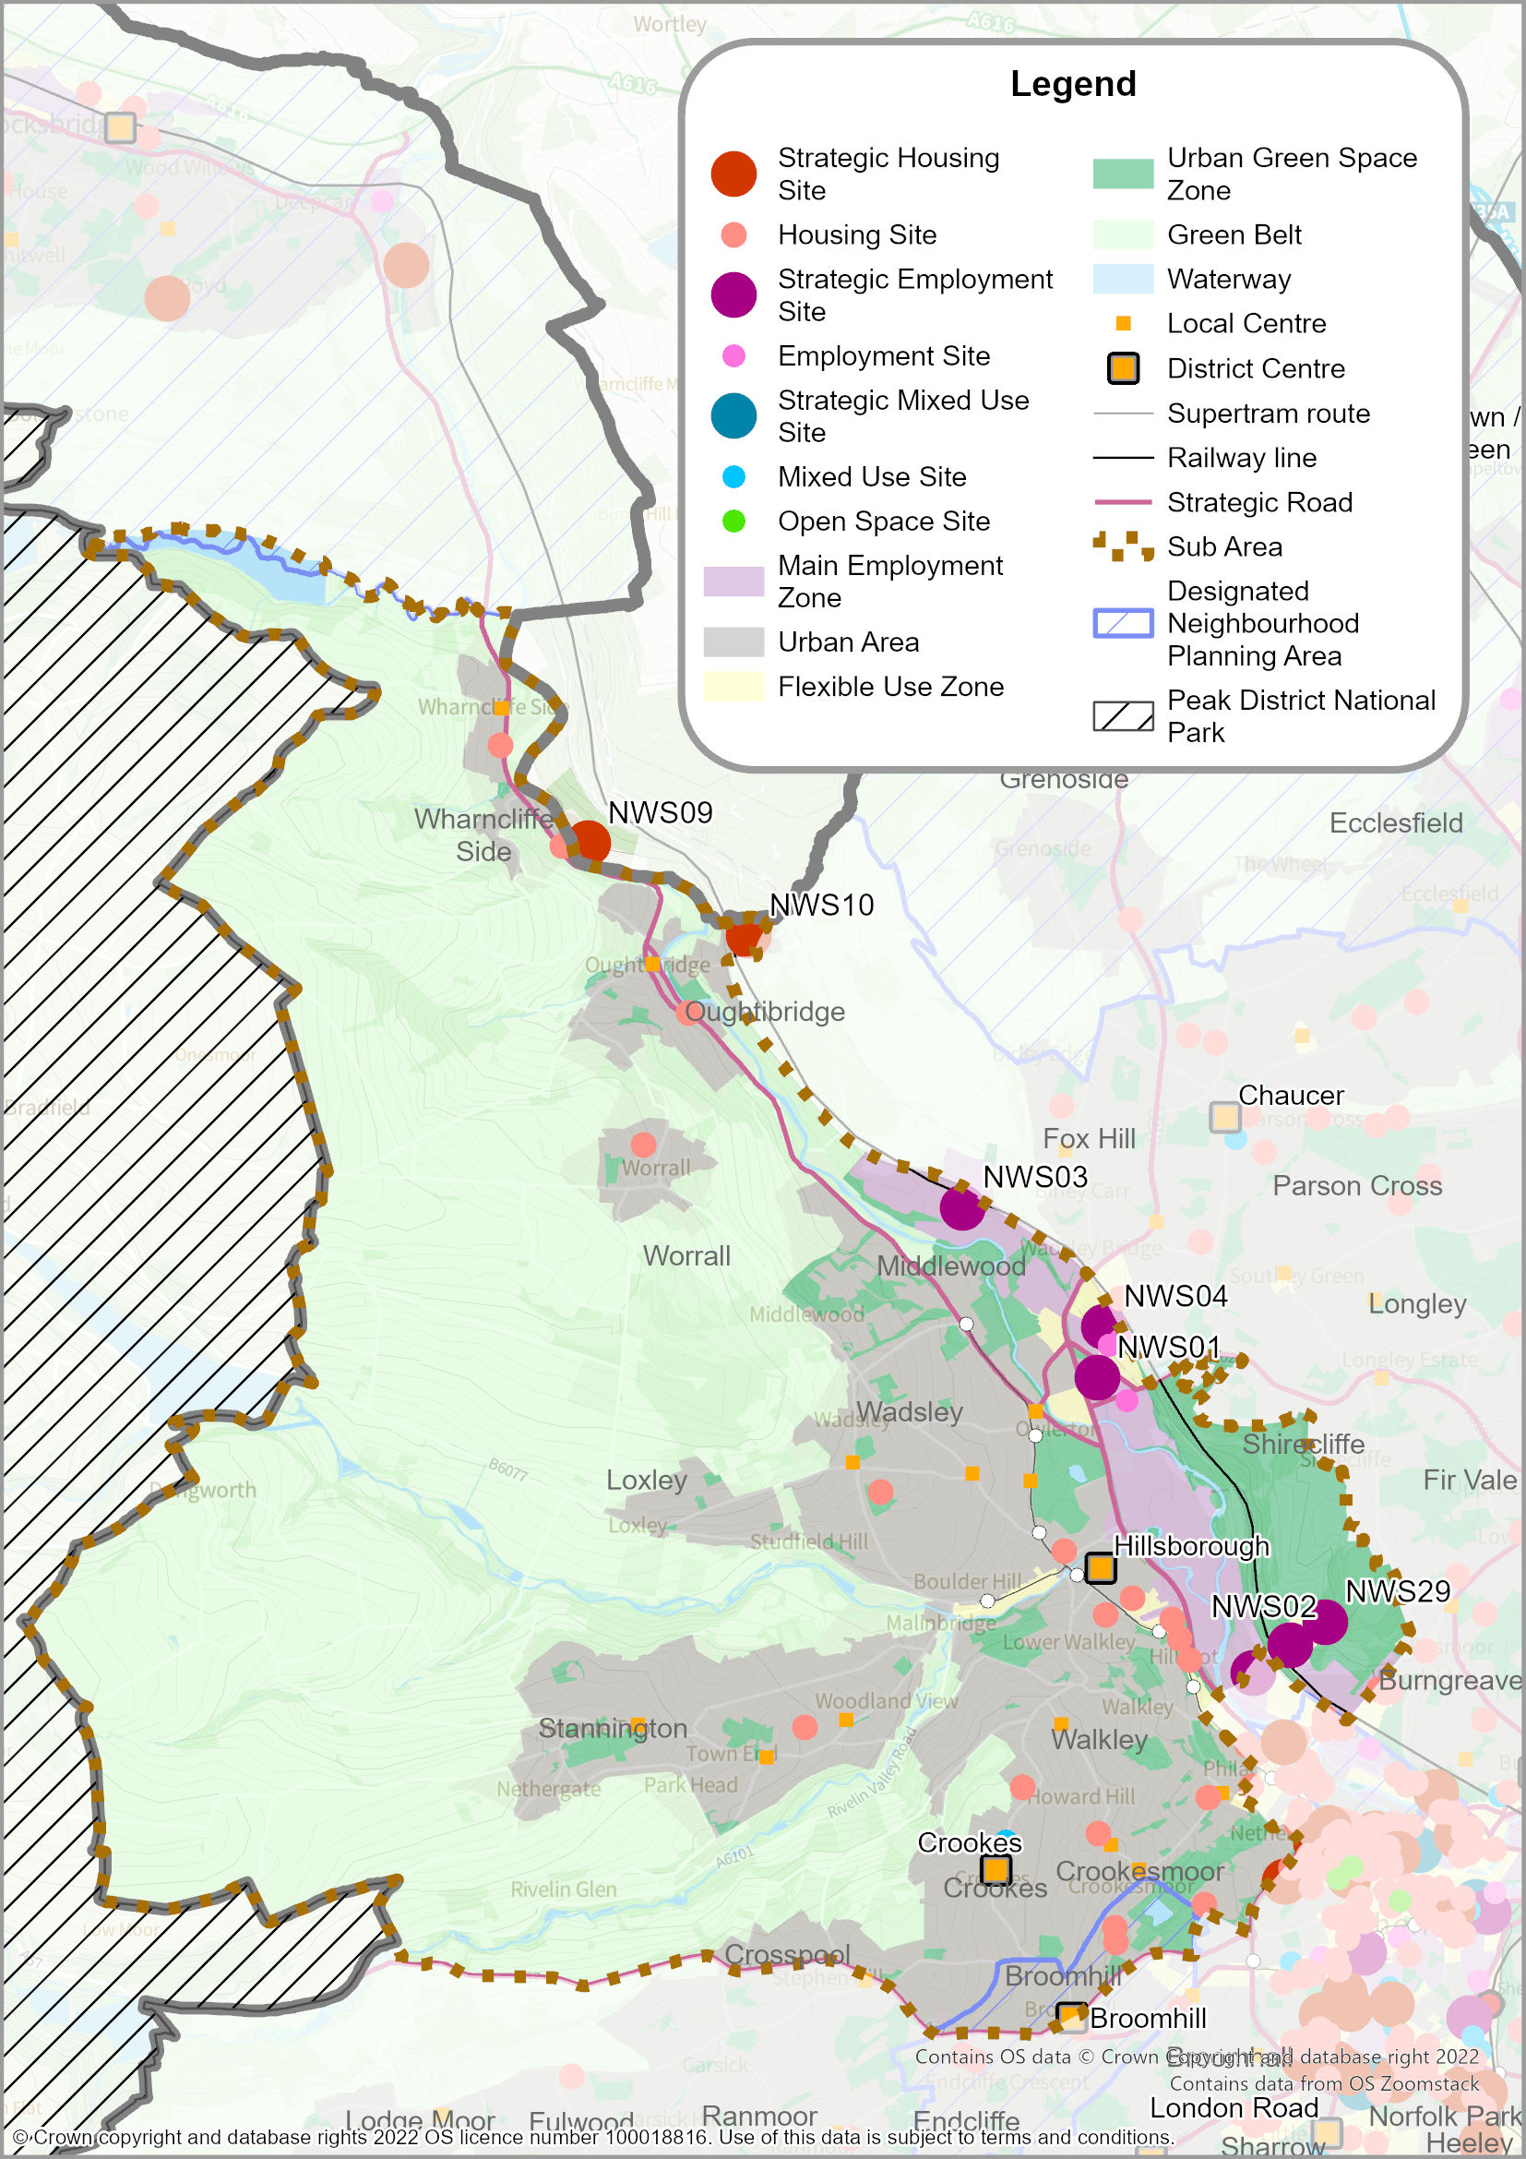
  - The Northwest Sheffield Sub-Area covers part of the Main Urban Area of Sheffield and includes several established residential areas (including Crookes, Crookesmoor, Hillsborough, Loxley, Middlewood, Stannington, Wadsley and Walkley). The larger villages of Oughtibridge, Wharncliffe Side and Worrall are all inset within the Green Belt; whereas the small villages of Brightholmlee and Dungworth are washed over by the Green Belt.
  - The sub-area’s role and function is shaped by the River Don and River Loxley, as well as established residential areas and a prominent industrial landscape. Parkwood Springs is a key asset for the sub-area and it extends to 150 hectares of open space. Parkwood Springs is valued for its outdoor recreation and heritage in the form of the Victorian Wardsend Cemetery.
  - The Rivelin and Loxley Valleys are popular areas for outdoor recreation, key to the sub-area’s industrial heritage, rich in biodiversity and connect the city to large areas of attractive countryside before it reaches the Peak District National Park. This land is almost entirely designated as Green Belt.
  - The tram connects Middlewood and Malin Bridge to the City Centre, although these areas are also particularly prone to congestion. There is no outer ring road in the Northwest so journeys across the area are convoluted and often cause congestion.
  - The area includes extensive employment areas in the Upper Don Valley, extending from the City Centre to Claywheels Lane and Wadsley Bridge (and including Neepsend, Hillfoot, Owlerton). The Penistone Road corridor offers employment and leisure opportunities, including Hillsborough Leisure Centre, the Greyhound Track, and a Casino.
POLICY SA2: NORTHWEST SHEFFIELD SUB-AREA
The sub-area includes part of the Main Urban Area of Sheffield; the Larger Villages of Oughtibridge, Wharncliffe Side, and Worrall; the District Centres of Hillsborough, Crookes and part of Broomhill; and 13 Local Centres.
Brightholmlee and Dungworth serve as Smaller Villages that are washed over by the Green Belt (see Policy GS2).
Development proposals in the Northwest Sheffield Sub-Area will:
- Deliver approximately 1,015 new homes, and 28.3 hectares of employment land (through a combination of existing planning permissions and new site allocations). Longer term housing growth will also take place within Flexible Uses Zones within the Upper Don Valley (‘Broad Locations for Growth’) where existing commercial uses will be allowed to transition to residential use (see Policies H1 and NC16).
- Deliver Site Allocations NWS01 to NWS29, including strategic sites: NWS01 to NWS04, NWS09, NWS10 and NWS29.
- Protect existing employment land in the Industrial and General Employment Zones in the Upper Don Valley and ensure it is a priority location for future employment, both in terms of supporting the expansion of businesses, and also for industrial uses relocating from the Central Sub-Area (see Policies EC4 and EC6).
- Consider the Upper Don Valley as the location to accommodate leisure developments serving smaller catchment areas.
- Support the vitality and vibrancy of the District Centres at Hillsborough, Crookes and Broomhill, and all Local Centres (see Policy SP3, Policy EC5, and Policy NC10).
- Deliver an Urban Country Park at Parkwood Springs, capitalising on the site’s natural, cultural and heritage assets, and to support Sheffield’s position as the UK’s “Outdoor City”.
- Deliver sustainable transport improvements, including:
- A61 highway junction improvements and links to Penistone Road, Shalesmoor;
- Support for the re-opening of the Don Valley Line, and associated connectivity improvements in partnership with SYMCA, and the rail industry;
- Active travel improvements, including projects proposed by Connecting Sheffield; and
- Mass Transit Corridors at: (i) City Centre to the Upper Don Valley; and (ii) City Centre to Chapeltown and High Green.
- Extend and enhance active travel routes along one bank of the Main Rivers (River Don, River Loxley, River Rivelin), wherever practicable and where it is consistent with biodiversity and heritage objectives
Definitions
- For ‘Industrial Zones’, ‘General Employment Zones’, ‘District Centres’, ‘Local Centres’, ‘Connecting Sheffield’ and ‘Mass Transit Corridors’- see Glossary.
Further information
A small part of the Northwest Sub-Area lies within the area covered by the Broomhill, Broomfield, Endcliffe, Summerville, Tapton (BBEST) Neighbourhood Plan (2021). The housing requirement figure for the Neighbourhood Plan area is set out in Policy SA7: Southwest Sheffield Sub-Area.

Northeast Sheffield Sub-Area
MAP 8: Northeast Sub-Area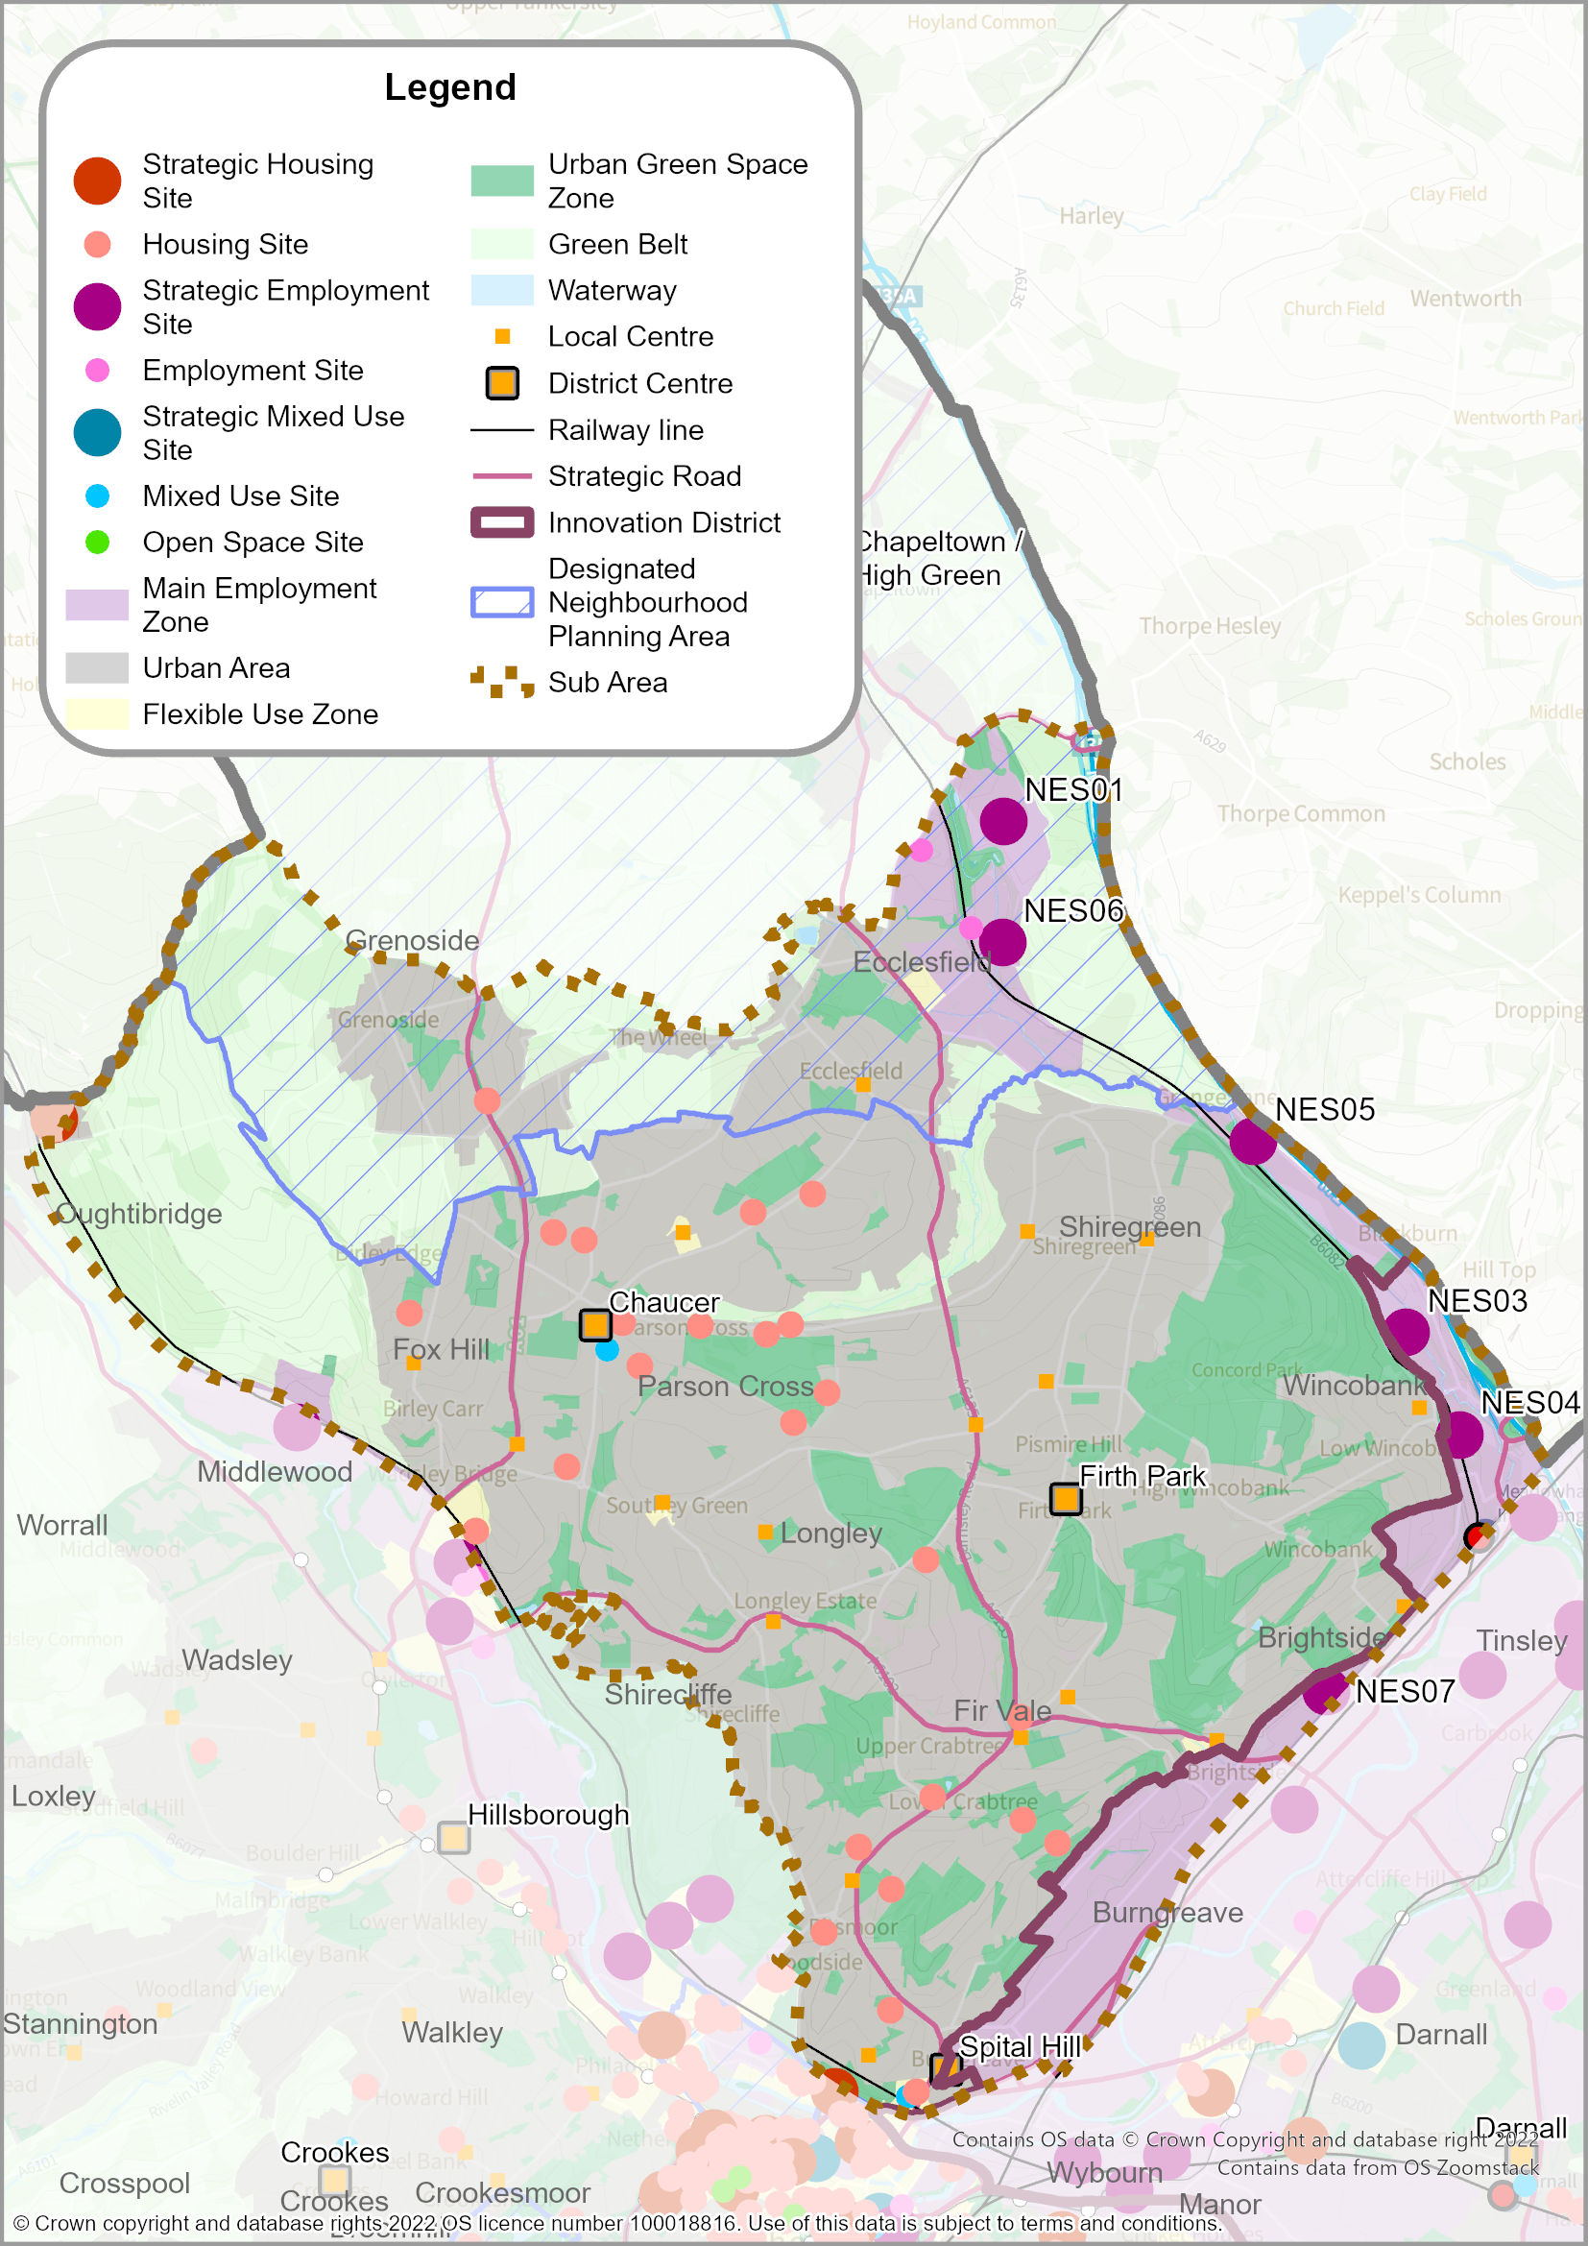
  - The Northeast Sheffield Sub-Area covers part of the Main Urban Area of Sheffield and is largely residential in character. It includes large areas of pre-war and post-war social housing (Fox Hill, Longley, Parson Cross, Shiregreen, Shirecliffe and Southey Green), as well as areas of mixed social and private housing (Wincobank and Grimesthorpe).
  - There are significant areas of Green Belt in the north of the sub-area, including large areas of woodland close to Grenoside (extending into the Chapeltown/High Green Sub-Area). This area also includes some of Sheffield’s largest parks, including Concord Park, Firth Park, Longley Park and Parson Cross Park.
  - The area is not accessible by tram but is conveniently located for easy access to the strategic highways network; the M1 Motorway runs along the eastern boundary. There are established industrial areas around Ecclesfield and the Blackburn Valley and one of Sheffield’s major hospitals, the Northern General, is located in the middle of the sub-area.
POLICY SA3: NORTHEAST SHEFFIELD SUB-AREA
The sub-area includes part of the Main Urban Area of Sheffield; the District Centres of Chaucer, Firth Park, and Spital Hill; as well as 18 Local Centres.
Development proposals in the Northeast Sheffield Sub-Area will:
- Deliver approximately 970 new homes, and 28.8 hectares of employment land (through a combination of existing planning permissions and new site allocations). Longer term housing growth may also take place within several of the Flexible Uses Zones in the Sub-Areas (‘Broad Locations for Growth’) where existing commercial uses will be allowed to transition to residential use (see Policies H1 and NC16).
- Deliver Site Allocations NES01 to NES35 - including strategic sites: NES01 and NES03 to NES07.
- Continue the regeneration of housing estates in collaboration with the Sheffield Housing Company and other house builders to continue developing cleared sites, particularly around Parson Cross and Fox Hill.
- Protect existing employment land at Blackburn Valley and Ecclesfield Common allowing them to contribute to the overall future supply of employment land, but with a local economic development role to provide local jobs and services (see Policy EC4 and Policy EC7).
- Support the vitality and vibrancy of the District Centres at Chaucer, Firth Park, and Spital Hill, and all Local Centres (see Policy SP3, Policy EC5, and Policy NC10).
- Prioritise the District Centres of Chaucer and Spital Hill for new education and training facilities.
- Provide a Health and Wellbeing District Hub at Parson Cross Park to improve the sport, leisure and recreation offer.
- Provide new open space provision at Woodside, and improved connections to recreation, leisure, and play facilities at Parkwood Springs, Nottingham Cliff Park, and Denholme Close.
- Deliver improvements to the resilience of the highway network at Junction 34N and Junction 35 of the M1 (in partnership with National Highways)
- Deliver sustainable transport improvements, including:
- implementing community-focused active neighbourhoods to improve walking and cycling access to local amenities;
- active travel connectivity between the City Centre and the Northern General Hospital and surrounding communities; and
- Mass Transit Corridors at: (i) part of the North Orbital; (ii) part of the City Centre to the Innovation District and Rotherham; and (iii) part of the City Centre to Chapeltown and High Green.

- Extend and enhance active travel routes along one bank of the Main Rivers (Blackburn Brook, Charlton Brook, Ecclesfield Brook, Hartley Brook, Whitley Brook, Bagley Dike), wherever practicable and where it is consistent with biodiversity and heritage objectives
Definitions
- ‘Health and Well-being District Hub’ – a building or buildings providing a range of health care facilities and services.
- For ‘District Centres’, ‘Local Centres’ and ‘Mass Transit Corridors’ - see Glossary.
- For the ‘Innovation District’ - see the Box on page 76 below.

East Sheffield Sub-Area
MAP 9: East Sub-Area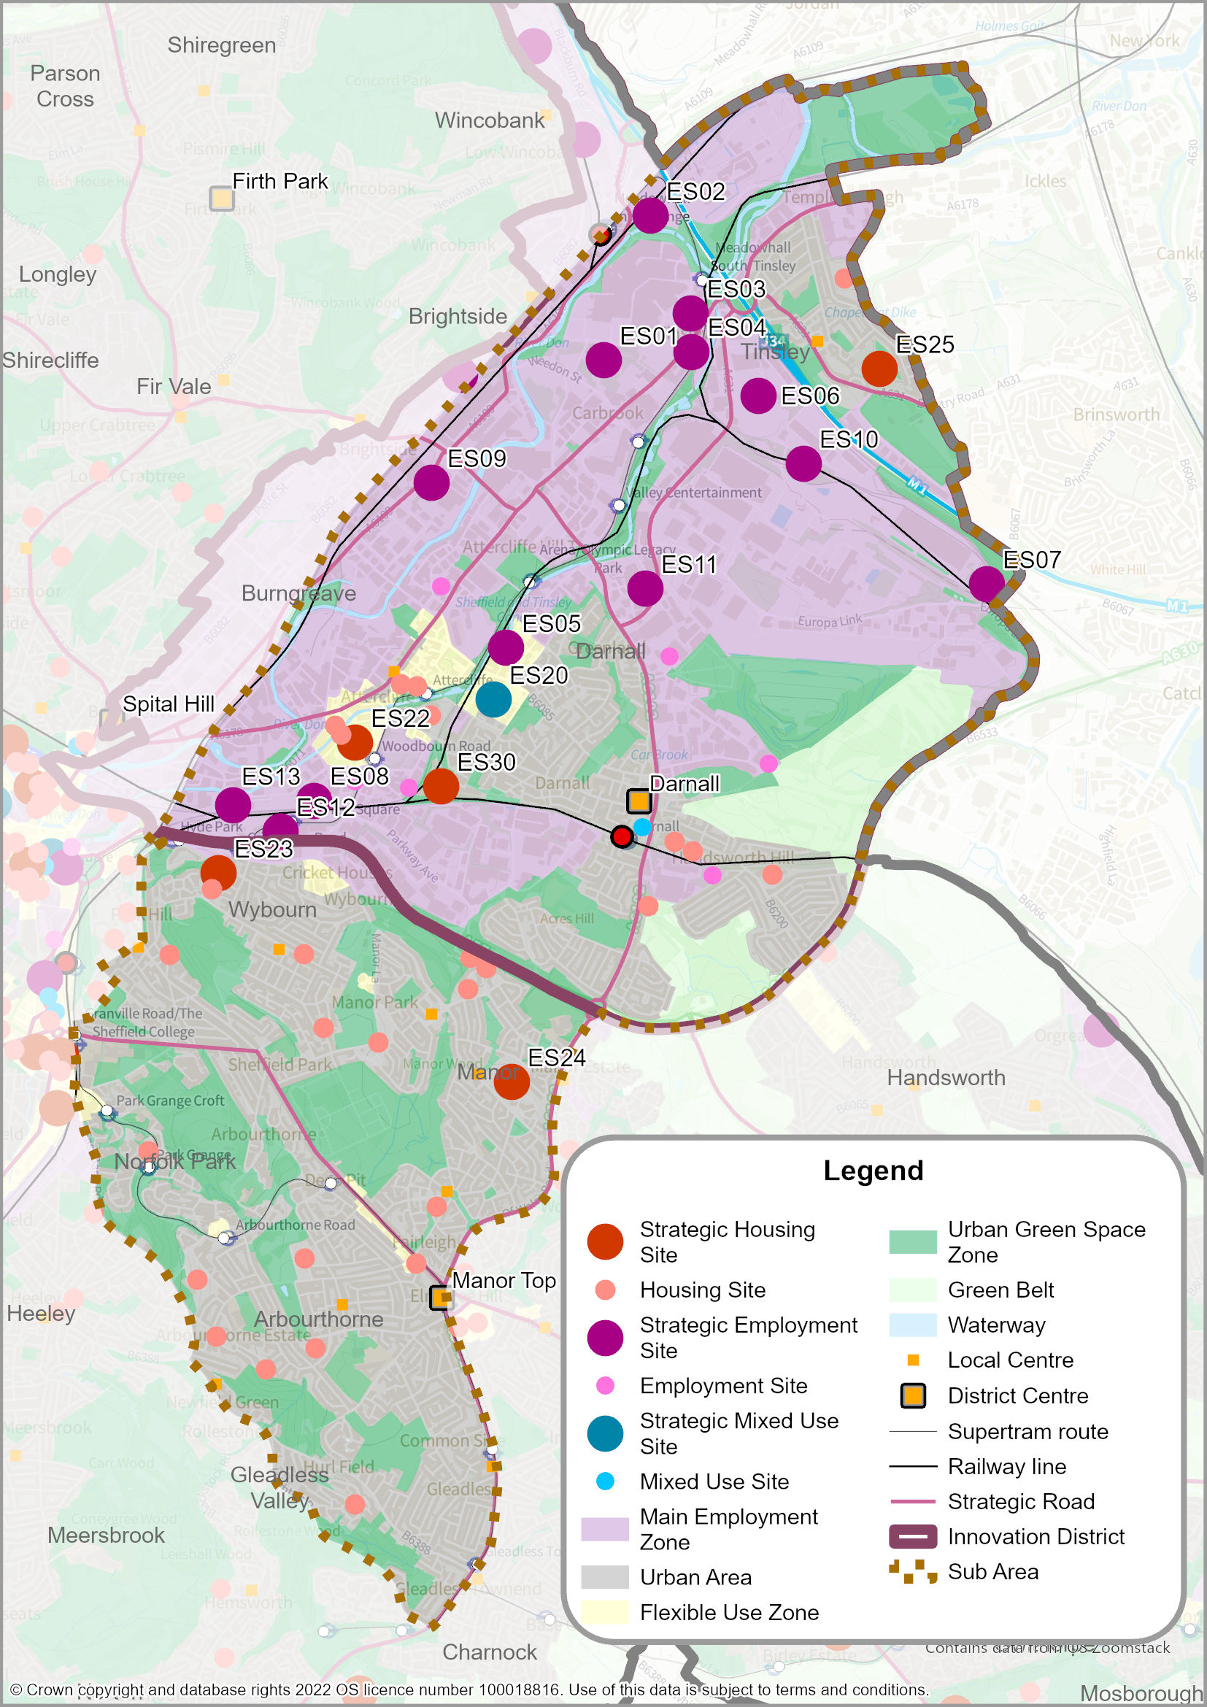
  - The East Sheffield Sub-Area includes a substantial part of the Main Urban Area of Sheffield and also includes the largest employment area, as well as established residential areas at Darnall, Tinsley, Wybourn, Arbourthorne, Norfolk Park and the Manor Estate.
  - The Lower Don Valley, which extends from the City Centre to Tinsley and east of the M1 Motorway, has seen extensive redevelopment over the last 30 years following the decline of the steel and engineering industries. The sub-area is home to the majority of the Innovation District which covers much of the Lower Don Valley and extends into Rotherham (see box below). The Meadowhall Shopping Centre, major sport and leisure related uses (e.g. Sheffield Arena, Centertainment, and English Institute of Sport) all lie in East Sheffield.
  - There are railway stations at Darnall and Meadowhall and the tram runs between the City Centre and Meadowhall. Although much of the Lower Don Valley is well-served by public transport, the area suffers from poor air quality and traffic congestion. Public transport connections across the area to the Sheffield Business Park, Advanced Manufacturing Research Centre (AMRC) and the Advanced Manufacturing Park (AMP) (in Rotherham) are also weak.
  - In the industrial areas of East Sheffield there are fewer green spaces in the built-up area than in other parts of the city. However, the Sheffield and Tinsley Canal runs through the Lower Don Valley from the City Centre to Tinsley, parallel with the River Don. These waterways provide attractive routes through the valley. In the residential areas around Norfolk Park and Manor, there are large parks and open spaces which provide recreational opportunities.

The Innovation District
The Innovation District is the UK’s leading Innovation District delivering innovation-led, advanced manufacturing and health research clusters. It represents one of the region’s greatest opportunities to deliver transformational economic development by creating a platform for innovation that will stimulate the economy of South Yorkshire and beyond. The area extends across the city boundary into Rotherham and includes four ‘hubs’ or campuses where there is a critical mass of world class innovation facilities and clusters of innovation-driven businesses which gives the Innovation District competitive advantage over other places nationally and internationally.
It also boasts developing centres of innovation excellence in advanced health and wellbeing as well as cutting edge sustainable energy research and redevelopment focussed on net-zero carbon processes. There are also proposals for further world-leading research in areas such as gene therapy, modern methods of construction and future mobility. With more than 30 nationally recognised research and development facilities, backed by Sheffield’s two universities, the Innovation District’s applied research capabilities are unrivalled and continue to attract world leading businesses such as McLaren, Rolls-Royce, Boeing and Cannon medical. The Innovation District already hosts over 120 advanced manufacturing and tech firms which employ more than 2,300 people. Ambitious plans being developed aim to generate 4,000 new jobs, 2,000 additional apprenticeships and supported by the creation of new homes.
The Innovation District is now entering a second phase and the Vision aims to deliver a more inclusive, resilient, integrated, and dynamic economy. It will be a place where people, places and businesses all play a complementary role in creating and sharing prosperity.
To realise the opportunity and secure success we will curate a dynamic, innovation led, ‘ecosystem’ that enables greater sharing of ideas and knowledge. The character and quality of the ‘place’ sets out a critical role in providing the supporting environment to facilitate greater collaboration between entrepreneurs, industry, and academia leading to greater diffusion and adoption of innovation.
The aim is to build and expand upon our businesses strengths and our collective innovation capabilities, so that more South Yorkshire start-ups and small manufacturing businesses can take advantage of opportunities in existing, growing and emerging sectors.
The Innovation District nucleus includes 4 campuses across 232 hectares. A new emerging masterplan will connect these areas and show how they can complement other areas of innovation expertise and clusters across South Yorkshire. These campuses are:
The Sheffield Olympic Legacy Park (OLP) - developed on the site of the former Don Valley Stadium, seeks to create a new science park focussed on applied advanced health and wellbeing innovation and connected opportunities for commercialisation.
Sheffield Business Park (SBP) is primarily occupied by innovation-focussed manufacturers but also includes complementary services and office functions. There is potential to create a new cluster of Innovation District related uses/activity at the western gateway of Sheffield Business Park with opportunities to exploit opportunities for convergence of research and technologies in relation to advanced health and wellbeing aligned to advanced manufacturing (medical devices for example).
The University of Sheffield Innovation District campus lies at the eastern gateway of SBP and is an exemplar Advanced Manufacturing Research Centre (AMRC). The ground-breaking AMRC Factory 2050 opened in 2017, marking the expansion of the Innovation District from a single site. Factory 2050 is a reconfigurable factory that can adapt to test and develop a range of new innovation processes which enables diversification beyond the well-established advanced manufacturing cluster.
The Advanced Manufacturing Park (AMP), lies just over the Sheffield boundary in Rotherham and includes the first AMRC group cluster. It has already delivered a successful and nationally important critical mass of advanced manufacturing and engineering firms and research and development facilities. The businesses established here have strong future growth potential supported by strong links to Sheffield’s universities, and opportunities for local and regional supply chain opportunities.

POLICY SA4: EAST SHEFFIELD SUB-AREA
The sub-area includes part of the Main Urban Area of Sheffield; the District Centres of Darnall and Manor Top; as well as 10 Local Centres.
Development proposals in the East Sheffield Sub-Area will:
- Deliver approximately 2,945 new homes, and 100.3 hectares of employment land (through a combination of planning permissions and new site allocations). Longer term housing growth will also take place within Flexible Uses Zones at Attercliffe (‘Broad Locations for Growth’) where existing commercial uses will be allowed to transition to residential use (see Policies H1 and NC16).
- Deliver Site Allocations ES01 to ES53 - including strategic sites: ES01 to ES13, ES20, ES22 to ES25 and ES30.
- Continue the regeneration of housing estates in collaboration with the Sheffield Housing Company, and other house builders, to continue developing cleared sites, especially at Norfolk Park, the Manor and Arbourthorne.
- Protect existing employment land within Industrial and General Employment Zones associated with the Innovation District (the Advanced Manufacturing Research Centre (AMRC)/Sheffield Business Park/Olympic Legacy Park) and across the Lower Don Valley (see Policy EC1, Policies EC3-EC4 and Policy EC6).
- Support the vitality and vibrancy of the District Centres at Darnall and Manor Top, and all Local Centres (see Policy SP3, Policy EC5, and Policy NC10).
- Prioritise Attercliffe for new primary education and healthcare facilities.
- Encourage leisure developments to locate within the Lower Don Valley, if they cannot be located in the City Centre.
- Deliver improvements to the resilience of the highway network at Junction 34N and Junction 35 of the M1 (in partnership with National Highways).
- Deliver sustainable transport improvements, including:
- implementing community-focused active neighbourhoods to improve walking and cycling access to local amenities;
- Meadowhall Interchange Mobility Hub; and
- Mass Transit Corridors at (i) City Centre via the Innovation District to Rotherham; and (ii) part of City Centre to Southeast.
- Safeguard the route of the potential Innovation Corridor road scheme, linking Meadowhall Road and Europa Link;

- Extend and enhance active travel routes along one bank of the Main Rivers (River Don, Blackburn Brook, Carr Brook, Kirkbridge Dike and Bagley Dike), wherever practicable and where it is consistent with biodiversity and heritage objectives
Definitions
- For ‘Industrial Zones’, ‘General Employment Zones’, ‘Innovation District’, ‘District Centres’, ‘Local Centres’, and ‘Mass Transit Corridors’ - see Glossary.

Southeast Sheffield Sub-Area
MAP 10: Southeast Sub-Area
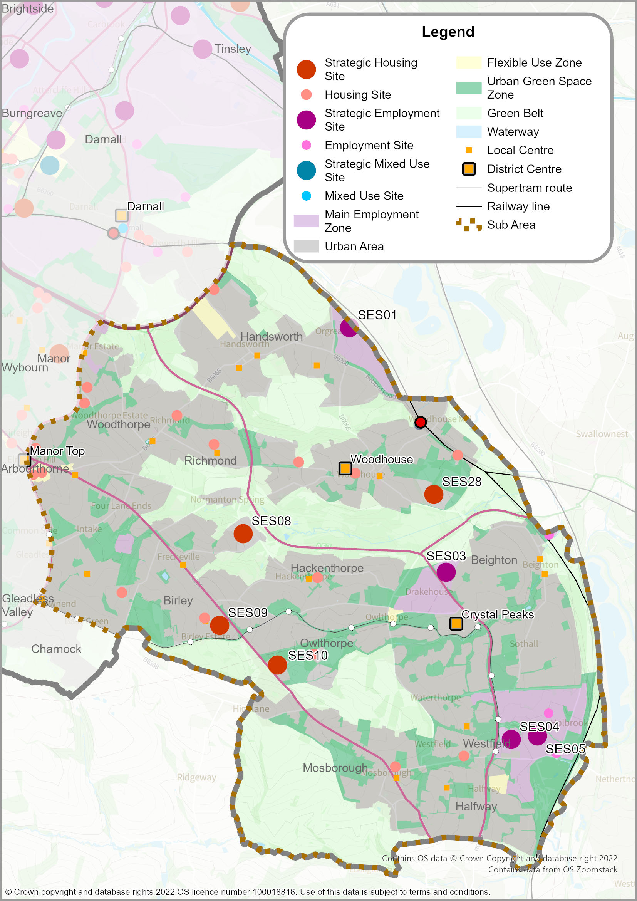
  - The Southeast Sheffield Sub-Area is predominantly residential in nature with a mix of owner-occupied and social housing set within an extensive landscape framework. A series of ‘townships plans’ delivered large suburban estates from the 1970s onwards, including Hackenthorpe, Waterthorpe, Owlthorpe, Sothall and Westfield, as well as housing developed around the old village cores of Woodhouse, Beighton and Mosborough. The Scowerdons, Weakland and Newstead (SWaN) estates are part way through a programme of regeneration. The northern part of the sub-area also includes the large residential areas of Handsworth, Richmond and the Woodthorpe Estate, with Birley, Frecheville, Base Green and Intake in the west.
  - The sub-area includes large areas of Green Belt which extend into the valleys adjacent to the urban areas (especially the Shirebrook and Shirtcliff Valleys and a large area of countryside between Owlthorpe and Mosborough). These areas are widely used by local people for recreation and contribute to creating popular suburbs. Countryside to the west and south of Mosborough and south of Oxclose extends into North East Derbyshire District and helps to separate the Main Urban Area of Sheffield from Eckington. The tram connects the sub-area to the City Centre and includes tram stops at Owlthorpe and Crystal Peaks District Centre, terminating at Halfway. The sub-area includes one of the only sections of outer-ring road in the city and has good access to the M1 Motorway. Crystal Peaks District Centre, including the indoor shopping centre, provides a focus for retail and leisure as well as local employment. There are two main employment areas at Handsworth (Dore House) and Holbrook.
POLICY SA5: SOUTHEAST SHEFFIELD SUB-AREA
The sub-area includes part of the Main Urban Area of Sheffield; the District Centres of Crystal Peaks and Woodhouse (Manor Top lies partly in the South East and East); as well as 19 Local Centres.
Development proposals in the Southeast Sheffield Sub-Area will:
- Deliver approximately 1,640 new homes, and 22.6 hectares of employment land (through a combination of planning permissions and new site allocations). Longer term housing growth will also take place within Flexible Uses Zones within the Sub-Area (‘Broad Locations for Growth’) where existing commercial uses will be allowed to transition to residential use (see Policies H1 and NC16).
- Deliver Site Allocations SES01 to SES28 - including strategic sites: SES01, SES03 to SES05, SES08 to SES10and SES28.
- Protect existing employment land at Holbrook Industrial Estate and Dore House Industrial Estate, allowing them to contribute to the overall future supply of employment land but with a local economic development role to provide local jobs and services (see Policy EC4 and Policy EC6).
- Support the vitality and vibrancy of the District Centres at Crystal Peaks, Woodhouse, and Manor Top; and all Local Centres (see Policy SP3, Policy EC5, and Policy NC10).
- Provide a Gypsy & Traveller Site as part of the employment site allocation SES3 - Land East of Eckington Way, Beighton (see Policy H1 and Policy NC7).
- Designate a Local Green Space at Owlthorpe Fields (Policy GS1).
- Deliver sustainable transport improvements, including:
- implementing community-focused active neighbourhoods to improve walking and cycling access to local amenities;
- Support for the re-opening of the Barrow Hill Line to passengers, including new railway stations at Beighton, Waverley (partly in Rotherham) and Killamarsh; and
- Mass Transit Corridor from City Centre to the Southeast

- Extend and enhance active travel routes along one bank of the Main Rivers (River Rother, The Moss, Ochre Dike and Shirtcliff Brook), wherever practicable and where it is consistent with biodiversity and heritage objectives
Definitions
- For District Centres’, ‘Local Centres’, ‘Local Green Space’ and ‘Mass Transit Corridors’ - see Glossary.

South Sheffield Sub-Area
MAP 11: South Sub-Area
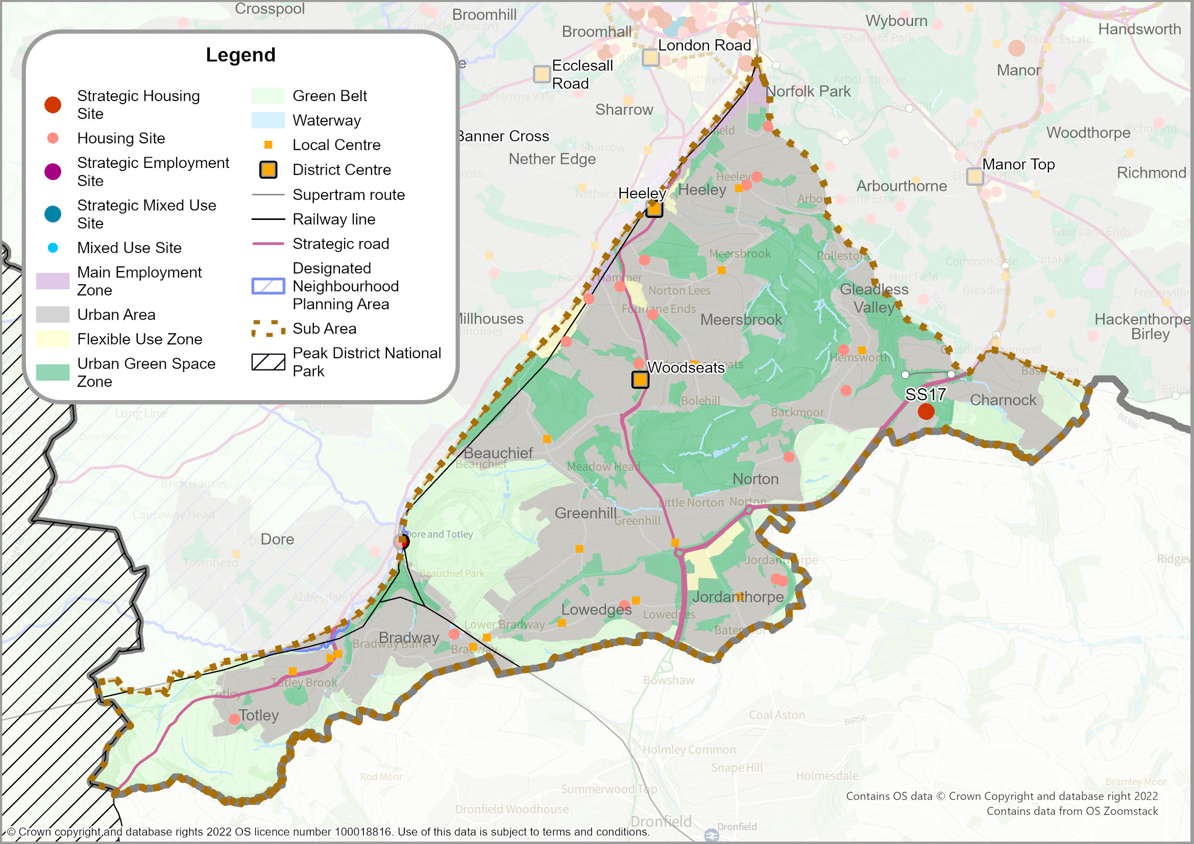
  - The South Sheffield Sub-Area is largely residential and characterised by large open spaces. Much of the housing is private owner-occupied, but there are also significant areas of social housing in the Gleadless Valley and at Jordanthorpe, Batemoor, and Lowedges. Other residential areas include Totley and Bradway on the south-western edge of the city, Beauchief, Greenhill, Meadowhead, Hemsworth, Herdings, Charnock, Norton and Woodseats, and closer to the City Centre - Heeley, Lowfield and Meersbrook.
  - The built-up area extends close to the city boundary but there are areas of Green Belt, especially on the south and south-western edges of the urban area. Historic Oakes Park also lies in the Green Belt. These areas form part of the wider Green Belt which extends into North East Derbyshire District. Beauchief Park forms a large wedge of Green Belt extending into the urban area. The city’s largest park, Graves Park, lies within the sub-area, but there are also other large areas of open space in the Gleadless Valley. The Peak District National Park lies close to the west of Totley.
  - The tram from the City Centre terminates at Herdings Park. The outer ring road serves part of the area and the A61 provides the main route into Sheffield from Chesterfield. The main employment area is in the Sheaf Valley and there are retail parks at Heeley and Meadowhead.
POLICY SA6: SOUTH SHEFFIELD SUB-AREA
The sub-area includes part of the Main Urban Area of Sheffield; the District Centres of Heeley and Woodseats; as well as 15 Local Centres.
Development proposals in the South Sheffield Sub-Area will:
- Deliver approximately 765 new homes (through a combination of planning permissions and new site allocations). Longer term housing growth will also take place within Flexible Uses Zones within the Sub-Area (‘Broad Locations for Growth’) where existing commercial uses will be allowed to transition to residential use (see Policies H1 and NC16).
- Deliver Site Allocations SS01 to SS18 - including strategic housing site SS17: former Norton Aerodrome.
- Protect existing employment land within General Employment Zones in the Sheaf Valley allowing it to contribute to the overall future supply of employment land but with a local economic development role to provide local jobs and services (see Policy EC3 and Policy EC6).
- Continue the regeneration of housing estates in collaboration with the Sheffield Housing Company, and other house builders, to continue developing cleared sites, particularly at Gleadless as part of the Gleadless Valley Masterplan.
- Protect existing Green Belt boundaries (see Policy GS2), with the exception of the proposed strategic release of the brownfield site allocation SS17 - former Norton Aerodrome.
- Designate a Local Green Space at Bolehill Woods at Norton Woodseats (Policy GS1).
- Support the vitality and vibrancy of the District Centres at Heeley and Woodseats, and Local Centres (see Policy SP3, Policy EC5, and Policy NC10).
- Deliver sustainable transport improvements, including:
- implementing community-focused active neighbourhoods to improve walking and cycling access to local amenities;
- Sheaf Valley Cycle Route; and
- Mass Transit Corridor at City Centre to Meadowhead.

- Extend and enhance active travel routes along one bank of the Main Rivers (River Sheaf, Totley Brook, Oldhay Brook, Abbey Brook and Meersbrook), wherever practicable and where it is consistent with biodiversity and heritage objectives

Definitions
- For ‘General Employment Zones’, ‘District Centres’, ‘Local Centres’, ‘Local Green Space’ and ‘Mass Transit Corridors’ - see Glossary.

Southwest Sheffield Sub-Area
MAP 12: Southwest Sub-Area
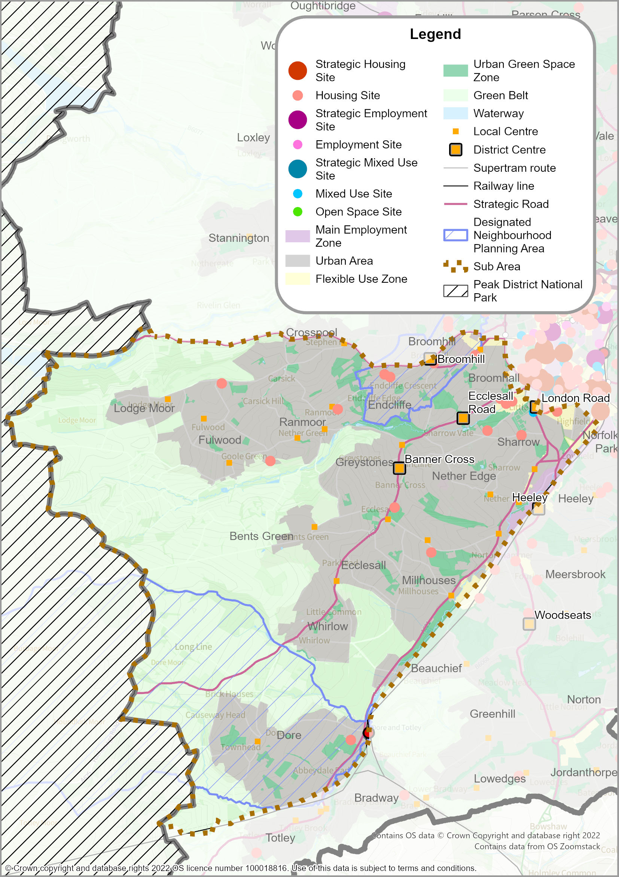

  - The Southwest Sheffield Sub-Area includes the suburbs of Broomhill, Broomhall, Crosspool, Ecclesall, Endcliffe, Fulwood, Greystones, Lodge Moor, Millhouses, Nether Edge, Nether Green, Ranmoor, Sandygate, Somerfield, Tapton and Whirlow. It also includes housing that has developed around the old village core at Dore as well as areas on the edge of the City Centre (Sharrow, Highfield). The area includes significant areas of Victorian and Edwardian housing, much of which are designated as Conservation Areas.
  - The area includes extensive areas of attractive countryside, which is designated as Green Belt, and popular parks and woodland. The very small village of Ringinglow straddles the boundary with the Peak District National Park and is within the Green Belt (on the Sheffield side of the boundary). The sub-area provides some of the main ‘gateway’ routes into the Peak District National Park with the Porter Valley providing a major recreational route linking the urban area to the countryside.
  - There is a railway station at Dore but the sub-area is not served by the tram and does not have an outer ring road; there is frequent congestion on main routes into the City Centre. Industry or manufacturing are largely limited to the Sheaf Valley but most of the city’s major hospitals, parts of the university campuses, and several large schools are located in the sub-area albeit in those locations which are closest to the Central Sub-Area. Local businesses have led the creation of the Antiques Quarter around Abbeydale Road, reinforcing the area's identity as an independent retail destination.
  - Two Neighbourhood Plans have been adopted in the sub-area: (i) Dore Neighbourhood Plan (2021), whose neighbourhood area extends into the Peak District National Park (so includes some areas that are not covered by the Sheffield Plan); and (ii) Broomhill, Broomfield, Endcliffe, Summerfield and Tapton (BBEST) Neighbourhood Plan (2021), whose neighbourhood area straddles the boundary between the Southwest Sub-Area and Northwest Sub-Area.
POLICY SA7: SOUTHWEST SHEFFIELD SUB-AREA
The sub-area includes part of the Main Urban Area of Sheffield; the District Centres of Banner Cross, Broomhill, Ecclesall Road, and part of London Road, as well as 20 Local Centres.
Ringinglow serves as a Smaller Village that is washed over by the Green Belt (see Policy GS2).
Development proposals in the Southwest Sheffield Sub-Area will:
- Deliver approximately 755 new homes and 0.02 hectares of employment land (through a combination of planning permissions and new site allocations). Longer term housing growth will also take place within Flexible Use Zones within the Sheaf Valley (‘Broad Locations for Growth’) where existing commercial uses will be allowed to transition to residential use (see Policies H1 and NC16).
- Deliver a housing requirement figure for the two neighbourhood plan areas:
- Dore - at least 40 homes (including homes which already have planning permission and windfall sites); and
- Broomhill, Broomfield, Endcliffe, Summerfield and Tapton (BBEST) – at least 224 homes (and will be limited to conversion or redevelopment of existing buildings and sites).
- Deliver Site Allocations SWS01 to SWS17.
- Protect existing employment land within the General Employment Zones in the Sheaf Valley allowing it to contribute to the overall future supply of employment land but with a local economic development role to provide local jobs and services (see Policy EC3 and Policy EC6).
- Support the vitality and vibrancy of the District Centres at Banner Cross, Broomhill, Ecclesall Road, and London Road, and Local Centres (see Policy SP3, Policy EC5, and Policy NC10).
- Enhanced and accessible green spaces and recreation opportunities, with specific initiatives: Porter Valley Recreation Cluster - comprising a series of linked greenspace and recreational facilities, with opportunities to grow outdoor recreational opportunities; and Carterknowle District Park to further improve this local sport and recreation hub.
- Help realise projects (including Connecting Sheffield) that deliver sustainable transport improvements, including:
- implementing community-focused active neighbourhoods to improve walking and cycling access to local amenities;
- the Sheaf Valley Cycle Route;
- a cycle route connecting the City Centre to Nether Edge;
- operational improvements to bus services;
- upgrades to the Hope Valley Line to increase capacity at Dore and Totley Station; and
- a Mass Transit Corridor from part of City Centre to the Southwest.

- Extend and enhance active travel routes along one bank of the Main Rivers (River Sheaf and Porter Brook), wherever practicable and where it is consistent with biodiversity and heritage objectives
Definitions
- For ‘General Employment Zones’, ‘neighbourhood plan’, ‘District Centres’, ‘Local Centres’, ‘Connecting Sheffield’ and ‘Mass Transit Corridor’ - see Glossary.

Stocksbridge/Deepcar Sub-Area
MAP 13: Stocksbridge/Deepcar
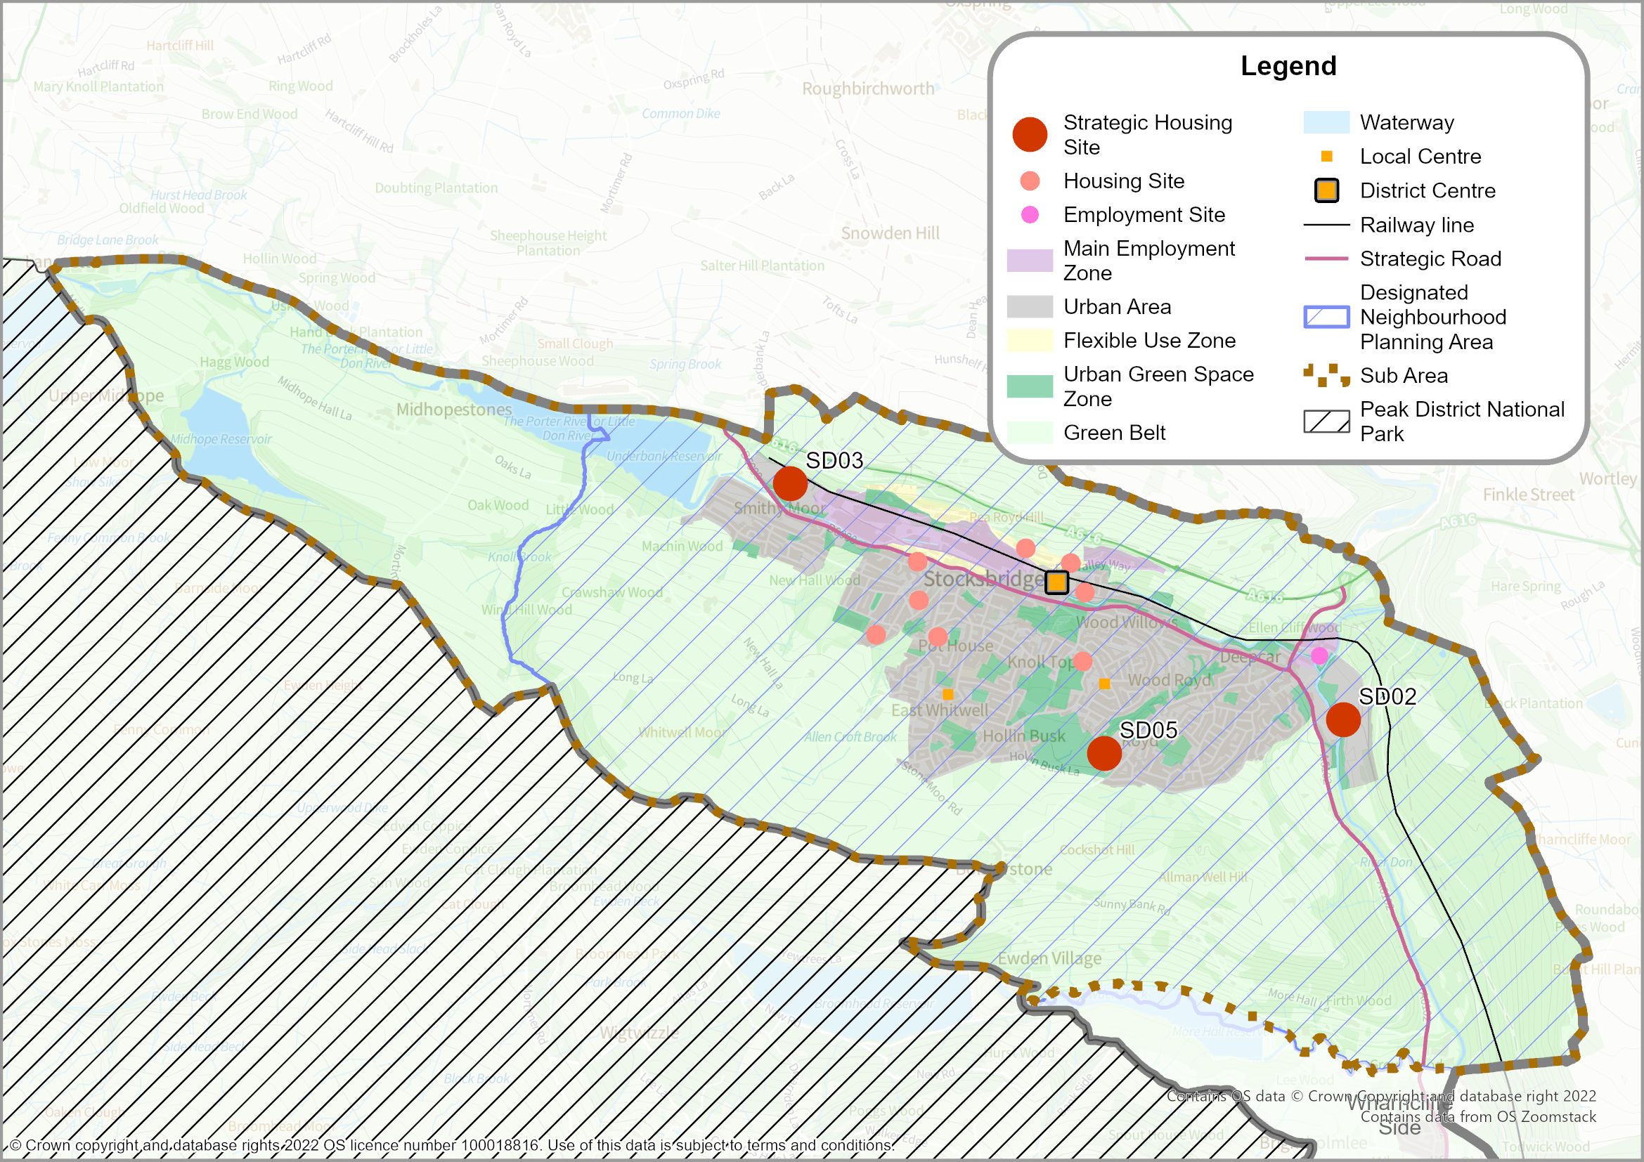
  - Stocksbridge lies to the northwest of the Main Urban Area of Sheffield, close to the boundary with Barnsley. It adjoins Deepcar and provides a popular place to live with a wide mix of social and private housing.
  - The sub-area’s role and function is contextualised by its proximity to the Peak District National Park, which lies to the southwest, as well as significant areas of Green Belt, which help to provide a rural setting.
  - The town of Stocksbridge is dominated by the major steelworks in the valley bottom. However, the area covered by the steelworks has contracted over the last few years as land has been redeveloped for an extension to Stocksbridge District Centre (Fox Valley Shopping Centre) and for housing. There is a wide range of shops and local facilities within the District Centre. Stocksbridge Leisure Centre is located outside the centre on the southern edge of the town and is run by the local community. A small employment area at Deepcar also provides local employment opportunities.
  - The A616 lies just to the north of the town, linking Sheffield and Manchester and providing convenient access to the M1 Motorway. The small villages of Bolsterstone, Ewden and Midhopestones are near the National Park boundary and there are several local reservoirs that provide a distinctive setting as well as recreational opportunities.
  - There is a long-standing ambition to open the existing freight line to passengers in order to allow easier access into Sheffield City Centre.
  - A neighbourhood area has been designated for Stocksbridge, although no Neighbourhood Plan has yet been ‘made’ (adopted). The designated area covers the Stocksbridge Town Council area and includes a substantial part of the Stockbridge/Deepcar Sub-Area. Policy SA8 sets the housing requirement for the sub-area and is this figure which would be included in any forthcoming Stocksbridge Neighbourhood Plan.
POLICY SA8: STOCKSBRIDGE/DEEPCAR SUB-AREA

The sub-area includes the Principal Town of Stocksbridge and Deepcar, served by Stocksbridge District Centre and Local Centres at Pot House and Stubbin/Lee Avenue. Midhopestones, Bolsterstone, and Ewden Village serve as Smaller Villages that are washed over by the Green Belt (see Policy GS2).
Development proposals in the Stocksbridge/Deepcar Sub-Area will:
- Deliver approximately 928 new homes on large sites, and 0.89 hectares of employment land (through a combination of planning permissions and site allocations). Longer term housing growth will also take place within Flexible Uses Zones within the Upper Don Valley (‘Broad Locations for Growth’) where existing commercial uses will be allowed to transition to residential use (see Policies H1 and NC16).
- Deliver a housing requirement figure for the designated neighbourhood plan area: Stocksbridge – at least 983 homes (including homes on small sites which already have planning permission).
- Deliver Site Allocations SD01 to SD03 and SD05 to SD13 – including strategic sites: SD02, SD03 and SD05.
- Protect existing employment land at Stocksbridge steel works, and Wharncliffe Industrial Area, Deepcar allowing them to contribute to the overall future supply of employment land, but with a local economic development role to provide local jobs and services (see Policy EC4 and Policy EC6).
- Support the vitality and vibrancy of the District Centre at Stocksbridge and Stocksbridge/Fox Valley and all Local Centres (see Policy SP3, Policy EC5, and Policy NC10).
- Deliver sustainable transport improvements, including:
- implementing community-focused active neighbourhoods to improve walking and cycling access to local amenities;
- Support for the re-opening of the Don Valley Line, and associated connectivity improvements in partnership with SYMCA, and the rail industry; and
- Mass Transit Corridor from the City Centre to the Upper Don Valley

- Extend and enhance active travel routes along one bank of the Main Rivers (River Don, Little Don, Clough Dike), wherever practicable and where it is consistent with biodiversity and heritage objectives
Definitions
- For District Centres’, ‘Local Centres’, ‘neighbourhood plan’ and ‘Mass Transit Corridors’ - see Glossary.

Chapeltown/High Green Sub-Area
MAP 14: Chapeltown/High Green
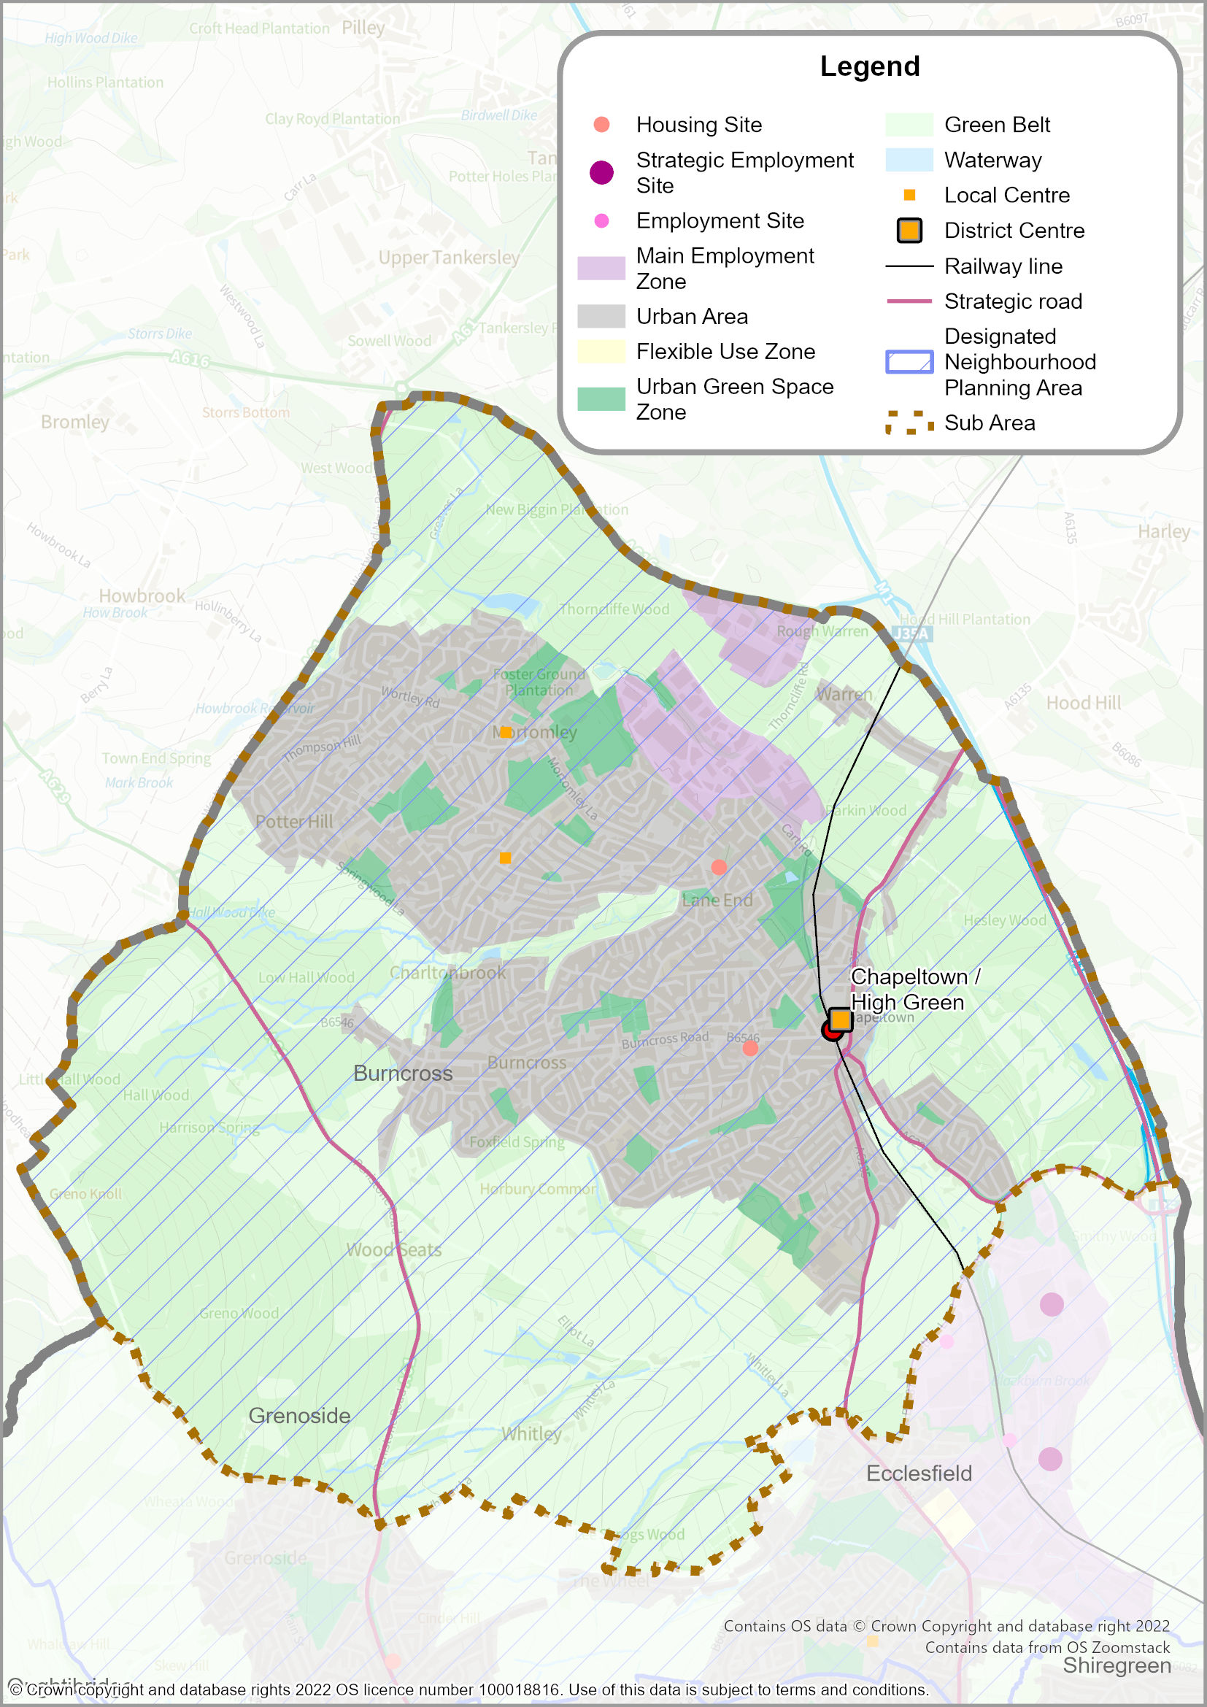
  - Chapeltown/High Green is a popular place to live. It lies to the north of Sheffield close to the boundary with both Barnsley and Rotherham and includes a mix of social and private housing.
  - The urban areas of Chapeltown/High Green are surrounded by Green Belt, which serves to separate the town from the Main Urban Area of Sheffield. The Green Belt around Chapeltown/High Green includes extensive areas of woodland (including Grenowoods, Hesley Wood, Thorncliffe Wood and Parkin Wood).
  - The town is well connected with access to the M1 Motorway to the east and there is a railway station at Chapeltown providing easy access to the City Centre of Sheffield.
  - A neighbourhood area has been designated for Ecclesfield, although no Neighbourhood Plan has yet been ‘made’ (adopted). The designated area covers the Ecclesfield Parish Council area, which includes all of the Chapeltown/High Green Sub-Area, and also extends part-way into the Northeast Sheffield Sub-Area. Policy SA9 sets the housing requirement for the Chapeltown/High Green Sub-Area and is this figure which would be included in any forthcoming Ecclesfield Neighbourhood Plan.
POLICY SA9: CHAPELTOWN/HIGH GREEN SUB-AREA
❡
The sub-area includes the Principal Town of Chapeltown/High Green. Chapeltown also serves as a District Centre, and there are Local Centres at Wortley Road and Greengate Lane.
Whitley serves as a Smaller Village that is washed over by the Green Belt (see Policy GS2).
Development proposals in the Chapeltown/High Green Sub-Area will:
- Deliver approximately 25 new homes on large sites, and 1.03 hectares of employment land (through a combination of existing planning permissions and site allocations).
- Deliver a housing requirement figure for the designated neighbourhood plan area: Ecclesfield - at least 145 homes (including homes on small sites which already have planning permission).
- Deliver Site Allocations CH01 and CH02.
- Protect existing employment land at the Thorncliffe Industrial Areas, allowing it to contribute to the overall future supply of employment land, but with a local economic development role to provide local jobs and services (see Policy EC4 and Policy EC6).
- Protect existing Green Belt boundaries (see Policy GS2).
- Support the vitality and vibrancy of the District Centre at Chapeltown, and all Local Centres (see Policy SP3, Policy EC5, and Policy NC10).
- Deliver improvements to the resilience of the highway network at Junction 34N and Junction 35 of the M1 (in partnership with National Highways).
- Deliver sustainable transport improvements, including:
- implementing community-focused active neighbourhoods to improve walking and cycling access to local amenities;
- Mass Transit Corridor from the City Centre to Chapeltown and High Green.
Definitions
- For District Centres’, ‘Local Centres’, ‘neighbourhood plan’ and ‘Mass Transit Corridors’ - see Glossary.

Topic Policies

Housing

Housing Growth and Housing Land Supply
  - Section 3 sets out the overall growth plan for Sheffield. Policy SP1 establishes Sheffield’s housing requirement figure. The approach to housing is sufficient to support the city’s economic growth aspirations and forecast levels of population and household change over the period 2022-2039.
  - It also takes into account the need to replace an average of 50 homes per year that are expected to be lost through demolition or conversion. The level of demolition is lower than in previous years because the majority of large-scale clearance of former Council housing has been completed.
  - Sufficient land supply has been identified to meet the proposed number of new homes over the period 2022 to 2039 (see Table 1 below). Sufficient deliverable sites have been allocated to provide a supply for the first five years of the plan period after adoption, these represent sites that have planning permission, and the identified site allocations. A further supply of developable sites will come forward on other sites, future allocations (which will emerge mainly in the Broad Locations for Growth - see below) and through development on windfall sites.
  - Allocated housing sites provide a significant margin of in supply, over and above the requirement for the first five years after adoption (2024-2029). This provides choice and flexibility in case some sites in the urban areas do not come forward, or if the need for new homes increases in the future. This is consistent with the NPPF. Some of the developable supply could come forward earlier than indicated but there is not yet sufficient evidence to show it is deliverable before 2029. The supply will be monitored annually.
  - Policy SP1 introduced the concept of ‘Broad Locations for Growth’. These are further highlighted in the policy approach for Northwest Sheffield (Policy SA2), Northeast Sheffield (Policy SA3), East Sheffield (Policy SA4) and Southwest Sheffield (Policy SA7), and (see box below for further explanation).
  - Public intervention will be needed to enable much of the former employment land to transition to sustainable, desirable residential areas. Within these areas, major improvements to neighbourhood facilities and services, highway infrastructure and flood defences will help raise land values and this is expected to improve the economic viability of development sites over time. Many of the potential development sites have multiple owners and the Council intends to work with landowners, tenants and other stakeholders to promote high quality new residential development. Financial support from the Government could enable sites to come forward sooner.
Broad Locations for Growth
Areas of the city where more housing is likely to be delivered on brownfield sites in the longer term are referred to as ‘Broad Locations for Growth’. They are areas which are already transitioning (or have potential to transition) from employment uses to housing, sometimes with public sector support. They include parts of the Upper Don Valley, the Lower Don Valley and the Sheaf Valley but there are Flexible Use Zones in most of the Sub-Areas where this is happening.
There is not yet sufficient certainty to allocate all the land that is potentially suitable for housing in these areas. Further work is needed to assemble sites, relocate existing uses, and plan for new infrastructure.
The Council’s analysis suggests that together, developable sites in the Broad Locations for Growth and windfalls on larger sites in other areas, could provide around 4,675 additional homes. This is over and above the Site Allocations and windfalls on small sites. Much of the additional developable supply is likely to be delivered after 2029 (years 6-15 of the Plan period).

  - Table 2 below provides a breakdown of the number of new homes proposed in each sub-area. This summarises the figures and information set out in Policy SA1 to Policy SA9.

Gypsies and Travellers
  - Policy SP1 also sets out the need for new pitches/plots for Gypsies and Travellers. The need identified in the policy includes those covered in the definition in the Annex to the national Planning Policy for Travellers Sites but also covers travellers who are not persons of nomadic habit of life but who identify as travellers.
  - The Sheffield Gypsy and Traveller Accommodation Assessment (2019) found a need for 44 new pitches/plots between 2019 to 2024, increasing to 50 pitches/plots by 2034. 15 pitches (1 pitch for a Gypsy and Traveller, 2 pitches for New Age Travellers and 12 yards for Travelling Showpeople) are needed to satisfy the needs of Gypsy and Travellers as covered by the definition in the Annex to the Planning Policy for Traveller Sites. The Plan identifies one site to meet the needs of Travelling Showpeople. The remaining needs will be met either by extensions to an existing site or through planning applications for development on small sites.
POLICY H1: SCALE AND SUPPLY OF NEW HOUSING
- Delivery of new homes will be in accordance with Policy SP1 and Policy SP2. It will be primarily focused on previously developed land within the existing urban areas - these are the Main Urban Area of Sheffield, and the two Principal Towns of Chapeltown/High Green and Stocksbridge/Deepcar.
- The target for homes delivered on previously developed land is 85% across the period 2022 to 2039.
- New housing will be delivered on sites that already have planning permission, on the identified housing site allocations, in the Broad Locations for Growth (Policies SA2-SA8), through a small site allowance and through large site windfalls (mainly after year 6 of the plan period).
- Delivery of new housing through windfalls may occur in the Residential Zones, Flexible Use Zones, Central Area Flexible Use Zones, University/College Zones, Hospital Zones, District and Local Centres, City Centre Office Zones and the City Centre Primary Shopping Area, in accordance with the relevant policies in Sheffield Plan Part 2.
- The housing requirement figure for Sheffield (set out in Policy SP1) accounts for affordable housing needs. Delivery of affordable homes will occur across each of the 12 identified Affordable Housing Market Areas, and in accordance with Policy NC3, Policy NC4, Policy NC5 and Policy NC6.
- Provision for Gypsies and Travellers covered by the definition in national policy will be made through extensions to existing sites and provision of new sites. As a minimum, a new site for Travelling Showpeople Sites (12 yards) will be provided. New sites required to meet other Gypsy and Traveller needs will be met through planning applications in accordance with Policy NC7.
- A wide range of new housing will be supported to meet identified needs including custom build and self-build homes, housing for older people and housing to meet the needs of disabled people (Policy NC4).
Definitions
For ‘Principal Towns’, ‘previously developed land’, ‘Residential Zones’, ‘Flexible Use Zones’, ‘Central Area Flexible Use Zones’, ‘University/College Zones’, ‘Hospital Zones’, ‘District and Local Centres’, ‘City Centre Office Zones’, ‘City Centre Primary Shopping Area’, ‘affordable housing’ and ‘Gypsies and Travellers’ – see Glossary.
Table 1: Housing Land Supply 2022-2039
Source of Supply | Total Supply (2022-2039)
Remaining capacity on large sites with planning permission not proposed as allocations (as at 1st April 2022) | 630
Proposed allocated sites | 26,853
Allowance for small sites with planning permission and windfall sites | 3,400
Estimated supply from developable sites in ‘Broad Locations for Growth’ and in other areas (mainly years 6-15) | 4,675
TOTAL | 35,558

Table 2: Distribution of Housing Supply by Sub-Area
Sub-Area | Potential Number of Homes 2022-2039
 | Large sites with Planning Permission* (not Allocated) | Allocated Sites with Planning Permission* | Allocated Sites without Planning Permission | TOTAL
Central | 280 | 7,865 | 10,320 | 18,465
Northwest | 20 | 670 | 325 | 1,015
Northeast | 180 | 300 | 485 | 965
East | 45 | 1,175 | 1,720 | 2,940
Southeast | 35 | 380 | 1,225 | 1,640
South | 0 | 330 | 420 | 750
Southwest | 55 | 620 | 80 | 755
Stocksbridge/ Deepcar | 15 | 640 | 273 | 928
Chapeltown/High Green | 0 | 25 | 0 | 25
Total | 630 | 12,005 | 14,848 | 27,483
*As at 1st April 2022.
Note: figures exclude the allowance for small sites, large windfall sites and developable supply in Broad Locations for Growth. All figures have been rounded to the nearest 5 dwellings.

Table 3: Housing delivery trajectory
 | Prior to Plan adoption 2022/23 and 2023/24 | Plan years 1 to 5 | Plan years 6 to 10 | Plan years 11 t0 15 | Total (17 years)
Large sites with planning permission | 510 | 110 | 9 | 0 | 629
Proposed allocated sites with permission | 3,728 | 7,271 | 967 | 95 | 12,061
Proposed allocated sites without permission | 0 | 4,937 | 4,938 | 4,938 | 14,813
Small sites allowance | 400 | 1,000 | 1,000 | 1,000 | 3,400
Large site windfall allowance | 0 | 0 | 2,340 | 2,335 | 4,625
Total (gross) | 4,638 | 13,318 | 9,254 | 8,368 | 35,528
Estimated losses | 100 | 250 | 250 | 250 | 850
Net completions | 4,538 | 13,068 | 9,004 | 8,118 | 34,728

Further information
For information on ‘Policy Zones’ see Sheffield Plan Part 2, Section 2.

Enabling Sustainable Travel
  - Sheffield’s growth ambitions must be supported by high quality transport infrastructure providing inclusive and sustainable transport connectivity. The Council’s aim of achieving net zero carbon by 2030 will require significant modal shift, as well as reducing the need to travel and supporting the move to zero emission vehicles. The Pathways to Net Zero report concluded that private car journeys in the city will need to halve if the city is to stand any chance of being net zero carbon by 2030.
  - Recent factors, such as the Coronavirus pandemic have re-shaped how people behave and travel, and there are uncertainties on the longer-term impacts on travel demand. However, new development will still usually generate some new trips and it is important that this demand is managed effectively through our planning policies. The strategic priorities for transport have significantly changed within the national context with the introduction of Gear Change and the National Bus Strategy . This has placed a requirement on Local Authorities to proactively support sustainable and active forms of travel for all journey purposes.
  - The South Yorkshire Mayoral Combined Authority (SYMCA) Transport Strategy (2019) sets out the transport priorities for the wider city region up to 2040. The Council’s Sheffield Transport Strategy (2019) sets out the vision for transport within the city and beyond up to 2035, recognising the urban nature of the city, its relationship with the Peak District National Park and the challenges that arise from its topography. The Council’s strategy provides a framework to identify, prioritise, commission, and deliver the transport projects needed to meet the challenges of a growing city.
  - Analysis indicates that future growth will have detrimental impacts upon air quality, climate, health and journey times unless travel is managed, and sustainable access and movement are prioritised over private car-based travel.
  - Rail has a distinctive contribution to make to the future of Sheffield. For longer distance travel the Council supports the aspirations to realise the proposals for Northern Powerhouse Rail (NPR). These strategic projects will allow Sheffield’s growth ambitions to be supported by excellent local and national rail connections between labour markets and core cities including London, Birmingham, Manchester, and Leeds.
  - In addition to these strategic projects, more localised rail infrastructure investment will be sought through programmes, such as the Department for Transport’s “Restoring Your Railways” programme.
  - As well as delivering new rail-based infrastructure, it is critically important that Sheffield’s existing tram network (Supertram) is supported, maintained, and wherever possible, enhanced. Securing the long-term future of the tram will be achieved by focusing new development within the catchment of its route and stations. This existing asset should also be supported by overall improvements in the efficiency of the public transport network, including delivering priority measures for trams and buses to provide for new and existing trips, and to improve journey time and reliability. This will involve prioritising public transport journeys over private car journeys.
  - To strengthen the role of public transport within the city, there are proposals to deliver a series of Mass Transit Corridors (as highlighted in Policy SP1). These will be dedicated, high-speed public transport corridors, initially focused on priority bus routes to establish critical mass, and with the intention to investigate a transition from private car-based journeys to tram, tram-train extensions, or rail where lines exist. Where appropriate these will incorporate park & ride on key gateways to the city. The South Yorkshire Enhanced Bus Partnership 2022 is a 5-year approach aimed at developing a network that is more reliable, higher quality and offers better value. It includes provision of a range of infrastructure, from bus priority to new bus shelters and real time information
  - Allied to this will be a radically altered approach to providing and improving the quantity and quality of pedestrian and cycle networks across the city. Initiatives and funding from Government, SYMCA and the Council will focus on increasing the length and breadth of coverage across the city, connecting housing and employment sites, and other key nodes to facilitate a high-quality integrated active travel network. It is important to make provision for non-standard cycles, including cargo bikes, as well as recognising the role that electrically assisted non-vehicular travel, such as E-Bikes, can have in making active travel accessible to more people and for more journeys. This is particularly important in Sheffield where the topography can be more challenging.
  - The movement of freight is important for everyone’s daily lives, but transportation of freight by road has adverse impacts on the city. The Council will support opportunities to utilise more sustainable freight movements as advances in engine technology arise and through strategies to improve air quality, including for example E-cargo bikes and consolidation hubs.
POLICY T1 - ENABLING SUSTAINABLE TRAVEL
Future travel patterns in Sheffield will be characterised by a sustainable, integrated and effective, decarbonised network, with excellent connections to and from the city region, which enables good development that contributes to a safe, attractive, healthy, inclusive, biodiverse and zero carbon city. A proactive approach will be taken to increase the role of technology and a range of mobility options, including mobility hubs, to ensure existing and future transport infrastructure remains fit for purpose and future-ready.
To realise an effective transport network that enables sustainable travel, the Council will prioritise initiatives and schemes in accordance with those set out in the SYMCA Transport Strategy and the Sheffield Transport Strategy, and any subsequent replacements. Proposals will also have regard to Policy CO1 and Policy CO2 as set out in Sheffield Plan Part 2.
Priority projects and initiatives include:
National & Regional Level
- Supporting rail infrastructure investment to improve connectivity, capacity, and journey time improvements between Sheffield and London, Birmingham, Manchester, Leeds and the East Midlands.
- Supporting the regeneration of Sheffield Midland Station and the delivery of the Sheaf Valley Development Framework to facilitate Northern Powerhouse Rail.
- Supporting the delivery of the Midland Mainline Electrification programme.
- Co-ordinating with Train Operating Companies, SYMCA, and partners to realise service enhancements as rail franchises are renewed.
- Encouraging the movement of freight by sustainable modes (including exploiting opportunities for freight to be moved from road to rail) and concentrating road-based freight onto the Strategic Heavy Goods Vehicle Route Network.
- Supporting National Highways in delivering improved trans-Pennine connectivity.
City-Region Level
- Securing the long term future of the tram network (Supertram) and, where viable, seeking to enhance and expand the network to new locations, including opportunities for connections between the rail and tram networks.
- Seeking improved rail connections within the Combined Authority Area, and adjacent areas.
- Re-opening the Barrow Hill Railway Line to passengers, including new stations at Beighton and Killamarsh, and improving connectivity between Sheffield and Chesterfield/North East Derbyshire. The proposal for a new station at Waverley (partly in Rotherham) is also supported.
- Re-opening the Don Valley Railway Line to passengers
- Increasing connectivity to the Innovation District and Rotherham through a package of multimodal transport improvements.
- Supporting the objectives set out in the SYMCA Bus Service Improvement Plan (2021), and the South Yorkshire Enhanced Bus Partnership (2022).
City Level
- Delivering the 7 identified Mass Transit Corridors (and options for complementary Park & Ride infrastructure) with a focus on developing scalable bus priority schemes. Initial projects will be:

Mass Transit Corridor (MTC) | Routes within MTC | Existing proposals and projects
City Centre to Upper Don Valley | - Stannington  - Wisewood  - Stocksbridge  - Grenoside | - City Region Sustainable Transport Settlement - A61 bus priority corridor from Sheffield City Centre to Stannington, Wisewood, and Grenoside
City Centre to Chapeltown/High Green | - via Northern General Hospital  - via Hillsborough | - City Region Sustainable Transport Settlement - A6135 bus priority corridor from Sheffield City Centre to Chapletown, Ecclesfield and Firth Park, via the NGH
City Centre to Meadowhead | - Meadowhead | - City Region Sustainable Transport Settlement - A61 Chesterfield Road bus priority corridor from Sheffield City Centre to Meadowhead Roundabout
North Orbital | - Hillsborough – Northern General Hospital- Meadowhall – Innovation District
Sheffield to –Innovation District to Rotherham | - Sheffield – Innovation District - Rotherham | - Transforming Cities Fund - Sheffield City Centre to Darnall to Attercliffe bus priority corridor  - City Region Sustainable Transport Settlement - Meadowhall Interchange Mobility Hub
City Centre to Southeast | - Handsworth - Beighton  - Woodhouse  - Birley
City Centre to Southwest | - Abbeydale Road  - Ecclesall Road | - Transforming Cities Fund - Abbeydale Road and Ecclesall Road bus priority corridors
City Centre Public Transport Priorities | - Arundel Gate/Eyre Street  - Cumberland Gate/Fitzwilliam Street  - West Street/Church Street | - Transforming Cities Fund - City Centre improvements to public transport infrastructure

- Major multimodal improvements to junctions on the strategic and main highway network, including the Inner Ring Road.
- Delivering the Active Travel priorities as set out in the Sheffield Transport Strategy and SYMCA Active Travel Implementation Plan and including those progressed through the Connecting Sheffield programme.
- Safeguarding for future transport use, rail alignments (including disused or dismantled routes) and land required for highway and public transport schemes, to enable the delivery of the city’s ambitious transport programme.
- Where necessary, reallocating road space to more sustainable modes to reflect the need to reduce private car use.
- Prioritising park and ride linked to Mass Transit Corridors and reducing long stay parking elsewhere.
- Supporting opportunities to utilise more sustainable freight movements including for example E-cargo bikes and consolidation hubs.

Definitions
For ‘Connecting Sheffield’, ‘Mass Transit Corridors’, ‘Mobility hubs’ – see Glossary.
For ‘Innovation District’ - see Box on page 76.

map 15: existing transport infrastructure
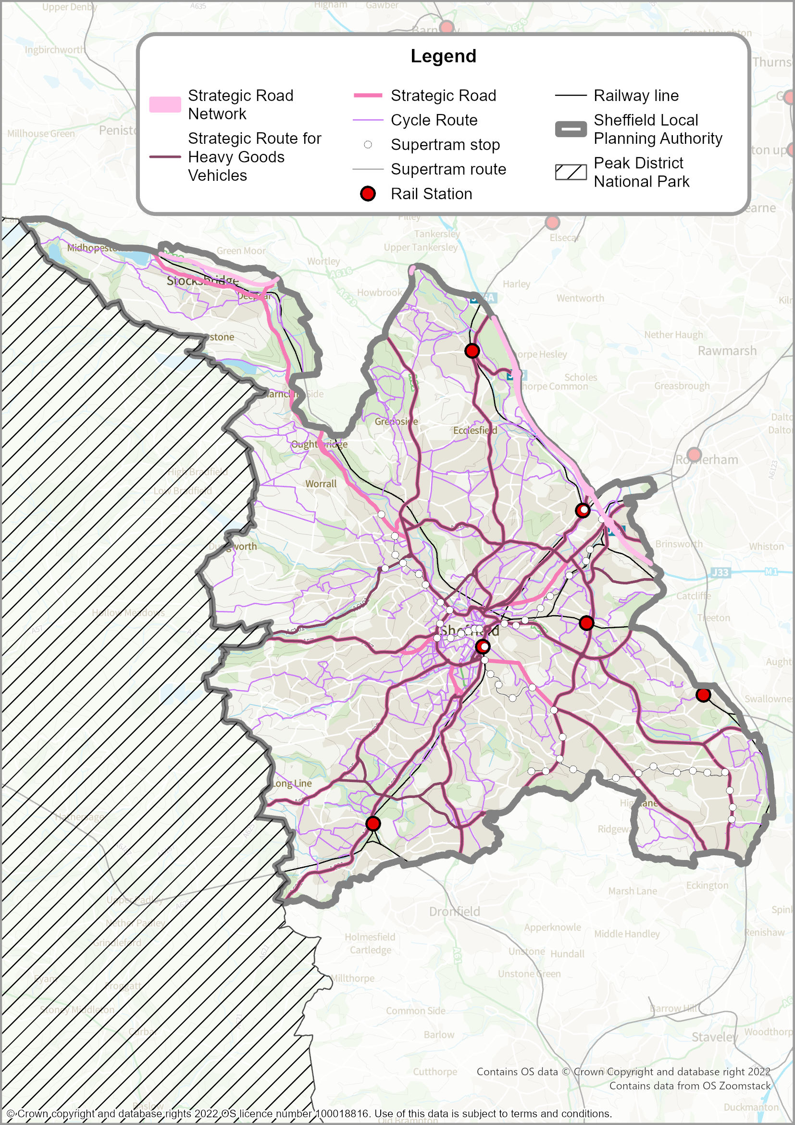
Map 16: Transport Opportunities
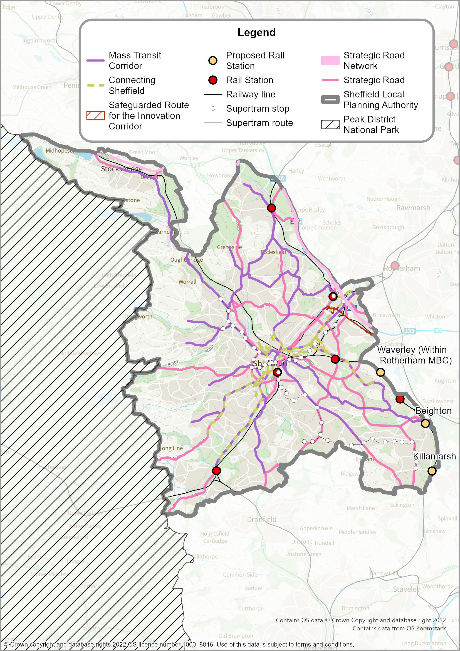

Blue and Green Infrastructure
  - Blue and green infrastructure refers to the living network of green spaces, water and other environmental features in both urban and rural areas including trees, rights of way, parks, gardens, transport corridors, allotments, cemeteries, woodlands, rivers, reservoirs and wetlands. It is often used in an urban context to provide multiple benefits including space for recreation, access to nature, climate change mitigation, food production and wildlife habitats, while also contributing to the enhancement of local character and quality of place.
  - Sheffield contains a myriad of habitats from upland moorlands, to wooded valleys and river corridors. Combined with the city’s many parks and green spaces this has contributed to giving Sheffield the reputation of being one of the greenest cities in Europe. This backdrop provides an established baseline from which measures to address the Biodiversity Emergency can begin.
  - Providing fair access to the city’s blue and green infrastructure is a fundamental part of the Council’s vision for Sheffield and in doing so will help to improve the health and well-being of its residents.
  - Sheffield’s strategic green infrastructure includes the rivers and streams of the larger valleys, complemented by a network of more local green links connecting open spaces, woodlands, footpaths, watercourses and corridors of dense vegetation. Within Sheffield there are also a range of outcrops representing different geological horizons and other distinctive rock features and landforms.
  - Sheffield’s existing blue and green infrastructure is important at all scales and the existing network of countryside and greenspace is represented on Map 17 below. Sheffield’s water courses are a very important part of the city’s network, as well as being a key part of the city’s industrial heritage and character. We have high ambitions to further improve connectivity in the network to support both nature recovery and improve recreational opportunities. A number of different organisations and agencies are involved in delivering specific blue and green infrastructure projects (e.g. the Environment Agency, Canal and Rivers Trust, Sheffield & Rotherham Wildlife Trust, the Upper Don Trail Trust and the Sheaf and Porter Rivers Trust).
Work on a new South Yorkshire Local Nature Recovery Strategy (the LNRS) is being led by the South Yorkshire Mayoral Combined Authority but, at the time of submitting this Plan, had not been completed. The LNRS will map the network of designated wildlife sites and identify greenspaces, countryside and previously developed sites that provide opportunities for nature recovery, helping to improve connectivity between existing wildlife habitats. More detail on this will be set out in a supplementary planning document, once the work on the LNRS has been completed.
  - Safeguarding and enhancing the city’s blue and green infrastructure is critical to ensure that it continues to fulfil its multi-functional role and delivers both Biodiversity Net Gain (BNG) and wider Environmental Net Gains (ENG). There can sometimes be tensions between biodiversity objectives and human access; the Plan seeks to deliver outcomes that support both objectives but where tensions cannot be resolved, the Plan will give priority to the protection and enhancement of biodiversity.
  - Policy SP1 and Policy BG1 provides the strategic context for the development management policies that follow in Part 2 of the Plan.
  - Where strategic green infrastructure crosses administrative boundaries, the Council will work closely with adjoining authorities and other stakeholders to manage assets.

POLICY BG1 - BLUE AND GREEN INFRASTRUCTURE AND THE LOCAL NATURE RECOVERY NETWORK
Blue and green infrastructure in the city will be protected, managed, enhanced and, wherever possible, extended to help increase biodiversity, provide wider environmental benefits to combat climate change, deliver opportunities for outdoor recreation and active travel, conserve heritage assets, support local food production and strengthen the city’s landscape character.
Very significant weight will be given to the protection and enhancement of Sheffield’s blue and green infrastructure and the Local Nature Recovery Network especially:
- the main river corridors (Rivers Don, Porter, Sheaf, Rivelin, Loxley and Blackburn Brook) and Sheffield and Tinsley Canal; and
- major parks and green spaces of citywide importance for recreation and/or biodiversity (Concord Park, Parson Cross Park, Norfolk Heritage Park, Graves Park, Ecclesall Woods, Endcliffe Park/Bingham Park/Whiteley Woods, Greno Woods, Millhouses Park, Meersbrook Park, Shirebrook Valley, Parkwood Springs); and
- registered historic parks and gardens; and
- green spaces that form (or have potential to form) wildlife corridors or ‘steppingstones’ connecting designated ecological sites
Valuable greenspaces will be protected from inappropriate built development and are shown on the Policies Map as either Urban Green Space Zones (see Policy GS1), Green Belt (where they perform the purposes of Green Belt) (see Policy GS2) or designated ecological or geological sites (see Policy GS5).

Where new green infrastructure is created, it should comply with the principles and standards set out in Natural England’s Green Infrastructure Framework (2023) or any successor document.

Definitions

‘Designated ecological and geological sites’ – internationally, nationally and locally designated sites as described in Policies GS5 and GS8.
For ‘biodiversity’, ‘Urban Greenspace Zones’, ‘Green Belt’ and the ‘Local Nature Recovery Network’ – see Glossary.

For ‘registered historic parks and gardens’ – see ‘Heritage Assets’ in Glossary.

‘Natural England’s Green Infrastructure Framework (2023)’ – provides a structure to analyse where greenspace in urban environments is needed most. It aims to support equitable access to greenspace across the country, with an overarching target for everyone being able to reach good quality greenspace in their local area.

Map 17: Existing Blue and Green Infrastructure
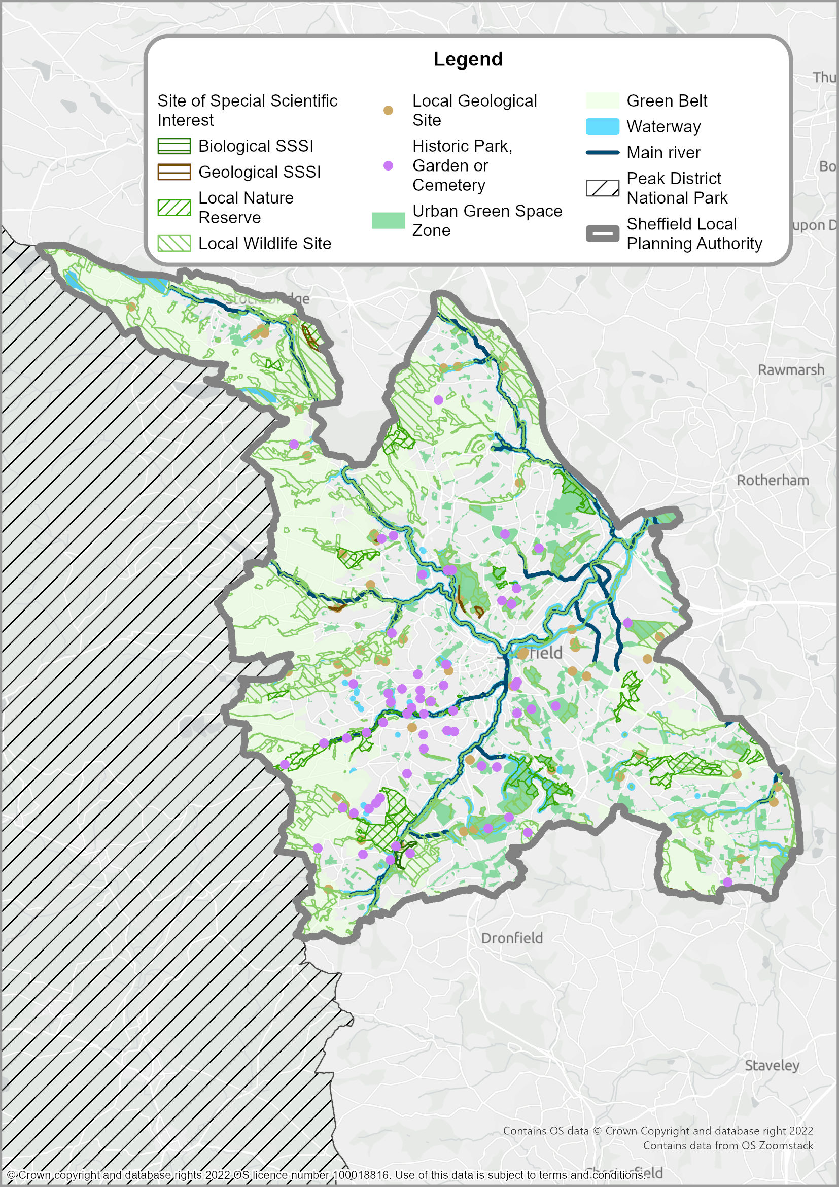

Design Principles and Priorities
  - Sheffield is a distinctive city with an urban form that in many places reflects its early industrial heritage, specifically the metal trades, and a unique topography that has resulted in the city’s townscape. Heritage assets are an integral element of the character of many areas of the city and conserving them alongside new development will have benefits for the wider culture and economy of the city, as well as creating a more individual sense of place.
  - The National Planning Policy Framework (NPPF) and associated guidance recognises that good design is a key aspect of sustainable development and an integral part of good planning. Sheffield has done much to promote high quality design across the built environment and the Plan’s policies will help to maintain these achievements by continuing to require the creation of beautiful places.
  - The ten characteristics of well-designed places, which are identified within the National Design Guide and National Model Design Code are embedded within the Plan’s policies. This will help to ensure the delivery of places that are rich in character, create a sense of community and positively address the challenges of climate change. Collectively this will contribute towards achieving the requirements for good design as established in the NPPF.
Policy D1 - DESIGN PRINCIPLES AND PRIORITIES
Development should be sustainable, beautiful, functional, of high-quality, and should respect, take advantage of, and enhance the characteristic features of the city, its settlements, districts, and neighbourhoods, including:
- Sheffield’s distinctive heritage, particularly the buildings, structures and settlement forms associated with, amongst others:
- Water-powered industries
- The metal trades and their supporting industries
- Non-conformism
- Sheffield Board schools
- The Central Sub-Area, including the historic street pattern
- Victorian, Edwardian and Garden City-style suburbs
- The city’s post-war built heritage
- Historic village centres and farmsteads
- The city’s rural setting, topography and landscapes
- Historic parks, gardens and cemeteries
- The distinctive landscape of river valleys, dramatic hillsides, extensive tree cover and views out to Sheffield’s Peak District setting.

Development should also:
c) be designed to mitigate climate change by reducing greenhouse gas emissions, to be resilient to future changes in temperature and rainfall patterns, and to minimise the relative heating of urban areas; and
d) be led by an informed understanding of the site, the wider context and the significance and character of any relevant heritage assets; and
e) create a healthy and safe environment; and
f) contribute to the city’s extensive and varied green infrastructure and public realm; and
g) make a positive contribution to local identity, helping to transform the character of physical environments that have become run down and are lacking in distinctiveness; and
h) enable all people to gain access safely and conveniently, irrespective of age or disability by creating a built environment that is compact and adheres to the principles of inclusive and dementia friendly design from the outset of the design process; and
i) contribute to place-making and create attractive, sustainable and successful neighbourhoods; and
j) where applicable, enhance the Main Gateway Routes into the city, the City Centre Gateway Routes, the main river corridors and the Canal; and
k) be robust, built to last, well managed and maintained.
Definitions
- For ‘Main Gateway Routes’ – these are:
- Lower Don Valley routes, A6109 and A6178
- prominent locations on the M1 junctions
- London Road, Abbeydale Road, Ecclesall Road and Queens Road
- Penistone Road (A61) and Burngreave Road (A6135)
- the railway line between Heeley and Blackburn Meadows
- For ‘City Centre Gateway Routes’ – these are:
- Corporation Street/Gibraltar Street
- Wicker/Savile Street
- Park Square
- Queens Road/St Mary’s Road
- St Mary’s Road/Bramall Lane
- St Mary’s Gate/London Road
- St Mary’s Gate/Moore Street
- Glossop Road/West Street
- Brook Hill
- Shalesmoor

- For ‘inclusive design’ and ‘dementia friendly design’– see Glossary.
- For ‘green infrastructure’ – see introduction to Policy BG1.
- For ‘Beautiful’ development – the following description is taken from the Government commissioned ‘Living with Beauty – Promoting health, well-being and sustainable growth’ report, by the Building Better, Building Beautiful Commission (2020): ‘Beauty includes everything that promotes a healthy and happy life, everything that makes a collection of buildings into a place, everything that turns anywhere into somewhere, and nowhere into home. It is not merely a visual characteristic, but is revealed in the deep harmony between a place and those who settle there. So understood, beauty should be an essential condition for planning permission.’

Infrastructure Provision
  - The city’s infrastructure must be sufficient to support the spatial strategy and scale of growth proposed in Policies SP1 to SP3. Policy IN1 provides a strategic policy framework to identify the city’s infrastructure priorities.
  - Specific infrastructure projects have been identified throughout the Sheffield Plan, notably in each of the Sub-Areas (see Policy SA1 through to Policy SA9). In addition, detailed infrastructure items are also listed in Policy T1, Policy BG1, and Policy D1. Those specific infrastructure items are not repeated here.
  - Further analysis of the infrastructure requirements to support the plan, as well as details on funding and implementation of infrastructure schemes, will be provided in the Sheffield Infrastructure Delivery Plan (IDP).
  - Policy IN1 has been prepared in light of the strategic policy objectives and technical assessment work carried out at a city-region, sub-regional, and local level. Regard has been given to the plans, priorities, and funding strategies of statutory infrastructure providers and operators; as well other relevant authorities, local stakeholders, the development industry, and landowners.
  - The Council has had specific regard to the South Yorkshire Mayoral Combined Authority’s Strategic Economic Plan (SEP) (2021), which sets out infrastructure priorities of:
- digital;
- low or zero-carbon transport;
- health;
- education;
- renewable energy; and
- flood protection.
  - The SEP’s delivery strategy involves a focus on ‘infrastructure packages’ that will target eight locations, which include Sheffield City Centre and the Innovation District.
  - It is acknowledged that needs for infrastructure are constantly evolving. Where possible the Sheffield IDP will be kept as a ‘live’ document, subject to on-going revision. This is likely to mean certain priorities for infrastructure funding and delivery may change over time.
  - Part 2 of the Sheffield Plan (see Policy DC1) confirms the Council’s use of a Community Infrastructure Levy (CIL) and the operation of the CIL Charging Schedule. It also sets out how other development contributions will be sought towards providing the necessary infrastructure to manage the impacts of development.
  - Where development is likely to create an identified shortfall in infrastructure capacity or exacerbate existing deficiencies, it will be required to mitigate or compensate for those deficiencies, in line with Policy DC1. Provision to address capacity issues will be required to be in place in a timely and phased manner.
POLICY IN1 - INFRASTRUCTURE PROVISION

Necessary infrastructure will be provided to support the delivery of the scale of growth and development in the locations proposed within the plan (see Policies SP1, SP2, and SP3; and Policies SA1 to SA9).

Infrastructure provision will be categorised and prioritised according to its importance in enabling development. Categories of infrastructure will be: ‘Essential’, ‘Required’, ‘Important’, and ‘Supportive’.

Infrastructure priorities will include:

- Transport - including major schemes to improve active travel, the passenger rail network, the rail freight network, the tram network, the bus network and the strategic highway network. The Council will collaborate with statutory providers and strategic transport stakeholders to increase service frequency and quality, improve connectivity and reliability, and promote sustainable transport patterns to help decarbonise the system, boost productivity, and encourage healthier and more active travel.
- Education - the provision of sufficient primary, secondary, Special Education Needs, and tertiary education places to meet the forecast demand arising from planned housing and economic growth (see Policy SP1). Specific focus will be on ensuring there is sufficient provision in, or near, the City Centre to meet future needs.
- Health - the provision of sufficient primary, secondary, and preventative care needs arising from planned housing and economic growth (see Policy SP1). Specific focus will be on ensuring there is sufficient provision in, or near, the City Centre to meet future needs.
- Utilities - working in collaboration with statutory providers to ensure that electricity, gas, water, waste water, heat supply, and renewable and low carbon energy generation and distribution networks have sufficient provision, capacity, and resilience to manage additional needs arising from planned housing and economic growth. Specific focus will be on ensuring that networks continue to meet demands, whilst also helping to meet the Council’s objectives as part of declaring a climate change emergency and targets for achieving net zero carbon.
- Digital infrastructure and connectivity - including both broadband and cellular networks. Provision will respond to the objectives set out in the South Yorkshire Digital Infrastructure Strategy (2021) to accelerate the development of ‘gigabit capable’ digital infrastructure and 5G networks to support social and economic opportunities as part of a more proactive approach to facilitating inclusive growth.
- Flood risk and drainage - Sheffield City Council (as Lead Local Flood Authority) will work in collaboration with statutory providers to deliver planned risk management and resilience measures, and help define future measures to reduce and mitigate the impacts of flooding. Specific focus will also be on delivering development that does not increase flood risk elsewhere and is designed in such a way that builds in flood resilience.
- Sport, leisure, recreation, community and cultural facilities - the provision of sufficient facilities to meet the forecast demand arising from planned housing and economic growth (see Policy SP1). Specific focus will be on ensuring that current and future provision supports the objective to become the ‘Outdoor City’, that provision is accessible, and is of a quality that supports improvements in the health and well-being of communities across the city.
Funding and delivery of infrastructure will be through the use of the Council’s Community Infrastructure Levy, alongside other necessary developer contributions, to ensure sustainable development is achieved, and impacts mitigated (see Policy DC1).

Appendix 1: LIST OF SITE ALLOCATIONS
6.1 Appendix 1 lists the sites for each of the following sub-areas that are allocated and outlined on the Polices Map:
- Policy CA1 – Site Allocations in Kelham Island, Neepsend, Philadelphia and Woodside
- Policy CA2 – Site Allocations in Castlegate, West Bar, The Wicker and Victoria
- etc

6.2 Strategic sites are denoted with an *.

Policy CA1 - Site Allocations in Kelham Island, Neepsend. Philadelphia and Woodside
The following sites are allocated and outlined on the Policies Map

Site Allocation Reference | Site Address | Proposed Use | Housing Capacity | Site Area (Ha)
KN01* | Land at Parkwood Road, S3 8AB | General Employment | 0 | 1.5
KN02 | 147-154 Harvest Lane, S3 8EF | General Employment | 0 | 0.06
KN03 | Wickes, 2 Rutland Road, S3 8DQ | Housing | 191 | 1.1
KN04* | Land at Russell Street and Bowling Green Street, S3 8RW | Housing | 200 | 0.86
KN05 | Former Canon Brewery, Rutland Road, S3 8DP | Housing | 132 | 0.81
KN06 | (Kelham Central) Site of Richardsons Cutlery Works, 60 Russell Street, Cotton Street and Alma Street, Sheffield S3 8RW | Housing | 114 | 0.84
KN07 | Buildings at Penistone Road, Dixon Street and Cornish Street, S3 8DQ | Housing | 98 | 0.94
KN08 | Sheffield Communtiy Transport, Montgomery Terrace Road, S6 3BU | Housing | 96 | 0.32
KN09 | Buildings at Shalesmoor and Cotton Mill Road, S3 8RG | Housing | 96 | 0.26
KN10 | 300-310 Shalesmoor, S3 8UL | Housing | 90 | 0.09
KN11 | Safestore Self Storage, S3 8RW | Housing | 87 | 0.62
KN12 | Land Between Cotton Mill Row, Cotton Street And Alma Street, Sheffield , S3 4RD | Housing | 86 | 0.19
KN13 | Warehouse, Boyland Street, S3 8AS | Housing | 93 | 0.79
KN14 | Land Between Swinton Street And Chatham Street | Housing | 75 | 0.2
KN15 | Nambury Engineering Ltd 56 Penistone Road, Owlerton, Sheffield , S6 3AE | Housing | 50 | 0.28
KN16 | 120 Henry Street, Shalesmoor, Sheffield, S3 7EQ | Housing | 62 | 0.11
KN17 | 2 Lock Street, Sheffield S6 3BJ | Housing | 61 | 0.15
KN18 | Buildings at Rutland Road and Rugby Street, S3 9PP | Housing | 60 | 1.41
KN19 | 100 Harvest Lane, S3 8EQ | Housing | 60 | 0.91
KN20 | Buildings at Gilpin Street, S6 3BL | Housing | 54 | 1.01
KN21 | Globe Works, Penistone Road, S6 3AE | Housing | 33 | 0.31
KN22 | Moorfields Flats, Shalesmoor and Ward Street, S3 8UH | Housing | 50 | 0.16
KN23 | Buildings at South Parade, Bowling Green Street and Ward Street, S3 8SR | Housing | 50 | 0.16
KN24 | Wharncliffe Works and 86-88 Green Lane, S3 8SE | Housing | 60 | 0.4
KN25 | Land at Mowbray Street and Pitsmoor Road, S3 8EQ | Housing | 45 | 0.66
KN26 | SIP Car Parks, Car Park At Junction With Bowling Green Street, Russell Street, S3 8SU | Housing | 44 | 0.08
KN27 | Buildings at Rutland Way, S3 8DG | Housing | 28 | 0.87
KN28 | Heritage Park 55 Albert Terrace Road Sheffield S6 3BR | Housing | 35 | 0.1
KN29 | Land at Montgomery Terrace Road and Penistone Road, S6 3BW | Housing | 23 | 0.1
KN30 | Land at Hicks Street and Rutland Road, S3 8BD | Housing | 30 | 0.08
KN31 | Site Of Watery Street , Sheffield, S3 7ES | Housing | 18 | 0.1
KN32 | Land at Acorn Street, S3 8UR | Housing | 15 | 0.1
KN33 | 284 Shalesmoor, S3 8UL | Housing | 13 | 0.07
KN34 | 132 Rugby Street, S3 9PP | Housing | 12 | 0.23
KN35 | Land at Rutland Road, S3 9PP | Housing | 10 | 0.13
KN36* | Land at Penistone Road and Rutland Road, S3 8DG | Housing and Open Space | 572 | 3.07

Policy CA2 - Site Allocations in Castlegate, West Bar, The Wicker, and Victoria
The following sites are allocated and outlined on the Policies Map

Site Allocation Reference | Site Address | Proposed Use | Housing Capacity | Site Area (Ha)
CW01 | Castlegate (Exchange Place) | General Employment | 0 | 0.12
CW02* | Castlegate (Shude Hill) | Office | 0 | 0.31
CW03* | West Bar Square | Mixed Use | 368 | 3.13
CW04* | Buildings at Dixon Lane and Haymarket, S2 5TS | Mixed Use | 75 | 0.83
CW05 | George Marshall (Power Tools) Ltd, 18 Johnson Street | Mixed Use | 56 | 0.07
CW06 | 29-57 King Street, S3 8LF | Mixed Use | 19 | 0.11
CW07 | 2 Haymarket and 5-7 Commercial Street, S1 1PF | Mixed Use | 5 | 0.05
CW08 | First Floor To Third Floors, 19 - 21 Haymarket, S1 2AW | Mixed Use | 3 | 0.03
CW09* | Land to the north of Derek Dooley Way, S3 8EN | Housing | 336 | 1.75
CW10* | Site Of Sheffield Testing Laboratories Ltd and 58 Nursery Street and Car Park on Johnson Lane, Sheffield, S3 8GP | Housing | 268 | 0.33
CW11* | 51-57 High Street And Second Floor Of 59-73 High Street | Housing | 206 | 0.07
CW12 | 28 Johnson Street, 14-20 Stanley Street and 37-39 Wicker Lane, S3 8HJ | Housing | 94 | 0.66
CW13 | Aizlewood Mill Car Park, Land at Spitalfields, S3 8HQ | Housing | 83 | 0.4
CW14 | Land at Spitalfields and Nursery Street, S3 8HQ | Housing | 65 | 0.19
CW15 | Land at Windrush Way, S3 8JD | Housing | 46 | 0.24
CW16 | Buildings at Nursery Street and Stanley Street, S3 8HH | Housing | 43 | 0.26
CW17 | Former Coroners Court, Nursery Street, S3 8GG | Housing | 77 | 0.1
CW18 | 23-25 Haymarket, Sheffield, S1 2AW | Housing | 28 | 0.04
CW19 | Sheaf Quay, 1 North Quay Drive, Victoria Quay, Sheffield, S2 5SW | Housing | 16 | 0.45
CW20 | 23-41 Wicker and 1-5 Stanley Street, S3 8HS | Housing | 16 | 0.23
CW21 | 29-33 Nursery Street, S3 8GF | Housing | 16 | 0.06
CW22 | Buildings at Joiner Street and Wicker Lane, S3 8GW | Housing | 15 | 0.14
CW23 | Land at Gun Lane, S3 8GG | Housing | 14 | 0.08

Policy CA3 - Site Allocations in St Vincent’s, Cathedral, St George’s and University of Sheffield)
The following sites are allocated and outlined on the Policies Map

Site Allocation Reference | Site Address | Proposed Use | Housing Capacity | Site Area (Ha)
SU01 | 178 West Street, Sheffield, S1 4ET | General Employment | 0 | 0.05
SU02 | 10-22 Regent Street and 2 Pitt Street, S1 4EU | Mixed Use | 32 | 0.11
SU03* | Land at Doncaster Street, Hoyle Street, Shalesmoor and Matthew Street, Sheffield, S3 7BE | Housing | 500 | 0.83
SU04* | Site of former HSBC, 79 Hoyle Street, Sheffield, S3 7EW | Housing | 355 | 1.01
SU05 | 26 Meadow Street, S3 7AW | Housing | 116 | 0.48
SU06 | Site of 1-7 Allen Street, 7, 9, 11, 13 and 15 Smithfield and Snow Lane, Sheffield | Housing | 100 | 0.43
SU07* | Radford Street/ Upper Allen Street/ Netherthorpe Road | Housing | 284 | 0.48
SU08* | Buildings at Scotland Street and Cross Smithfield, S3 7DE | Housing | 225 | 0.72
SU09* | Queens Hotel, 85 Scotland Street, S1 4BA | Housing | 229 | 0.3
SU10 | 175-173 Gibraltar Street and 9 Cupola, S3 8UA | Housing | 34 | 0.11
SU11 | Greenfield House, 32 Scotland Street, S3 7AF | Housing | 118 | 0.67
SU12* | 134 West Bar, 10 Bower Spring and 83 Steelhouse Lane, S3 8PB | Housing | 216 | 0.5
SU13 | Land at Bailey Street, S1 4EH | Housing | 120 | 0.11
SU14 | Land Bounded By Hollis Croft And Broad Lane Sheffield S1 3BU | Housing | 118 | 0.14
SU15 | 23 Shepherd Street, S3 7BA | Housing | 27 | 0.12
SU16 | Buildings at Meadow Street and Morpeth Street, S3 7EZ | Housing | 93 | 0.4
SU17 | 30-32 Edward Street and 139 Upper Allen Street, S3 7GW | Housing | 88 | 0.29
SU18 | Buildings at Edward Street and Meadow Street, S3 7BL | Housing | 85 | 0.28
SU19 | Land at Hollis Croft, S1 4BT | Housing | 84 | 0.28
SU20 | Buildings at Meetinghouse Lane and Harts Head, S1 2DR | Housing | 61 | 0.2
SU21 | Land at Doncaster Street and Shephard Street, S3 7BA | Housing | 58 | 0.3
SU22 | North Church House 84 Queen Street City Centre Sheffield S1 2DW | Housing | 58 | 0.06
SU23 | Hayes House, Edward Street, S1 4BB | Housing | 56 | 0.19
SU24 | 1-3 Broad Lane, S1 1YG | Housing | 48 | 0.16
SU25 | The Nichols building, Shalesmoor | Housing | 48 | 0.1
SU26 | 65-69 Broad Lane and 1-10 Rockingham Street, S1 4EA | Housing | 45 | 0.15
SU27 | 115-121 West Bar and land adjacent, S3 8PT | Housing | 23 | 0.15
SU28 | Hewitts Chartered Accountants 60 Scotland Street Sheffield S3 7DB | Housing | 43 | 0.05
SU29 | B Braun, 43 Allen Street, Sheffield S3 7AW | Housing | 47 | 0.18
SU30 | Shakespeare's, 146-148 Gibraltar Street, S3 8UB | Housing | 22 | 0.13
SU31 | 11-25 High Street, S1 2ER | Housing | 39 | 0.13
SU32 | 123-125 Queen Street, S1 2DU | Housing | 39 | 0.13
SU33 | Hanover Works, Scotland Street, S3 7DB | Housing | 38 | 0.31
SU34 | Buildings at Allen Street and Copper Street, S3 7AG | Housing | 77 | 0.36
SU35 | Land to the south of Furnace Hill, S3 7BG | Housing | 20 | 0.11
SU36 | Works at 25-31 Allen Street | Housing | 20 | 0.07
SU37 | Buildings at Allen Street and Snow Lane, S3 7AF | Housing | 61 | 0.32
SU38 | 86-90 Queen Street and 35-47 North Church Street, S1 2DH | Housing | 29 | 0.1
SU39 | 63-69 Allen Street and 28-32 Cross Smithfield, S3 7AW | Housing | 46 | 0.1
SU40 | Buildings at Lee Croft and Campo Lane, S1 2DY | Housing | 26 | 0.09
SU41 | Courtwood House, Silver Street, S1 2DD | Housing | 25 | 0.08
SU42 | Portland House, Moorfields, S3 7BA | Housing | 57 | 0.27
SU43 | Land to the south of Allen Street, S3 7AG | Housing | 17 | 0.08
SU44 | 6 Campo Lane Sheffield S1 2EF | Housing | 22 | 0.02
SU45 | 39-41 Snig Hill and 4-8 Bank Street, S3 8NA | Housing | 21 | 0.07
SU46 | Old County Court House 56 Bank Street Sheffield S1 2DS | Housing | 21 | 0.07
SU47 | 129-135 West Bar, S3 8PT | Housing | 10 | 0.07
SU48 | Land at Townhead Street, S1 2EB | Housing | 20 | 0.07
SU49 | Johnson & Allen Ltd Car Park Furnace Hill Sheffield S3 7AF | Housing | 18 | 0.1
SU50 | Industrial Tribunals Central Office Property Centre, 14 East Parade, S1 2ET | Housing | 18 | 0.03
SU51 | 22 Copper Street and St Judes Church, Copper Street, S3 7AH | Housing | 17 | 0.06
SU52 | 90 Trippet Lane/8 Bailey Lane Sheffield S1 4EL | Housing | 13 | 0.03
SU53 | 54 Well Meadow Street Sheffield S3 7GS | Housing | 11 | 0.11
SU54 | Land and buildings adjacent to 94 Scotland Street, S3 7AR | Open Space | 0 | 0.26
SU55 | Paradise Square, S1 2DE | Open Space | 0 | 0.18
SU56 | Car Park, Solly Street, S1 4BA | Open Space | 0 | 0.09

Policy CA4 - Site Allocations in City Arrival, Cultural Industries Quarter, Sheaf Valley
The following sites are allocated and outlined on the Policies Map

Site Allocation Reference | Site Address | Proposed Use | Housing Capacity | Site Area (Ha)
SV01 | Buildings at Cross Turner Street, S2 4AB | Office | 0 | 1.45
SV02* | Land at Midland Station, Cross Turner Street, S1 2BP | Office | 0 | 0.53
SV03 | Land at Harmer Lane and Sheaf Street, S1 2BS | Office | 0 | 0.15
SV04* | Decathlon, Eyre Street, S1 3HU | Mixed Use | 303 | 0.84
SV05 | K.T Precision Engineering and land adjacent, Turner Street, S2 4AB | Mixed Use | 42 | 0.35
SV06* | Klausners Site, Sylvester Street/ Mary Street | Housing | 335 | 0.59
SV07 | Buildings at Shoreham Street and Mary Street, S1 4SQ | Housing | 149 | 0.54
SV08 | Mecca Bingo, Flat Street, S1 2BA | Housing | 121 | 0.2
SV09 | 3-7 Sidney Street and land adjacent, S1 4RG | Housing | 117 | 0.39
SV10 | Land at Sylvester Street and Arundel Street, Sheffield, S1 4RH | Housing | 27 | 0.36
SV11 | 48 Suffolk Road, S2 4AL | Housing | 102 | 0.29
SV12 | Stepney Street Car Park, Stepney Street Sheffield S2 5TD | Housing | 100 | 0.12
SV13 | Development at Bernard Works Site, Sylvester Gardens, Sheffield S1 4RP | Housing | 96 | 0.26
SV14 | Park Hill (Phases 4-5) | Housing | 95 | 2.22
SV15 | 125-157 Eyre Street and land adjacent, S1 4QW | Housing | 89 | 0.47
SV16 | St Mary's Wesleyan Reform Church, S1 4PN | Housing | 85 | 0.19
SV17 | Buildings at Arundel Street and Eyre Street, S1 4PY | Housing | 75 | 0.25
SV18 | 66-76 Sidney Street, S1 4RG | Housing | 66 | 0.22
SV19 | 121 Eyre Street, S1 4QW | Housing | 58 | 0.09
SV20 | Former Head Post Office Fitzalan Square Sheffield S1 1AB | Housing | 42 | 0.44
SV21 | Land at Claywood Drive, S2 2UB | Housing | 40 | 1.39
SV22 | 93-97 Mary Street, S1 4RT | Housing | 30 | 0.15
SV23 | 40-50 Castle Square, Sheffield, S1 2GF | Housing | 22 | 0.09
SV24 | 121 Duke Street, S2 5QL | Housing | 16 | 0.07
SV25 | 95 Mary Street, Sheffield S1 4RT | Housing | 10 | 0.04

Policy CA5 - Site Allocations in Heart of the City, Division Street, The Moor, Milton Street, Springfield, Hanover Street
The following sites are allocated and outlined on the Policies Map

Site Allocation Reference | Site Address | Proposed Use | Housing Capacity | Site Area (Ha)
HC01* | Land at Carver Street and Carver Lane, S1 4FS | Office | 0 | 0.37
HC02 | Orchard Square Shopping Centre, S1 2FB | Retail | 0 | 0.61
HC03* | Land and buildings at St Mary's Gate and Eyre Street, S1 4QZ | Mixed Use | 1006 | 1.6
HC04 | NCP Furnival Gate Car Park, Matilda Street, S1 4QY | Mixed Use | 100 | 0.34
HC05 | Site Of 68-82 Pinstone Street, 1-19 Charles Street, Laycock House - 14 Cross Burgess Street Sheffield | Mixed Use | 52 | 0.3
HC06 | 113-125, Pinstone Street, S1 2HL | Mixed Use | 9 | 0.08
HC07* | Buildings at Wellington Street and Trafalgar Street, S1 4ED | Housing | 1230 | 0.59
HC08* | Moorfoot Building, The Moor, S1 4PH | Housing | 714 | 1.79
HC09* | Milton Street Car Park Milton Street Sheffield S3 7UF | Housing | 410 | 0.51
HC10* | Kangaroo Works - Land at Wellington Street and Rockingham Street | Housing | 364 | 0.73
HC11* | Wickes, Young Street, S3 7UW | Housing | 364 | 0.72
HC12* | Midcity House 17, 23 Furnival Gate, 127-155 Pinstone Street And 44 Union Street Sheffield S1 4QR | Housing | 298 | 0.16
HC13* | 999 Parcel Ltd, 83 Fitzwilliam Street, Sheffield S1 4JP | Housing | 213 | 0.12
HC14 | DWP Rockingham House 123 West Street City Centre Sheffield S1 4ER | Housing | 162 | 0.14
HC15 | Land and Buidlings at Fitzwilliam Street, Egerton Street and Thomas Street, S1 4JR | Housing | 136 | 0.32
HC16 | Flocton House and Flocton Court, Rockingham Street, S1 4GH | Housing | 135 | 0.48
HC17 | Car Park, Eldon Street, S3 7SF | Housing | 135 | 0.16
HC18 | 50 High Street City Centre Sheffield S1 1QH | Housing | 101 | 0.27
HC19 | Eye Witness Works, Milton St | Housing | 97 | 0.34
HC20 | Concept House 5 Young Street Sheffield S1 4LF | Housing | 95 | 0.29
HC21 | Site Of Former Swifts Performance 172 - 182 Fitzwilliam Street Sheffield S1 4JR | Housing | 93 | 0.07
HC22 | Building adjacent to 20 Headford Street, S3 7WB | Housing | 92 | 0.22
HC23 | Charter Works 20 Hodgson Street Sheffield S3 7WQ | Housing | 77 | 0.06
HC24 | Buildings at Egerton Lane, S1 4AF | Housing | 46 | 0.14
HC25 | Milton Street Car Park, Milton Street, S3 7WJ | Housing | 45 | 0.29
HC26 | Land at Headford Street and Egerton Street, S3 7XF | Housing | 45 | 0.14
HC27 | Land at Cavendish Street, S3 7RZ | Housing | 30 | 0.11
HC28 | 165 West Street, City Centre, S1 4EW | Housing | 22 | 0.04
HC29 | 162-170 Devonshire Street Sheffield S3 7SG | Housing | 12 | 0.05
HC30 | Yorkshire Bank Chambers, Fargate Sheffield, S1 2HD | Housing | 12 | 0.03

CA6 - Site Allocations in London Road and Queens Road

The following sites are allocated and outlined on the Policies Map

Site Allocation Reference | Site Address | Proposed Use | Housing Capacity | Site Area (Ha)
LR01* | B & Q Warehouse, Queens Road, S2 3PS | Housing | 466 | 3.69
LR02* | Buildings at Sheaf Gardens and Manton Street, S2 4BA | Housing | 367 | 2.91
LR03* | Land at Queens Road and Farm Road, S2 4DR | Housing | 336 | 0.45
LR04 | Grovesnor Casino, Duchess Road, S2 4DR | Housing | 111 | 0.88
LR05 | Buildings at Duchess Road and Edmund Road, S2 4AW | Housing | 84 | 0.6
LR06 | 2 Queens Road, S2 4DG | Housing | 61 | 0.12
LR07 | Wheatsheaf Works, 55-57 John Street, S2 4QS | Housing | 56 | 0.86
LR08 | 89 London Road, S2 4LE | Housing | 14 | 0.1

Policy SA2 - Northwest Sheffield Sub-Area Site Allocations
The following sites are allocated and outlined on the Policies Map

Site Allocation Reference | Site Address | Proposed Use | Housing Capacity | Site Area (Ha)
NWS01* | Land and buildings at Penistone Road North, S6 1QW | General Employment | 0 | 4.58
NWS02* | Land at Wallace Road, S3 9SR | Industrial | 0 | 4.04
NWS03* | Land at Beeley Wood Lane, S6 1QT | General Employment | 0 | 2.62
NWS04* | Allotments to the south of Wardsend Road North, S6 1LX | Industrial | 0 | 2.35
NWS05 | Land to the northwest of Wardsend Road, S6 1RQ | Industrial | 0 | 0.74
NWS06 | Land at Wardsend Road, S6 1RQ | Industrial | 0 | 0.64
NWS07 | Land adjacent to Elsworth House, Herries Road South, S6 1PD | General Employment | 0 | 0.42
NWS08 | Land At Junction With Cobden View Road, Northfield S10 1QQ | Mixed Use | 13 | 0.06
NWS09* | Former Oughtibridge Paper Mill, S35 0DN (Barnsley) | Housing | 311 | 13.3
NWS10* | Land at Oughtibridge Lane and Platts Lane, S35 0HN | Housing | 169 | 6.02
NWS11 | The Hillsborough Arcade And Site Of Former Old Blue Ball Public House, Middlewood Road And Bradfield Road, Sheffield S6 4HL | Housing | 77 | 1.13
NWS12 | Former British Glass Labs, Crookesmoor | Housing | 76 | 0.42
NWS13 | Wiggan Farm, S35 0AR | Housing | 63 | 2.03
NWS14 | Hillsborough Hand Car Wash Centre 172 - 192 Langsett Road Sheffield S6 2UB | Housing | 48 | 0.22
NWS15 | Bamburgh House and 110-136 Cuthbert Bank Road, S6 2HP | Housing | 41 | 0.92
NWS16 | Dragoon Court Hillsborough Barracks Penistone Road Owlerton Sheffield S6 2GZ | Housing | 32 | 0.3
NWS17 | St. Georges Community Health Centre, Winter Street, S3 7ND | Housing | 23 | 0.16
NWS18 | Sevenfields Lane Play Ground, Sevenfields Lane (land at Spider Park) | Housing | 22 | 0.25
NWS19 | Former Bolehill Residential Home, Bolehill View, S10 1QL | Housing | 19 | 0.38
NWS20 | Site Of 252 Deer Park Road Sheffield S6 5NH | Housing | 14 | 0.19
NWS21 | James Smith House, 11 - 15 Marlborough Road, S10 1DA | Housing | 14 | 0.09
NWS22 | Burgoyne Arms 246 Langsett Road Sheffield S6 2UE | Housing | 14 | 0.08
NWS23 | Former Oughtibridge Paper Mill, S35 0DN (Sheffield) | Housing | 13 | 0.4
NWS24 | Cloverleaf Cars, Land Adjacent To 237a Main Road Wharncliffe Side Sheffield | Housing | 13 | 0.36
NWS25 | Car Park Adjacent to Upperthorpe Medical Centre Upperthorpe, Sheffield, S6 3FT | Housing | 12 | 0.04
NWS26 | Land at Trickett Road, S6 2NP | Housing | 11 | 0.23
NWS27 | Daisy Chain, Middlewood Villas, 95 Langsett Road South, S35 0GY | Housing | 10 | 0.08
NWS28 | Land Adjacent 240 Springvale Road Sheffield S10 1LH | Housing | 0 | 0.06
NWS29* | Former Sheffield Ski Village, S3 9QX | Leisure and Recreation | 0 | 10.91

Policy SA3 - Northeast Sheffield Sub-Area Site Allocations
The following sites are allocated and outlined on the Policies Map

Site Allocation Reference | Site Address | Proposed Use | Housing Capacity | Site Area (Ha)
NES01* | Smithywood, Cowley Hill, Chapeltown | General Employment | 0 | 13.32
NES02 | Land adjacent to Chapeltown Academy, Nether Lane, S35 9ZX | General Employment | 0 | 0.67
NES03* | Land to the west of Blackburn Road, S61 2DW | Industrial | 0 | 11.12
NES04* | Gas Works, Newman Road, S9 1BT | Industrial | 0 | 3.91
NES05* | Land between Grange Mill Lane and Ecclesfield Road, S9 1HW | Industrial | 0 | 2.01
NES06* | Land to the north of Loicher Lane, S35 9XN | Industrial | 0 | 1.42
NES07* | Upwell Street/Colliery Road (North) | Industrial | 0 | 1.27
NES08 | Land adjacent to Yarra Park Industrial Estate and Station Road, S35 9YR | Industrial | 0 | 0.48
NES09 | Rock Christian Centre Lighthouse and 105-125 Spital Hill, S4 7LD | Mixed Use | 53 | 1.68
NES10 | Land at Wordsworth Avenue and Buchanan Road, S5 8AU | Mixed Use | 32 | 0.54
NES11 | Lion Works Handley Street Sheffield S4 7LD | Housing | 88 | 0.22
NES12 | Land at Mansell Crescent, S5 9QR | Housing | 73 | 1.1
NES13 | Parson Cross Park, Buchanan Road, S5 7SA | Housing | 68 | 2.16
NES14 | 'Lytton' (Land Opposite 29 To 45 Lytton Road) Sheffield S5 8A | Housing | 44 | 1.18
NES15 | Land adjoining 434-652 Grimesthorpe Road | Housing | 19 | 1.05
NES16 | Land adjacent to Deerlands Avenue roundabout, S5 7WY | Housing | 32 | 0.95
NES17 | Remington Youth Club, Remington Road, S5 9BF | Housing | 29 | 0.92
NES18 | Land at Longley Hall Road, S5 7JG | Housing | 24 | 0.77
NES19 | Buzz Bingo, Kilner Way Retail Park, S6 1NN | Housing | 24 | 0.61
NES20 | Land at Somerset Road and Richmond Street, S3 9DB | Housing | 24 | 0.47
NES21 | Jasmin Court Nursing Home, 40 Roe Lane, S3 9AJ | Housing | 23 | 0.17
NES22 | Land adjacent to Foxhill Recreation Ground, S6 1GE | Housing | 21 | 0.6
NES23 | Land East Of Fir View Gardens, Osgathorpe Drive, S4 7BN Land East Of Fir View Gardens, Osgathorpe Drive, S4 7BN | Housing | 20 | 0.43
NES24 | Parson Cross Hotel, Buchanan Crescent, S5 8AG | Housing | 20 | 0.4
NES25 | Land At The Junction Of Abbeyfield Road And Holtwood Road Including 11 Holtwood Road Sheffield S4 7AY | Housing | 20 | 0.38
NES26 | Eden Park Service Station, Penistone Road, Grenoside, Sheffield S35 8QG | Housing | 20 | 0.24
NES27 | Land adjacent to 264 Deerlands Avenue S5 7WX | Housing | 19 | 0.8
NES28 | Land adjacent to 177 Deerlands Avenue, S5 7WU | Housing | 19 | 0.59
NES29 | Land at 16-42 Buchanan Road, S5 8AL | Housing | 19 | 0.35
NES30 | St. Cuthberts Family Social Club, Horndean Road/Barnsley Road, Sheffield S5 6UJ | Housing | 19 | 0.09
NES31 | Sheffield Health And Social Care Trust 259 Pitsmoor Road Sheffield S3 9AQ | Housing | 18 | 0.17
NES32 | Land between Chaucer Road and Mansell Avenue, S5 9QN | Housing | 17 | 0.8
NES33 | Land at Wordsworth Avenue, S5 9FP | Housing | 16 | 0.44
NES34 | Site Of Norbury 2 Crabtree Road Sheffield S5 7BB | Housing | 14 | 0.6
NES35 | Land at Palgrave Road, S5 8GR | Housing | 12 | 0.3

Policy SA4 - East Sheffield Sub-Area Site Allocations
The following sites are allocated and outlined on the Policies Map

Site Allocation Reference | Site Address | Proposed Use | Housing Capacity | Site Area (Ha)
ES01* | Land to the south of Meadowhall Way, S9 2FU | General Employment | 0 | 17.1
ES02* | Alsing Road Car Park and Meadowhall Interchange, S9 1EA | General Employment | 0 | 9.98
ES03* | M1 Distribution Centre and The Source, Vulcan Road, S9 1EW | General Employment | 0 | 3.24
ES04* | Land at Sheffield Road, S9 2YL | General Employment | 0 | 1.22
ES05* | Pic Toys, Land to the north of Darnall Road, S9 5AH | Industrial | 0 | 1.05
ES06* | Outokumpu, Shepcote Lane | Industrial | 0 | 19.53
ES07* | Land at Europa Way, S9 1TQ | Industrial | 0 | 3.38
ES08* | Land adjacent to Veolia Sheffield, Lumley Street, S9 3JB | Industrial | 0 | 3.26
ES09* | 710 Brightside Lane, S9 2UB | Industrial | 0 | 2.14
ES10* | Land to the north of Europa Link, S9 1TN | Industrial | 0 | 1.6
ES11* | Land at Shepcote Lane, S9 5DE | Industrial | 0 | 1.52
ES12* | Land adjacent to 232 Woodbourn Road, S9  3LQ | Industrial | 0 | 1.36
ES13* | Land at Lumley Street, S4 7ZJ | Industrial | 0 | 1.1
ES14 | Rear of Davy McKee, Land to the east of Prince of Wales Road, S9 4BT | Industrial | 0 | 0.89
ES15 | Land to the northeast of Barleywood Road, S9 5FJ | Industrial | 0 | 0.89
ES16 | Former Dr John Worrall School, Land at Brompton Road, S9 2PF | Industrial | 0 | 0.68
ES17 | Land at Ripon Street, S9 3LX | Industrial | 0 | 0.65
ES18 | Land at Catley Road, S9 5NF | Industrial | 0 | 0.55
ES19 | Land adjacent to 58-64 Broad Oaks, S9 3HJ | Industrial | 0 | 0.45
ES20* | Darnall Works, Darnall Road, S9 5AB | Mixed Use | 80 | 6.51
ES21 | Land between Prince of Wales Road and Station Road, S9 4JT | Mixed Use | 28 | 1.11
ES22* | Attercliffe Canalside, Land to the north of Worthing Road, S9 3JN | Housing | 596 | 4.73
ES23* | Globe II Business Centre 128 Maltravers Road Sheffield S2 5AZ | Housing | 371 | 1.09
ES24* | Manor sites 12/13, Land to the north of Harborough Avenue, S2 1RD | Housing | 210 | 6.1
ES25* | Land to the north of Bawtry Road, S9 1WR | Housing | 147 | 5.6
ES26 | Land at Algar Place, S2 2NZ | Housing | 121 | 2.8
ES27 | Land at Kenninghall Drive, S2 3WR | Housing | 120 | 3.42
ES28 | Fitzalan Works, Land to the south of Effingham Street, S9 3QD | Housing | 116 | 0.92
ES29 | Pennine Village, Land at Manor Park Avenue, S2 1UH | Housing | 101 | 3.74
ES30* | Ouseburn Road, Darnall (referred to as the Darnall Triangle) | Housing | 98 | 4.23
ES31 | Staniforth Road Depot, Staniforth Road, S9 3HD | Housing | 93 | 3.32
ES32 | Land Adjacent 101 Ferrars Road Sheffield S9 1RZ | Housing | 93 | 2.81
ES33 | Westaways, Land at Bacon Lane, S9 3NH | Housing | 82 | 0.66
ES34 | St. John's School, Manor Oaks Road, S2 5QZ | Housing | 68 | 1.87
ES35 | Land at Berner's Place, S2 2AS | Housing | 63 | 1.67
ES36 | Land at Daresbury Drive, S2 2BL | Housing | 48 | 1.31
ES37 | Land at Harborough Rise, S2 1RT | Housing | 47 | 1.61
ES38 | Land at Prince of Wales Road, S9 4ET | Housing | 46 | 1.03
ES39 | Buildings at Handsworth Road, S9 4AA | Housing | 42 | 1.18
ES40 | Stadia Technology Park, Shirland Lane, S9 3SP | Housing | 41 | 0.64
ES41 | Site Of Park & Arbourthorne Labour Club Eastern Avenue/City Road Sheffield S2 2GG | Housing | 39 | 0.19
ES42 | Buildings at Blagden Street, S2 5QS | Housing | 37 | 1.02
ES43 | Norfolk Park 5B, Park Spring Drive (site of former health centre), Frank Wright Close, Sheffield S2 3RE | Housing | 35 | 1.21
ES44 | Land At Main Road Ross Street And Whitwell Street Sheffield S9 4QL | Housing | 28 | 0.61
ES45 | Site Of Former Foundry Workers Club And Institute Beaumont Road North Sheffield S2 1RS | Housing | 26 | 0.59
ES46 | Land at Wulfric Road and Windy House Lane, S2 1LB | Housing | 24 | 0.9
ES47 | Land to the north of Shortridge Street, S9 3SH | Housing | 17 | 0.24
ES48 | Windsor Hotel, 25-39 Southend Road | Housing | 17 | 0.12
ES49 | Site Of Foundry Workers Club And Institute Car Park, Beaumont Road North, S2 1RS | Housing | 16 | 0.42
ES50 | Land at Spring Close Mount, S14 1RB | Housing | 16 | 0.4
ES51 | 331 & 333 Manor Oaks Road, And 7 & 8 Manor Oaks Place Sheffield S2 5EE | Housing | 12 | 0.12
ES52 | Land Opposite 299 To 315 Main Road Darnall Sheffield S9 4QL' | Housing | 11 | 0.16
ES53 | Land At Daresbury View Sheffield S2 2BE | Housing | 10 | 0.46

Policy SA5 - Southeast Sheffield Sub-Area Site Allocations
The following sites are allocated and outlined on the Policies Map

Site Allocation Reference | Site Address | Proposed Use | Housing Capacity | Site Area (Ha)
SES01* | Land at Orgreave Place, S13 9LU | General Employment | 0 | 1.29
SES02 | Land adjacent to the River Rother, Rotherham Road, S20 1AH | General Employment | 0 | 1.1
SES03* | Land to the east of Eckington Way, S20 1XE | Industrial and Traveller Site | 0 | 6.85
SES04* | Mosborough Wood Business Park, Land to the north of Station Road, S20 3GR | Industrial | 0 | 9.41
SES05* | Land to the east of New Street, S20 3GH | Industrial | 0 | 3.75
SES06 | Warehouse and land adjacent, Meadowbrook Park, S20 3PJ | Industrial | 0 | 0.57
SES07 | Land at New Street and Longacre Way, S20 3FS | Industrial | 0 | 0.54
SES08* | Land at Silkstone Road, Wickfield Road and Dyke Vale Road, S12 4TU | Housing | 272 | 9.48
SES09* | Former Newstead Estate, Birley Moor Avenue, S12 3BR | Housing | 218 | 6.49
SES10* | Land to the east of Moor Valley Road, S20 5DZ | Housing | 151 | 4.2
SES11 | Manor Top Army Reserve Centre, Hurlfield Road, S12 2AN | Housing | 151 | 3.35
SES12 | Land at Vikinglea Drive, S2 1FD | Housing | 90 | 2.54
SES13 | Land to the east of Jaunty Avenue, S12 3DQ | Housing | 75 | 2.09
SES14 | Owlthorpe E, Land Off Moorthorpe Way, S20 6PD | Housing | 74 | 3.11
SES15 | Former Prince Edward Primary School and land adjacent, Queen Mary Road, S2 1EE | Housing | 50 | 2.82
SES16 | Manor Community Centre, Fairfax Road, S2 1BQ | Housing | 34 | 1.08
SES17 | Former Joseph Glover Public House, Land at Station Road and Westfield Southway, S20 8JB | Housing | 31 | 0.88
SES18 | Site Of The Cherry Tree Social Club 40 Main Street Hackenthorpe Sheffield S12 4LB | Housing | 28 | 0.59
SES19 | Land at Waverley Lane and Halesworth Road, S13 9AF | Housing | 27 | 0.74
SES20 | Sheffield Dragons College Of Martial Arts 36 - 38 Market Square Sheffield S13 7JX | Housing | 27 | 0.06
SES21 | Curtilage Of Basforth House, 471 Stradbroke Road Sheffield, S13 7GE | Housing | 26 | 0.52
SES22 | Land at Smelter Wood Road, S13 8RY | Housing | 21 | 0.52
SES23 | Land to the north of Junction Road, S13 7RQ | Housing | 20 | 0.57
SES24 | Former Foxwood, Land at Ridgeway Road, S12 2TW | Housing | 19 | 0.83
SES25 | 363 Richmond Road Sheffield S13 8LT | Housing | 14 | 0.18
SES26 | Site Of Frecheville Hotel, 1 Birley Moor Crescent, S12 3AS | Housing | 11 | 0.12
SES27 | Former Club House, Mosborough Miners Welfare Ground, Station Road, Mosborough, Sheffield S20 5AD | Housing | 10 | 0.14
SES28* | Woodhouse East, Land to the north of Beighton Road, S13 7SA | Housing and Open Space | 258 | 10.53

Policy SA6 - South Sheffield Sub-Area Site Allocations
The following sites are allocated and outlined on the Policies Map

Site Allocation Reference | Site Address | Proposed Use | Housing Capacity | Site Area (Ha)
SS01 | Land to the west of Jordanthorpe Parkway, S3 8DZ | Housing | 52 | 1.43
SS02 | Site Of Kirkhill Resource Centre 127 Lowedges Road Sheffield S8 7LE | Housing | 45 | 0.45
SS03 | Land Between 216B And 218 Twentywell Lane, Sheffield, S17 4QF | Housing | 44 | 1.09
SS04 | Former Hazlebarrow School, Land at Hazelbarrow Close, S8 8AQ | Housing | 37 | 1.03
SS05 | Site of Vernons the Bakers and Bankside Works, Archer Road, Sheffield S8 0JT | Housing | 33 | 0.47
SS06 | Land at Gaunt Road, S14 1GF | Housing | 30 | 2
SS07 | Site Of TTS Car Sales Ltd, Archer Road, Sheffield | Housing | 28 | 0.12
SS08 | Woodseats Working Mens Club The Dale Sheffield S8 0PS | Housing | 26 | 0.44
SS09 | Scarsdale House, 136 Derbyshire Lane, Woodseats | Housing | 12 | 0.19
SS10 | S R Gents, 53 East Road, S2 3PP | Housing | 17 | 0.43
SS11 | Land To The Rear Of 29 To 39 Heeley Green, Denmark Road, S2 3NH | Housing | 14 | 0.28
SS12 | 298 Norton Lane, S8 8HE | Housing | 14 | 0.21
SS13 | The Ball Inn, Myrtle Road, S2 3HR | Housing | 14 | 0.2
SS14 | Goodman Sparks Ltd, Fulwood House, Cliffefield Road, S8 9DH | Housing | 12 | 0.17
SS15 | (The orchards) Totley Hall Farm Totley Hall Lane Sheffield S17 4AA | Housing | 11 | 0.41
SS16 | Garage Site Adjacent Working Mens Club Smithy Wood Road Woodseats Sheffield S8 0NW | Housing | 10 | 0.75
SS17* | Former Norton Aerodrome, Norton Avenue, S17 3DQ | Housing and Open Space | 270 | 8.4
SS18 | Hemsworth Primary School, Land at Constable Road, S14 1FA | Housing and Open Space | 81 | 2.47

Policy SA7 - Southwest Sheffield Sub-Area Site Allocations
The following sites are allocated and outlined on the Policies Map

Site Allocation Reference | Site Address | Proposed Use | Housing Capacity | Site Area (Ha)
SWS01 | Land adjacent to 112 London Road, S2 4LR | Mixed Use | 15 | 0.11
SWS02 | Land At Napier Street Site of 1 Pomona Street and Summerfield St. Former Gordon Lamb | Housing | 132 | 0.96
SWS03 | 245 Ecclesall Road Sheffield S11 8JE | Housing | 184 | 0.46
SWS04 | Sheffield Health and Social Care, Fulwood House, 5 Old Fulwood Road, Sheffield S10 3TG | Housing | 60 | 2.26
SWS05 | Block A, Hallamshire Business Park, 100 Chatham street, S11 8HD | Housing | 59 | 0.51
SWS06 | Howdens Joinery Co, Bramall Lane, S2 4RD | Housing | 43 | 0.31
SWS07 | Willis House Peel Street Sheffield S10 2PQ | Housing | 39 | 0.16
SWS08 | Tapton Court Nurses Home, Shore Lane, S10 3BW | Housing | 38 | 1.38
SWS09 | Loch Fyne 375 - 385 Glossop Road Sheffield S10 2HQ | Housing | 27 | 0.04
SWS10 | Springvale Gospel Hall, Land to the south of Carter Knowle Road, S7 2ED | Housing | 14 | 0.64
SWS11 | Abbeydale Tennis Club Abbeydale Road South Sheffield S17 3LJ | Housing | 14 | 0.62
SWS12 | Fulwood Lodge 379A Fulwood Road Sheffield S10 3GA | Housing | 14 | 0.46
SWS13 | Cemetery Road Car Sales 300 Cemetery Road Sheffield S11 8FT | Housing | 14 | 0.07
SWS14 | Tapton Cliffe And Lodge 276 Fulwood Road Sheffield S10 3BN | Housing | 13 | 0.66
SWS15 | Premier 127 Sharrow Lane Sheffield S11 8AN | Housing | 13 | 0.02
SWS16 | 83 Redmires Road, Sheffield S10 4LB | Housing | 12 | 0.22
SWS17 | Land at Banner Cross Hall, Ecclesall Road South, S11 9PD | Housing | 10 | 0.52

Policy SA8 - Stocksbridge/Deepcar Sub-Area Site Allocations
The following sites are allocated and outlined on the Policies Map
Site Allocation Reference | Site Address | Proposed Use | Housing Capacity | Site: Area (Ha)
SD01 | Ernest Thorpe's Lorry Park, Land adjacent to the River Don, Station Road, S36 2UZ | General Employment | 0 | 0.89
SD02* | Former Steins Tip, Station Road, Deepcar | Housing | 428 | 24.21
SD03* | Site A, Stocksbridge Steelworks, Manchester Road, S36 1FT | Housing | 190 | 6.8
SD05* | Land at Junction with Carr Road, Hollin Busk Lane, Sheffield S36 2NR | Housing | 85 | 6.88
SD06 | Land at Manchester Road and adjacent to 14, Paterson Close, Park Drive Way, Stocksbridge, Sheffield. | Housing | 55 | 0.37
SD07 | Site G, Stocksbridge Steelworks, Fox Valley Way, S36 2BT | Housing | 34 | 0.75
SD08 | Balfour House, Coronation Road, S36 1LQ | Housing | 33 | 0.73
SD09 | Land Adjacent Ford House 4 Fox Valley Way, S36 2AD | Housing | 33 | 0.27
SD10 | Sweeney House, Oxley Close, S36 1LG | Housing | 18 | 0.52
SD11 | 49 Pot House Lane, Sheffield, S36 1ES | Housing | 14 | 0.58
SD12 | Land Within the Curtilage of Ingfield House, 11 Bocking Hill, Sheffield S36 2AL | Housing | 14 | 0.33
SD13 | Enterprise House, Site Adjacent to 1 Hunshelf Park, Sheffield | Housing | 10 | 0.26
Note: There is no site SD04.

Policy SA9 - Chapeltown/High Green Sub-Area Site Allocations
The following sites are allocated and outlined on the Policies Map
Site Allocation Reference | Site Address | Proposed Use | Housing Capacity | Site Area (Ha)
CH01 | Former Chapeltown Training Centre, 220 - 230 Lane End, Sheffield, S35 2UZ | Housing | 14 | 0.76
CH02 | Swimming Baths, Burncross Road Sheffield, S35 1RX | Housing | 10 | 0.31

Legal status is given to the Development Plan through Section 38 of the Planning and Compulsory Purchase Act 2004 (as amended), and Section 70 of the Town and Country Planning Act 1990 (as amended).
As at 1st April 2022.
The area within the Peak District National Park is covered by the Peak District National Park Local Development Framework Core Strategy.
The waste management policies to be saved are: Policy CS68 Waste Development Objectives; Policy CS69 Safeguarding Major Waste Facilities; Policy CS70 Provision for Recycling and Composting.
The Neighbourhood Planning (General) Regulations 2012 (as amended)
Sheffield Plan: Our City, Our Future - Issues and Options (September 2020): https://www.sheffield.gov.uk/sites/default/files/docs/planning-and-development/draft%20sheffield%20plan/Sheffield%20Plan%20Issues%20and%20Options%20document.pdf
Sheffield City Council, Statement of Community Involvement (July 2020): https://www.sheffield.gov.uk/sites/default/files/docs/planning-and-development/sheffield-plan/Statement%20of%20Community%20Involvement%202020.pdf
Issues and Options - Sheffield Plan (2020) - Consultation Report.
National Planning Policy Framework (NPPF) (2021) - paragraph 22.
National Planning Policy Framework (NPPF) (2021).
Sheffield Plan - Evidence Base: https://www.sheffield.gov.uk/planning-development/emerging-sheffield-plan-draft
Section 33A of the Planning and Compulsory Purchase Act 2004 (as amended by Section 110 the Localism Act 2011)
See Publication (Pre-Submission) Draft Sheffield Plan Duty to Co-operate Statement.
https://www.sheffield.gov.uk/planning-development/sheffield-plan-background-studies-reports)
SYMCA - Strategic Employment Land Appraisal - Summary Report (Lichfields) (May 2020): https://governance.southyorkshire-ca.gov.uk/documents/s2676/Appendix%201%20SELA%20Final%20Summary%20Report.pdf
South Yorkshire Mayoral Combined Authority Strategic Economic Plan: Our Strategic Economic Plan 2021-2041: https://southyorkshire-ca.gov.uk/getmedia/4256c890-d568-42c8-8aa5-c8232a5d1bfd/SCR_SEP_Full_Draft_Jan_21-(accesssible).pdf.
NPPF 2021, paragraph 22.
There are also 3 Site Allocations for Open Space.
https://www.sheffield.gov.uk/planning-development/sheffield-plan-background-studies-reports
Sheffield City Centre Strategic Vision (March 2022): https://democracy.sheffield.gov.uk/documents/s50689/Appendix%201%20-%20City%20Centre%20Strategic%20Vision.pdf
https://www.sheffield.gov.uk/planning-development/sheffield-plan-background-studies-reports
This figure includes 2,648 homes on large sites and 5 homes on small sites with planning permission as at 1st April 2022.
Part of AMID lies in the Northeast Sub-Area.
This figure includes 14 homes on large sites and 26 homes with existing planning permission on small sites as at 1st April 2022.
This figure includes 187 homes on large sites and 37 homes on small sites with existing planning permission as at 1st April 2022.
This figure includes 1,069 homes on large sites and 56 homes with planning permission on small sites as at 1 April 2022.
The Ecclesfield designated neighbourhood plan area covers parts of both the Chapeltown/High Green sub-area and the Northeast sub-area. There is capacity for 24 homes on large sites in Chapeltown/ High Green and 20 homes on large sites in the Northeast. As at 1st April 2022 there is additional capacity for 101 homes with planning permission on small sites.
Planning policy for traveller sites - DCLG (2015): https://assets.publishing.service.gov.uk/government/uploads/system/uploads/attachment_data/file/457420/Final_planning_and_travellers_policy.pdf
Pathways to Zero Carbon In Sheffield, Zero Carbon Commission, Arup. https://www.arup.com/perspectives/publications/research/section/pathways-to-zero-carbon-in-sheffield
Gear Change: A bold vision for cycling and walking - Department for Transport (2020): https://assets.publishing.service.gov.uk/government/uploads/system/uploads/attachment_data/file/904146/gear-change-a-bold-vision-for-cycling-and-walking.pdf
Bus Back Better: National Bus Strategy for England - Department for Transport (2021): https://assets.publishing.service.gov.uk/government/uploads/system/uploads/attachment_data/file/980227/DfT-Bus-Back-Better-national-bus-strategy-for-England.pdf
SCR Transport Strategy (2019) and Implementation Plans: https://southyorkshire-ca.gov.uk/getmedia/69c38b3f-1e97-4431-91f4-913acf315632/SCR_Transport_Report-v4-5-04-06-19-(1).pdf
Sheffield City Council Transport Strategy (2019): https://www.sheffield.gov.uk/sites/default/files/docs/travel-and-transport/transport%20strategy/Sheffield%20Transport%20Strategy%20%28March%202019%29%20web%20version.pdf
Restoring Your Railway Fund - Department for Transport (2020): https://www.gov.uk/government/collections/restoring-your-railway-fund
See Glossary for definitions of Biodiversity Net Gain and Environmental Net Gains
NPPF (2021), paragraph 126.
South Yorkshire Mayoral Combined Authority Strategic Economic Plan: Our Strategic Economic Plan 2021-2041: https://southyorkshire-ca.gov.uk/getmedia/4256c890-d568-42c8-8aa5-c8232a5d1bfd/SCR_SEP_Full_Draft_Jan_21-(accesssible).pdf

