Schedule of Suggested Amendments to the Publication Draft Plan (Policies Map)

Non area-specific changes:

GC 28 - Amend key in policies map for Cycle Routes to read “Cycle routes (existing)”
GC17
Rename Strategic Road Network (National Highways) to ‘Strategic Road Network’ and amend colours of different networks to improve legibility
RH91 - Change the Proposals Map Key, “Advanced Manufacturing Innovation District” to “Innovation District”

Area-specific changes:
PG25 – 1 Wood Royd Road, Stocksbridge
Before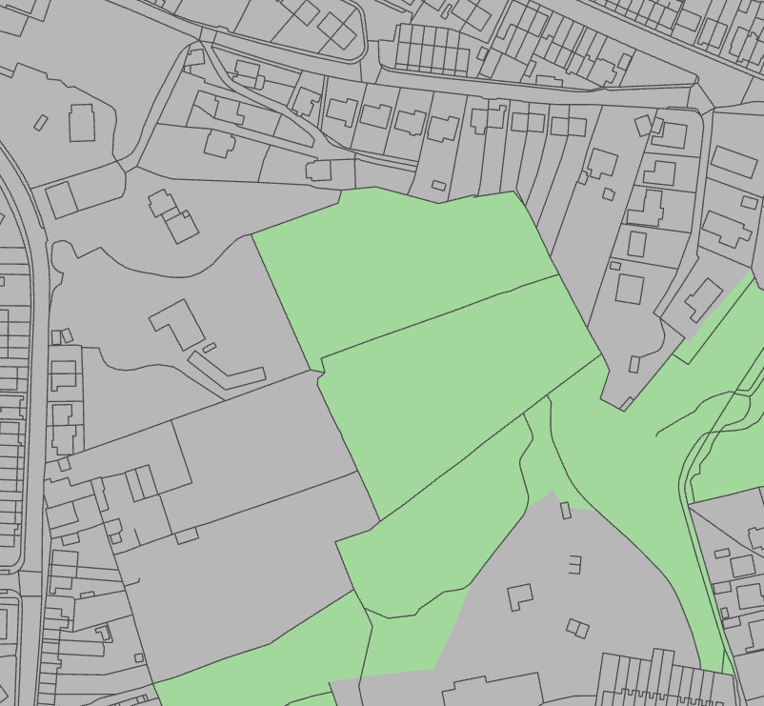
After
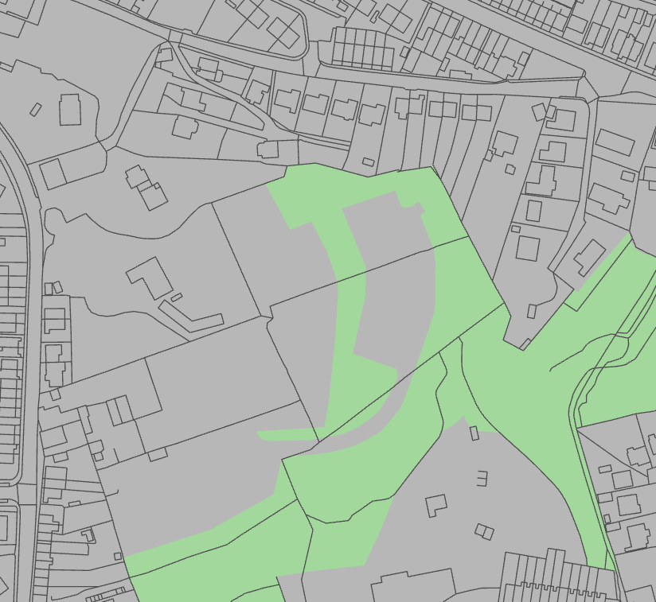
PG25 – 2 Hollin Busk Lane, Stocksbridge
Before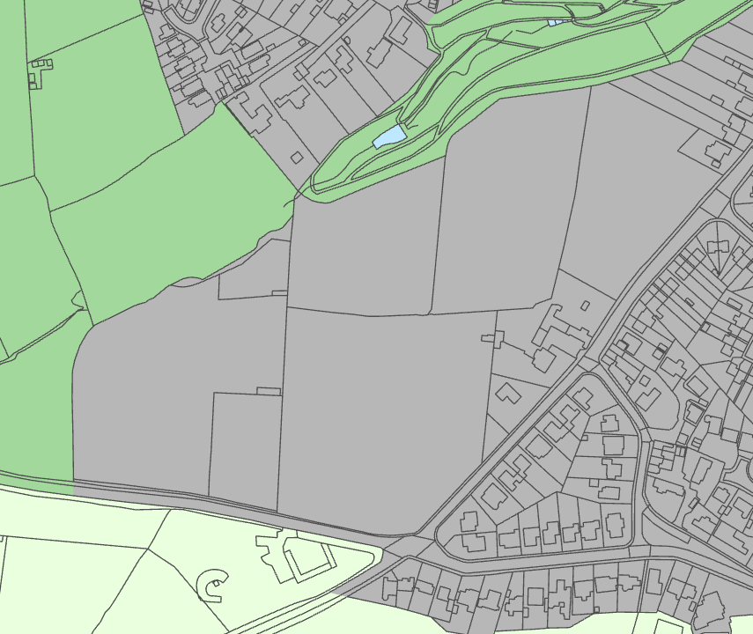
After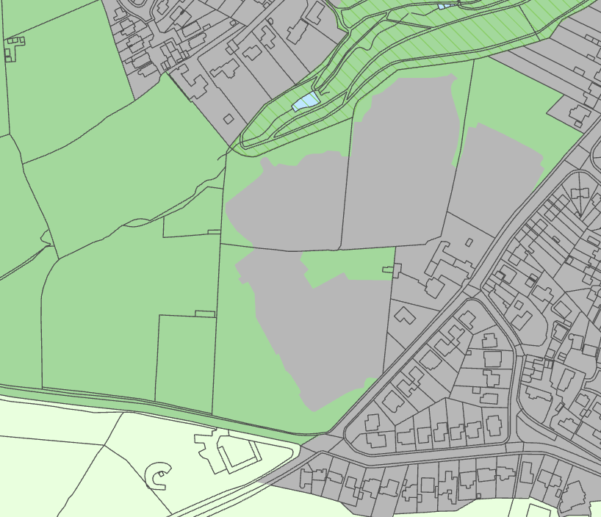
PG10 – NWS04 Wardsend Road North, Owlerton
Before 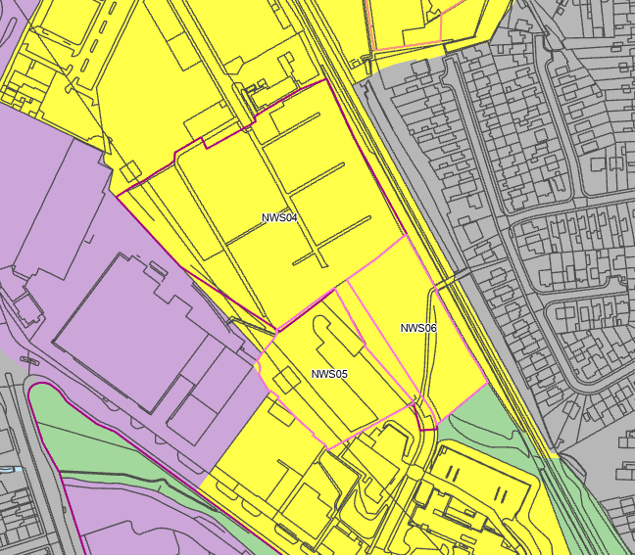
After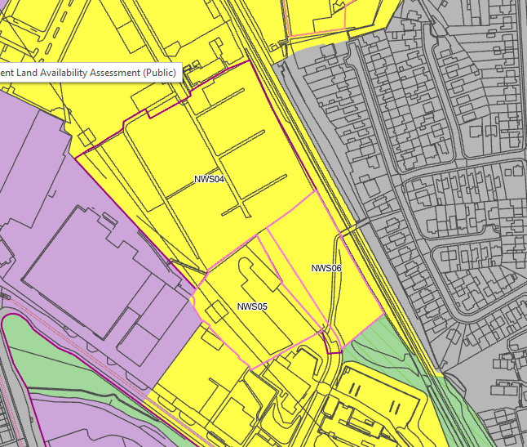
RH108 – SV01 Cross Turner Street, City Centre
Before
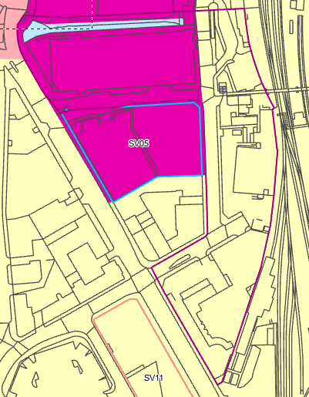
After
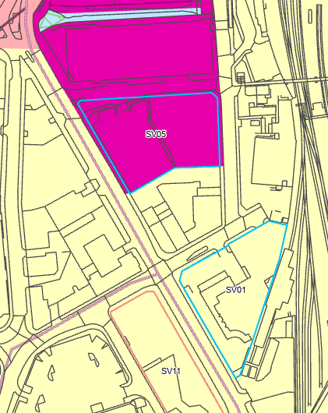
RH98 Rother Valley Way, Holbrook
Before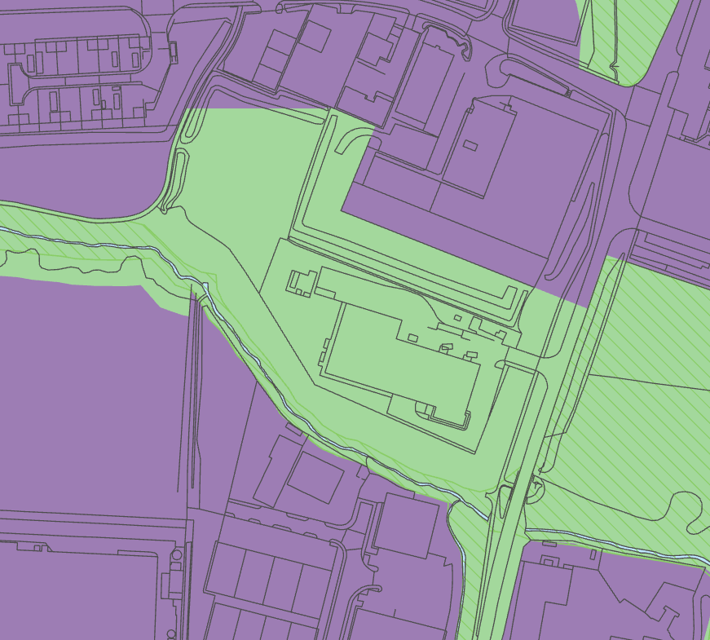
After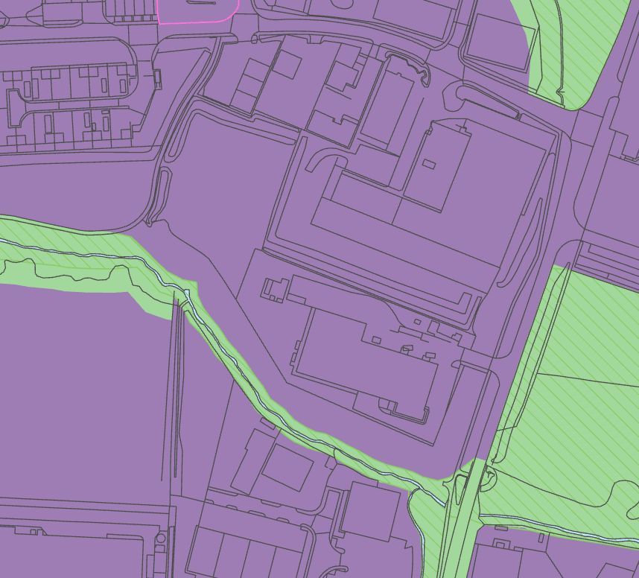
LS2 Wheel Lane, Grenoside
Before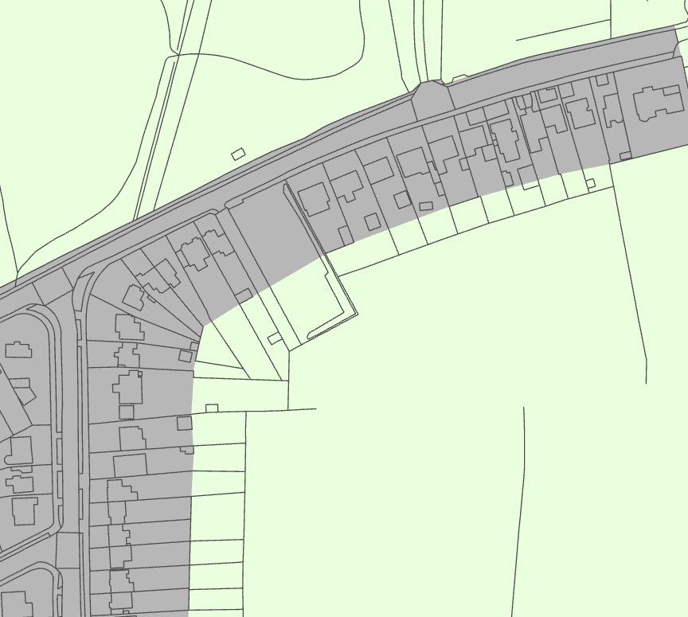
After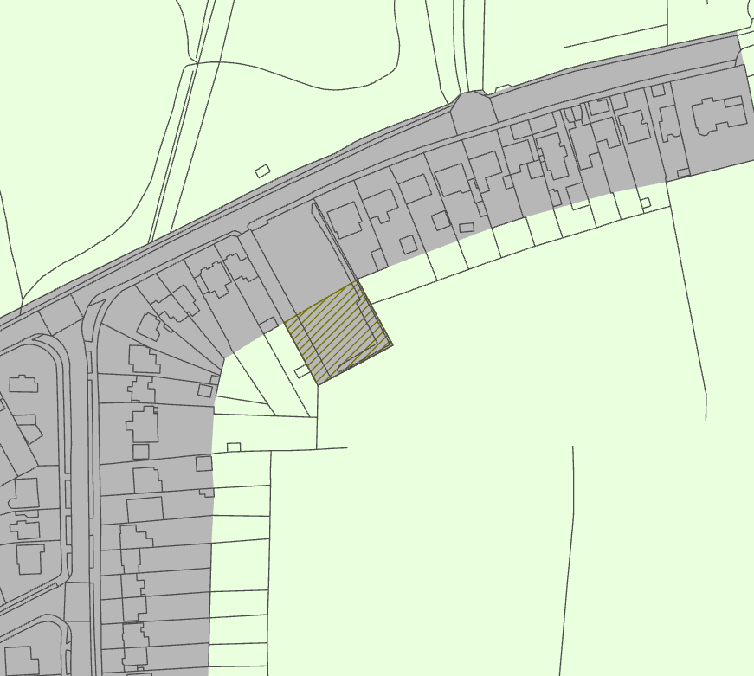
GC38 Hutcliffe Wood, Beauchief
Before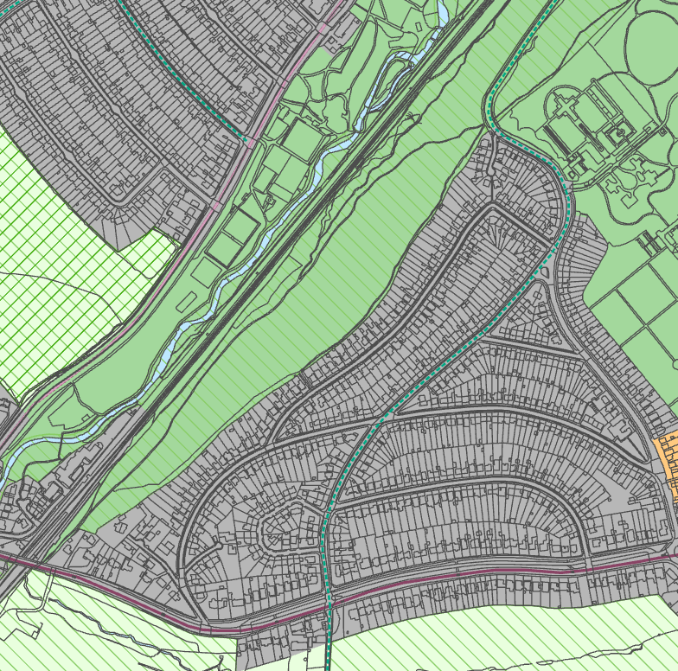
After