Recruitment Information Pack
SEND 1 to 1 Teaching Assistant – Full Time

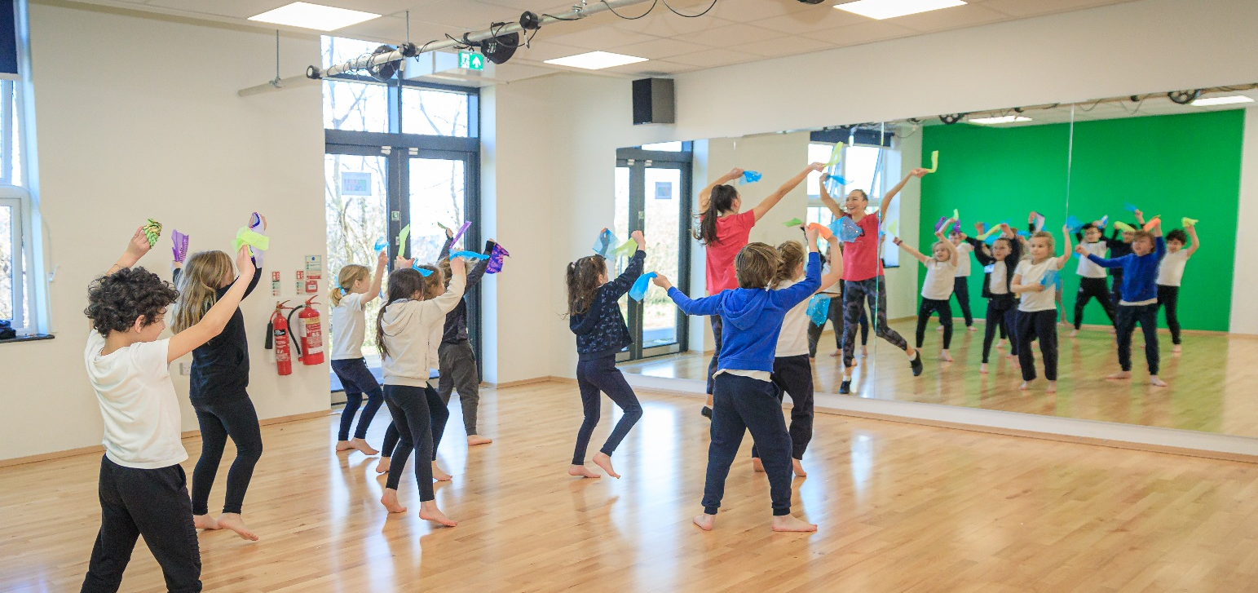
SEND 1 to 1 Teaching Assistant Level 1 to Level 2
Full Time – Permanent
Grade 2 or Grade 3 – Scale point 3 to 6 (£20,812 to £21,968) starting point dependent on experience.
To start as soon as possible
Walkley Primary is a two-form entry school with a wonderful caring culture and an excellent reputation within the diverse local community. Ambitious, bespoke and creative teaching and learning inspires, challenges and empowers pupils to reach their full potential. We are now based in our newly built premises with excellent, purpose-built resources. We have a discovery zone for research; a creative zone for art, DT and science; and a dance and music studio with a greenscreen in which we promote performing arts. We also have outstanding outdoor resources, such as a forest school area and a wealth of outdoor space with the scope to develop into sports facilities. We are looking to recruit a kind, caring and resilient Teaching Assistant who can effectively support a student with SEND needs. You will work alongside the year one teaching team supporting a child with social and emotional needs to access learning and engage in all aspects of school life.  You will receive ongoing advice and support from outside agencies who work with the child.  You will also receive internal support and guidance from the school Special Needs Coordinator, Inclusion team and class teaching team.  For more information about the school, visit www.walkley.sheffield.sch.uk  Informal visits to the school are welcomed by appointment. To arrange this, please contact Chris Wallis, Headteacher. | The appointed Teaching Assistant will:  - Have experience working with children with additional needs  - Have a patient, firm, calm approach  - Promote pupils’ independence, self-esteem and social inclusion  - Demonstrate they can adopt and adapt relevant strategies to support the progress of a pupil with social and emotional needs  - Communicate effectively with other staff members and pupils, and with parents and carers under the direction of the class teacher  In return, we can offer you:  - The opportunity to work in a happy, thriving inclusive school.  - A wonderful school building and extensive site  - Enthusiastic, confident and courteous children, keen to do well, who work and play together across the year groups.  - A strong and experienced staff team who are committed to the school and its creative ethos.  - A talented, highly motivated and dedicated leadership team.  - The support and challenge of an active and committed governing body who will encourage your professional development.  - A school with strong community ties.
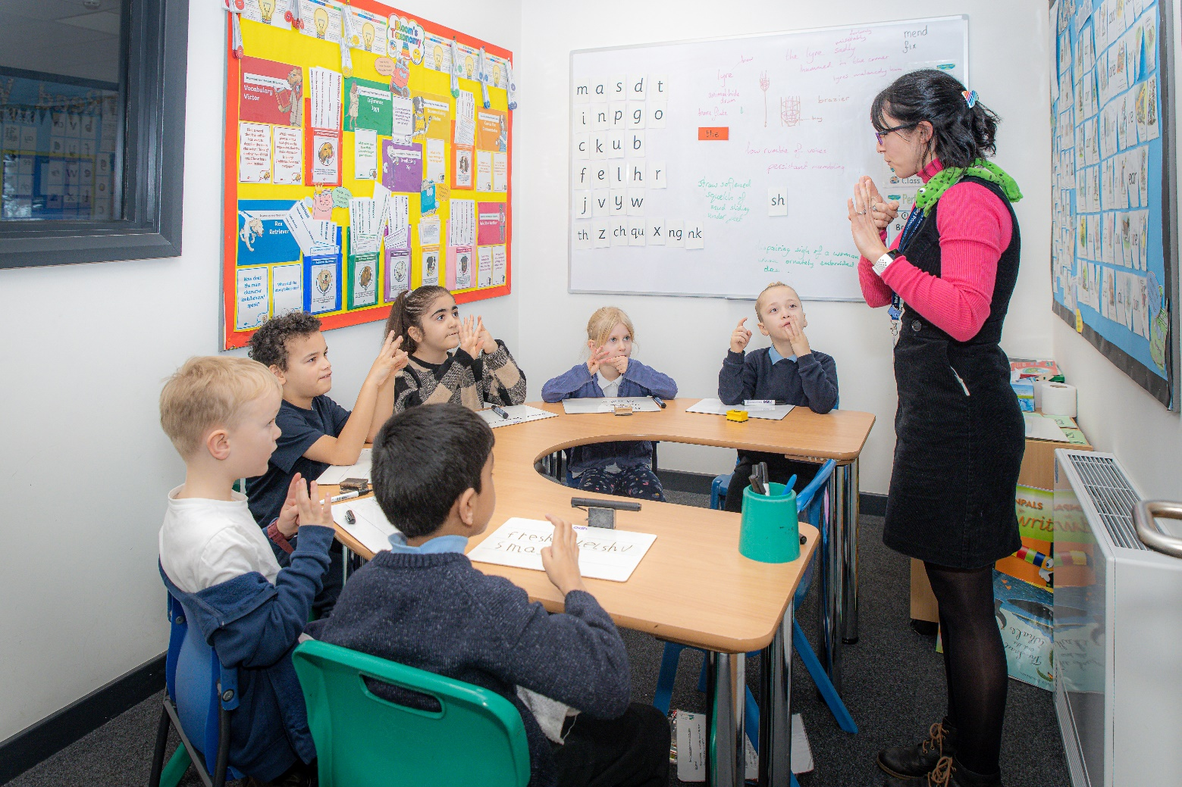
Applications
Please use the personal statement of the application form to demonstrate how you meet the person specification, with examples and, wherever possible, evidence of positive impact.
Closing Date
The deadline for receipt of applications is 12 noon on Monday 9th October 2023. Completed forms should be submitted to the Headteacher at enquiries@walkley.sheffield.sch.uk. If you would prefer to send your application by post, please address it for the attention of the Headteacher at:
Walkley Primary School, Burnaby Crescent Sheffield S6 2RZ
Visiting the school
As stated in the advert, school visits are encouraged and should be arranged directly with the school.
Shortlisting
All candidates will be informed of the shortlisting outcome by 6.30pm on Tuesday 10th October 2023.
Assessment Process
Interviews will take place on Monday 16th October 2023.
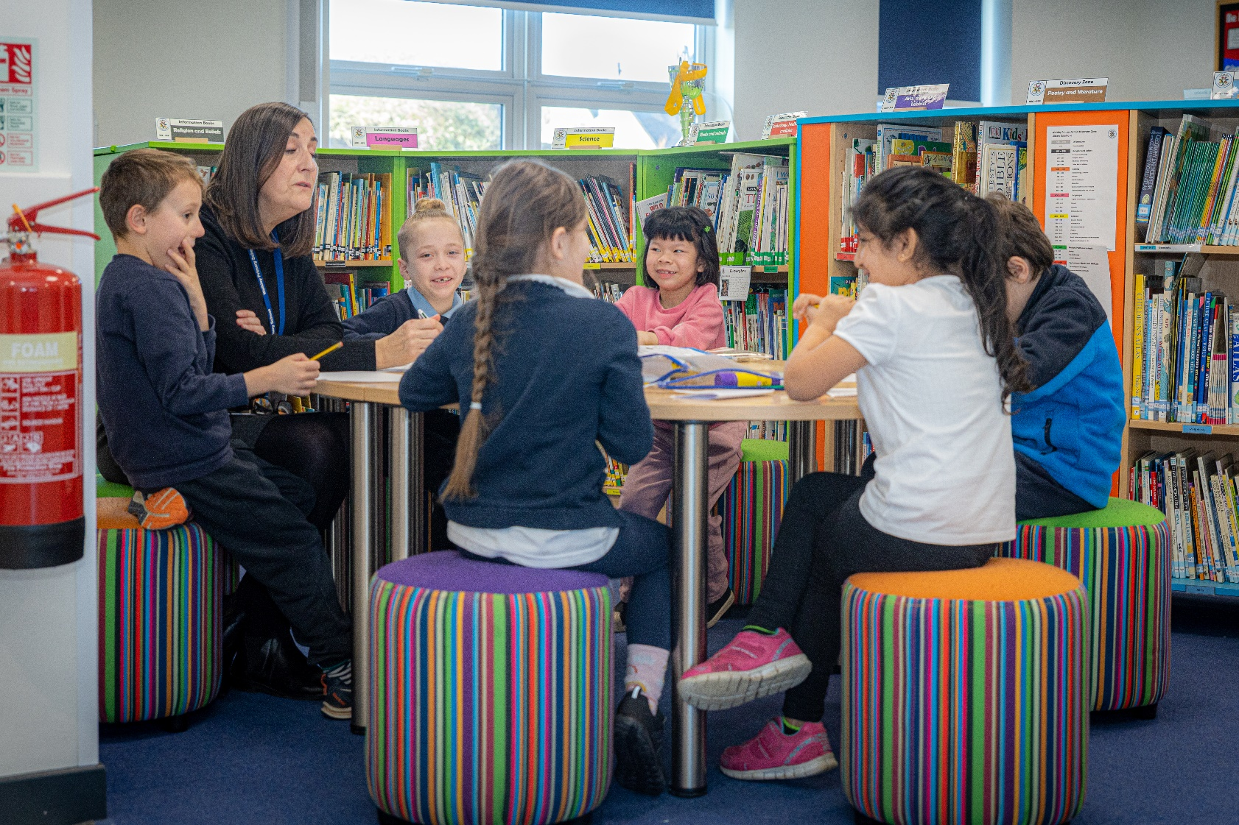
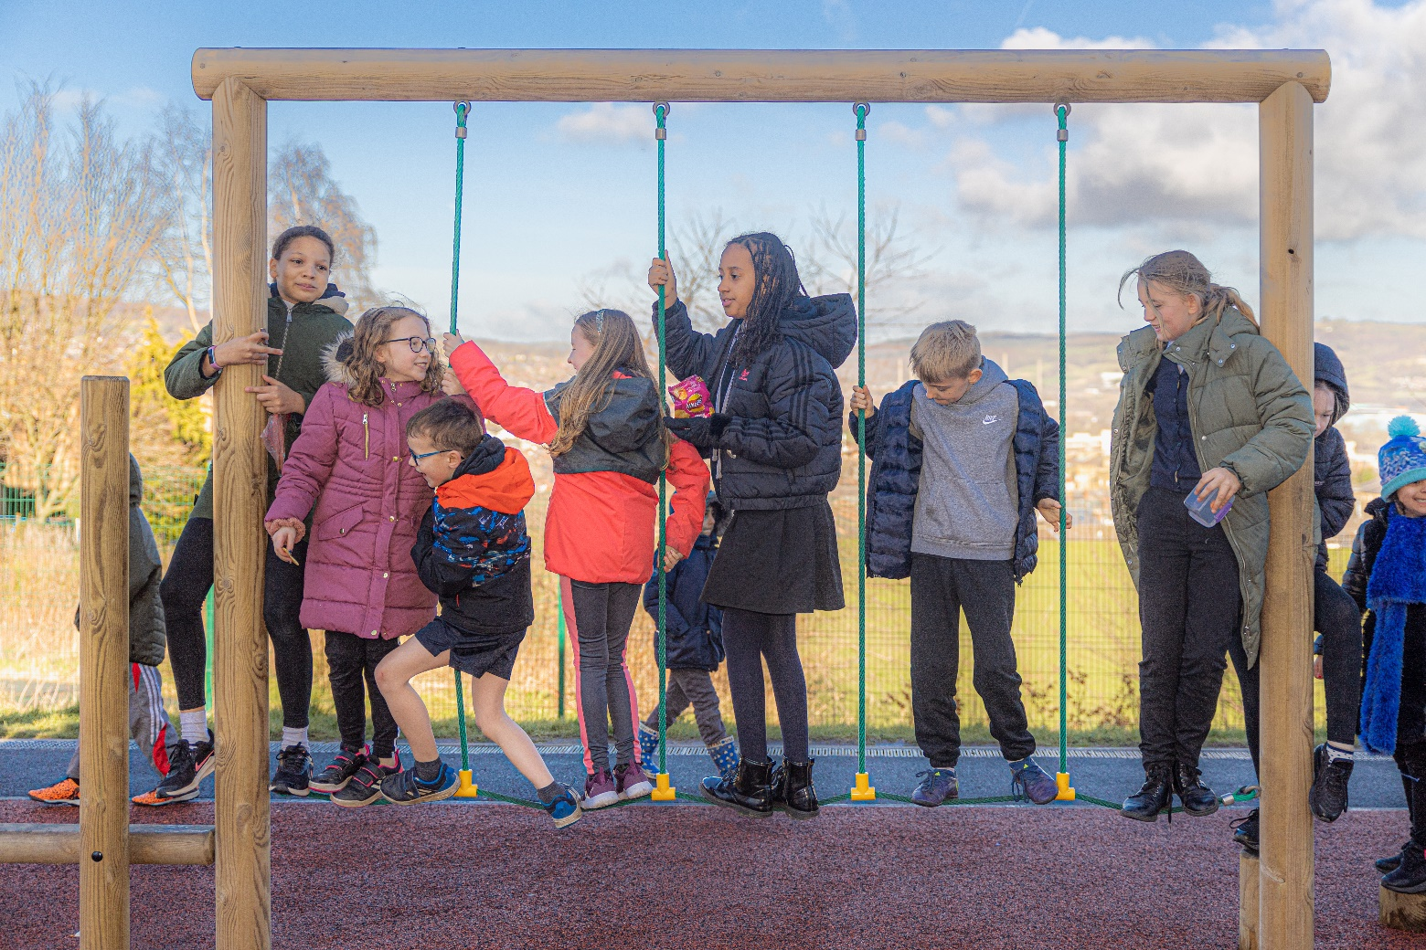
Walkley Primary School

SEND 1 to 1 Teaching Assistant Job Description

Walkley Primary School is committed to creating a diverse workforce. We’ll consider all qualified applicants for employment without regard to sex, race, religion, belief, sexual orientation, gender reassignment, pregnancy, maternity, age, disability, marriage or civil partnership.
Salary range: | Grade 2 / Grade 3 Scale point: 3 to 6 (£20,812 to £21,968) starting point dependent on experience.
Hours: | 39 weeks per year 8.30am to 3.30pm (30 minutes for lunch)
Contract type: | Full Time

The post holder must at all times carry out his/her responsibilities within the spirit of City Council and School policies and within the framework of the Education Act 2002, and School Standards and Framework Act 1998 with particular regard to statutory responsibilities of the Governing Bodies of Schools.
Responsible to: | The Headteacher, the Governing Body of the school and the Executive Director of Children, Young People and Families.
Responsible for: | Supporting pupil with Social and Emotional needs (SEND)

The purpose of the post:
- To provide learning and care support for pupils with special educational needs (SEN). This will involve working with the teacher to plan and deliver activities and supporting pupils with routines, transitions and behaviour management.
- Build positive relationships with pupils, promoting high self-esteem and independence
- Adapt communication style to respond to pupils according to their individual needs
- Support pupils with their social, emotional and mental health needs, escalating concerns where appropriate
- Promote high standards of behaviour, responding to incidents in line with the school’s behaviour policy and guidelines on physical intervention
- Assist with the development and delivery of individual education and support plans
- Give support to a pupil with social and emotional needs so they can access their curriculum, take part in learning, and experience a sense of achievement
- Work with class teachers to raise the learning and attainment of pupils
- Promote pupils’ independence, self-esteem and social inclusion
- Provide opportunities for developing independence.
- Create a purposeful, orderly and supportive environment.

The following responsibilities will include, in liaison with the Headteacher and the Senior Leadership Team as appropriate:
Teaching and learning
- Demonstrate an informed and efficient approach to teaching and learning by adopting relevant strategies to support the work of the teacher and increase achievement of pupils with special educational needs and disabilities (SEND)
- Promote, support and facilitate inclusion by encouraging participation of all pupils in learning and extracurricular activities
- Support the teaching of a broad and balanced curriculum aimed at pupils achieving their full potential in all areas of learning
- Use effective behaviour management strategies consistently in line with the school’s policy and procedures
- Support class teachers with maintaining good order and discipline among pupils, managing behaviour effectively to ensure a good and safe learning environment
- Organise and manage teaching space and resources to help maintain a stimulating and safe learning environment
- Observe pupil performance and pass observations on to the class teacher
- Supervise a class if the teacher is temporarily unavailable
- Use ICT skills to advance pupils’ learning
- Undertake any other relevant duties given by the class teacher
- Contribute to effective assessment and planning by supporting the monitoring, recording and reporting of pupil performance and progress as appropriate to the level of the role
- Read and understand lesson plans shared prior to lessons, if available
- Prepare the classroom for lessons

Working with staff, parents/carers and relevant professionals
- Communicate effectively with other staff members and pupils, and with parents and carers under the direction of the class teacher
- Communicate their knowledge and understanding of pupils to other school staff and education, health and social care professionals, so that informed decision making can take place on intervention and provision
- Contribute to meetings with parents and carers by providing feedback on pupil progress, attainment and barriers to learning, as directed by teachers
- With the class teacher, keep other professionals accurately informed of performance and progress, or concerns they may have about the pupils they work with
- Understand their role in order to be able to work collaboratively with classroom teachers and other colleagues, including specialist advisory teachers
- Collaborate and work with colleagues and other relevant professionals within and beyond the school
- Develop effective professional relationships with colleagues

Health and safety
- Promote the safety and wellbeing of pupils, and help to safeguard pupils’ wellbeing by following the requirements of Keeping Children Safe in Education (KCSIE) and our school’s child protection policy
- Look after children who are upset or have had accidents

Professional development
- Help keep their own knowledge and understanding relevant and up-to-date by reflecting on their own practice, liaising with school leaders, and identifying relevant professional development to improve personal effectiveness
- Take opportunities to build the appropriate skills, qualifications, and/or experience needed for the role, with support from the school
- Take part in the school’s appraisal procedures

Other areas of responsibility
Safeguarding
- Work in line with statutory safeguarding guidance (e.g. Keeping Children Safe in Education, Prevent) and our safeguarding and child protection policies
- Promote the safeguarding of all pupils in the school

The TA will be required to follow school policies and the staff code of conduct.
Please note, this is illustrative of the general nature and level of responsibility of the role. It is not a comprehensive list of all tasks that the TA / HLTA will carry out. The postholder may be required to do other duties appropriate to the level of the role, as directed by the headteacher or line manager.

Person Specification (Teaching Assistant)
All candidates should demonstrate how well their qualifications and experience, personal qualities, skills, professional knowledge and understanding and knowledge of safeguarding meet the requirements of the person specification.

QUALIFICATION AND EXPERIENCE | Method of Assessment
Candidates should have:
GCSE or equivalent level, including at least a Grade 4 (previously Grade C) in English and Maths | Application Form
Experience of working within a school environment or other educational setting | Application Form, References
Experience working with children / young people with Special Educational Needs (SEND) | Application Form, References
Experience planning and delivering learning activities | Application Form

SKILLS AND KNOWLEDGE | Method of Assessment
Candidates should have:
Well-developed interpersonal skills and the ability to work collaboratively, manage initiatives effectively and to motivate others: e.g. sharing good practice. | Application Form, References, Interview
Good literacy and numeracy skills | Application Form, References, Interview
Good organisational skills | Application Form, References, Interview
Ability to build effective working relationships with pupils and adults | Application Form, References, Interview
Skills and expertise in understanding the needs of all pupils | Application Form, References, Interview
Knowledge of how to help adapt and deliver support to meet individual needs | Application Form, References, Interview
Subject and curriculum knowledge relevant to the role, and ability to apply this effectively in supporting teachers and pupils | Application Form, References, Interview
Active listening skills | Application Form, References, Interview
Knowledge of guidance and requirements around safeguarding children | Application Form, References, Interview
The ability to remain calm in stressful situations | Application Form, References, Interview
Skills in conflict resolution | Application Form, References, Interview
Good ICT skills, particularly using ICT to support learning | Application Form, References, Interview
The ability to respond effectively and efficiently to daily challenges | Application Form, References, Interview
Understanding of roles and responsibilities within the classroom and whole school context | Application Form, References, Interview

PERSONAL QUALITIES | Method of Assessment
Candidates should have:
Enjoyment of working with children | Application Form, Interview
Sensitivity and understanding, to help build good relationships with pupils | Application Form, Interview
A commitment to getting the best outcomes for all pupils, and promoting the ethos and values of the school | Application Form, References, Interview
Enthusiasm and determination, a positive attitude and a good sense of humour | Application Form, Interview
Excellent self-management skills including the ability to plan and organise one’s time effectively | Application Form, Interview
Have a flexible approach and a willingness to offer help | Application Form, References, Interview
The ability and willingness to work in partnership with other members of the school team | Application Form, References, Interview
A high level of personal integrity and flexible approach to responsibilities | Application Form, References, Interview
Ability to work under pressure and prioritise effectively. Able to systematically process enquirers, work requests and cope with interruptions | Application Form, References, Interview
Capacity to inspire, motivate and challenge children and young people | Application Form, References, Interview
Commitment to maintaining confidentiality at all times | References, Interview
Commitment to safeguarding and equality | References, Interview

Walkley Primary School is committed to safeguarding and promoting the welfare and safety of children. We expect all our staff and volunteers to share this commitment. This post is exempt from the Rehabilitation of Offenders Act (ROA) 1974. All shortlisted candidates will be asked to disclose any cautions or convictions prior to interview. The amendments to the ROA Exceptions Order 1975 (2013 & 2020) provide that certain convictions and cautions are 'protected' and are therefore not subject to disclosure to employers. Guidance and criteria on the filtering of these cautions and convictions can be found on the Ministry of Justice website.

