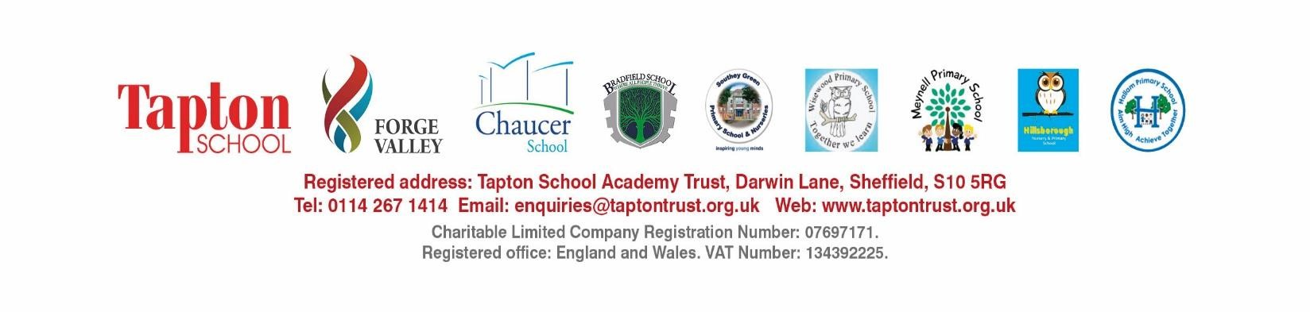
Level 2 Teaching
Assistant
Temporary position
–

Aug 2024

Candidate Information Pack

Contents
1
. A message from our CEO
2
. About TSAT
3
. Our Schools
4
. The Role
5
. Responsibilities
6
. The Person
7
. How to apply
Thank you for your interest in joiningTSAT.
We were established in 2011 and operate a family of schools across Sheffield, offering education from early years to sixth form.
At the heart of all our endeavours is outstanding teaching, high quality learning and effective support for individual needs.
We employ over 900 staff and work hard to foster the right conditions to make the Trust a great place to work. We know that our staff are our greatest resource, and put in place support and opportunity to enable colleagues to progress within the Trust and reach their full potential.
Thank you again for your interest in joining us and the best of luck with your
application.
David Dennis,
CEO

About TSAT
Since forming in 2011 TSAT has grown to 9 schools, 5 primary and 4 secondary, providing learning to over 7,500 learners from 2 – 18.
Collaboration is at the heart of our Trust.Our aspiration,with distributed leadership across TSAT,is to be greater than the sum of our parts.
OurVision : To realise the life chances and dreams of every child.
Our Mission : To provide a safe place to be; provide great teaching and learning; create an
environment where all opportunities are in reach.

OurValues
- A culture of professionalism.
- A focus on nurture as well as achievement.
- Involvement of the family and wider community in everything we do.
- Make visible those who feel invisible through disability,poverty,ethnic or cultural disadvantage.
- Mutual support and development.
- The health,well-being and safety of all our people.

Our ways of working
- Schools sign up to our ‘Mission,Vision andValues’ and collaborative ways of working.
- Schools collaborate ‘in partnership for excellence withTSAT.’
- Each has something to bring to the table and can lead on this.
- Schools retain their identity and are part of something special.
- Differentiated solutions according to support needs.
- Mentoring,coaching,directing.
- A clear scheme of delegation and decision making to ensure that all our children get the best
educational experience.
For further information please visit the Trust website: TSAT - Home (taptontrust.org.uk)

Our Schools
Our five primary and four secondary schools work in close partnership with the aim of realising the life chances and dreams of every child and becoming an outstandingTrust.
Each of our schools has its own distinctive character, reflecting the local community it serves. Children joining us have a broad range of abilities and social backgrounds. We recognise and celebrate different aptitude and interests and believe that everyone can develop through dedication and hard work,leaving our schools fully prepared for successful lives.

Primary Education
4 of our 5 primary schools are Ofsted rated ‘Good’ giving our children an excellent start to their education and preparing them fully for their secondary transition.
Primary Education

Secondary Education
Our secondary schools work in close collaboration to further develop our curriculum and
outcomes.
Our sixth form provision is Ofsted rated ‘Good’ or ‘Outstanding’
Secondary Education

Central Services
Our support staff are highly valued and we offer a range of central services to our schools to enable them to concentrate on outstanding teaching, high quality learning and effective support for
individual needs.Services include:
- Catering
- Communications and Marketing
- Facilities
- Finance
- Governance
- HR
- IT
- School Improvement.
About Southey Green Primary School and Nurseries.
Southey Green are committed to giving our children the very best education. We recognise the individuality of every child and young person and aim to ensure that each one achieves their full potential.
The curriculum is unique and personalised to Southey as it incorporates a range of key elements aimed to remove specific barriers to children’s learning and enrich children’s experiences to ensure that they leave our primary school as successful learners.
- Our aim is that children leave our school:
- As responsible members of society.
- With curious minds and a developing understanding of the world around them.
- Articulating ideas while being respectful and considerate of others views.
- With raised aspirations – children are ready to take on new challenges.
- Literate and numerate.
The school was inspected in October 2021 and was graded ‘Good’ in all areas. Ofsted stated that ‘Pupils are happy, keen and engaged. Pupils, staff, parents and carers appreciate the family feel of the school.’ Pupils said, ‘School is just marvellous.’ Staff have high expectations and aspirations for all pupils, including those with special educational needs and/or disabilities (SEND). Pupils live up to these expectations; they are ever mindful of being ‘Ready, Respectful and Responsible’. They have positive attitudes to learning and enjoy all that they do.
The school has a 32 place two year old provision and a three/four year old nursery with a 78 place capacity often giving 156 children on roll in the nursery.
The Senior leadership team is made up of a Headteacher, six assistant Headteachers, and an inclusion lead. It also has a large Inclusion/SENCO team.
The School has a new individual governing body.

The Role
We are seeking to appoint a Level 2 Teaching Assistant to support learning across the school. The Teaching assistant will support the delivery of quality first teaching in the classroom by working with individuals and small groups of children. They will deliver specific interventions for individuals outside of the classroom.
Salary Range: | Grade 3 SCP 5-6  £19,650 -£20,043 PRO RATA
Responsible To: | Assistant Headteacher for Inclusion /  Headteacher
Responsible For: | Learning support for children across the school.  To address the individual needs of children and help them overcome barriers to learning both in and outside school in order to achieve their full potential.
Holidays: | Holidays in line with the Sheffield school calendar
Benefits: | - Salary Sacrifice Car Scheme  - Cycle to Work Scheme  - Discounted membership for Westfield Health  - Occupational Health  - Wellbeing Programme  - Continuous CPD and Training
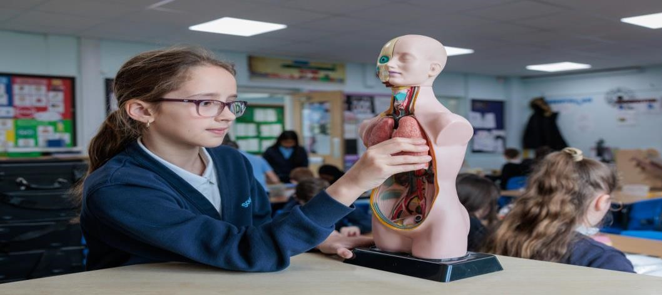

Responsibilities
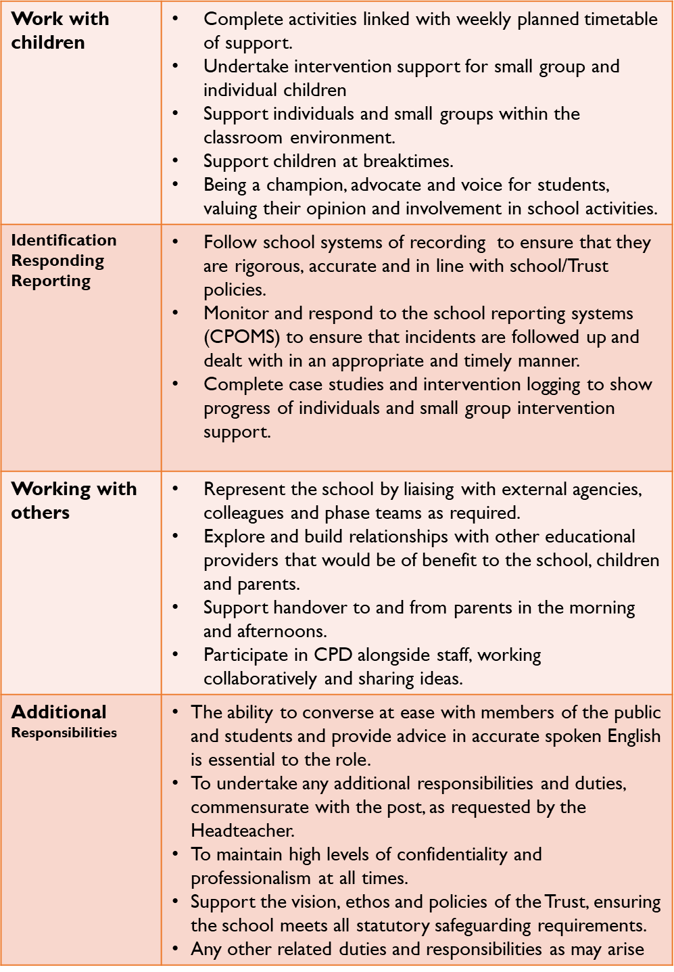

The Person
The successful candidate will demonstrate the following:
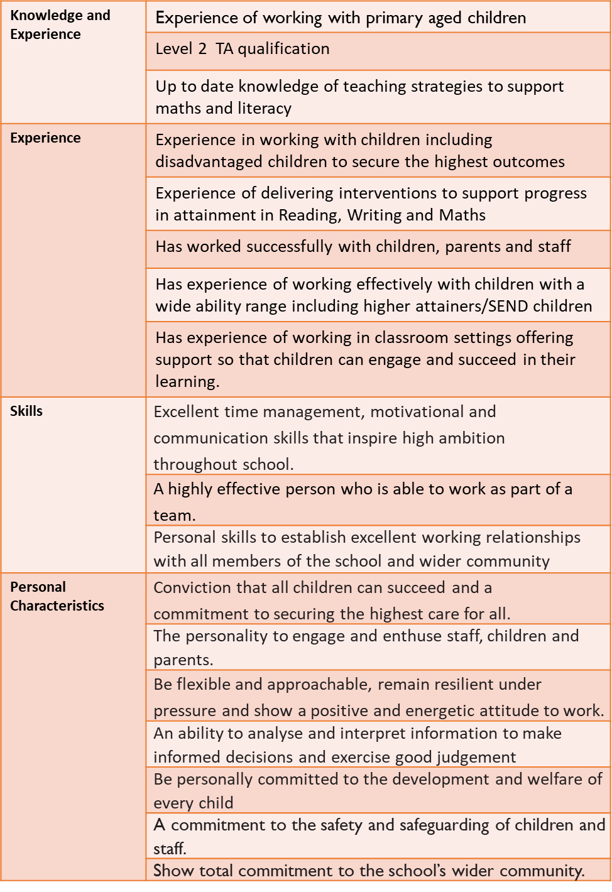

How to apply
Informal discussions about the role and visits to the school are warmly welcomed. Please contact us to arrange:
- Main School Office 0114 2326879
- enquiries@southeygreen.sheffield.sch.uk
Applications for this role are via the TES website. If you require a paper of the copy of the
application form please contact us: enquiries@southeygreen.sheffield.sch.uk .
The closing date for applications is Wednesday 4th October 2023 Interviews will be held Friday 13^{t} October 2023.

Safeguarding
TSAT is committed to safeguarding children and promoting the welfare of children and young people and expects all staff and volunteers to share this commitment. We will ensure that all our
recruitment and selection practices reflect this commitment. All candidates will be subject to the following employment checks:
Shortlisted Candidates:
- References will be requested before interview.
- A Criminal Convictions Disclosure Form will be requested at interview.
- Evidence of identity / right to work in the UK will be requested at interview.
- Qualification certificates will be requested at interview.
- Disclosures concerning child protection investigations, relationships with pupils, employees, governors or trustees, prohibition orders and section 128 directions (where applicable) will be requested at interview.
- We may conduct online searches for shortlisted candidates prior to making our final decision. If any information obtained from the online searches raises concerns around someone’s suitability for the role or to working with children then this may be raised with the candidate at interview
and/or we may take advice from the local authority children’s services.
Successful Candidates:
- Successful candidates will be required to undertake a DBS Enhanced Disclosure (with barred list)
check.
- Successful candidates will be required to complete a Childcare Disqualification under the Childcare Act 2006 Declaration (for applicable posts).
- Pre-employment medical screening.
Please note: Canvassing of any employee, Trustee or member of the Local Governing Board directly
or indirectly is prohibited and your application will be disqualified.

Policies
Our approach to safeguarding, and school safeguarding policies can be found on the Trust website:
TSAT - Safeguarding (taptontrust.org.uk)

Equality & Diversity
We are committed to providing equality of opportunity for all and ensuring that all stages of recruitment and selection are fair and that applicants are not discriminated against on the grounds of race, nationality, gender, religion, age, disability, marital status or sexual orientation. Click Here to accessTSAT`s Equality and Diversity Statement.

Data Protection
As part of the recruitment process, we need to collect your personal data. For more information about what we do with your personal data, please see our Recruitment Privacy Notice on the
policies page of our website.

