Poly Studio X50 & TC8 Tablet User Guide

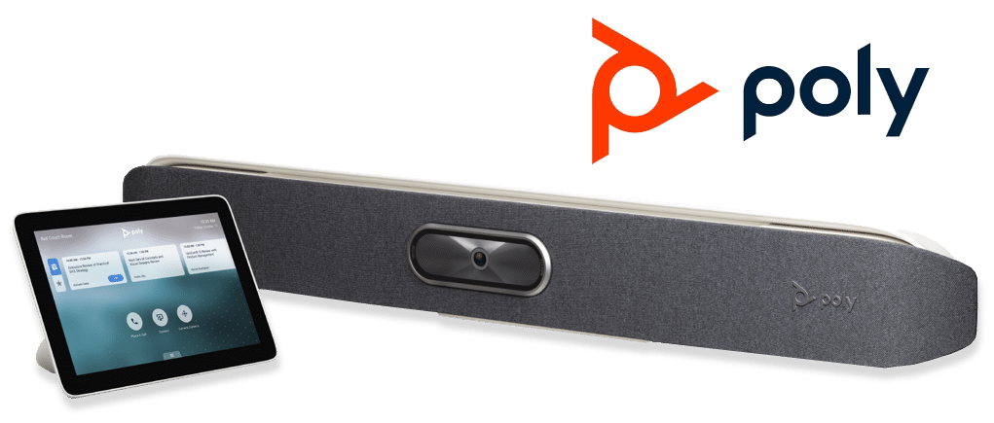

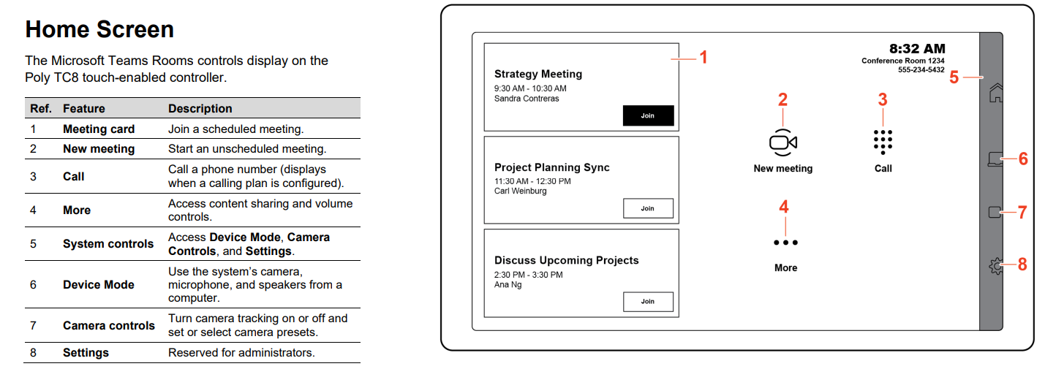

Join a Meeting from Poly TC8
- On the Poly TC8 device, select a meeting card.
- Select Join

Join a Meeting from a Computer
Join a meeting and connect to the room from your computer.
- Join a meeting from the Microsoft Teams desktop application on your computer.
- On the Choose your video and audio options screen, select Room audio
- Choose the conference room from the list and select Join now.

Schedule a Meeting
Set your Teams meeting up in Outlook/Teams, inviting the Teams Meeting Room as a required attendee by populating the Required field with the room email address, for example Howden-Teams-Room@sheffield.gov.uk.
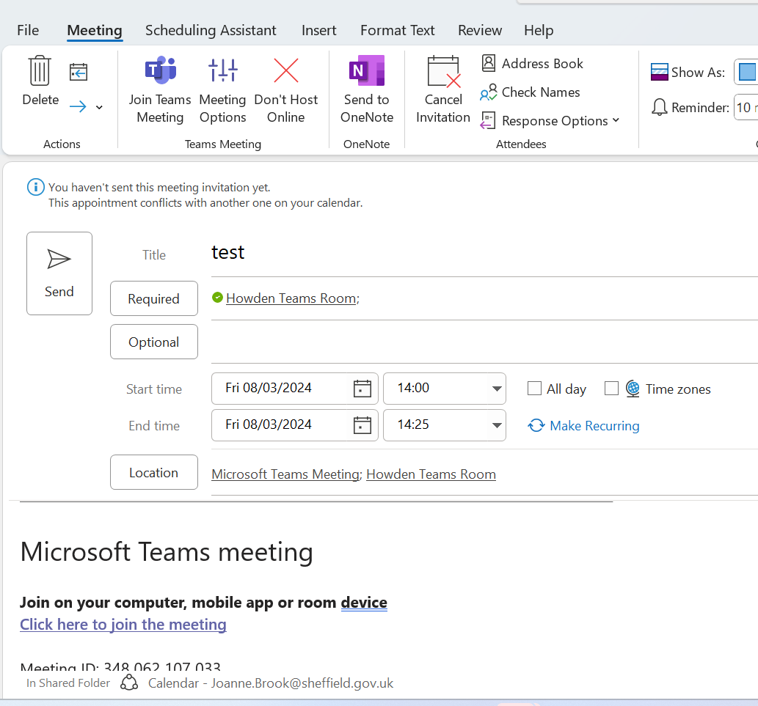

At the meeting select ‘Join’ on the tablet to start the meeting. Attendees will be able to share content into the meeting via their own Teams logging on their devices

Start an Unscheduled Meeting

- Select the Meet icon
- Search for a name in the directory or enter the contact’s email address.
- Select Invite

Please note that external attendees can only attend a scheduled meeting.

Please ensure you remove the magnetic cover from the Poly Studio when using video.

