Living the Life, You Want to Live

Adult Care and Wellbeing CQC Self-Assessment March 2024

Living the Life, You Want to Live

Contents

SECTION 1 - INTRODUCTION | PAGE
Foreword | 3
Introduction | 4
About Sheffield | 5
About Adult Care in Sheffield | 7
Celebrating Team Sheffield | 8
SECTION 2 – SELF ASSESSMENT
CQC Theme 1: Working with People | 10
- Our Data | 11
- Our Strengths | 12
- Our Challenges | 14
CQC Theme 2: Providing Support | 19
- Our Data | 20
- Our Strengths | 21
- Our Challenges | 23
CQC Theme 3: Ensuring Safety within the System | 27
- Our Data | 28
- Our Strengths | 29
- Our Challenges | 32
CQC Theme 4: Leadership | 36
- Our Data | 37
- Our Strengths | 38
- Our Challenges | 39

Foreword
P a g e | 2

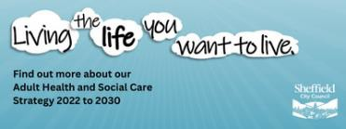
I am delighted to introduce the first CQC Self-Assessment as Strategic Director of Adult Care and Wellbeing here in Sheffield. Since I started in this role in November 2020 I have been so impressed by the hard work, dedication, and commitment of our teams, our partners, unions, experts by experience and unpaid carers. I want to use this self- assessment along with my Local Account, as always to say a really big thank you to everyone involved in adult social care.
I have used this self-assessment, as with our Local Account, to give a summary of adult social care in Sheffield and to celebrate what we do well in Sheffield. I know that our workforce across all of adult social care have made a real difference to the lives of thousands of people, as evidence by our continued improvement in relation to our local I statements and national outcomes (ASCOF).

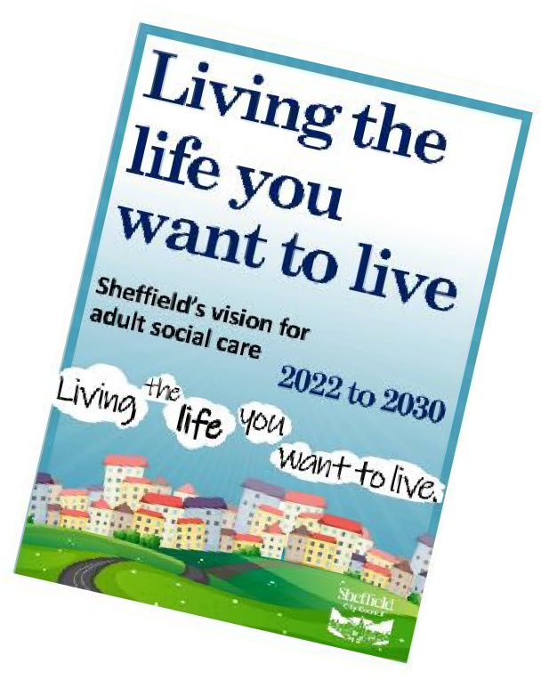
I also want this self-assessment to reflect on our challenges and our areas where we are working to improve our performance and delivery of adult care. We know that there are things that we can do better, and we want to do the very best we can. This is not always an easy task. We face budget pressures and growing demand on our services.

That’s why we have co-developed a new strategy Living the Life you want to live and used this Strategy as the foundation for all of our changes in Adult Care.

This includes developing a new operating model, a delivery plan and practice framework all built around our strategic outcomes set out in our Strategy. We have used the I- statements along with our focus on performance as a way of measuring our progress so that over the next 10 years we can show how we are delivering on what people said mattes to them.
We have used the Care Quality Commission’s four assurance themes to structure this self-assessment. We are really looking forward to feedback from the different sessions, interviews and audits that will make up the assurance visit. It is important that we know ourselves well and are open to learning so once again, thank you for being part of this assurance process and helping us do even more to make our vision real.

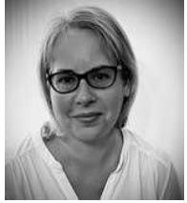
Alexis Chappell
Strategic Director
Adult Care and Wellbeing

Introduction
P a g e | 3

We are really proud to serve the residents of Sheffield to deliver excellent quality, valued social care services. We are incredibly proud of what we have achieved and the difference this has made to the people of Sheffield, our workforce, and stakeholders.
We want people of Sheffield to live in a place they can call home, in communities that care, doing things that matter to them, celebrated for who they are and when they need it, they receive care and support that prioritises independence, choice, and recovery.
Adult Social Care (ASC) is a partnership of individuals in need of support, carers, our workforce, our partners, the voluntary and community sector, unions, and our communities. We work together to close the gap on inequalities, prevent or reduce the need for care and support, and develop opportunities for people to live independent and fulfilled lives in their local communities. We do this by providing information, advice, and guidance, as well as support and services people of all ages in Sheffield.
We have structured this self-assessment around the new Care Quality Commission’s Single Assessment Framework and the following four themes and their underpinning quality statements:
- Working with people: assessing needs, supporting people to live healthier lives and equity in experiences and outcomes.
- Providing support: care provision, integration, continuity, partnerships, and communities.
- Ensuring safety: safe systems, pathways and transitions and safeguarding.
- Leadership: includes governance, management, sustainability, and learning, improvement, and innovation.

About Sheffield
Sheffield is on the up and it is being noticed. It’s a city which is being recognised as one of the best cities in the UK to live in. Sheffield is an amazing and welcoming city for about 600,000 people which celebrates and values our diversity, culture, history and all the wonderful green spaces across the city. We Sheffielder’s are really proud of our brilliant city and have big ambitions for the future.
Putting people at the heart of what we do, openness and honesty and equality and inclusion are our values underpinning the work we do. As a Council, we are focused on celebrating differences, treating each person with respect and dignity, and helping them to be safe and socially included, supporting their own sense of identity.
We are known around the world for the friendly welcomes you give in the UK’s first City of Sanctuary, and for your determined spirit. And this gives communities,

P a g e | 4

neighbourhoods, and networks their own unique feel, as well as significant strength. People have told us that they want meaningful influence over decisions in their communities and by working together to achieve real change will be the driving force behind our future.

Our Council Plan – Together we get things done 2024 – 2028  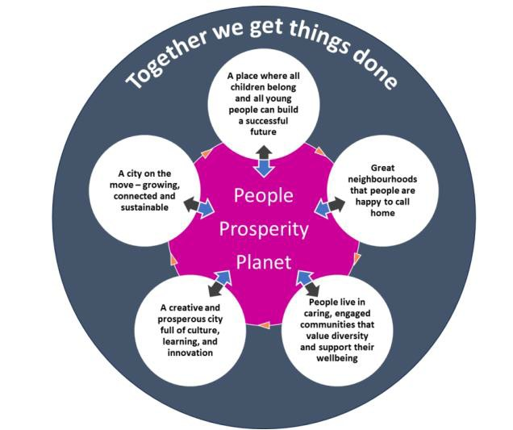 | Through the Council Plan our aim as a Council is to work with the people of Sheffield, with other public services, with our voluntary, community, faith and social enterprise (VCFSE) partners, with business and with Government as a whole council to get things done for our great city.  By delivering the outcomes set out in this plan, we will help to achieve the City Goals.  We will listen, involve, collaborate with others and empower – leading and taking action where we need to and getting out of the way where others are  better placed.

As a Council, we have moved towards a Committee System in 2022, following a referendum in 2021, which changed the governance of the Council and how democratic decisions were made and Local Area Committee’s, which aim to support a move of decision making closer to local communities.
As part of our Committee System, there is a dedicated Adult Health and Social Care Policy Committee, and Health Scrutiny Committee which Members have been fully engaged with and leading. Through the Adult health and Social Care Policy Committee all decisions made in relation to Adult’s are transparent and in public domain, enabling greater accountability in relation to Adult Care in the City.
Locally, our Health and Wellbeing Board provides a collective city-wide approach to earlier intervention, prevention and enabling a joined-up approach to improving the lives and outcomes for everyone in the city. We are committed to continually learning as a Council and as a City our Corporate Peer Review Update demonstrated positive progress alongside our progress in delivery of our Lowcock report and the Race Equality Commission. What’s great about Sheffield is our collective focus on collaboration and delivering the best outcomes for the people of Sheffield.

About Social Care in Sheffield

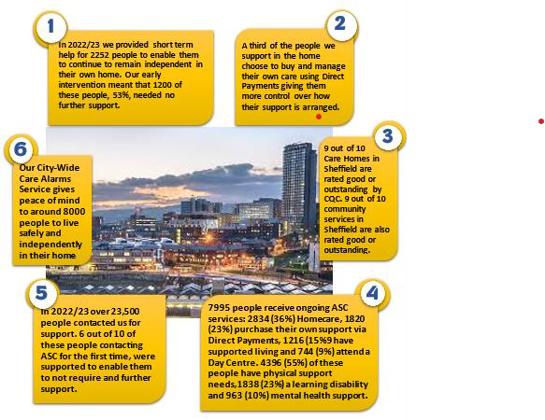P a g e | 5

The last three years have seen a radical transformation of Adult Care and Wellbeing (ACW) in Sheffield. We are proud of our journey of improvement which has moved ACW from a largely underperforming portfolio, to one which is now making a sustained and lasting positive difference to the people of Sheffield, enabling them to live the life they want to live and have both choice and control over the decisions that affect them. Our improvement journey is an essential part of the background and context for our achievements and performance to date.
Our journey started anew 2021, with appointment of a new DASS and a self- assessment using LGA Towards Excellence in Social Care, independent reviews of safeguarding, health and safety and our governance and initiation of co-production of our first strategy and target operating model.
Our Adult Care Strategy, Living the life you want to live was approved by the Co- operative Executive in March 2022, The Strategy is for the period 2022 to 2030 and it builds on citywide commitments in the Joint Health & Wellbeing Strategy 2019-2024 and Shaping Sheffield 2019-2024.

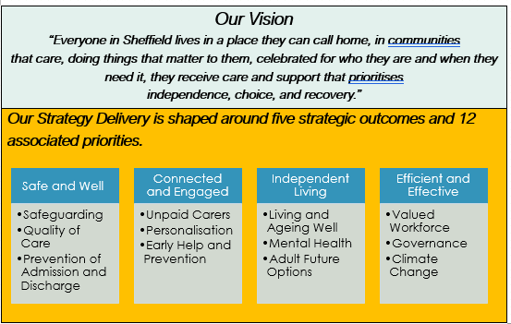P a g e | 6

We also provide quarterly performance updates to Committee, with latest in Performance Update in December 2023 and subject specific updates linked to our Cycle of Assurance so that we are publicly accountable and demonstrate our journey travelled in delivering upon our strategic ambitions. During the last couple of years, we have focused on stabilising and operationalising the strategy through our Adult Care Target Operating Model to enable a focus on a shift towards personalised, early help and prevention in line with ADASS DASS Guidance’s our partners so that individuals and unpaid carers can live the life they want to live. The model is described below.
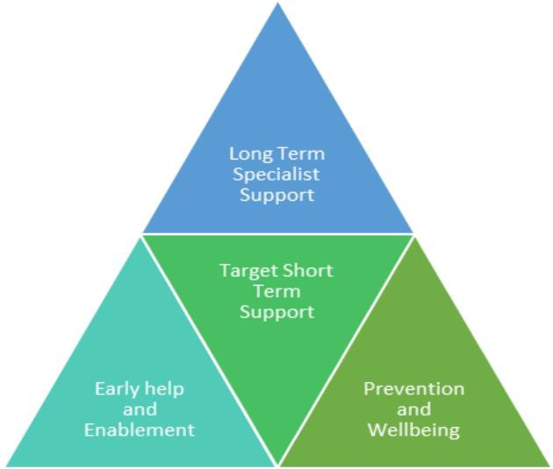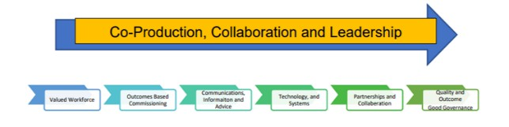

Core to our model is a committed to genuinely valuing the voice and experience of individuals, their families, carers, and those with lived experience and to developing

P a g e | 7

partnerships across the city. There are many examples of our co-production, engagement and partnerships throughout this self-assessment, including our DASS Local Account 2022 - 2023, our Learning Disability Strategy. our all-age Autism
Strategy and our changing futures programme as well as Adult Multi-Agency Screening Hub. We are also committed to continually learning to build the conditions for excellent outcomes for people and our workforce. Our LGA Adult Care Peer Review, Safeguarding Review, Health & Safety Review and commitment towards gaining ISO9001 and Investors in People Accreditation have all provided excellent foundations for our improvements over the last three years.
People are at the heart of our practice and approach to ACW in Sheffield. Collaboration, partnership working and integration, with both our Statutory and community partners, are also core components of our practice, in recognition that ASC cannot operate effectively in isolation. Instead, we see ourselves as part of a wider Adult Health and Social Care (AHSC) system, where genuine collaboration and integration maximises the experiences and outcomes for people. Examples of our approach to collaboration, Integration and partnership working are detailed throughout this self-assessment. In addition, our DASS now sits on the Council’s Senior Leadership Team, reporting directly to the Chief Executive. Combined with our regular Committee reporting and engagement of Elected Members this has helped to ensure that ASC is at the very core of Council business and strategic developments, alongside raising the profile of of the care and support we provide in the city.

Celebrating Team Sheffield
Key to our programme of delivery over the last 3 years has been our workforce across social care. Everyday our workforce undertakes fantastic work to support people of Sheffield and along with our Unions and Partners have been a key critical friend to our journey of development and scrutiny.
In January 2024, we provided our first workforce update and in particular our development of our first Care Academy, progression routes as well as our trajectory towards meeting LGA Workforce Standards, enhancing our support to Personal Assistants, and delivering on our first Workforce Strategy. Key has been our partnership with our Workforce, Skills for Care and the ICB (Integrated Care Board).
To celebrate our workforce, we launched an annual Sheffield Adult Care Dignity Award in July 2023, co-produced with individuals and unpaid carers. These awards are a celebration of exceptional practice and recognition of the work of nominees and winners are open to all of our workforce across the sector. In 2024 we will be hosting a celebration event with partners to publicly recognise and support our staff.
We are incredibly proud of our achievements over the last two years and the commitment of our workforce to achieve our ambitions. Many of our 17,500 City Wide Social Care Workforce have dedicated all or a large part of their working life to adult social care which we are proud to acknowledge and celebrate.

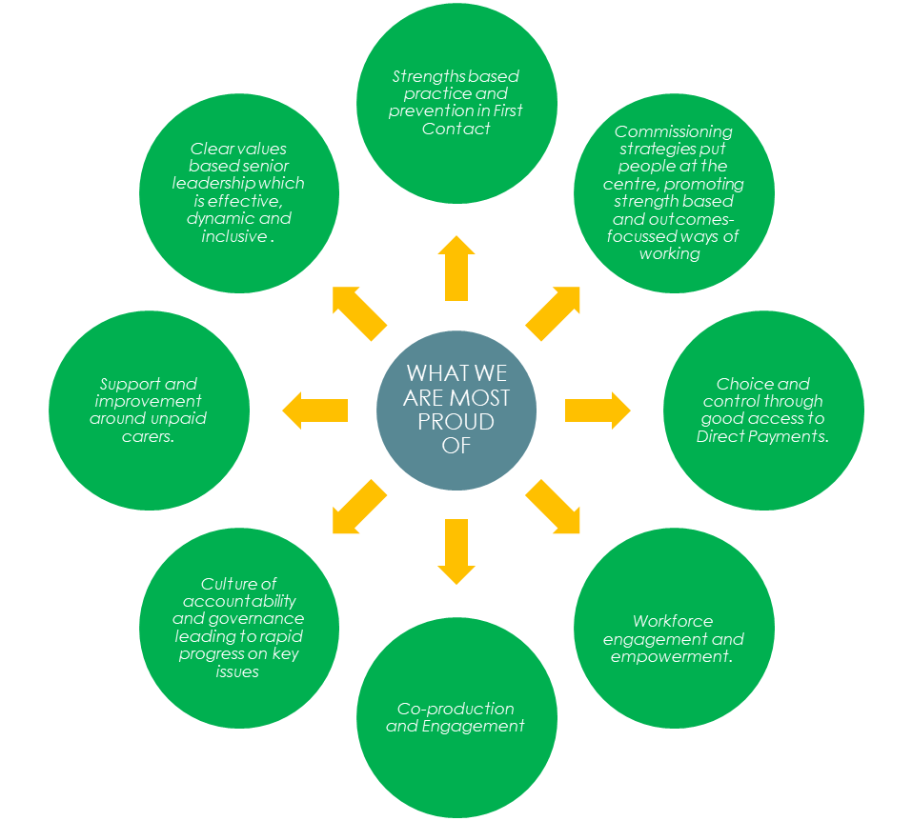P a g e | 8

P a g e | 9
Theme 1: Working With People

Introduction: Our Position Against the Quality Statements
This section is our self-assessment response for the Quality Statements relating to Assessing Needs, Supporting People to Live Healthier Lives and Equity in Experience and Outcomes.

Assessing Needs
Our approach highlights our strengths in relation to our support to unpaid carers, early help and prevention, and our direct payments offer. Our improvement journey has led to tangible improvement to assessing need, including:
- Care and support needs are assessed in a timely and consistent way and people receive assessment and access to aids and equipment to promote independence in a timely manner.
- Assessments and care and support plans are co-produced, up-to-date, and regularly reviewed, to ensure they are person-centred and reflect the needs and aspirations of our customers.
- Ensuring that wherever possible people are assessed in their home environment, rather than an acute medical setting, because we recognise this makes a significant difference to outcomes, sustainability and longer-term care needs.

Supporting People to Live Healthier Lives
Our collaborative approaches enable us to:
  - Co-ordinate support across different agencies and services ensuring decisions and outcomes are clear and transparent.

Provide people with easy access to information and advice.
  - Enable individuals and their families to have positive experiences and access to direct payments and uptake.

Equity in Experience and Outcomes
We are working with people, partners, and the local community to: -
  - Identify people whose care and support needs are not being met and promote independence and support people to prevent, reduce or delay the need for care and support.
  - Work with community partners to understand and reach the seldom heard, to ensure our services and provision are inclusive and accessible for all
  - Have arrangements for identifying people at risk of having unmet needs or poor outcomes because of their protected equality characteristics and reducing inequalities of experience and outcomes relating to our Care Act duties.

What Does Our Data Tell Us

P a g e | 10

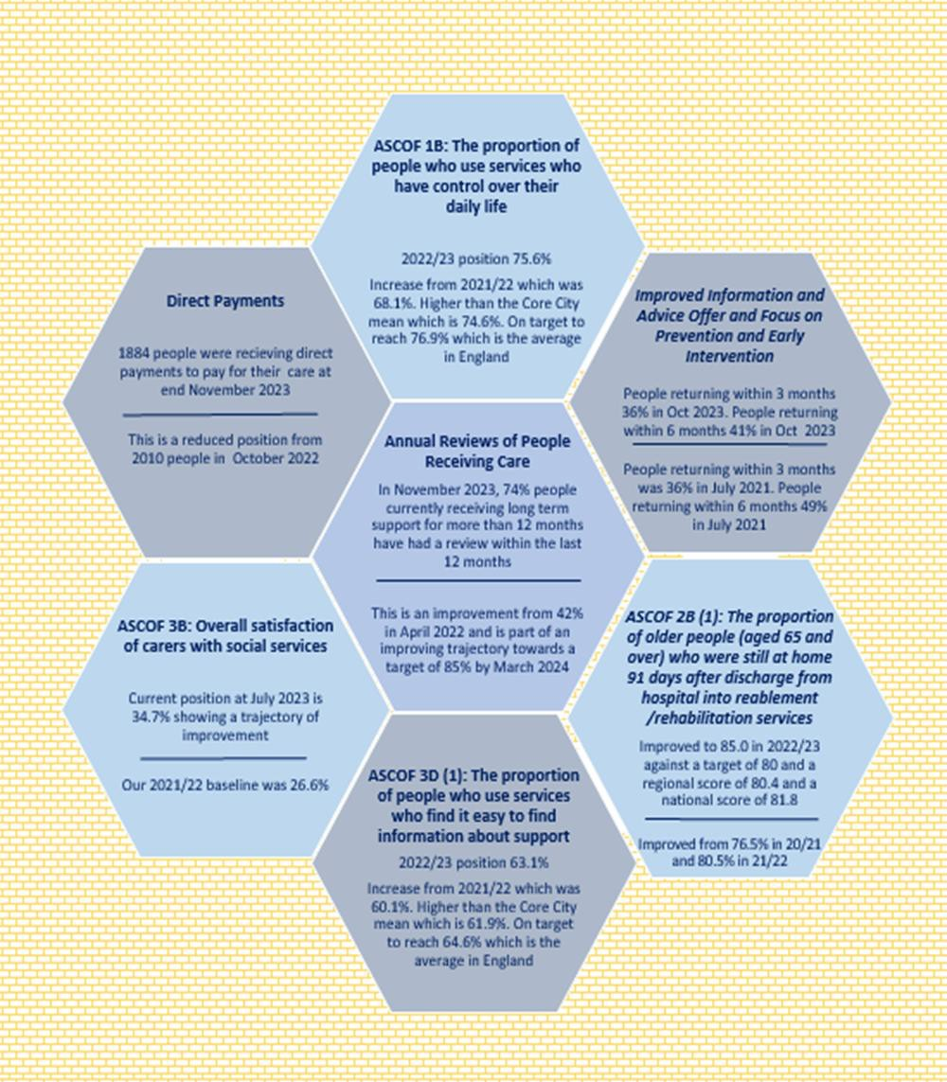

P a g e | 11

Our Strengths: What We Are Most Proud Of

Our Responsiveness
Our ambition is to deliver responsive services to all, which enable people to have timely access to support at the point they need it, where they need it, and in a way that makes sense to them.

What We Did
People who access our services have told us that being responsive is an important part of their experience of adult care. In response to this we have prioritised ensuring our services are accessible, reducing waiting times, increasing reviews, and reducing hand offs between services. This is evidenced in the delivery of our Active and Independent Strategic Outcome Strategy and was recently highlighted in a report to our Adult Health and Care Policy Committee on 13th December 2023.
Despite a 40% increase in demand and referrals for our services from 2019, we have successfully managed to increase the number of long-term reviews completed, reduce assessment waits, and reduce our waits for support. We have achieved this by working innovatively and by building capacity, resulting in reducing our waits to pre-pandemic levels.

Outcomes and Impact
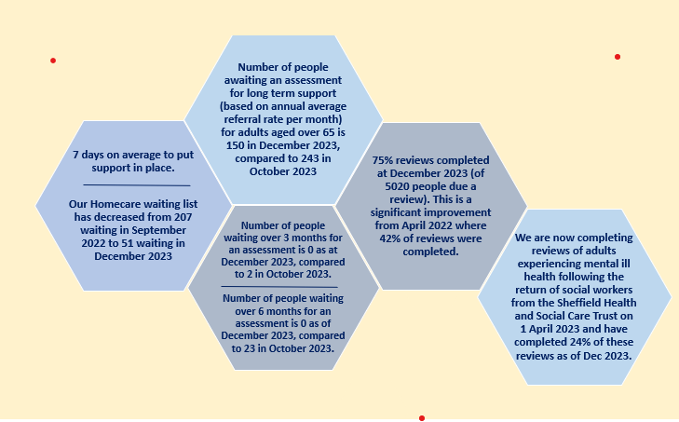

Support to Unpaid Carers
Our ambition is for all carers in Sheffield to feel supported, recognised and valued with access to the information, advice and resources they need, in recognition of the massive contribution they make to AHSC in the City.

What We Did
There are approximately 47,904 unpaid carers 7,000 young carers in Sheffield. The caring population is not static; in Sheffield around 20,000 people start caring and 20,000 people stop caring each year. Carers UK calculated that each carer saves the economy £19,336 per year. In Sheffield that equates to approximately £1.1 billion

P a g e | 12

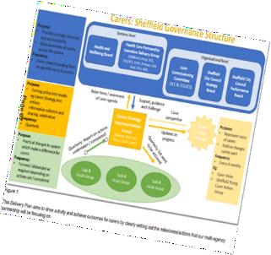
per year. This is massive and yet many carers do not recognise themselves as carers or have access to support. We want to change that to recognise and support unpaid carers in the city, and the huge contribution they make, often unseen.
We are committed to delivering our Young Carer, Parent and Adult Carer Strategy through our Carers Delivery Plan, which was approved on 19th December 2022 and the Carers Partnership, which is jointly chaired by our Operations Director and the Chief Executive Officer from the Sheffield Carers Centre.

Outcomes and Impact
The Carers Delivery Plan has been live for over 1-year. Our notable successes include:
- The launch of our multiagency Carers Strategy Implementation Group that scrutinises and evolves the Carers Delivery Plan in collaboration with Carers.
- Delivering our first ever ‘Carers Roadshow’ which 33 support agencies attended, with 1728 contacts between carers and support organisations and 2041 pieces of information given out. 100% of Carers who gave feedback said the roadshow made them feel valued and supported.
- Sheffield Teaching Hospitals have created a ‘Carer Passport’ which it is currently piloting on several wards and a prompt within admissions and discharges to support the identification of Unpaid Carers and Young Carers.
- Sheffield City Council’s Community Youth Services working on their database/forms to ensure they routinely identify Young Carers and link into the Young Carers Register.
- We are referring 65% more Carers to the Carers Centre: 2023 (to end of October) – 612 (61 carers per month) set against in 2022 – 443 (37 carers per month). 100% asked said they were satisfied or very satisfied with the service they received.
- There is currently no wait for Carers who are high priority and require support urgently, and those with a lower priority waiting no more than 1 to 3 weeks. This currently stands at 15, a reduction from 68 in May 2023.

Early Help and Prevention
Our ambition is to ensure an early response in the community for all who need it, to avoid unnecessary hospital admission and maximise independence, enabling people to live in their home and local community for longer.

What We Did
As a City, a Council and Region, we have made a collective commitment to earlier intervention and prevention through our Health and Wellbeing Board Strategic

Plan, Our City Goals and South Yorkshire Integrated Care Partnership Strategy.
Our DASS is the lead for the South Yorkshire Prevention Bold Ambition with Public Health, ICB and Trust Colleagues, bringing a system leadership role to collaboration across the sector and South Yorkshire. Our notable successes include:
- Launch of Synergy Mental Health Alliance Model which is an innovative multi- agency model which enables VSCE organisations to deliver mental health prevention activities across Sheffield.

P a g e | 13

- Key performance data for our Sheffield Directory, shows 50,000+ website hits every month, a huge growth from just 2000 for the previous site.
- Joint working with Yorkshire Ambulance Service and Pharmacy colleagues to prevent falls and medication errors. We are currently preventing around 10 ambulances a week, supporting uninjured fallers through our City-Wide Care Alarms Service.
- Technology Enabled Care, as a further way of promoting independent living and with that reducing and delaying the need for care and support, including hosting a national event early in 2023 with national Technology providers.
Outcomes and Impact
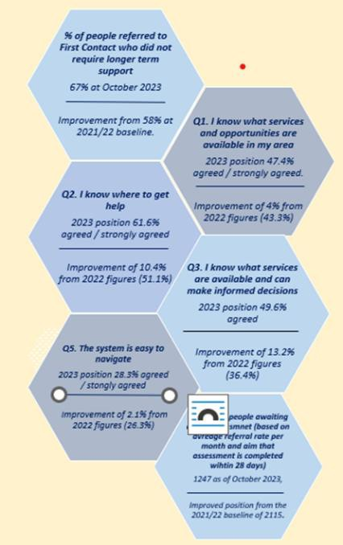 | Our I-Statements results indicate a positive direction of travel and demonstrate we are on a much-improved trajectory. In addition, our December 2023 Performance report demonstrates we are enabling individuals to live independently at home and upon discharge through our enablement, occupational therapy and first contact services.  The % of people receiving support from First Contact that no longer need support has remained at 67% in October 2023 which is the same as the 2022/23 average, despite a 10% increase in demand for this area which has seen an increase in contacts from 19556 in October 2022 to 21,459 in October 2023 (rolling average).

Our Challenges and Opportunities: What We Are Improving

Assurance and Learning from Practice
Our ambition is to ensure high quality, person centred and consistent practice in all areas of case management and recording through assurance and sharing learning, reflected in the outcomes, experiences and records of people who use our services and their families and carers.

What We Are Doing
Our learning from a 150-case file audit in December 2022 to January 2023 told us we needed to improve the consistency and quality of our case file recording. This included

P a g e | 14

placing a greater focus on the expected standards informing our practice and embedding personalisation of practice across Adult Care.
To build our approach to consistency of strength-based practice, we have prioritised: building our learning and development offer, our leadership and governance of practice, embedding practice standards, moving to an operating model which provided conditions for good practice including a move to specialist care, and assessment teams and building our  workforce capacity. | 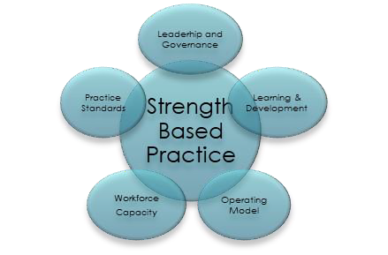
To support these developments, we have introduced:
- A Chief Social Work Officer post in 2022 to champion and lead good practice across ACW.

Practice Quality Standards, Quality Matters Frameworkand aReflective Supervision Model in 2022.
- All staff have regular 1-2-1s, Team Meetings and PDRs (Personal Development Reviews) to review the quality of their practice, undertake reflective practice, raise issues, for support, and ensure their continuous development. A supervision audit (called the Pulse Survey) was introduced in 2023 to continue to learn and embed our practice.

Outcomes and Impact
Our most recent update to Committee in January 2024 as part of our Quality Matters and Workforce Update by the Chief Social Work Officer (CSWO), highlights:
- Our Case File Audits are now in place across all teams, including an annual 150 case file audit, with learning coordinated by the CSWO. As a result of this learning, we have amended our mandatory Safeguarding training to emphasize elements of recording that has not been up to expected standards, this is also being fed back to staff via peer learning huddles.
- Our pulse survey (the supervision audit) shows that of the 189 people who responded 92% said they have had supervision/ one to ones in the last 3 months. 54% of those were completed on the new reflective supervision document. 89% felt that they got the support they needed from the supervision.

P a g e | 15

- We are being recognised for our good practice with our teams achieving Social Worker of the Year Awards from South Yorkshire Teaching Partnership in November 2023.
- Our Liquid Logic Improvement Plan, (our case management and recording system) is progressing well with 6 actions identified as a priority now completed and plans in place to complete remainder by Dec 2024.
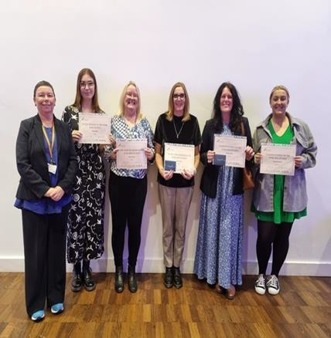
Occupational Therapy Waits
Our ambition is to develop an Occupational Therapy and Adapted Housing Service, which means people can access these services at the time they need them, supporting them to live as independently as possible for longer.

What We Are Doing
In July 2021, we identified we had over 2900 people waiting for an occupational therapist assessment, some of whom had been waiting for over 18 months. This increase in our figures was set against an increase in demand. Before Covid the team received on average 4100 applications per year (342 per month). In 2023 the team have been averaging 619 per month or approximately 7,430 per annum., which represents an 81% increase in demand since before the-pandemic. This is due to an increase in referrals from health services (21%), and from individuals (177%).
To address this, we implemented an improvement programme for Occupational Therapy in late 2021, with progress reports provided to Committee for assurance through our Equipment and Adaptations Update and a number of immediate actions.

Outcomes and Impact
Our update to Committee in November 2023, highlights our impact as follows:
- In November 2023, 99.9% people receive equipment within timescales through our dedicated contract. This is an increase from 98.6% in 2021.
- At November 2023,1300 adults on our waiting list with the majority waiting for 4 months or less. This is set within the context of an 81% increase in demand, which means our responsivity to referrals is increasing not decreasing despite the significant increase in demand.
- 83% of people referred needed no further support due to the enablement focus interventions undertaken by the team, which meant that only 17% of people referred need adaptations or equipment.
- An Equipment and Adaptations Criteria, which includes information about funding was approved in November 2023.This provides a clear, transparent framework for equitable decision making for provision of equipment and adaptations.

P a g e | 16

We have clear plans in place to achieve a no waiting list position and implement a sustainable model for delivery by June 2024., which will further enhance and build our approach to early help and prevention across Adult Care.

Equity of Access, Experience and Outcome
Our ambition is for everyone to experience fair and accessible services irrespective of where they live or their circumstances, with the dignity and respect they deserve, and where their differences are celebrated.

What We Are Doing
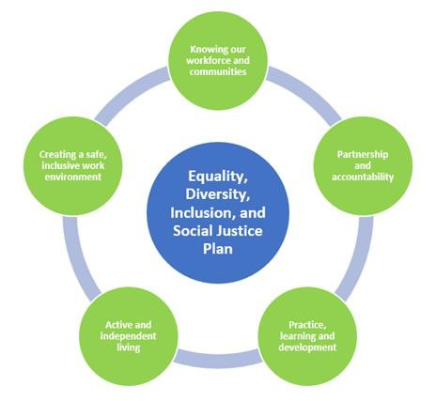 | We recognise that we have more to do, to ensure our services and provision deliver on our ambitions in Adult Care and Wellbeing. An Equality, Diversity, Inclusion and Social Justice Delivery Plan and Workforce Equality Data was agreed at the Adult Health and Social Care Policy Committee on 13th December 2023. The Plan includes implementing a new operating model and recommissioning our homecare, supported living, day activities and respite services; structured around five priorities, matching the  Council’s corporate objectives.
The gap in life expectancy from birth to death within Sheffield between the least and most deprived communities is estimated to be 10.9 years for males and 8.7 years for females (as measured by the slope index of inequality, Public Health Profiles 2022).
18% of Sheffield’s adult population is from a Black Asian Minority Ethnicities (BAME) community. However, only 13% people in receipt of Adult Care are from BAME backgrounds and these communities disproportionately access direct payments.
Building on our learning from SACHMA, our workforce analysis and learning from the Race Equality Commission to ensure equity of experience, we have: -
- Embedded a requirement for our commissioned (Homecare) providers to ensure delivery of culturally appropriate care and recruitment to make this a reality.
- Reviewed our approach to sensory impairment to ensure individuals with a sensory impairment have equitable access to support. This is leading to the development of a partnership strategy.
- Reviewing the rights and responsibilities of organisations and embedding Safeguarding as part of our Healthwatch Contract based-on learning from our Festival of Involvement so that we do not have inequalities in either referral or uptake of safeguarding in the city.
- Provided dedicated funding to SACMHA to lead community engagement and develop a peer volunteer model for promoting and embedding culturally appropriate care across the sector.
- Set objectives for all Assistant Directors to monitor training to ensure all staff have completed EDI (Equality, Diversity & Inclusion) training and equalities. We expect to see 100% completion of this training across all teams by December 2024.

P a g e | 17

- Resourced a dedicated trainer in British Sign Language available as part of our practice development team for the sector to access and grow developments.
- Implemented equality champions across ACW to drive forward open discussions across adult care in terms of how we embed equality and diversity.

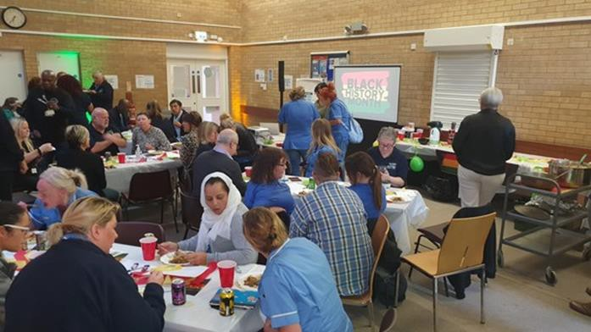
  - Dedicated sessions with staff and Trade Unions to recognise Black History Month, International Women’s Day and Holocaust Memorial Day.

Outcomes and Impact
Our I-statement data from 2023, shows a positive trajectory for a number of indicators relating to equity of access, experience and outcome:
- Question 6. I have a conversation with someone who understands me: 70.7% of people strongly agree/ / agree in 2023, which is a 5.8% increase from 2022
- Question 9. I know that I have some control over my life and that I will be treated with respect: 79.2% of people strongly agree/agree in 2023, which is an 8.5% increase from 2022.
- Question 15. I am listened to and heard and treated as an individual: 71.8% of people strongly agree/agree, which is an increase of 5.3% from 2022.
Although this does show positive outcomes and impact in relation to this challenge, these responses are from people who already care and support from ACW. To enable us to make sustained, successful progress in this area we are building a full understanding of our provision in this context and the barriers impacting on equity of access and experience, in conjunction with our work with SACMHA, and Healthwatch.

P a g e | 18
Theme 2: Providing Support

Introduction: Our Position Against the Quality Statements This section is our self-assessment response for the Quality Statements relating to Care Provision, Integration and Continuity and Partnerships and Communities.

Care Provision, Integration and Continuity
We respond to the diverse health and care needs of people and our local communities, to ensure care is joined-up, flexible and supports choice and continuity, including: -
  - Good variety of care providers, with provision that is resilient, and has sufficient capacity to meet demand now and, in the future, through our recommissioning of Homecare.
  - Diverse range of safe, effective, high-quality support options to meet their care and support needs. This includes unpaid carers and those who fund or arrange their own care, providing sustainable, and affordable services which provide continuity for people.
  - Confidence that we have effective commissioning strategies and market sustainability plans outlined in our reports and updates to Committee.
  - Clear strategy for maintaining capacity and capability in the social care workforce and arrangements for determining a fair cost of care with providers, outlined in our recruitment and retention strategies, and interventions.
  - Robust arrangements for quality monitoring and improvement of commissioned services and for supporting improvement. This includes arrangements for detecting early warnings of potential failure, including for services commissioned from outside of the area.
  - Training and support for commissioning staff to undertake their roles effectively.

Partnership and Communities
Our priority is to collaborate and work in partnership, to ensure our services work together seamlessly for people. We understand that partnership working enables the more effective delivery of shared local and national objectives. This is evident via examples such as our utilisation of the Better Care Fund in Sheffield, Direct Payments and Personalisation, Changing Futures programme and approach to hospital discharge.
A core component of our approach is working with voluntary and charity sector groups to understand and meet local needs, monitor and evaluate the impact of partnership working on people’s outcomes, and having information sharing, roles and responsibilities, governance, and accountabilities. This can be seen in our work with Disability Sheffield, SACMHA and Healthwatch, alongside co-chairing key forums with people with lived experience including the Autism Partnership and Carers Forum.

What Does Our Data Tell Us

P a g e | 19

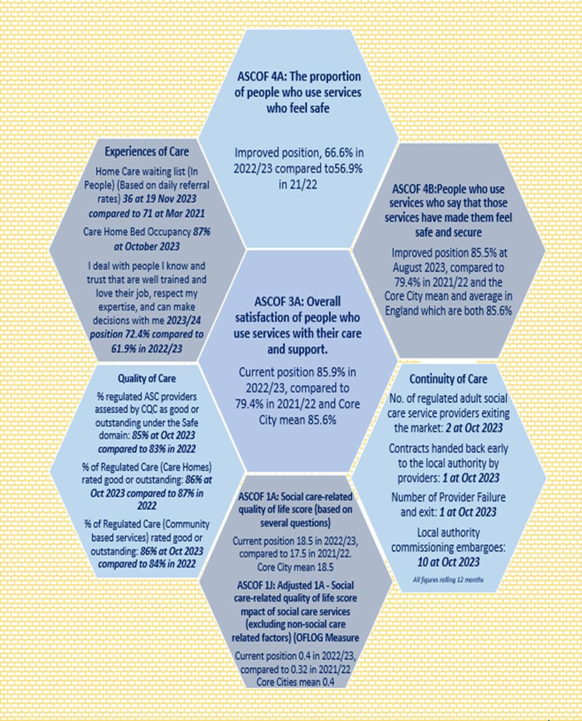

P a g e | 20

Our Strengths: What We Are Most Proud Of
Quality, Continuity of Care and Our Commissioning Programmes for Older People
Our ambition is to facilitate an efficient and effective market for Older People, leading to a sustainable and diverse range of excellent quality care and support, no matter which agency is providing the care, delivering choice, and driving improvement and better outcomes for adults in need of care and support in the City.

What We Did
We are proud that our commissioning strategies put people at the heart of what we do and are directly shaped and informed by those with lived experience. All of our new contract arrangements aim to embed long term stability in the market, supported by:
  - Commissioning strategies and specifications underpinned by involvement from people with lived experience. We have a Citizen involvement project based within the commissioning service which has further improved the influence and voice of people with lived experienced in strategic decision making.
  - Providers engaged in service development and well supported through mobilisation of new contracts.
  - Stronger alignment of commissioned services with Adult Care delivered provision and our Care & Assessment Teams including sharing of best practice, workforce development opportunities and alignment in city patches to enable a joined up social care provision.
  - Fee rate reviews following Fair Cost of Care exercises.
  - Longer-term (10 Year) contracts which include inbuilt fee uplifts to ensure stability, sustainability, value for money and opportunities for partnerships and innovation in the sector.
  - Outcomes and Enablement focused contracts and improved payment processes for providers.
In the past two years we have focused on delivering a Market Oversight and Delivery Plan 2023/24. This sets out our actions for improvement for each sector of the market around the themes of Quality, Sufficiency and Stability and Value for Money. The development of our performance dashboards, together with our JSNA (Joint Strategic Needs Assessment),and evidence from engagement and feedback from people in Sheffield and our partners, actively inform our Commissioning approach, ensuring the support we procure and deliver meets the needs of people in the city.

Our collaborative work with providers and people with lived experience is at the heart of our development of these new service models and contracts, supports our ambitions to deliver care that meets the needs of Sheffield’s diverse communities. We are particularly aware to enable this, we need to ensure we engage different communities across the city, including the seldom heard, so that people from diverse backgrounds have the opportunity to inform our strategic planning.

P a g e | 21

We are investing further in our quality arrangements as one of our key priorities through dedicated leadership and expanding the capacity of our quality teams. This includes the implementation of the CQC Single Assessment Framework, which includes both Local Authority and Regulated Provision across the City, implementation of a joint health and care quality standard across the council, commissioned and non- commissioned provision, and work to prevent provider failure.
Outcomes and Impact
Case Study: Feedback from Dementia Day Activities  “All the staff are very friendly, I like the activities and getting to talk to people.”  “I’m too old to be having this much fun!”  “My son was right (even though I don’t want to admit it) - I really like coming. I like to be busy.”  “D was far from willing when he first  started attending day activities; But he now looks forward to coming and enjoys his time with you. Of course, the other great benefit you provide is giving me a much-needed break while D is with you.” | Our December 2023 performance update highlights that: -  - 8 out of 10 providers are rated as good or excellent,  - Our homecare waits remain low  including discharge from hospital.  - 85% of people who use services say that those services have made them feel safe and secure. (ASCOF 4B).  - We have care home sufficiency.  - Sheffield has low numbers of provider failures and exits from the Market.  - We have low number of embargoes and 0 regulation 28 reports.

Our Direct Payments and Personalisation
Our ambition is to put people first so that the citizens of Sheffield are empowered to take control and self-direct their own care and support; able to achieve the outcomes that they choose and live the life they want to live.

What We Did
We undertook a review of Direct Payments in 2020 to 2021. From this an improvement programme was developed enabling people accessing social care to have positive experiences of Direct Payments. Our dedicated programme ensures consistency and transparency across ACW, with all the Council’s policies, procedures and processes for delivery being actively reviewed and enhanced.
A core part of our approach is that we work collaboratively with people with lived experience, their families and carers, our partners, and stakeholders to shape, design and produce new and improved ways of working; including through our Direct Payments Steering Group. For us, this element is critical to ensure we make real and sustainable improvements which matter most to the people using our services.

P a g e | 22

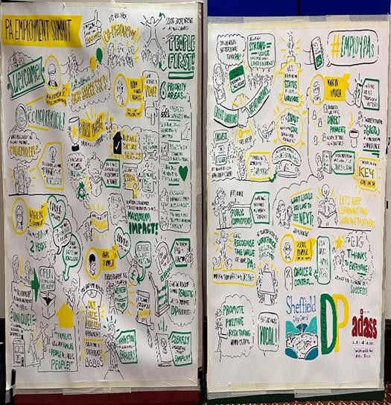

Outcomes and Impact
This work has directly contributed to the successful creation of our Personalisation and Direct Payments Strategy, approved in December 2022, which outlines the Council’s vision and commitments for embedding personalised support with good outcomes through support planning and as required, personal budgets for the longer term. By personal budgets we mean the money people need to meet their eligible care and support needs to self-direct their support, which includes Direct Payments and Individual Service Funds (ISFs).

Over the past 2 years we have:  - Promoted and encouraged recruitment and retention to the role of Personal Assistants.  - Strengthened our Direct Payment Audit Function.  - Implemented a ISF Pilot with good results.  - Hosted a Regional PA Summit | 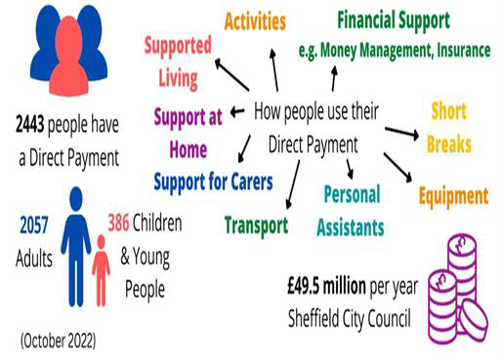
What people are saying about the programme (Spring 2023)
SACMHA said - “The Money Management Company Forums are the best thing that’s ever happened, and the new letters are so much clearer and easier to understand”.
From Club 61 and Seven Steps re the uplift letters - “We feel like we’re in the loop and it’s important for smaller providers to feel included”
From a person with lived experience - “The work you and your colleagues have done has had a very noticeable and positive impact. My PAs and I really appreciate it”
“I can’t thank you enough for helping with this. It all makes perfect sense now that you have talked it through with me”.

Our Challenges and Opportunities: What We Are Improving
Our support to People with a Learning Disability and People with Autism
Our ambition is to be an Autistic and Disability Friendly City, with Autistic People and People with a Learning Disability voices at the centre of driving change, alongside more accommodation with care in Sheffield so that people can have care closer to their families and their home.

P a g e | 23

What We Are Doing
In 2021 we undertook a listening exercise alongside a review of our performance and provision. Individuals and families told us that they felt that the voices of people with a learning disability and autistic people were seldom heard and that our staff did not have the specialist knowledge to support individuals. Our performance in relation to reviews and provision of care was further evidence of individuals experience.
Our learning informed the development of a new operating model which established specialist care & assessment teams, new commissioning frameworks and a refreshed strategic direction and partnership board. | 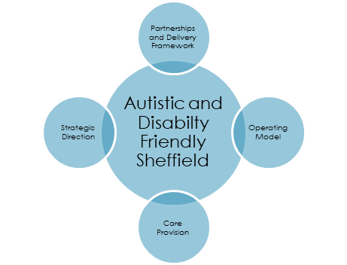
We work collaboratively with our existing Autism Partnership Board, the autistic community and health partners and have produced and All-Age Autism Strategy which was endorsed by the Strategy and Resources Policy Committee in May 2023. This strategy reviewed previous engagement and consultation exercises with autistic people and family carers over the past 5 years. Further engagement was undertaken with groups that had been less represented, including people from Black African and Black Caribbean communities, LGBT+ communities, and a focused workshop for Children and Young People.
Our Learning Disability Strategy was approved in November 2023. This was also co- produced with community members and stakeholders including health, housing, education, employment in different settings including supported living and day services. With Sheffield Voices, we engaged with people at “We Speak, You Listen” events and the Big Voice conferences to develop our strategy – ‘Hear Our Voice’.

Outcomes and Impact
Our All-Age Autism Strategy sets out our ambitions for a cultural shift to make Sheffield an understanding, supportive and welcoming place for the whole autistic community: An Autism Friendly city.
We have appointed two co-chairs from the autistic community to be our ambassadors and work with us to finalise the restructure of the Partnership Board and set up delivery groups to continue work on each of the strategic themes. It is our intention to hold a Spring conference: “Sheffield: an autism friendly city”, co-designed and delivered by the Autism Partnership Board membership.
The Learning Disability Partnership Board was relaunched in October 2023. The co- chair is a young woman with a learning disability, and we have 18 board members from the learning disability community. The next steps in 2024 are for groups to be set up and begin work on the delivery plan priorities to enable us to make a clear and lasting positive impact for the autistic community in Sheffield.

Organisational Abuse
Our ambition is to prevent abuse and harm, particularly in residential services and ensure that individuals living in a care home are safe, well and can

P a g e | 24

experience excellent quality care focused on their individual needs and wishes. Our goal is to ensure we are able to identify concerns about organisations early and with that prevent harm in institutional settings.

What We Are Doing
We recognise that a multi-faceted approach is required to effectively address organisational abuse which has informed our approach in developing our own operating model and focused our implementing: on:  - Coordinating systems and processes.  - Increasing capacity through establishing a dedicated care home social work team, a multi-agency Adult MASH and commissioning team.  - Establishing joint standards and a joint quality committee with ICB colleagues  - Adopting a new quality monitoring approach as part of our recommissioning of care homes in the city and our focus on Out of  Area Placements. | 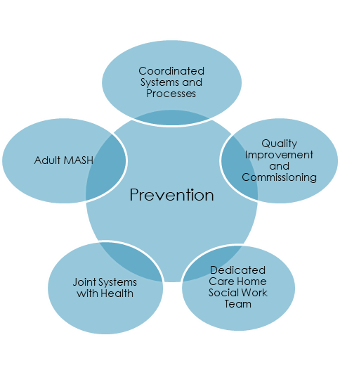
We piloted a new recording method to identify early indicators of concern between October 2023 and January 2024, involving our Adult MASH team, Commissioning Team, and Care Homes Team. An evaluation of our learning is taking place in February 2024 to inform further implementation across Adult Care and Wellbeing. As part of this pilot, we have developed workflows, criteria, and guidance for staff both in the wider sense of what may constitute Organisational Abuse Safeguarding (OAS) alongside step-by-step guidance on how to manage and record this. We have also introduced OAS Huddles where the MASH, Contracts & Quality and Care Home Teams can come together to discuss information/intelligence regarding different organisations with the goal of prevention if indicators of organisational abuse are present and risk management plans need to be instigated. Our learning from the Pilot has identified this approach, is an effective model, and in the longer term, safer for the people of Sheffield.

Outcomes and Impact
We began conversations with wider services around domiciliary care providers, supported living and out of area placements to extend the pilot in January 2024. This is a step forward in having clearly recorded actions and mitigations to address concerns. Our early indicators of concern policy along with rights and responsibilities in relation to safeguarding will be presented at our update to Committee in March 2024 as part of our planned Safeguarding Delivery Plan Update.

Recruitment and Retention
Our ambition is both locally and nationally, to attract more people to the social care sector and to promote social care as a long-term career choice. Sheffield needs a skilled, valued and engaged workforce to be able to support individuals to achieve their wellbeing outcomes and live the life they want to live.

P a g e | 25

What We Are Doing
As part of the Council’s then ‘Council Delivery Plan’ we undertook a range of actions 2022 - 2023 under the heading, ‘valuing our social care workforce’ including:
- Marketing Campaign for Sheffield – ‘Be the missing Piece.’ and Social Care Recruitment Fair – this took place on 21st February 2023, with around 316 people attending to secure roles in the care sector.
- Social Workers and Occupational Therapists Recruitment Campaign – to be launched in April 2024 to recruit to remaining vacancies.
- Workforce Wellbeing - both across council and care sector in partnership with trade unions, including our first ever Social Work conference 21st March 2023.
- Successful Recruitment Campaign with Indeed to be expanded with a focus on social workers, OTs (Occupational Therapy) and other social care professions.
- Care Friends - Expansion of care friends for care staff which supported stability of sector during winter. This approach has been highlighted as a best practice with Kings Fund. We are now expanding this to support further recruitment into provider sector and piloting the approach with social workers
- Recruitment Events – Sheffield is working in partnership with DWP and ICS (Integrated Care System) to host a series recruitment events for social care.
- Significant investment in SCCs directly employed workforce in 2024/25 f
These actions are incorporated into the Council’s new Care Sector Workforce Development Strategy 2023 – 2026 which was published in March 2023. Our workforce strategy is important because it provides us with a clear plan about our priorities in Sheffield, what is going to be done, by whom and when. It sends a clear signal that the Council values its workforce and creates the opportunities for discussion and engagement with the workforce around how improvements can be made. To support this, we have established a workforce board comprising of representatives from Care Sector, Skills for Care, Health, and Trade Unions to enable a collaborative approach across the sector.

Outcomes and Impact
We are in the early stages of the delivery of the workforce strategy and although it is too early to demonstrate a causal impact on workforce data there are early signs, such as the reducing sickness of the direct-employed workforce, and our good relationships with Trade Unions, that things are improving. We have also seen a significant increase in the representation of the ASC workforce. The proportion of BAME staff working in ASC has increased from 16% in 2021/22 to 25% in 2022/23.

Theme 3: Ensuring Safety

Introduction: Our Position Against the Quality Statements

P a g e | 26

This section is our response to our self-assessment for the quality statements Safe Systems, Pathways and Transitions, and Safeguarding.
Safe Systems, Transitions and Pathways Our primary focus in this area is working with people and our partners to establish and maintain safe systems of care, in which safety is managed, monitored and assured. To embed this approach, we have ensured: -
- There is a strong awareness of the risks to people across their care journeys. Our approach to identifying and managing these risks is proactive and effective, including robust monitoring and management to keep people safe.
- Care and support is planned and organised with people, together with partners, and communities in ways that improve their safety across their care journeys and ensures continuity in care. This includes referrals, admissions, and discharge, and where people are moving between services.

The views of people who use services, partners and staff are listened to
- Our safety policies and processes are aligned with key partners who are involved in people’s care journey to enable shared learning and improvement.
- Safety during transitions and continuity of care, including where people are moving between services (including children into adulthood, hospital discharge, moving to another local authority and when transitioning between services).

Safeguarding
Sharing concerns quickly and appropriately is a core priority for us. We have:
- Effective systems, processes, and practices to make sure people are protected from abuse and neglect.
- Our section 42 safeguarding enquiries are carried out sensitively and without delay, keeping the wishes and best interests of the person concerned at the centre.
- We have a clear understanding of the key safeguarding risks and issues in the area and a clear, resourced strategic plan in place to address them.
- Lessons are learnt when people have experienced serious abuse or neglect, and action is taken to remove future risks and drive best practice - SARS
- People can participate in the safeguarding process and are supported to understand safeguarding, what being safe means to them, and how to raise concerns when they don’t feel safe, or they have concerns about the safety of other people, via Healthwatch.
- People are supported to make choices that balance risks with positive choice and control in their lives.
- People are supported to understand their rights, including their human rights, and rights under the Mental Capacity Act 2005 and Equality Act 2010.

What Does Our Data Tell Us

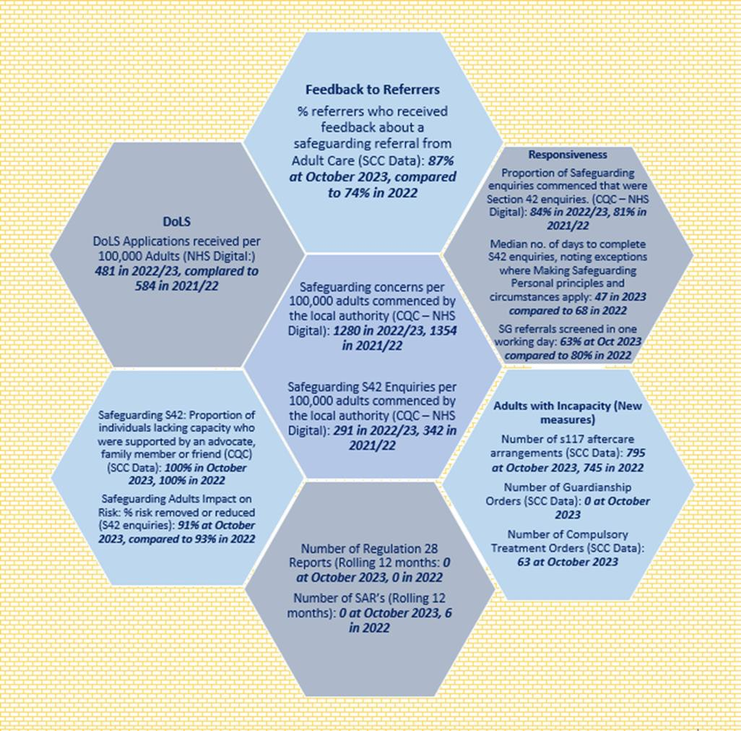P a g e | 27

P a g e | 28

Our Strengths: What We Are Most Proud Of

Our Approach to Transitions
Our ambition is that our children and young people have the best start in life and for young people in need of long-term support they experience a seamless journey and feel enabled to live the life they want to live.

What We Did
To improve our Transitions offer we have undertaken a series of targeted actions over the past two years. This includes investing £600k in 2021 to establish a dedicated Preparation for Adulthood Team, supporting young people to have an improved experience of the transition to Adult Services.
We are proud of the joint working we have developed with families and colleagues from children services to develop our new model and approaches. We believe that this collaboration provides a strong foundation for continuing to build on our approach and ensure young people have the best start in life. This learning and engagement have led to further development of this team, bringing together the Adults and Children’s Transitions Teams in August 2023.Adult Care take the lead role in this team and have adopted an early intervention model with the goal of reaching into supporting young people from age of 14 and focus on enablement and independence. Our Adults Future Options Working Age Framework was launched in May 2023, following approval to tender in November 2022. This offers supported living, activities outside the home and overnight short breaks. The Framework is for people who are 16+ with a range of disabilities and health conditions. Our plan is to further enhance our offer to include specialist Emergency Overnight Short breaks during 2024, which was approved at Committee in December 23.
We are actively building a new in-house respite provision mix having identified areas where we can add value in the previous offer. We have begun this by launching a new respite facility, called Norfolk Lodge, with a dedicated enablement team on hand to support independence. The initial feedback on Norfolk Lodge from parents has been very positive.

Outcomes and Impact
One of our team has been nominated for a BBC Radio Sheffield “Make a difference” award and a different member of the team has been named runner up as Practice Educator of the year (South Yorkshire Teaching Partnership awards).

P a g e | 29

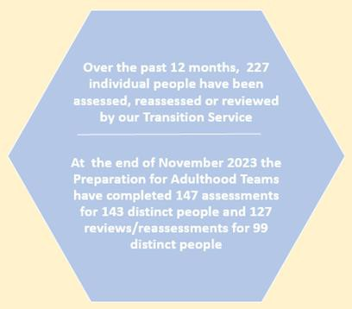 | We provided a Transitions update to Committee in September 2023. This highlighted our notable successes to date including lower waits as a result of our new transitions arrangements, and positive feedback from young people and families. We have been identified as good practice by DfE due to our approach of “reaching down to under 18’s” and building systems and processes that are reducing hand offs, which has led to improved communications.
The increased visibility of our Preparing for Adulthood Team Managers has extended opportunities to share their knowledge and experience. This includes:
- Coffee mornings / marketplace events / information evenings with the 6 main special schools & colleges and local parent carer groups to help share information and support individuals/families with the transition into adulthood.
- Regular participants at the SEND (Special Educational Needs and Disabilities) “Preparing for adulthood” events.
- Accelerated Progress Plan (APP) work coordinated in response to the Ofsted inspection of SEND.
- Setting up and part of the South Yorkshire regional forum for teams supporting people to prepare for adulthood.
Our key priority for transitions in 2024, is to embed joint pathways with health and voluntary sector services, alongside developing a model to support young people experiencing mental ill health as part our mental health social workers return to ACW.

Our Multi-Agency Safeguarding Hub - MASH
Our ambition is to prevent abuse and ensure safety from harm, continuously learning in collaboration with all the agencies that work in relation to safeguarding, so that we deliver an outstanding safeguarding response and consistent practice for the people of Sheffield and that they feel safe.

What We Did
In partnership with colleagues across the city, we developed and launched an Adult Multi-Agency Safeguarding Hub (MASH) in April 2023 to improve the quality of safeguarding referrals, support a faster response, and build collective intelligence to prevent harm and abuse. Health Colleagues (ICB / SHSC (Sheffield Health and Social Care) / STH and Primary Care Networks) contribute regularly to the MASH with additional resources are being negotiated to enable bi-weekly involvement, which will strengthen the role and function of the MASH across the Health and Social Care system.

P a g e | 30

Over the past six months, the MASH has become embedded in our practice and way of working. In particular, the twice weekly “MASH Huddles” are very successful and well established, with regular attendance from partners within South Yorkshire Police, Probation Service and Council Housing and information shared regularly from SHSC.
Preventative conversations alongside Making Safeguarding Personal principles at the point of initial triage, ensures progression to an unnecessary safeguarding episode is reduced. Investment in the MASH and our growing partnerships will deliver our target of 95% contacts consistently screened in one day from April 2024. A key challenge for the MASH is the high volume of concerns it receives from partners, providers, and citizens. In October 2023 there were 508 confirmed safeguarding episodes, screened in from circa 100 concerns received per working
day, which challenges the capacity available to deliver the agreed targets.
Outcomes and Impact

MASH example: We were contacted by the Children’s Service about a group of young women who it was feared were the victims of sexual exploitation. The ages of these young women straddled the age range between Adults and Childrens and it was clear that we needed a joint approach. The MASH being in place meant that we could quickly bring all interested parties together to share information. A number of these young women were accommodated by a local supported housing provider who were looking to statutory services to support. We are working with the young women to help them understand their situation better, including making taxis
available to take them back to their accommodation if they find themselves in a risky situation. We have also covered rent for young women at risk of eviction to keep them housed in order for us to work with them to help secure legitimate income.
‘Having a person from each agency at the  huddles provides the best means of navigating the agency, using knowledge of who to direct any queries towards to get things done. This speeds things up and is a great feature e.g., recently a high-risk missing person with a  variety of additional needs was discussed at the huddles and this resulted in all involved in his  care attending and providing a bespoke support package allowing him to return home.’  Victoria Kenny, Detective Sergeant, South Yorkshire Police | ‘I was a victim of domestic abuse from my  husband. After the police had been round, someone from MASH called me and we talked about what was happening whilst my husband was at work. I was too scared to  call IDAS, so I was helped over the phone to fill in the online form. I then got all the help I needed to get away from the abusive relationship and start again. The MASH team was extremely helpful, and I don't think I would have managed to get the right help without them.’ Person supported

Changing Futures
Our ambition is to improve the outcomes for people experiencing multiple disadvantages, enabling a greater shift towards prevention of abuse and neglect, to ensure people can live the life they want to live.

What We Did
In Sheffield, there are estimated to be around 3000 people who fit the description of vulnerable adults facing multiple disadvantages who need support in three or more of

P a g e | 31

the following areas: Substance use, Mental Health, Housing, Criminal Justice, and Domestic Abuse. Our active work in this area enabled us to identify a gap in current provision within the City.
We have worked. with key stakeholders across the statutory and voluntary sectors to shape and develop a successful Changing Futures funding bid, resulting in funding of
£3.267million. Our work in this area includes coproduction of the building design and support available to tenants; a Community Domestic Abuse Service specification which is currently out to tender; and a new Peer Audit model as a new way of evaluating service delivery, which has completed its first phase with 4 organisations.
Coproduction is a key priority for the programme, connecting workstreams across the city with people with lived experience, referred to as coproduction associates within the programme, and recognised as equal partners. Our coproduction associates are part of a National Expert Citizens Group in Sheffield, meaning Sheffield is now part of a national coproduction network informing the priorities in central government.
Outcomes and Impact
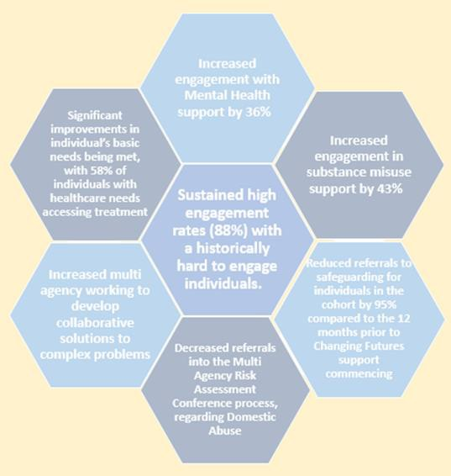 | We have achieved significant positive outcomes for our initial cohort of vulnerable adults, including transitioning these individuals onto lower-intensity support services in the city. Our programme is now moving into the next phase of delivery, embedding workers into key partner agencies, and expanding the number of individuals supported by the programme. A key priority for us is to be able to demonstrate the impact of the programme in improving the lives and outcomes of people experiencing multiple disadvantages. The programme directly supports a cohort of 80 vulnerable adults in the City and to date has delivered: positive outcomes that really do put  people at the heart of everything we do, including improving our services and provision.

Our Challenges and Opportunity: What We Are Improving

Deprivation of Liberty Orders- DoLs
Our ambition is to enable a greater shift towards prevention of abuse and neglect, so that people in Sheffield living in restrictive settings are protected against being unlawfully deprived of their liberty.

What We Are Doing
The DoLS team is made up of Supervisory Body staff (who authorise assessments and manage the work of the team) and employed and independent Best Interest Assessors (BIA’s). It is insufficiently resourced to meet current demand and there is, and always has been, a backlog of DoLS referrals waiting to be assessed and authorised. In 2023 a DoLS Improvement Plan was agreed and as an immediate risk mitigation, additional investment was identified in the short-term, increasing to a gross investment of

P a g e | 32

£872,000 over the longer term, to build resources and resilience into the team. This will be a similar model to our AMHP (Advanced Mental Health Professional) Service and will aim to reduce our backlog and improve quality by:

- Increasing our Supervisory Body function to meet the demands of the flow of work and to provide necessary supervision and support to our BIA team
- Increasing our employed Best Interest Assessor Team by fourfold and continue to utilise in-house social work BIA’s
- Consolidating our DoLS Service with a dedicated Team Manager to lead the significantly larger team
- Exploring our options for utilising Independent BIA’s when needed
- Increasing our business support function to better support the team
- Developing a risk assessed, project-based approach to managing and address the backlog of DoLS Assessments
- Developing our ability to provide support to BIA’s and quality assure their work
- Developing a robust partnership with NHS colleagues and in particular with STH and ICB to enable responsivity regards DoLS assessments required in a hospital setting.

Our progress, in reducing our backlogs and establishing a sustainable service, is overseen via the Safeguarding Delivery Plan which is reported to the AHSC Policy Committee and Safeguarding Partnership Board every 6 months.

Outcomes and Impact
In undertaking this investment and these improvement actions, we have already successfully:
- Embarked on two short term (13 week) projects focussed on addressing the backlog. 1) By using agency BIA’s to undertake High Priority assessments we have been able to 2) Use our employed BIA’s to undertake our longest waiting Low Priority assessments
- Recruited successfully to achieve a sustainable Supervisory Body
- Run two successful employed BIA recruitment campaigns since November 23 and have recruited 7 new BIA’s (full time equivalent), with more planned
- Developed a more robust process to manage Court of Protection cases and S21a Challenges with Legal Services
- Developed a sustainable plan for supervision and management of employed BIA’s.

Hospital Discharge
Our collective ambition across health and care services in Sheffield is to prevent unnecessary admission and readmission to hospital where possible so that individuals can live independently and well at home.

What We Are Doing
Prevention is our preferred approach in Sheffield, in line with our strategic outcome Safe and Well and associated priorities of prevention of admission and discharge from hospital. Where individuals do require a period in hospital our collective ambition, is to

P a g e | 33

make discharge personal. This is highlighted in our Hospital Discharge Model agreed at Committee in June 2023, and means all individuals and their families:
  - Have good experiences during their stay in hospital,
  - Experience a positive, safe, and timely discharge.
  - Experience discharge planning, they are involved in, which is effective, person centred, and begins early to prevent avoidable delays in discharge.
Partners across the city are committed to the principle of home first, optimising on- going care and support through timely out of hospital assessment. We are moving towards the national pathway definitions to describe our work, with 95% of people, supported to return home upon discharge. We have established clear city-wide collaborative and governance arrangements, set out in our Sheffield Discharge Model. This will enable us to implement a new way of working where people are discharged within 24 hours of being identified as having No Criteria to Reside, by November 2024. Key to this is delivering a person-centred approach which puts the individual's views and wishes at the heart of discharge, shifting our focus towards prevention of admission.

Our Impact
Over the past two years, we have made significant progress to achieve our ambitions. Our daily reporting shows minimal waits for new home care support required for discharge, somewhere to assess and residential care beds, alongside good flow for our internal homecare provision. NHS England weekly reported
performance data highlights Sheffield discharges more people home than regional and peer comparators and have reduced length of stay over 7 days (from 19% in 2021 to 10.3% in December 2023). Our progress has been reported publicly and transparently through our committee system in February and June 2023, and January 2024, to enable us to build openness, transparency and accountability within our approach.
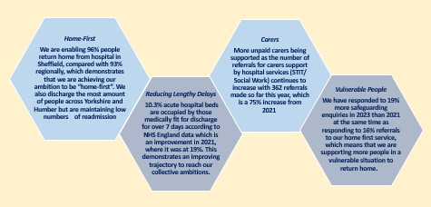

Case Study: Person-centred, joined up, responsive care. Sept 2023: I've just had a call from
Northern General Hospital to say that I will be receiving funding for Dad to go to a
respite home, and it will be Brackenfield Hall with Mum they have space. I'm so
grateful for everyone's hard work and so proud of how all the services have come
together and helped. Thank you so so much you have made such a difference to my

P a g e | 34
family and after 60 years of a happy marriage, they can spend their later years together in a safe environment, thank you."

Our Support for People with Mental Health
Our ambition is to enable all individuals experiencing mental ill health to recover and live the life they want to live, accessing the care and support they need, at the time they need it.

What We Are Doing
A decision was made at the Co-Operative Executive on 16th March 2022 to return our mental health Social Workers from their long term (18 year) secondment to Sheffield Health and Social Care Trust (SHSC) in April 2023, to improve consistency, outcomes and join up approaches to Care and Wellbeing. Teams have remained co-located where possible to continue partnership working and their strong links with SHSC community mental health and clinical colleagues. The returned teams include Community Mental Health Social Work teams, Approved Mental Health Professionals (AMHP) and the Forensic Social Work Teams.
Our work programme in this area includes:
  - A Mental Health Update, which included our AHMP Annual Report .
  - Workforce Development Programme: in place with specific provisions for identified knowledge and experience gaps alongside practice development.
  - Integrated Approach to S117 Reviews of the 1983 Mental Health Act to reach a position where we have no outstanding reviews, and all individuals are supported to live as independently as possible.
  - Initial technical issues around IT have been overcome and improvements are being sustained.

Outcomes and Impact
Our key risks in this area include allocation delays, outstanding reviews, and delayed discharges. To mitigate this, we have created a performance dashboard and risk log for all previously seconded services, which are reviewed and updated regularly at all strategic and operational levels.
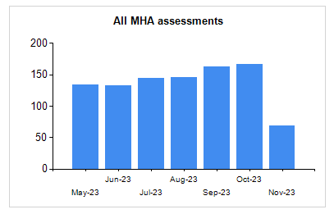 | At December 2023, we have completed 24% of reviews for adults experiencing mental ill health upon return of the social workers from the Sheffield Health and Social Care Trust on 1st April 2023. Between June 2023 and November  2023, we have completed 905 Mental Health Act assessments.
Overall, all risks are reducing, and on a positive trajectory. The service is confident that all the risks will be reduced to standard operating levels by April 2024. We can see that the outcomes for people who use mental health services are improving as is the wellbeing of our staff in this area, and the productivity of our staff is increasing.

P a g e | 35

Theme 4: Governance
Introduction: Our Position Against the Quality Statements This section is our self-assessment response for the quality statements: Governance, Management and Sustainability, and Learning, Improvement and Innovation.

Governance, Management and Sustainability
We are particularly proud of our achievements in relation to leadership over the past couple of years, which include:
- The development of our vision / strategy for Adult Care and Well-being in Sheffield, ‘Living the Life you want to Live’: Our vision / strategy was approved in 2022 following several years of co-production. This provides a clear strategic ambition and objectives, forming the basis of our strategic plans including the Directorate plan and our Performance Management Framework.
- Our new governance framework: We endeavour to make the best possible decisions for the people of Sheffield in a clear and transparent way. Our focus with providers establishes an overarching framework for the governance of all aspects of Adult Care and Wellbeing Services and Support, providing transparent assurance, oversight, and accountability.
- Our long-term financial strategy to support the implementation of the adult health and social care strategy consists of three elements: supporting people to be independent; secure income and funding streams, and good governance. Ultimately the financial success of the adult health and social care strategy will be a sustainable service that operates within budget.

Learning, Improvement and Innovation
We are proud to be a learning organisation, including:
  - The development of our Care Sector Workforce Development Strategy 2023 – 2026: This has been developed in recognition of the significant challenges facing the system to recruit and retain staff, alongside the opportunity for a long term, system wide vision to make the changes necessary to value the Adult Social Care workforce in Sheffield, whilst supporting progression and wellbeing.
  - Leading system wide approaches to maximise outcomes for people in Sheffield in relation to numerous areas including hospital discharge, the recommissioning of Homecare, mental health, Transitions, Vulnerable Adults, and TEC (Technology Enabled Care) enabled care.
  - Embedding practice development and learning from case file audits, complaints and safeguarding across ACW.

P a g e | 36

  - Proactive participation in regional and national learning networks, including ADASS, to share learning and best practice.

What Does Our Data Tell Us
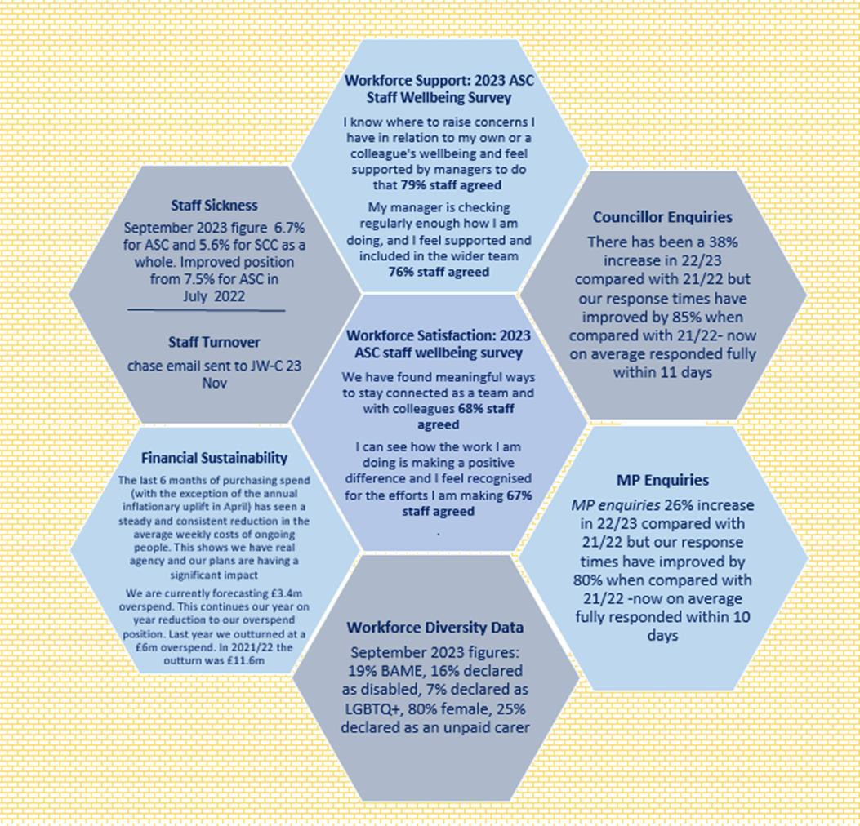

P a g e | 37

Our Strengths: What We Are Most Proud Of

Our Vision and Strategy
Our ambition is to have a vision and strategy which reflects the voice and resonates with our staff, partners, customers, their families, carers and those with lived experience for all adults in Sheffield.

What We Did
We developed our strategy between November 2020 and February 2022, in collaboration, consultation and codesign with a significant number of stakeholders across the city. Our development approach took care and time to ensure we developed a strategy based on the experiences and issues of communities directly impacted by it. The Adult Social Care Strategy Delivery Plan was approved by the Adult Health and Social Care Committee on 15 June 2022 with further updates regarding progress and delivery provided in March and September 2023.

The purpose of our framework and the resulting Directorate-wide Performance Clinics and I-Statement survey is to measure progress against the delivery of the five outcome themes from the vision/ strategy | 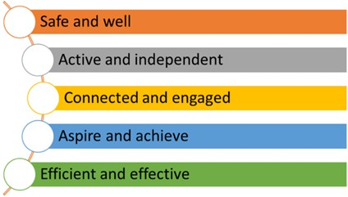
Our Vision/ Strategy was published alongside our financial strategy and ‘a plan on a page’ which sets out our key commitments, actions and corresponding ‘I-statements’. The first iteration of the AHSC Performance Management Framework was published in June 2022, with a further update in September 2023, proposing development of a refreshed Strategy, Delivery, Directorate and Engagement Plan.

Outcomes and Impact
The co-production of our vision / strategy means it is owned by people and partners across the city. It is our single reference point in Adult Care, encapsulating the priorities and values of the service alongside a clear direction of travel and outcomes focus for our collective ambitions in the city. This has ensured resilience and longevity, surviving changes in governance and political leadership, whilst providing a continued and consistent focal point for the directorate and its improvement journey.

Our Governance Framework
Our ambition is to have a clear, comprehensive, and transparent framework which provides assurance and accountability in relation to all aspects of Adult Social Care to ensure the best possible outcomes for the residents of Sheffield.

What We Did
Our Care Governance Strategy was first approved by Committee in June 2022 and then updated in June 2023. Our Cycle of Assurance (updated for Committee in June 2023) sets out how reports and updates are escalated through the portfolio on a routine basis. This cycle provides robust assurance about the activity and compliance of our

P a g e | 38

services, enabling us to identify and escalate risks, alongside monitoring and governance of actions to mitigate these.

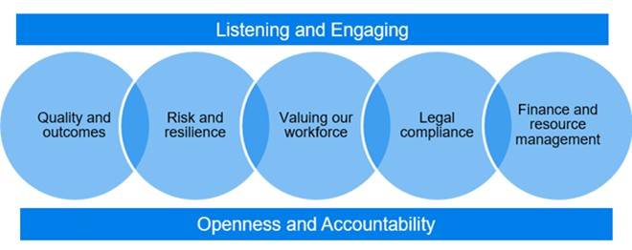  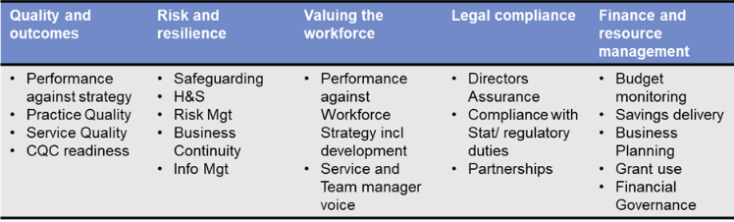 | Supported by the Business Management Improvement Plan (BMIP), our cycle of assurance is structured according to the 5 domains of the Governance  Strategy. The BMIP is a system for holding, monitoring, and reporting all improvement actions across the tiers of the Directorate, providing accountability for the improvements we are making.

Outcomes and Impact
AHSC in Sheffield has been making significant and rapid improvements over the last two years following many years of underperformance. Sustained improvements have been seen across a full range of indicators including annual care review throughput, waiting times and average homecare package size (previously an outlier).
In May 2022 42% people due an annual review had been party to one. By the end quarter 2 2023/24 (Sept) this had risen to 68% and this figure is now at 73% in December 2023. This is a significant indicator because it tells us people are being seen, providing assurance on safety, that our care packages reflect need, peoples’ outcomes are being delivered, and we are better able to prevent crisis and an escalation of need and cost. This improvement has led to other positive impacts on financial assessments, equipment and adaptations, and safeguarding waiting times.
The change which is the most important to us is the experience of people. We developed our local annual ‘I-Statement’ survey in autumn 2022, which tracks the views of people in relation to the outcomes expressed in our vision and strategy. The results provide the first clear evidence that our improvements to Adult Care and Wellbeing are having a positive impact on the experience of people. Our I-Statement survey results in 2023 show an average improvement of 5% across all domains.

Our Challenges and Opportunities: What We Are Improving

Workforce Engagement and Confidence in Leadership
Our ambition is to have an engaged, skilled, resilient and supported workforce who have confidence in their leadership, and are able to develop and grow, providing high quality care and outcomes for all.

What We Are Doing
Our workforce is our biggest asset which needs to be supported, nurtured, and celebrated for their work. The improvements to the experiences of people and working

P a g e | 39

conditions for staff made to ACW over the last two years have been a significant achievement welcomed by the majority of our workforce. The impact of this is very little of the ACW or commissioned services have been without change, putting additional pressure on our workforce. We have introduced a range of engagement, and wellbeing interventions to mitigate this but we recognize our pace of change is relentless and will remain so until all our services have reached a good standard. This pressure is reflected in the results of the corporate workforce strategy 2023 for our teams.
To support our workforce, we are developing:
- A fully recruited workforce with the skills to deliver our ambitions and duties, with a Social Care Academy to aid domiciliary and care home staffing and portable training passport, shared training and rewards for attaining learning targets.
- Clear progression opportunities for vocationally qualified staff, occupational therapy qualified staff and social work qualified staff, including apprenticeships for social work and occupational therapy.
- Supporting mechanisms for staff including ‘Moving Up’ for BAME staff, to aid progression and increase representation within management positions, a pilot around menopause support and sessions on wellbeing.
- Increased communication and engagement with staff including monthly service events, visible leadership team, ‘open door’ policies, weekly newsletter, thank you wall and online platform ‘Your Voice’ to support whistleblowing.
- A workforce wellbeing survey alongside the annual corporate staff survey.
- Assurance and governance around 1-2-1s, PDRs, Team Meetings, and staff related policies, including lone working, in terms of quality and quantity.
- A health and wellbeing plan and Workforce Development Strategy, alongside investing in additional resources to support practice development.

Outcomes and Impact
We are embedding our approaches to increasing workforce engagement and confidence in leadership and are starting to see some positive results including increased retention and lower sickness absence but know we have further to go.
Workforce Wellbeing Survey 2023
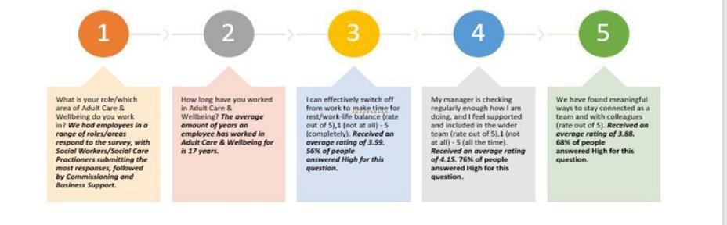
Corporate Workforce Survey –2023 (results reported January 2024)

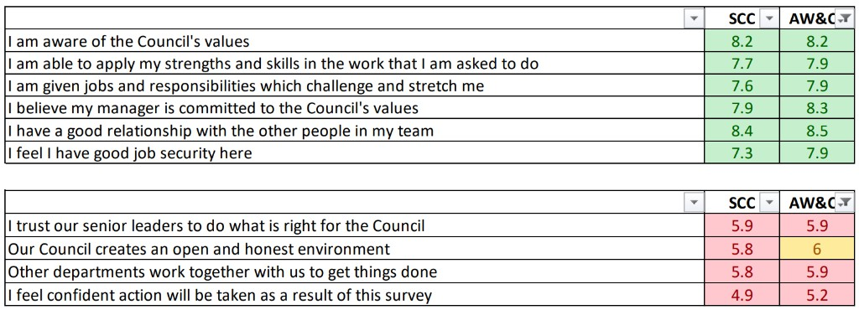P a g e | 40

In 2024, we are further embedding and developing our engagement opportunities for staff, informed by the outcomes from our staff surveys and the voices of our staff at all levels within ACW.

Information Management
Our ambition is to have robust arrangements for the accessibility,
confidentiality and security of data, records and management systems that comply with legislative, regulatory and policy expectations, protecting the privacy of our customers, their families, and those with lived experience.

What We Are Doing
We have reviewed and amended our Records Retention policy. This policy, alongside our legal requirements that support the length of retention required, is currently being subject to consultation with assistant directors to ensure it covers everything it needs to for all areas of ACW. We are also reviewing the ROPA (Record of Processing Activities) to ensure this is up to date and robust, working with Information Management team colleagues to implement a new ROPA process via SharePoint commencing Jan 2024. Critical to this activity is assurance we adhere to legislative, regulatory and Policy requirements, alongside ensuring the actions and recommendations including those identified in the internal audit process are completed at pace.

Outcomes and Impact
We face possible penalties if GDPR is breached, and there is also a reputational risk. It is vital we establish robust arrangements around GDPR going forward to drive forward the improvements we are making, including further integration with key services and information sharing with partners.

