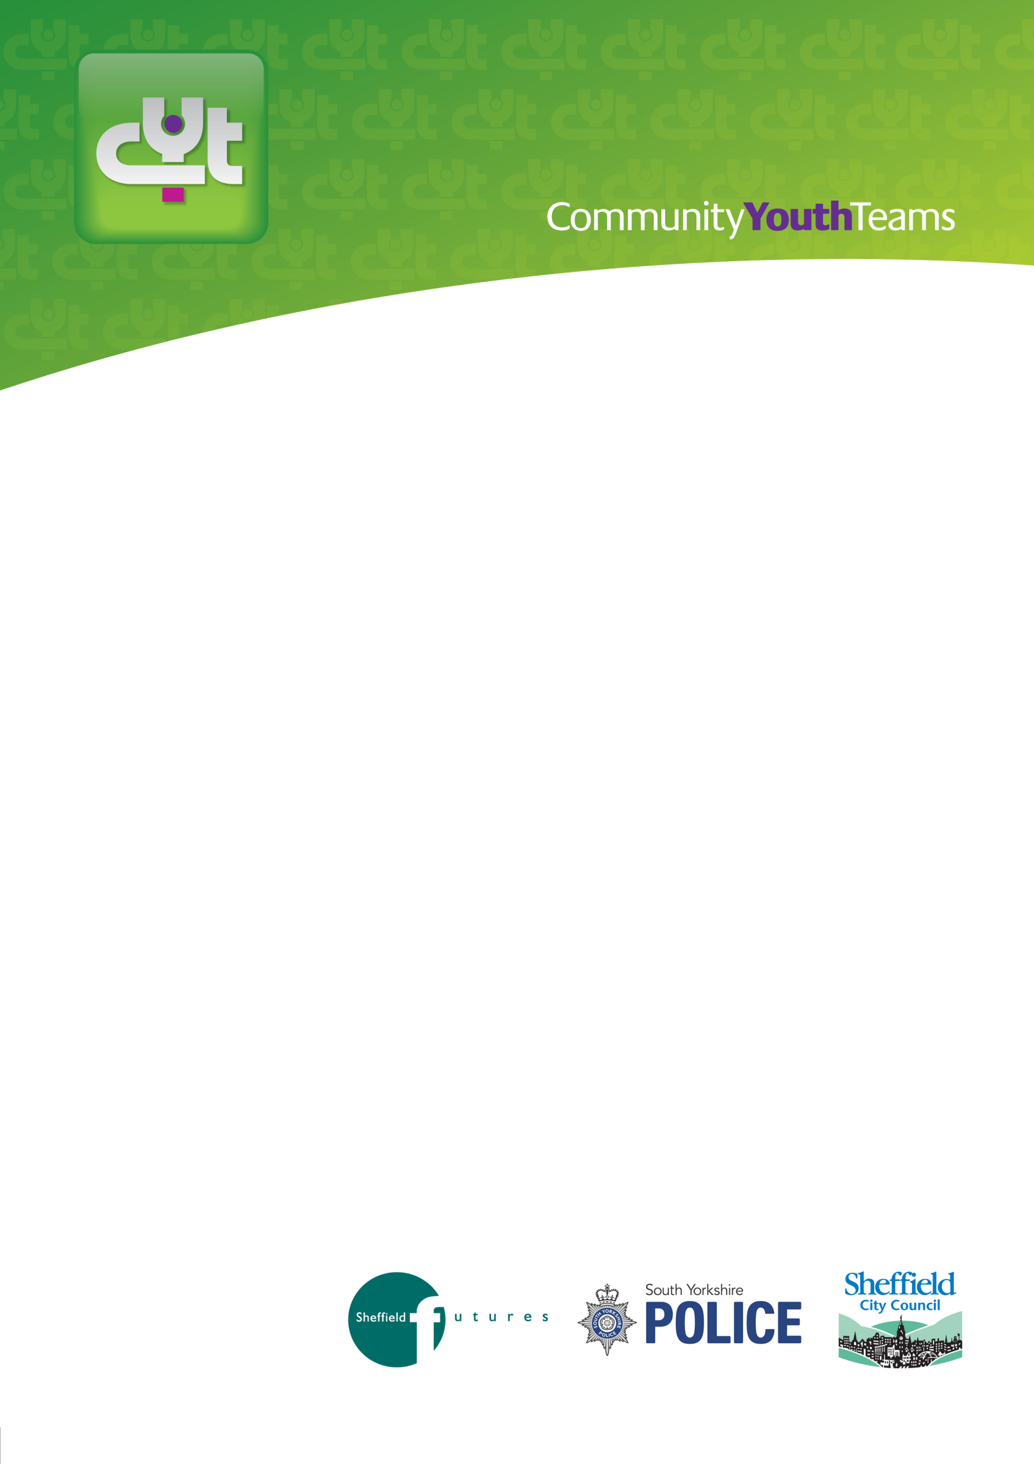

YOUNG PERSON
REFERRAL FORM

(Age 16 plus only)

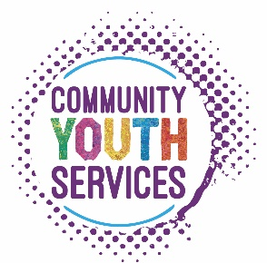

COMMUNITY YOUTH TEAMS

This referral form is for you to complete if you feel you need additional support to make better choices for your future.
Once completed return the form to:

CYT  Unit C7, Alison Business Centre  39/40 Alison Crescent  Sheffield  S2 1AS | and/or | cyt@sheffield.gov.uk  Tel: 0800 138 8381 or 0114 205 7450

YOUR DETAILS:
Family Name: |  |  |  | Gender: | Male ☐ Female ☐
First Name: |  |  |  | Address:
Age: |  |  |  | Postcode:
Date of Birth: |  |  |  | Telephone No:
1st Language: |  |  |  | Interpreter Needed: | Yes ☐ No ☐
Looked After Child? | Yes ☐ No ☐
Parent or Main Carer(s)
Full Name: |  |  |  | Date of Birth:
Relationship: |  |  |  | Address if different:
 |  |  |  | Telephone No:
Name of School/College (if applicable):
Key school staff  involved (if applicable): |  |  |  | Contact Details:
Ethnicity:
White – British ☐ | White – Irish ☐ | Roma ☐
Eastern European ☐ | Any Other White Background ☐ | White & Black Caribbean ☐
White & Black African ☐ | White and Asian ☐ | Any Other Mixed Background ☐
Asian – Indian ☐ | Asian – Pakistan ☐ | Asian – Bangladeshi ☐
Any Other Asian Background ☐ | Black – Caribbean ☐ | Black – African ☐
Somali ☐ | Yemeni ☐ | Chinese ☐
Any other ethnic group:……………………………………………………………….. |  | Prefer not to say / not stated ☐

WHAT ARE YOU WORRIED ABOUT?
Not going to School or College? | Yes ☐ No ☐
Not working? | Yes ☐ No ☐
Drinking too much? | Yes ☐ No ☐
Taking Drugs? | Yes ☐ No ☐
Hanging around with the wrong people? | Yes ☐ No ☐
I’m in a situation I can’t deal with? | Yes ☐ No ☐
Getting stopped by the Police? | Yes ☐ No ☐
Please give us some more details about what you are most worried about:
How do you want to be contacted? | Post ☐ Email ☐ Phone ☐
Email Address: | Mobile Phone Number:
Do you need any other additional support?  E.g. housing/benefits/other.  If yes please give details: | Yes ☐ No ☐
If you would also like further information about youth clubs or activities in your area please let us know and we will send you the details: | Yes ☐ No ☐

YOUR CONSENT:

Are you willing to work with the Community Youth Team? Yes ☐ No ☐

If you are under 16, for some of our services, we need to have permission from your parent/carer to work with you, is this ok? Yes ☐ No ☐

- I agree that the information on this form and other relevant information held by partner agencies may be shared for the purpose of deciding which support is appropriate. The agencies involved are: Community Youth Teams, Children & Young People and Families (SCC), Housing, Police, Health Services (including CAMHS), School and other voluntary and community agencies.

Signed:__________________________ Name:_____________________________________
Date:____________________________

