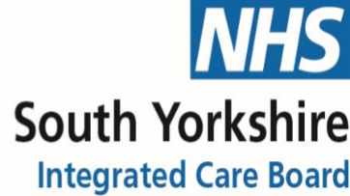

Contents

Introduction 3
Aim of the strategy 3
Scope of the strategy 3
Definitions 4
What things are like now in Sheffield 5
Our values for Personalisation 6
Sheffield’s Direct Payments Vision 6
What people have told us 7
Our priorities 8
What we will do 9
Postcards from the Future 11
Appendices 14
Appendix A1 - Personalisation and Direct Payments Strategy Delivery Plan 15
Appendix A2 – Our journey so far 20
Appendix A3 – What people have told us is important to them 25
Appendix A4 – Financial Statement 32
Appendix A5 - How the Personalisation and Direct Payment Strategy will deliver on the ASC Strategy Commitments 38
Appendix A6 – Context for the Strategy 41
Appendix A7 – Market Shaping Statement 46

Introduction
“Personalised care and support services should be flexible so as to ensure people have choices over what they are supported with, when and how their support is provided and wherever possible, by whom.” Care Act (2014) Statutory Guidance: 4.46

Aim of the strategy
The Personalisation and Direct Payments Strategy ensures that we put people first so that the citizens of Sheffield are empowered to take control and self-direct their own care and support; as a result, citizens will achieve the outcomes that they choose and live the life they want to live.
It describes how we will work collaboratively with people with lived experience, their families and carers, our partners and stakeholders to shape, design and produce new and improved ways of working.
The strategy outlines Sheffield’s commitments to increase and further develop approaches and practice around personalisation over the next 5 years (2023-2028).

Scope of the strategy
This strategy sets out Sheffield City Council’s ambition for personalisation to become a reality and describes how we ensure people accessing social care achieve personalised support with good outcomes through support planning and where required, personal budgets. By personal budgets we mean the money people need to meet their eligible care and support needs to self-direct their own support, which includes Direct Payments and Individual Service Funds (ISFs).
This strategy aligns with Sheffield’s Adult Social Care Strategy (2022-2030), Living the life you want to live, which has the following vision:
“Everyone in Sheffield lives in a place they can call home, in communities that care, doing things that matter to them, celebrated for who they are - and when they need it, they receive care and support that prioritises independence, choice, and recovery.”
We are committed to ensuring personalised approaches are embedded in all our social care support and activities. This strategy sets out the aspirations for how we embed personalised support into our practice, our council-arranged services and opportunities we offer for people direct their own support.
More information about how this strategy aligns with and contributes to the wider Adult Social Care Strategy can be found in Appendix A5.
The scope of the Personalisation and Direct Payments Strategy will include children, young people and adults who access social care support, and their carers.
We also recognise that some people who have complex ongoing healthcare needs may also use a personal health budget to pay for specific health needs. Although personal health budgets are not in scope for this strategy, we will make sure that both personal budgets and personal health budgets connect in their approaches.

Definitions
To reach a shared understanding of personalisation related concepts and approaches, we have worked with people with lived experience to develop and agree the following definitions:
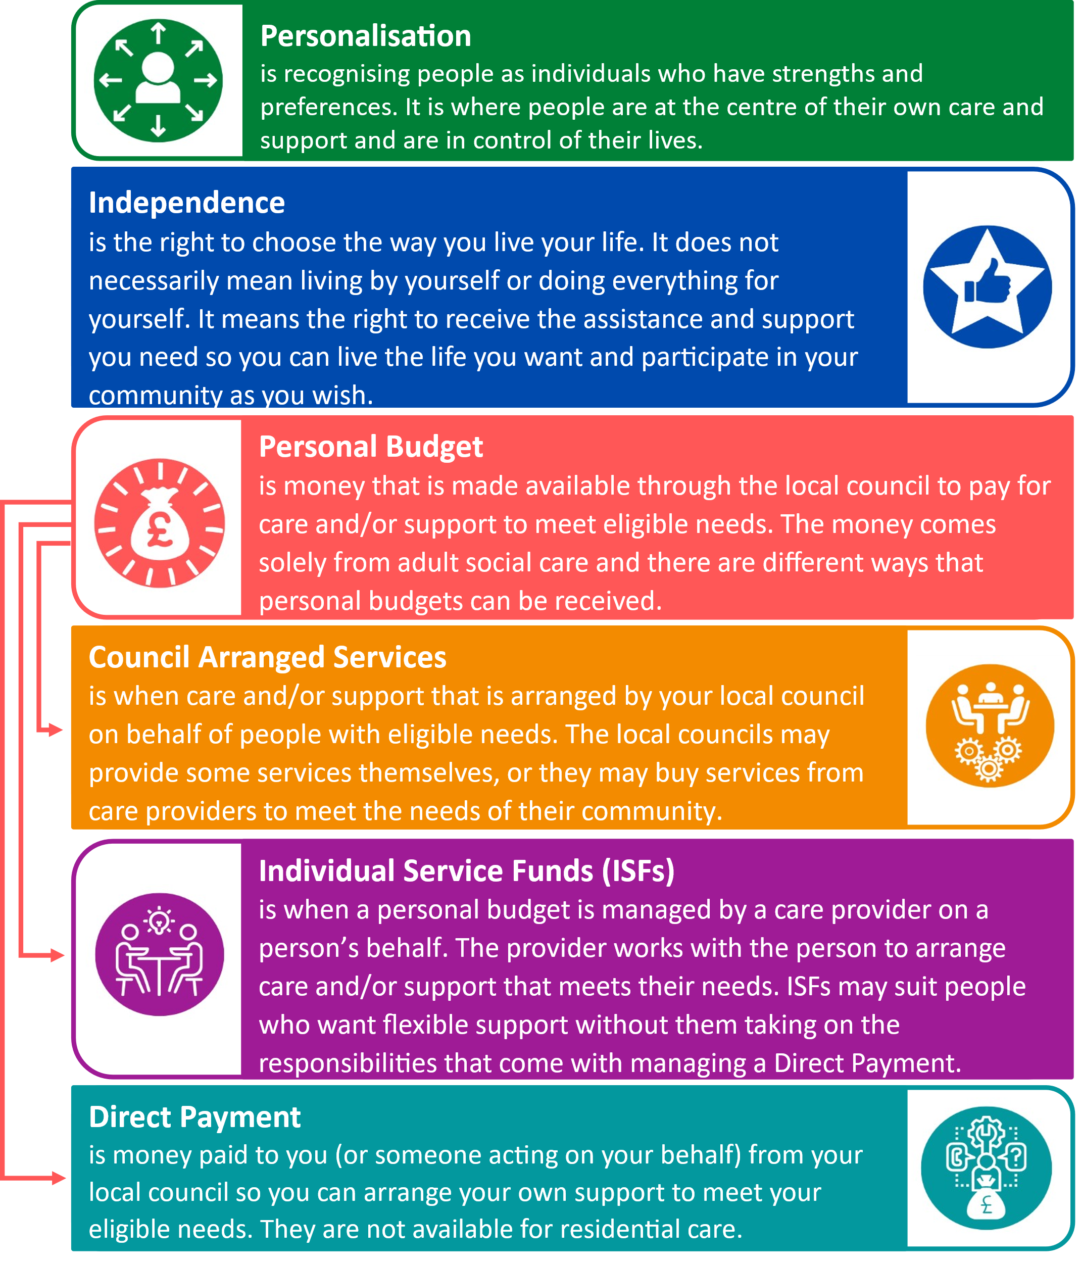
People who are unable to manage a Direct Payment themselves, or the suitable person who makes decisions around Direct Payments for them, may choose to have a nominated agent who can manage the money. This could be provided by a nominated individual or through a Money Management Organisation.

What things are like now in Sheffield
Improving personalisation in Sheffield to date has largely been focussed on developing the Direct Payments offer. This work has directly contributed to the successful creation of this strategy which outlines the Council’s vision and commitments for embedding personalisation for the longer term. This strategy will guide, co-ordinate and align the development and growth of personalised approaches for people who use social care moving forward.
A review of the Direct Payment system was carried out in 2020 and a programme of work was developed that would bring improvements for people accessing social care, Sheffield City Council, South Yorkshire Integrated Care Board and partner organisations. The dedicated programme of organisational change ensures consistency and transparency across social care and health services, with all the Council’s policies, procedures and processes for delivery being actively reviewed and enhanced.
The Direct Payments Improvement Programme is currently underway and now forms a core element of this strategy. The programme works collectively with citizens and partners to co-produce improved ways of working. In addition to the work completed to date, there are further opportunities in Sheffield to develop new personalised approaches which will offer greater choice and control for local people with social care needs. Opportunities include the continued advancements to the Direct Payment offer, the introduction of Individual Service Funds (ISFs), market shaping, development of more personalised support options, investment in the Personal Assistant workforce, improved support planning techniques that leads to better options of strengths-based, flexible support and the exploration of mechanisms for calculating fair and equitable personal budgets.
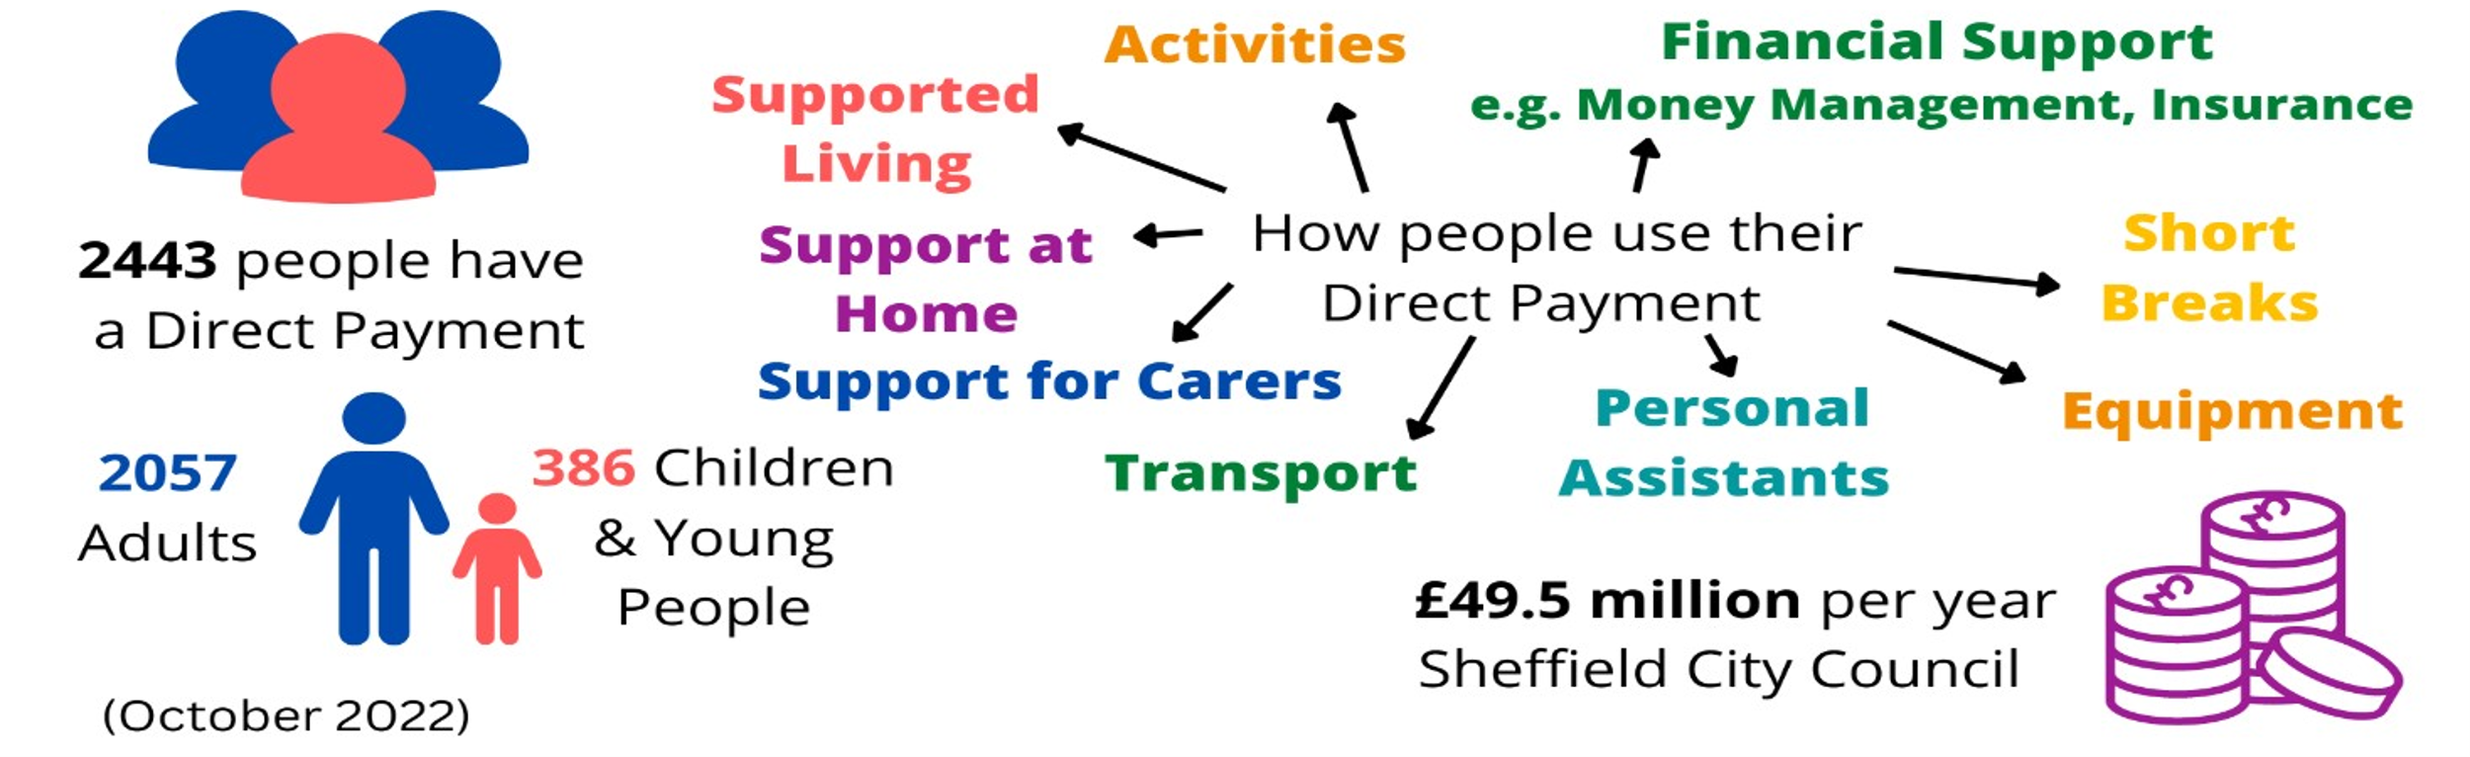

Our values for Personalisation
Working together to improve personalisation in Sheffield requires us to share a set of values for how we go about our work and means that everyone knows what to expect. These values are key to delivering the vision for personalisation in Sheffield and reflect what people have told us is important about how we should all work.
Open and Honest
By working together with open and honest communication, the right information will be shared right from the start when people first consider a personalised support, and then every step of the way.
Flexible and Creative
Working together to be more personalised means working in flexible and creative ways, ensuring discussions and decisions support well-being and the lives people want to lead.
Clear and Simple
By working together, personalised support can be straightforward to understand while being organised and managed in clear and simple ways which develops skills and confidence.

Sheffield’s Direct Payments Vision
In August 2021, Sheffield City Council, in partnership with NHS Sheffield Clinical Commissioning Group (now the South Yorkshire Integrated Care Board) and Disability Sheffield, published Sheffield’s Direct Payments Vision. The vision was co-produced between people who access Direct Payments, staff, and partners. The vision is available on the Council website.
The vision for Direct Payments makes it possible for many people who have care and support needs to be able to think ‘outside the box’ and be more creative and innovative when making choices that improve their health and wellbeing.
Our vision was developed from a variety of people’s perspectives, and says:
“Together, we will be bold, brave, and ambitious in our approach to Personalisation and Direct Payments. People can be flexible and creative with their personal budget, so the support they choose works for them.
By having open and honest conversations about support needs, we can plan together focusing on well-being and outcomes. We will make sure people are able to try new things and feel safe when making their own choices about the support they have. People will know what their personal budget is to help them plan better.

To achieve this, we will build vibrant and innovative communities, a strong offer for personal assistants and a marketplace that reflects what people want. Our staff will have a deep understanding about personalisation, the values that underpin it and how they can support personalisation becoming a reality in Sheffield.
We will listen to, and work together with, people receiving their own personal budget, council and health staff, and partners. Together, creating ways of working that are simple, easy to use and transparent.
There will be created opportunities for people using Direct Payments to get support from peers and other Direct Payment experts when they want it. We will be clear about what’s expected from people using Direct Payments and monitor how they are spent so we can offer support when people need it.”

What people have told us
As part of the development of the Direct Payment Improvement Programme, Sheffield City Council engaged with a range of people to identify the key issues and concerns they had and to ask about what changes they would like to see made in the future. Further information can be found in Appendix A3.
Further engagement with Direct Payment recipients, their families, carers, staff, and partners took place in July 2022. The key issues and ideas for change agreed were much wider than just direct payments and apply to how people currently experience and feel about personalisation in Sheffield.
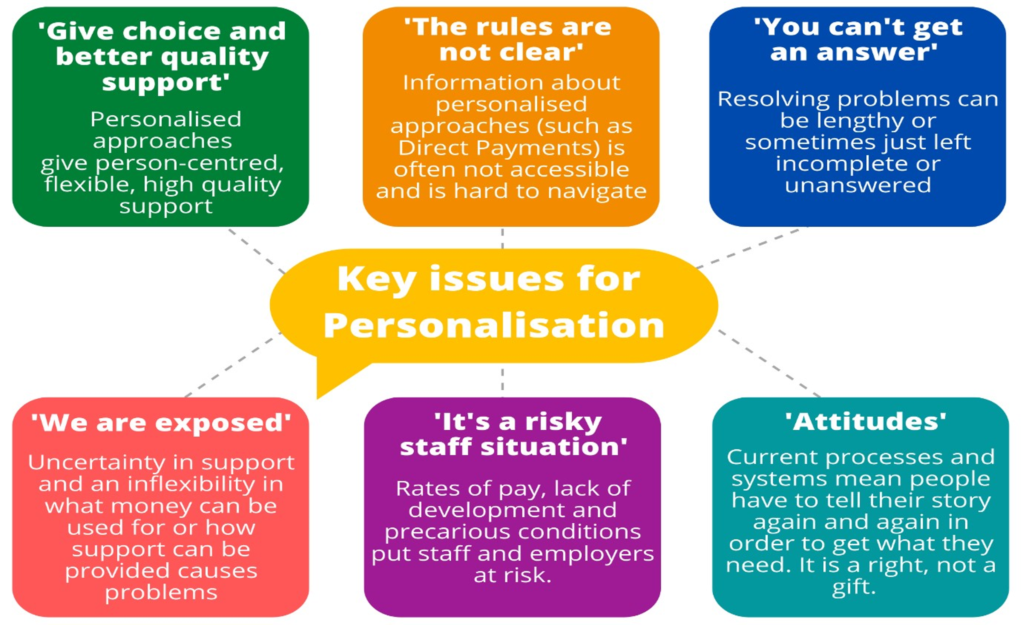
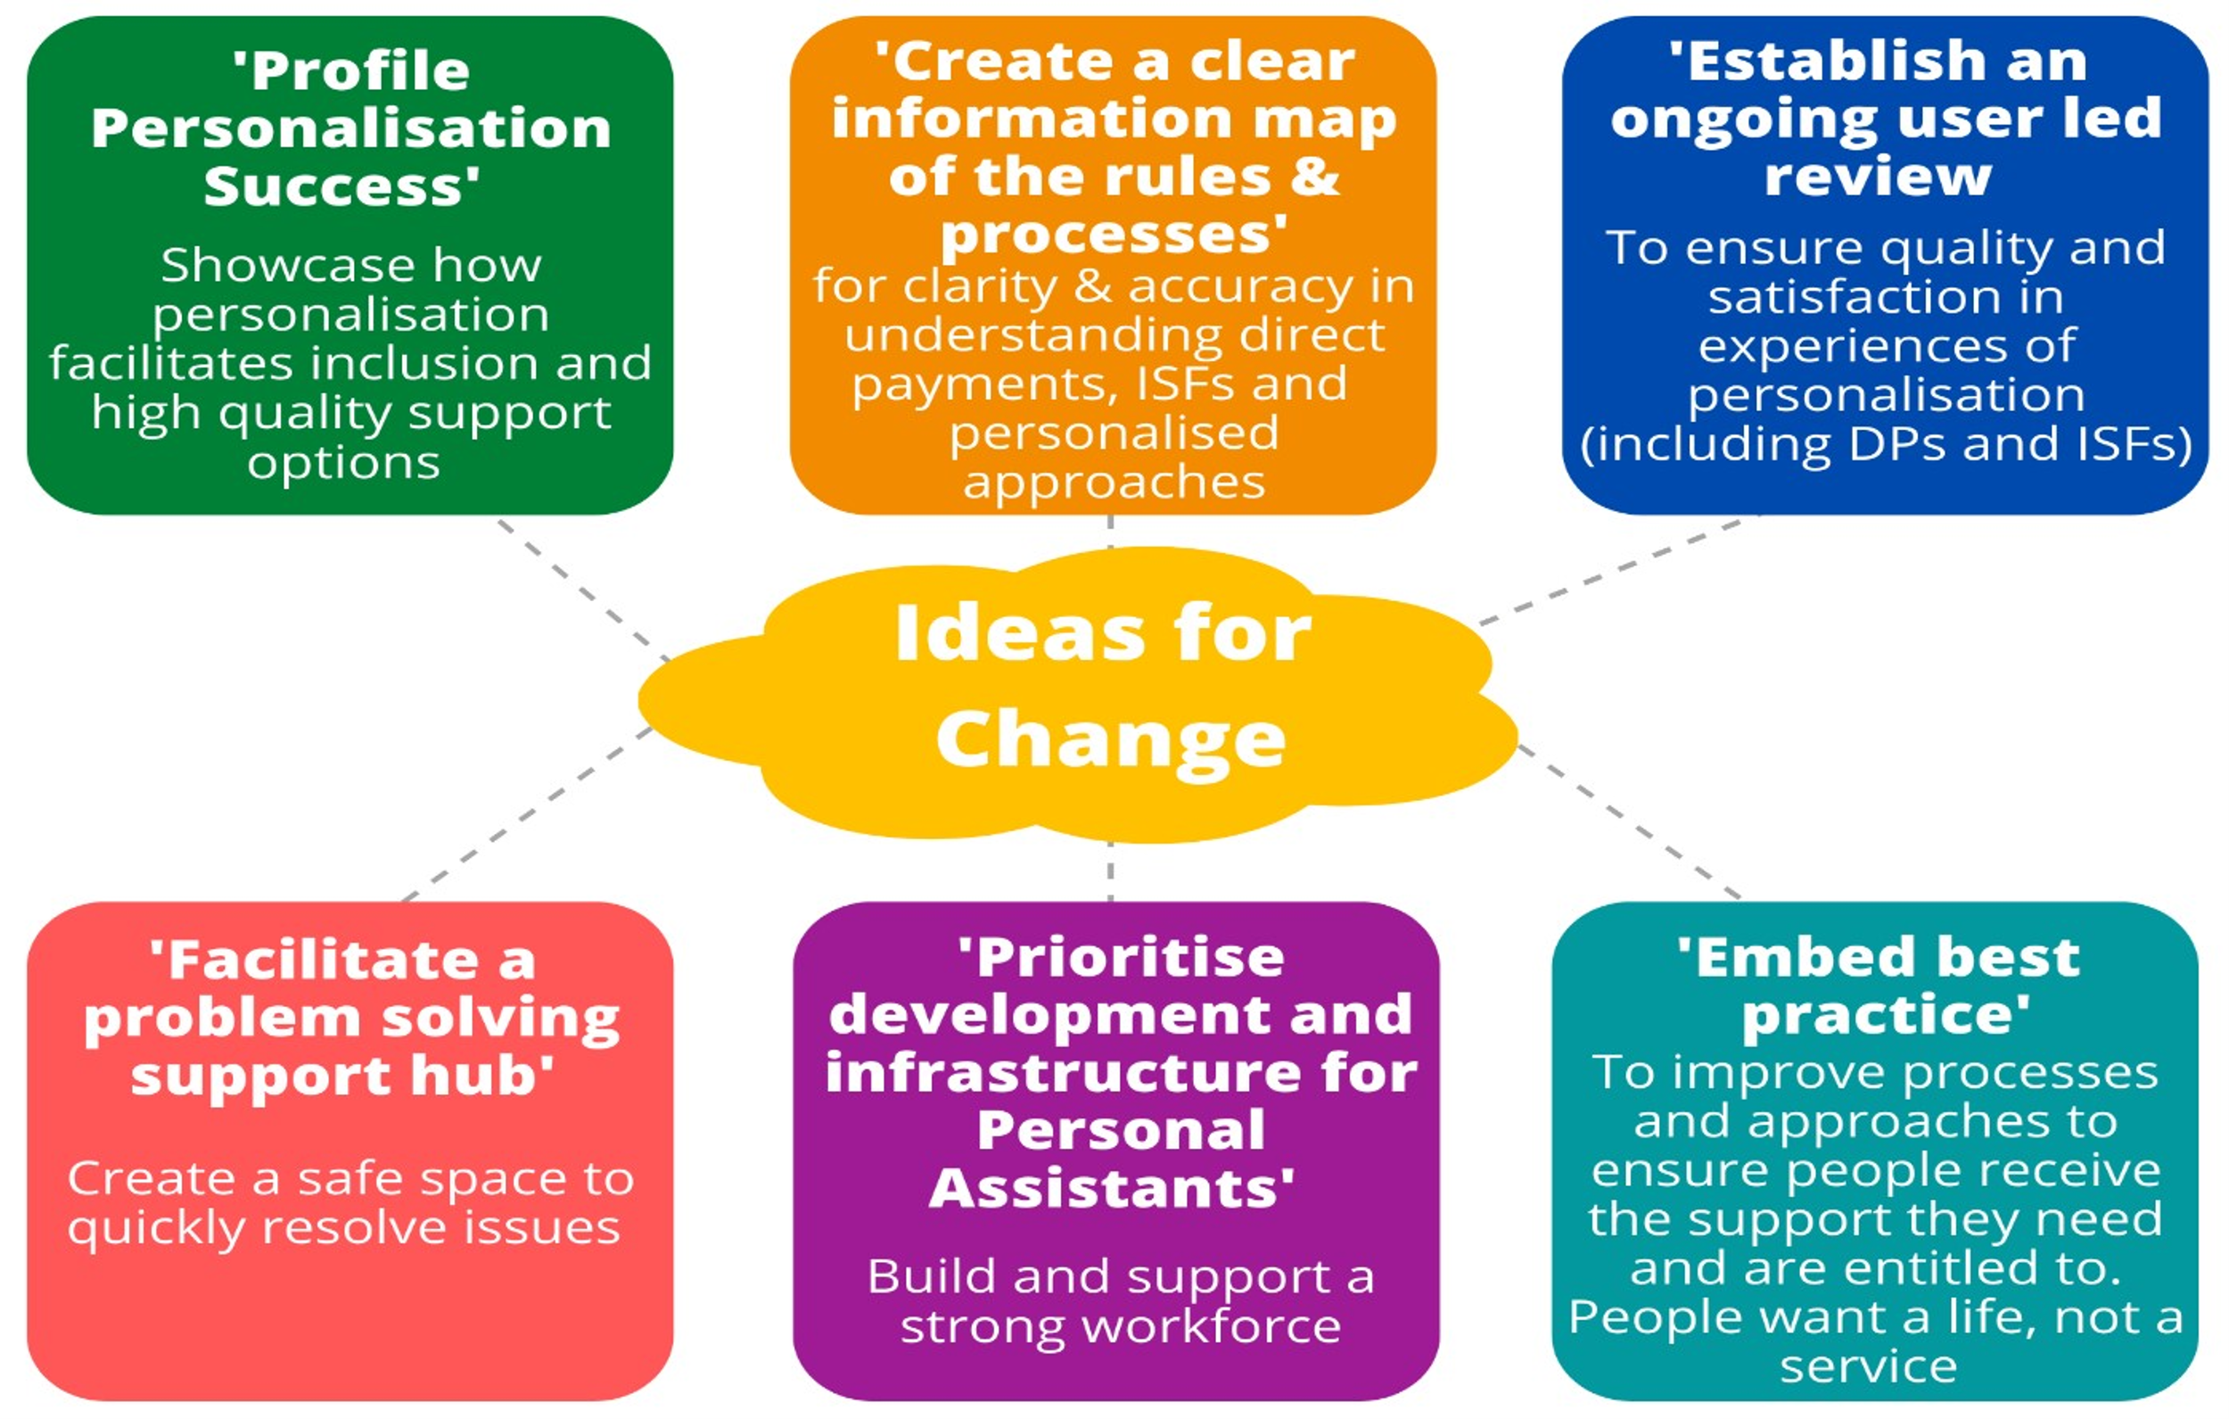

Our priorities
We have worked with people to agree 5 priorities for the strategy that will address the key issues, respond to the ideas for change and will enable us to grow and develop approaches and practices around personalisation, ensuring that the way we work puts people first and empowers them to self-direct their own care and support.
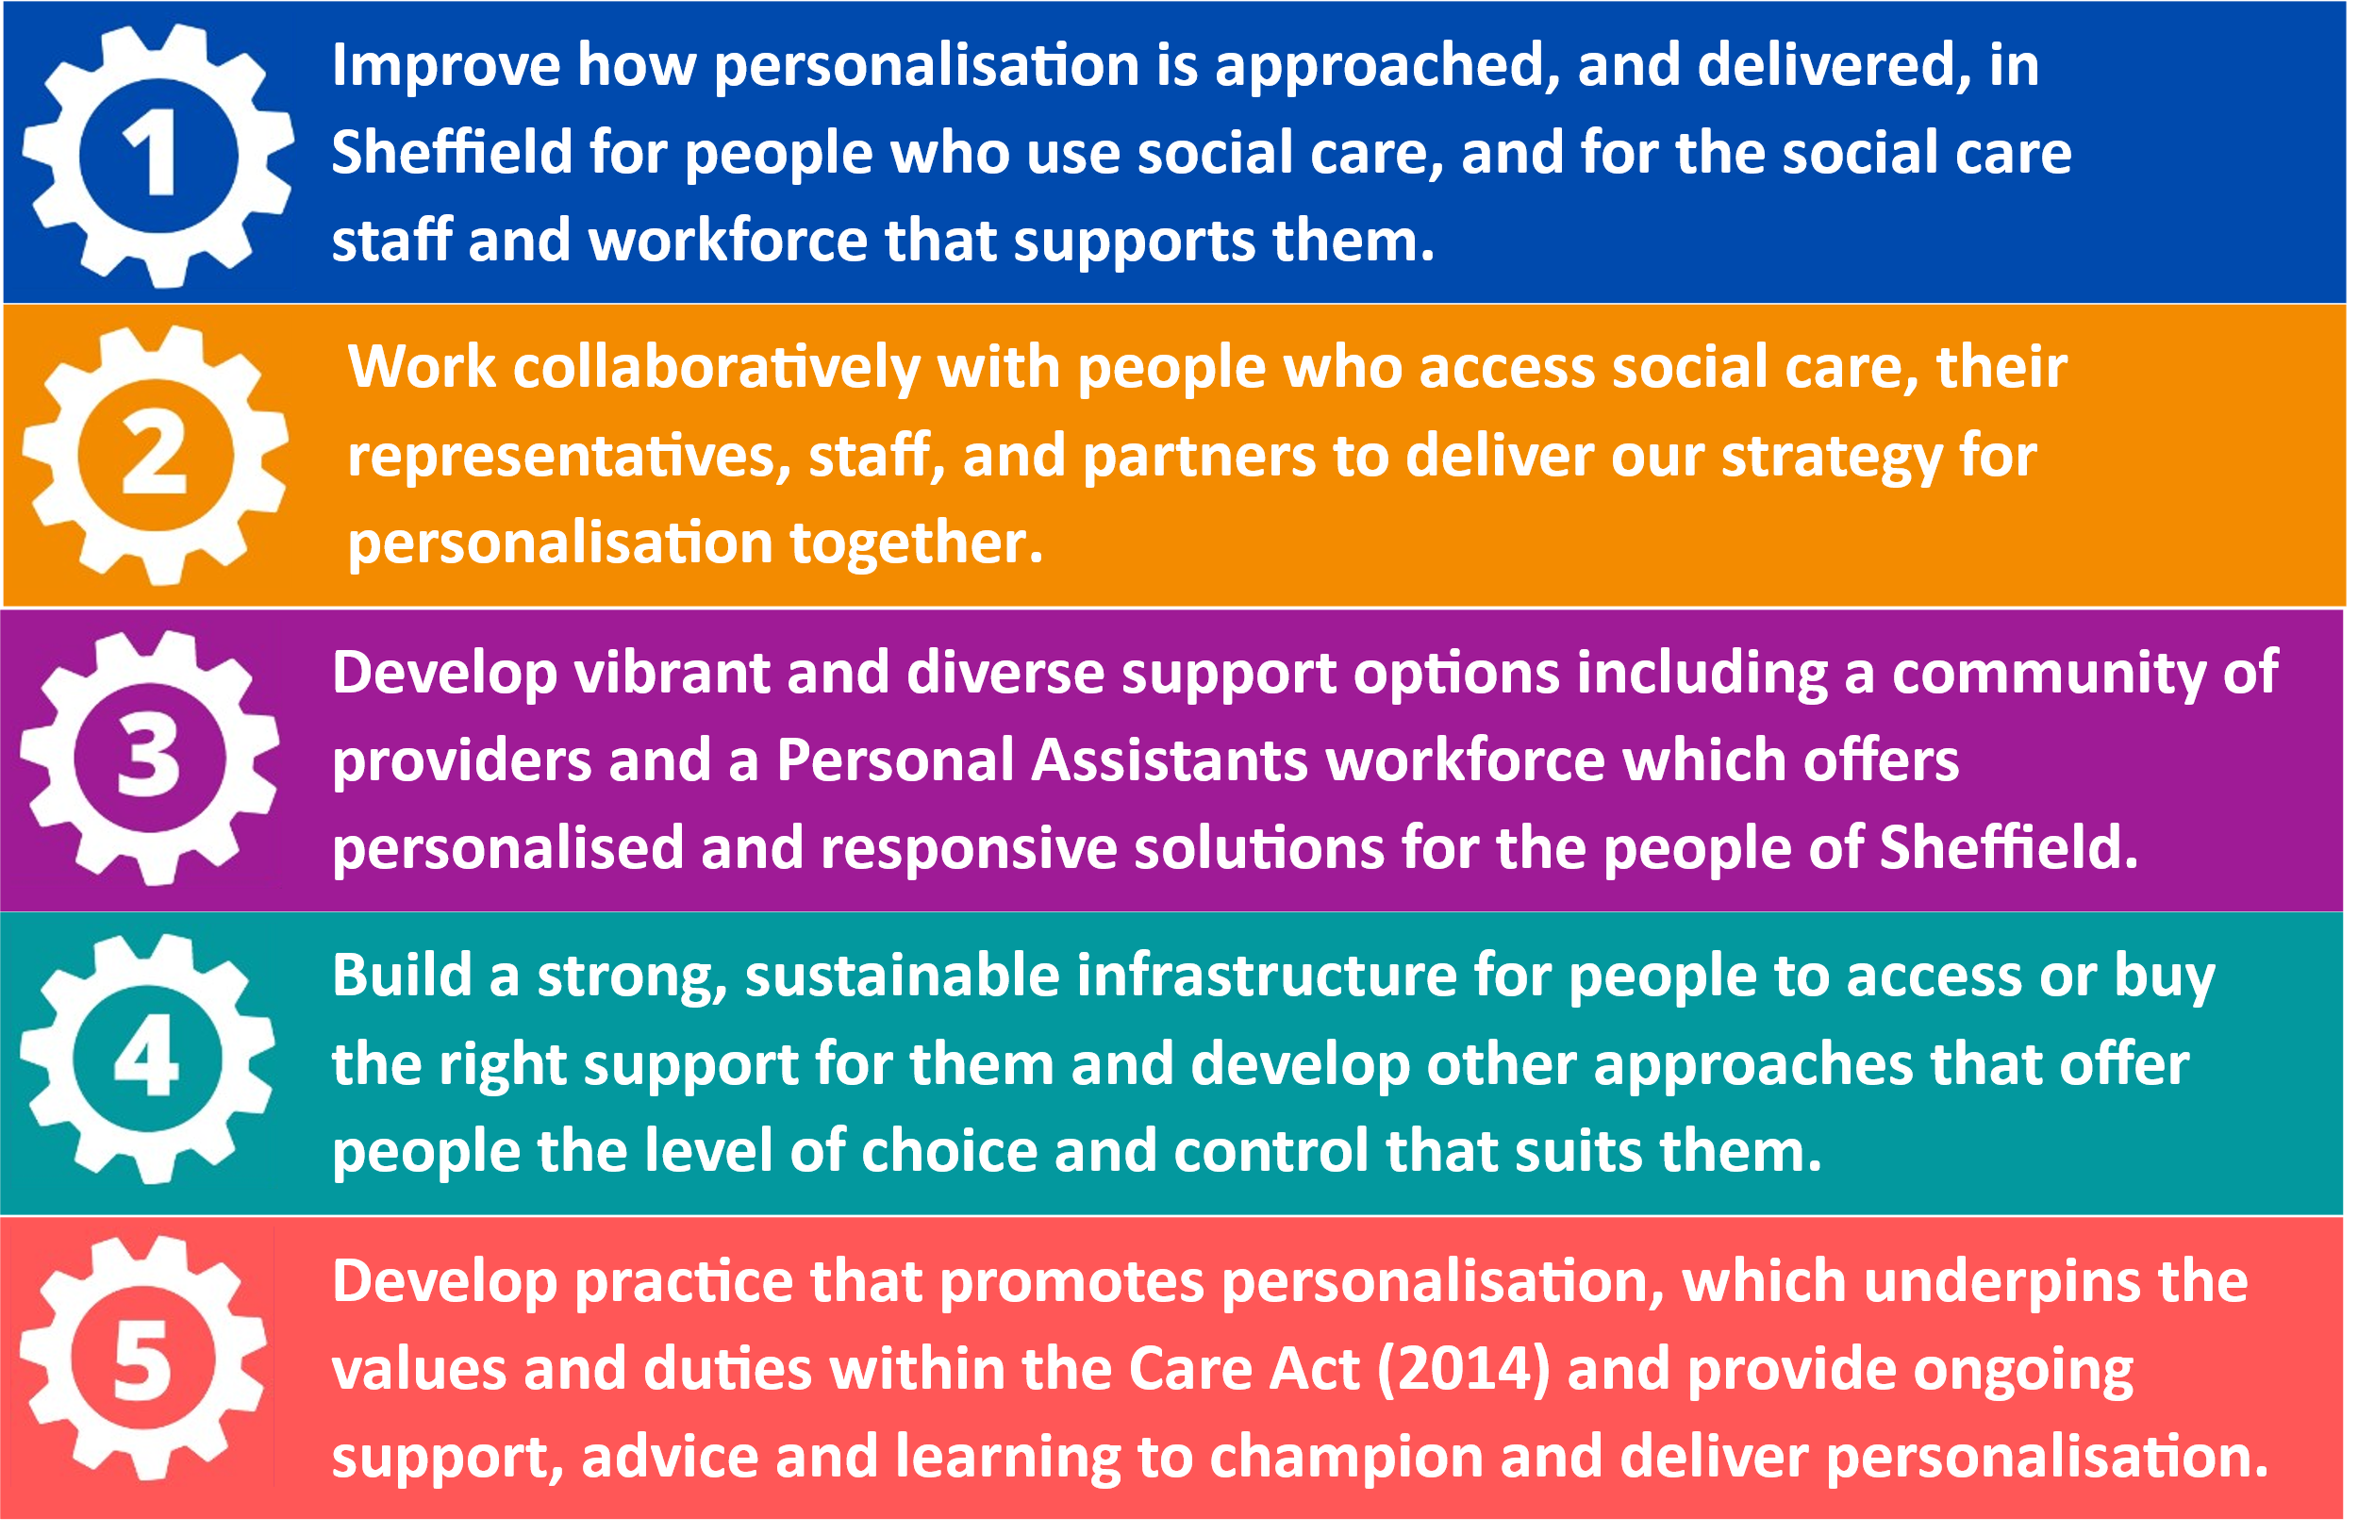
We have developed a high-level delivery plan describing what we will do to enable us to address our strategy priorities and make the changes that people want to see. This delivery plan can be found in Appendix A1.
Building on the co-production of the Direct Payment Improvement Programme and the development of this strategy, we will continue to work with and involve people with lived experience, their families and carers, our partners, and stakeholders to agree and develop specific and more detailed project plans. We will continue to keep people updated about the progress being made and work together to report on the difference that the strategy makes to people’s lives. Progress and delivery of the strategy will be governed through the Direct Payment Steering Group, which includes people with lived experience within its membership. The Steering group reports to and is accountable to the Adult Health Social Care Transformation Programme.

What we will do
Below are our key actions aligned to our 5 priorities, which will be addressed through the strategy and delivery plan:
We will…
keep things simple, easy to follow and understand.
improve knowledge, access and availability of personalised support and Direct Payments.
create a straight-forward way to calculate personal budgets and simplify processes to manage Direct Payments.
develop support planning to become more personalised, focusing on strengths and outcomes.
We will…
continue to expand our work with local people and other stakeholders to deliver our strategy together.
ensure people and staff have access to the right information at the right time.
aim to co-produce all the work that we do which means that when we develop things together there are no surprises.
create a vibrant marketplace which reflects local need and demand and provides real options for people to be supported in the way they choose.
work with people who purchase or direct their own support to develop and shape the market.
work with the market to develop and implement new methods which help people to have confidence about the quality of local support options.
promote and champion the role of Personal Assistants (PAs) leading to the growth of a skilled and dynamic Personal Assistant workforce.
We will…
develop a new Individual Service Fund (ISF) offer for Sheffield.
build a directory of the local market which is quality marked, for people to shop, choose and direct their own support.
explore creative options for people to maximise their resources when arranging their support such as pooled budgets and the use of new technology.
We will…
develop a new Individual Service Fund (ISF) offer for Sheffield.
build a directory of the local market which is quality marked, for people to shop, choose and direct their own support.
explore creative options for people to maximise their resources when arranging their support such as pooled budgets and the use of new technology.

Postcards from the Future
Postcards from the Future helps us to imagine what things will be like in the future and help bring the strategy to life. They tell us how things will be better and how different people’s lives are because of the strategy. This tell us that the strategy has been successful.
Yes – I’ll be coming to the reunion! I managed to recruit a couple of new Personal Assistants to care for my daughter and with the new ‘skills passport’ we found PA’s who already had some or all the training they needed.
The evening PA is already signed off to manage my daughter’s
equipment and meds – now she’s through her probationary period she’s moved onto the next pay band – and she and my daughter are looking forward to a trip to the cinema while I meet up with my old friends!
The other new PA is going to do night shifts. I’m sure my own health will improve once I’m getting enough sleep, and I’ll have the energy to enjoy time with my daughter as an unpaid carer. I’m grateful for the support available to an Individual Employer like me and pleased to be helping our PAs build their skills portfolios and their careers in care.
See you soon, Jenny

I just wanted to let you know that my new Personal Assistant started today and once we’d got over our nerves and we’d started her induction we had a really good day together.
She hadn’t worked in Social Care before but had been attracted to the advert as it looked like a really interesting job with lots of variety and opportunities for development.
She had seen the advert on the PA job website after spotting an article in the Sheffield Star about being a PA. She had also been attracted by the competitive pay rates.
She is interested in joining the PA network where she’ll be able to get support and have an opportunity to talk with other Personal Assistants.
See you soon, Zoë

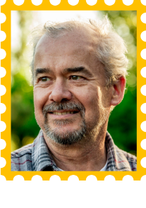
Having a Direct Payment has never been easier!
There is such a wide choice of different services and providers available to me and I can compare what they offer so I can choose the service that meets my needs the best. When looking for providers I find the ratings and feedback from other people who have used these services really helpful.
I have attended the Direct Payment Market Forum a few times now and found these meetings really useful to hear about new services and offers from service providers. With other people who use Direct Payments I am also able to give feedback to providers about what we need and what might be missing locally.
I look forward to seeing you soon, Ray
Hi there, I’m so pleased I became a PA!
At first I was worried about undertaking personal care as I had no previous experience before I started my current role, however, I’ve learnt so much from this job and thoroughly enjoyed it.
The woman I work for is lovely and is a very good employer.
There is plenty of support available in Sheffield for PAs
including groups to meet and share our experiences with others.
Because of my role, I now know how to make chapatis and daal, have visited new places, learnt practical tasks, and developed my empathy. I’d definitely encourage anybody who thinks they can’t do it, to give the PA role a go.
Thanks, Megan
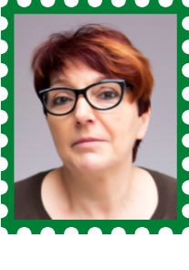
So excited, I will be able to join you for the weekend away with the girls after all. I have a couple of new PAs since we last saw each other, and they are wonderful. The role of a
PA is so well known now it made the recruitment so easy
and smooth. There are so many people wanting to work 1:1 whilst having a flexible work life balance.
I’ve now got a group of PAs that are happy and able to come away and assist me whilst we trek across the Lake District. I did sometimes moan about having to be an employer, but these days there is so much support and assistance that it is definitely worth it. And the added bonus is that my PAs and I enjoy the same things.
See you at the weekend! Mary
I am so pleased to have an Individual Service Fund!
Before these were introduced my support was arranged by the Council for me. This was ok, but I wanted more flexibility and more control over my support. I had been offered a Direct Payment before, but I didn’t want the responsibility of managing this myself.
My ISF holding provider works closely with me, and my family, to plan and manage my support, and work towards achieving my outcomes. As my confidence and skills have grown I have been able to change and use different services as I need to – I feel like I am making real progress.
There are more options available to people in Sheffield now and it has made such a difference to me and how I live my life.
Hope to catch up soon, Samuel
So great to catch up,
I came to PA work with no previous experience - but I love the variety and the opportunity to work with others.
No day is alike, but every day is rewarding.
Knowing that I can make a difference to someone else's day,
and give them independence makes being a PA a rewarding and enjoyable role.
Can’t believe I’ve been in this job for 7 years now!
Kind regards, Sarah
Direct Payments are so easy to set up!
As a social worker I feel very positive about the Direct Payments training we can access as it explains things in a simple and easy to understand way. It also incorporates the up-to-date Direct Payments processes on our Electronic Manual to support in making it a lot easier for social work staff to set up a Direct Payment.
The set-up process gives me a clear step-by-step guide and helps ensure everything that is needed to set up a Direct Payment is covered. The prompts and reminders are very helpful.
I’ve never felt as confident about Direct Payments! Shamim

Appendices
Appendix A1 - Personalisation and Direct Payments Strategy Delivery Plan
Appendix A2 - Our journey so far
Appendix A3 - What people have told us is important to them
Appendix A4 - Financial Statement
Appendix A5 - How the Personalisation and Direct Payment Strategy
will deliver on the ASC Strategy Commitments
Appendix A6 - Context for the Strategy
Appendix A7 - Market Shaping Statement

Appendix A1 - Personalisation and Direct Payments Strategy Delivery Plan
Below is the high-level delivery plan of the Personalisation and Direct Payments Strategy. A comprehensive improvement and development programme has been underway for the past 18 months, with some areas of work already complete (see Appendix A3), therefore this delivery plan describes current and planned deliverables.

Theme: Policy Workstream
Milestone/action | By when | Lead | Progress
Co-produce Personalisation and Direct Payments Strategy outlining Sheffield’s commitments to increase, and further develop, approaches and practices around personalisation. | December 2022 | Mary Gardner,  Andy Buxton | In progress
Co-produce Personalisation Policy to include flexibility, autonomy, and creative use of personal budgets to meet eligible needs and outcomes. | June  2023 | Mary Gardner,  Andy Buxton | Not yet started
Develop a practice model that ensures the offer of how to receive personal budget is upfront and leads support planning. | July  2023 | Mary Gardner/  Chief Social Work Officer | Not yet started
Develop an approach to topping up Direct Payments and implement revised guidance for social care. | December 2022 | Mary Gardner,  Shamim Akhtar | In progress

Theme: Process Workstream
Milestone/action | By when | Lead | Progress
Define and review end-to-end journey process models providing clarity, and consistency, in delivering, and providing, personalised approaches. This will include processes for set-up, support and payments, personal contributions and, process interfaces with children’s and health services. | January 2023 | Mary Gardner/  Kat Dyson-Baggaley | In progress
Review, update, and publish a suite of factsheets about Direct Payments which have been co-designed with people with lived experience and colleagues. | January 2023 | Mary Gardner/  Kat Dyson-Baggaley | In progress
Work with people with lived experience and colleagues to identify and develop further factsheets as required as new personalised approaches are introduced. | December 2025 | Mary Gardner/  Kat Dyson-Baggaley | In progress
Design and deliver introduction to Direct Payments training and learning resources for social care staff to support practice development. | March 2023 | Shamim Akhtar | In progress
Design and deliver identified training and learning resources for social workers to support practice development around new and developing personalised approaches. | December 2025 | Shamim Akhtar/ Mary Gardner/  Practice Development Team | In progress
Embed new practice around Direct Payments and Personalisation. | December 2027 | Mary Gardner/  Shamim Akhtar | In progress
Improve data integrity and the quality of information for Direct Payments and Personal Budgets. | December 2023 | Mary Gardner/  John Higginbottom | In progress
Improve and embed support planning techniques that leads to better options of strengths-based, person-centred, flexible support. | March 2028 | Mary Gardner/  Chief Social Work Officer | Not yet started
Exploration, development and embedding of mechanisms for calculating fair and equitable personal budgets. | March 2028 | Mary Gardner/  Finance/Chief Social Work Officer | Not yet started
Existing process and recording systems for auditing Direct Payments to be reviewed and amended to align with service improvements. | January 2023 | Elizabeth Thomson/  Paul Edwards | In progress
New monitoring and/or auditing processes developed and established to facilitate new approaches including Individual Service Funds (ISFs). | March 2024 | Elizabeth Thomson/  Paul Edwards/  Andy Buxton | In progress
Develop new protocols for joint working to facilitate an effective communication system and working relationship between commissioning, social care, and providers. | February 2023 | Elizabeth Thomson/  Paul Edwards/  Andy Buxton | In progress

Theme: Money Management Workstream
Milestone/action | By when | Lead | Progress
Progress the revised Money Management Quality Assurance to business as usual. | December 2023 | Lauren Beever/  Andy Buxton | In progress
Create a range of options for people to manage their personal budget. | December 2024 | Lauren Beever/  Andy Buxton | In progress
Ensure people have access to clear and correct information about options for managing their money to make informed choices. | December 2023 | Lauren Beever/Andy Buxton | In progress

Theme: Direct Payment Support Workstream
Milestone/action | By when | Lead | Progress
Establish and implement a robust and responsive internal support offer including social work expertise, Direct Payments advice and financial monitoring and support. | April 2023 | Mary Gardner | In progress
Successful mobilisation of interim, commissioned Direct Payment Support Service. | January 2023 | Andy Buxton | In progress
Evaluate of Year 1 of 2-year interim Direct Payment Support Service. | September 2023 | Andy Buxton | Not yet started
Complete an options appraisal of potential options for the long-term support service offer. | October 2023 | Andy Buxton | In progress
Proposed future option for support service approved. | November 2023 | Andy Buxton | Not yet started
Development and co-design of future support service. | March 2024 | Andy Buxton | Not yet started
Procurement of future, long-term Direct Payment support offer. | July  2024 | Andy Buxton | Not yet started
Mobilisation of future, long-term Direct Payment support offer. | August 2024 | Andy Buxton | Not yet started

Theme: Market Shaping Workstream
Milestone/action | By when | Lead | Progress
Develop an understanding of the current market for Direct Payments, and work with people with lived experience, to identify gaps and priority areas to inform the shaping of a diverse and responsive market. | December 2022 | Andy Buxton/  Kat Dyson-Baggaley | In progress
Develop and invest in the Personal Assistant (PA) workforce. | March 2024 | Mary Gardner/  Andy Buxton | In progress
Develop and shape a diverse, responsive, and creative marketplace for people purchasing their own support. | December 2025 | Andy Buxton/  Kat Dyson-Baggaley | In progress
Ensure people have access to clear and correct information about the Direct Payment market meaning people are aware of what options are available and have real choice. | December 2025 | Andy Buxton/  Kat Dyson-Baggaley | In progress
Pilot and develop an Individual Service Funds (ISFs) offer in Sheffield. | September 2023 | Andy Buxton/  Mary Gardner | In progress
Building upon the pilot, expand and further develop the ISF offer for wider roll-out, ensuring ISFs are a viable and sustainable option in Sheffield. | December 2027 | Andy Buxton/  Mary Gardner | Not yet started
Create a range of options to make sure people have assurance of the quality and appropriateness of market offers. | December 2024 | Andy Buxton/  Lauren Beever | In progress
Explore and develop options for tech-enabled care and assistive technology that can be accessed via a Direct Payment. | June 2023 | Andy Buxton/  Paul Higginbottom | In progress
Work with people with lived experience and the market to co-produce the future market approach for personalised support. | December 2027 | Andy Buxton | In progress

Theme: Direct Payments Review Workstream
Milestone/action | By when | Lead | Progress
Undertake reviews for people whose support has been particularly impacted by Covid-19. | March 2023 | Julie Marshall | In progress
Undertake reviews of people whose support is unclear since the migration to Liquid Logic. | July 2023 | Julie Marshall | In progress
Undertake reviews for people who may prefer or require alternative options to Direct Payments. | March 2024 | Julie Marshall | In progress

Appendix A2 – Our journey so far
The Direct Payment Improvement Programme is a series of interlinked workstreams with the common purpose of transforming the Direct Payments approach in Sheffield. This ensures compliance with the Care Act, more independence for people using social care, value for money for both Sheffield City Council and Direct Payment recipients and to offer specialised advice and support to staff and recipients.
The aims of the improvement programme are:
- To improve our Direct Payments offer to people who use social care and to the social care staff that arrange them.
- To develop a vibrant and diverse community of providers and support options for the people of Sheffield.
- To build a strong, sustainable infrastructure for people to ‘micro commission’ their own support.
- To develop practice which underpins the values and duties within the Care Act.
- To work collaboratively with staff, partner agencies and people who use Direct Payments, as equal partners, to deliver the aims of the improvement programme.
- To provide ongoing support, advice and learning on Direct Payments.
The programme comprises of 7 workstreams which each contain multiple areas of work and projects:
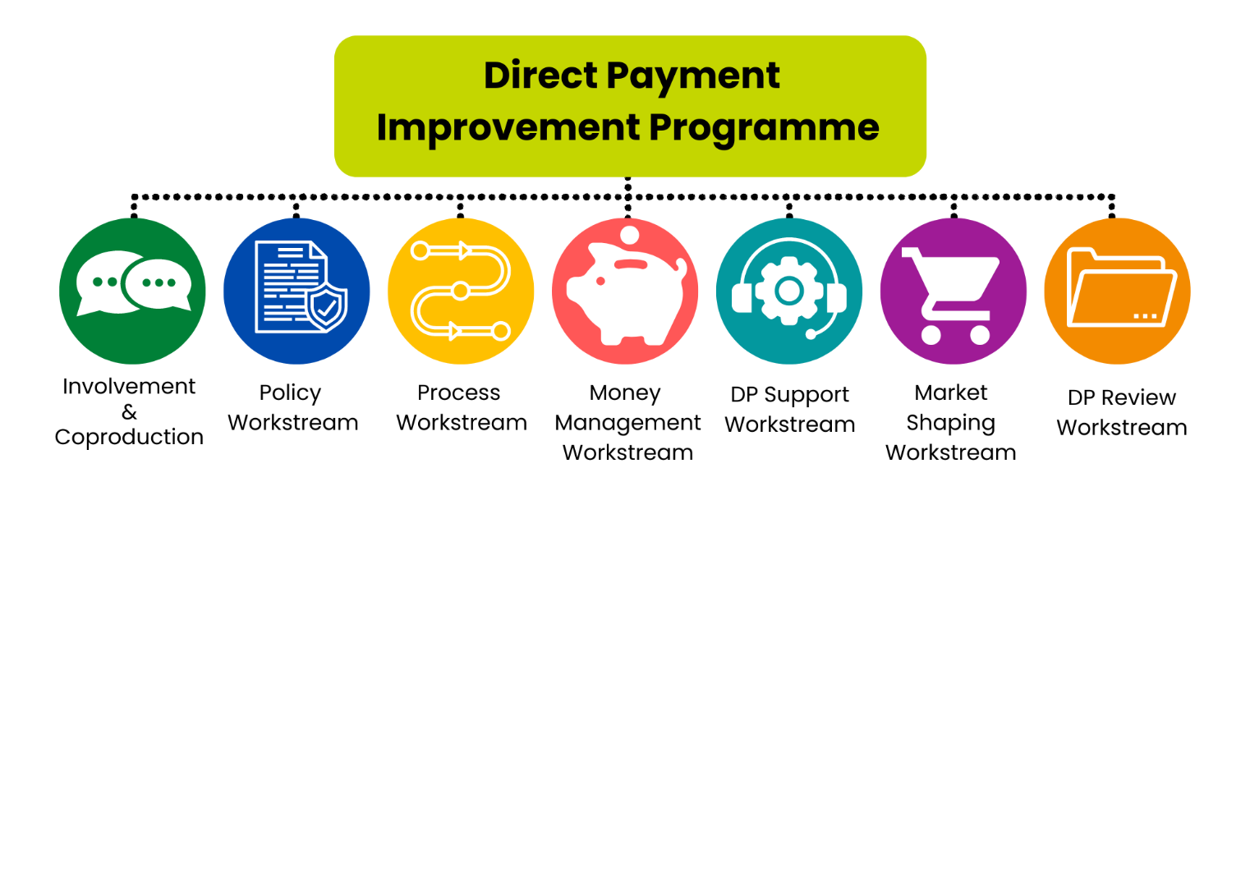
Involvement & Co-production Workstream – This focusses on how we identify, and involve, a wide range of people with lived experience of using social care in Sheffield to co-produce a model for the future of personalised support. We will work together as equal partners to design and deliver the improvement programme.
Policy Workstream – This focusses on creating Sheffield City Council’s offer to Direct Payments and how to improve this. It addresses policy decisions and provides commitment to personalisation across the Council. This covers creating the Direct Payment Vision, the Personalisation strategy, and producing policies which comply with our statutory duties.
Process Workstream – The focus is on the processes for staff and customers and how to improve these to become more effective and efficient. This covers embedding practice, improving data quality, a Direct Payment audit review, designing a Direct Payment calculator, expanding advice, guidance and training, and developing practice guidance for all staff.
Money Management Workstream - Developing options for managing Direct Payments, ensuring that there are robust structures in place to provide, and quality assure, money management support as well as building strong relationships between the Council and money management companies. This covers developing principles of use, standards of quality and monitoring, and creating joint working protocols.
Direct Payment Support Workstream – Develops the requirements the Council has to offer specialist support and advice to people and its staff, aiming to increase the uptake of Direct Payments and fulfil its duties in the Care Act. It focusses on creating an environment with the relevant level of knowledge and expertise. It covers the procurement of an interim support service enabling us to appraise and develop an effective long-term support solution.
Market Shaping Workstream – Its purpose is to shape and develop a creative, diverse, and responsive marketplace for personalised support. Enabling people to have more choice and control over, and to have alternative options for, arranging their support. This covers a market stock take, PA workforce development, expansion of Individual Service Funds (ISFs), market quality assurance and exploring assistive technology options.
Direct Payment Reviews Workstream – A focus on reviews for people whose support has been particularly impacted on by Covid-19, those who were asked to accept Direct Payments to meet their needs but may now have alternative support options available and those whose support is unclear since the migration to Liquid Logic.
These workstreams have now been incorporated into the Personalisation and Direct Payments Strategy Delivery Plan.

When Direct Payments work well
Below is a story about employing a PA with Autism from Hannah, a parent with a son who has a Direct Payment in Sheffield:
“It has been an amazing opportunity for our family to employ a PA for our 13-year-old autistic son. Having the support of a PA has made a huge difference for our son and our family as a whole.
Having a PA has provided our son with regular and consistent interaction with someone outside our immediate family unit. Before having a PA our son had not been able to make any meaningful connections or relationships with others due to his high level of need and was lonely and isolated. When considering recruiting a PA, we wanted to create a role that could be accessible to someone with a disability and were committed to making reasonable adjustments within the role to accommodate this.
We have been extremely fortunate to be able to employ a PA who is on the autistic spectrum, and he is a fantastic employee who we will be able to give an excellent reference to when he looks for full-time employment in the future. Our PA is eight years older than our son and so is really aware of the different things our son is facing as he goes through his adolescence, our son loves spending time with his PA because he doesn't put any unwanted social pressure or expectations on him. Both our son and his PA both enjoy doing similar things, and our PA provides companionship for our son that he has been unable to access from any of his peers.
It has been really beneficial for our PA to gain employment as having routine hours has given him a sense of purpose and value and has helped his self-esteem. We are able to give him regular positive feedback as he thrives in his role, and this contributes to his well-being. He has been able to see that he is capable of completing the application and interview process and be reliable and punctual in his work. He is therefore, highly valued in the workplace and we know that this will contribute to helping him gain employment in the future.
We make reasonable adjustments to make sure our PA is able to do his job, and while this takes some time, effort and thoughtfulness, it is a joy to be able to be a considerate employer providing an opportunity of employment for someone that otherwise may not have been able to enter into the world of work.
We are so grateful that we can employ a PA as we feel that the employment benefits both our son and his PA often in equal measure.”

A summary of the progress based on the themes people highlighted as the key issues made on the Direct Payment Improvement Programme to date is below:
You said, we did
“Give choice & better quality support.”
- Direct Payments Vision co-produced and sets out a commitment to flexible use.
- Co-produced an updated PA Employers Handbook.
- Direct Payment Support Service started in September 2022, free to access.
- Factsheets produced to help people make informed choices about managing their money.
- Refreshed standards for Money Management Companies.
- Market shaping to increase the diversity of personalised support options.
“The rules are not clear.”
- The Vision says what is expected from both the Council and people receiving Direct Payments.
- Personalisation and Direct Payments Strategy is being developed with our commitment for the next 5 years.
- There is a new dedicated webpage for Direct Payments.
- New processes have been developed for how Direct Payments are set up.
- New factsheets have been produced on topics linked to organising and managing Direct Payments.
“You can’t get an answer.”
- Clear and consistent processes, and decision making improved, to include:
  - A Direct Payment calculator to work out the costs
  - A new set up process for all to use
  - An expert Direct Payment social worker to support staff to get answers accurately and quickly
  - A new training programme for staff.

“We are exposed.”
- Following the guidance within the Care Act (2014).
- Co-production means we develop things together, meaning no surprises.
- Improvements to systems such as automatic annual increases and regular weekly payments put people in control to plan their support.
- A review of the audit process to simplify.
- Introduction process and letters to explain Direct Payments.
“It’s a risky staff situation.”
- A review of PA role and wages has been completed.
- PA Rates Decision Making Tool has been created to set the pay range.
- The role of the PA has been linked to the Sheffield-wide Workforce Strategy.
- We are creating a training & development offer for PAs and Employers.
- Introduced incentive and benefit schemes for PAs such as Togetherall.

Appendix A3 – What people have told us is important to them
In the creation of this strategy extensive engagement has taken place with a range of people with lived experience of using social care, their carers, Personal Assistants, Council staff working both face-to-face with people and those in supporting roles, and external partners and stakeholders. Feedback, opinions, and views were gathered about the existing picture and their wishes for the future.
During the development of the Personalisation and Direct Payments Strategy, 861 people with lived experience and 91 staff have had the opportunity to shape its content and to comment on its development. People have been able to contribute through face-to-face workshops, email, telephone call and one-to-one sessions.
This section provides detail of their views and opinions captured over the last two years, focussing initially on Direct Payments, but then more broadly on this strategy and drivers to achieve personalisation.
Initially people who shared their views and experiences of Direct Payments through a mixture of surveys, interviews, and discussion groups. The key issues identified and what people told us were:
“Give choice & better quality support.”
Direct Payments offer person centred, flexible, high-quality support.
People report that Direct Payments enable a greater level of choice and control. Support can be styled in a person-centred way to suit the individual.
‘…My children get the support they need and they are kept safe by dedicated PA's who are committed to their role. As a family, we are able to have a better quality of life, instead of just coping from one day to the next and being terrified for our children's safety. We are able to put all the therapies in place (speech and language, OT, behavioural support) that we couldn't do before as we were constantly doing crisis management...’
Local management of support and assistance offer a way to wider participation as well as being able to avoid institutional values of the ‘care’ setting that focus on reducing tasks to body parts, not inclusion.
“The rules are not clear.”
Information about Direct Payments is not often accessible and is hard to navigate.
While there is a range of general information available about direct payments, such as what it is, how to access it and the support available this is not always easily accessible and can be difficult to navigate.
‘…It feels like a part-time job all of its own. There is a lot to remember and a great deal of paperwork to sort out. Whilst I appreciate there has to be auditing and processes around this, it would be really helpful to have a web resource which really sets out all steps, templates and expectations. The information from the Council is okay but the financial confirmation letter is nonsense. It doesn't relate to the support in an understandable way and then that impacts on overspend…’
Members from BAME communities in Sheffield talk about how disabled people find social care information to be confusing and unintuitive; especially that about care charges and in the reporting of situations where individuals avoid seeking help as they feel it to be problematic, rather than supportive.
Additionally, more detailed information about specific aspects of information, including entitlement, processes, expectations, and responsibilities are not well mapped out.
The presentation of this information is also not transparent, and people report experiences of assessors withholding information about direct payment options. This was articulated as being about an imbalance of power in the relationship; that Direct Payment recipients feel as though they are treated as competitive service contractors, rather than independent partners facilitating citizenship and inclusion.
“You can’t get an answer.”
Resolving problems can be lengthy or sometimes just left incomplete or unanswered.
When things go wrong or there are disputes about say, contributions, inflationary uplifts, reviews, or expenditure queries people report a frustration at the long lengths of time it might take to resolve issues.
‘…Getting the correct figures from the assessment - there were numerous errors in the calculations made by the Council. At one point, the monthly sum was being paid in weekly. Arranging uplifts for providers is a nightmare. It would be great if the money could be used very flexibly between providers…’
Additionally, when matters are resolved there appears to be a lack of ownership or responsibility taken as why the error may have occurred, such as a disability related expenditure readjustment or overcharging.
“We are exposed.”
Uncertainty in support, and an inflexibility in what allocation can be used for, causes pressure and distress.
People report feeling isolated and having to sort out things for themselves from the off. While some initial guidance may be given, set up and development of the support arrangement can become a significant responsibility.
‘…I found the whole process extremely slow. We no longer have a social worker assigned to us so cannot approach anyone for further support or advice. It's not monitored even though I keep getting hints that [the Council] will start this, you [the Council] haven't actually asked for any paperwork yet. I didn't want to be an employer but was left with little choice and found this aspect extremely daunting. … I think it has been more to do with the mental health team not knowing how it works properly and not supporting the whole thing appropriately. It is much better now I have different people involved but it put me in a lot of dangerous positions…’
While some are keen and capable to take on the Direct Payment, they also can feel unsupported, with some managing and some not, which can lead to difficulties and a breakdown in the support arrangement. There is also a frustration concerning the lack of flexibility in what a Direct Payment can be used for, the length of time it can take to get authorisation for minor changes and an excessive focus on budget lines, rather than broader headings that relate to independent living.
“It’s a risky staff situation.”
Rates of pay; the lack of development opportunities and precarious conditions can put staff and employers at significant risk.
Rates of pay; development opportunities and support infrastructure are reported as fundamental workforce and management issues. For individual employers with PAs recruiting skilled staff can be difficult, and for those using staff via agencies there is a key issue about consistency.
‘...[it’s a problem] finding quality PAs, especially at such low pay e.g. £10 [and] training them especially as funding is hard to get at the time needed. Coping with Covid, the risks of PA passing on Covid if they are in property. It takes a lot of time recruiting PAs, induction and training, and then twice I’ve found they’re unreliable or not suitable and it’s very hard to terminate them as legal advisors are fearful of litigation, regarding unfair dismissal due to alleged discrimination. Which is very distressing for [us as] the employer…’
Overwhelmingly respondents raised issues with the low wages for staff and the difficulties this causes. An individual employer from a BAME community in Sheffield reported PAs persistently asking for wage increases, and the relationship breaking down. People report challenges of staff retention and will try and use creative ways to reward staff, such as encouraging training opportunities or flexible working arrangements etc. Back up cover can be problematic and can put additional pressure on families who will take on support responsibilities.
People made suggestions and ideas for change in Sheffield. These were drawn from the key issues into themes for change:
Ideas for change – what people told us
1. ‘Profile Direct Payment success.’
‘…Direct Payments were developed to give people with a defined budget the ability to have control and choice in their lives - in order to give them equality with their able-bodied peers- but in practice they have anything but these. There are still many discriminatory aspects of the whole personal budget process and operation which deny disabled people those basic rights…’
Explore ways to promote everyday Direct Payment success stories that will encourage new or potential recipients to make informed decisions. This could be linked to training materials that support people with setting up a Direct Payment or making decisions to take one on. Also, this should be targeted at professional roles. As well as this, human stories of positive Direct Payment usage can be profiled to ensure they showcase how inclusion can be done across a range of backgrounds, cultures, lifestyles and impairment effects.
2. ‘Create a clear information map of the rules and processes.’
‘…Make it more open. [We should] be able see social worker submissions. Decisions being [made] clear, accurate and more timely. [And] be there 24/7…’
Create a range of accessible information, on a variety of platforms with the diverse communities of Sheffield that empower and informs recipients factually, impartially, and in a way that is culturally relevant. It should be produced in a range of formats and utilise human stories to promote potential of Direct Payments. Information should be presented accurately across the many contexts that it is delivered. That is, during formal interactions like assessments or reviews, official correspondence, or other information material, both online and offline. Information for Direct Payment recipients, current or potential, should be broken down into clear sections and map out the journey, expectation, entitlement and responsibilities in a transparent and accountable way. It was also noted that a 2012 guide for individual employees previously produced was useful, but now is felt to require an update.

3. ‘Establish an ongoing user led review.’
‘…To universally embrace the clear rationale of Direct Payment by those who support, work and deliver. An equal relationship between the Local Authority and the individual to ensure a full and rich life.’
Commit to an ongoing partnership and involvement with an expert group of direct payment stakeholders to review and assess policy and practice periodically. The group should ideally have a formal role within the statutory structure, be made up of people with lived experiences, direct payment recipients and council staff and others with formal responsibility. The purpose being to work in partnership to ensure inclusion through quality. This group could undertake reviews of performance, quality, troubleshoot barriers and develop solutions. This group should be informed by robust data about direct payment take up, usage and outcomes.
4. ‘Facilitate a problem-solving supportive hub.’
‘…What I wanted was more advice & support about recognised providers who could help us, instead of money thrown at us and being left to muddle though it by ourselves…’
Develop a peer support, but a multi-agency hub that offers practical guidance and advice in a human and sensitive way to support recipients resolve issues and develop strong direct payment support functions. Such a space should be able to connect people looking for advice or solutions with those that can offer help or provide information and examples of such. It should be able to offer guidance and support and facilitate sharing problems and solutions and be supported by ‘champions’ within the community and local authority who actively promote direct payments.
While some are keen and capable to take on the direct payment, they also can feel unsupported, with some managing and some not, which can lead to difficulties and a breakdown in the support arrangement. There is also a frustration concerning the lack of flexibility in what a direct payment can be used for, the length of time it can take to get authorisation for minor changes and an excessive focus on budget lines, rather than broader headings that relate to independent living.

5. ‘Prioritise staff development and infrastructure.’
‘… higher rates of pay for the Personal Assistants who without them I couldn't do my job...’
Increase PA pay rates and enhance Direct Payment recipient’s opportunities to reward, retain and develop their staff doing PA roles. Develop a PA peer support network to offer support, such as through a peer support and non-managerial supervision. Enable Direct Payment budgets to include staff development headings specific to the individual employer. Further develop a ‘back up’ PA register so that people have support if emergencies arise. Coordinate opportunities for training and development so that recipients can access training that is relevant to their roles easily and promptly.
Sheffield City Council staff were also surveyed about their experience and views of the Direct Payments offer. Findings from the survey highlighted the need to:
- build confidence in Direct Payments, creating an environment of empowerment, trust and transparency
- invest in strong support, training, and guidance to influence staff and to improve everyone's confidence and experience
- simplify the current system, removing complicated processes
A summary of the feedback and ideas for change from staff are as follows:
Our Support, Information & Advice
"Clear and simple information about how to use a Direct Payment is needed"
"We need a Direct Payments support service"
"Our Direct Payment guidance is non-existent, pretty much"
"We are not given the information or tools needed to think 'out of the box' to find client specific support."
Our Approach
"I feel that we control Direct Payments, and they don't offer people any flexibility as we have to get everything signed off"
"When I have worked with people to make changes I feel that Direct Payments have been forced upon them because there are not enough commissioned services"
"Staff are scared that if we go back to using Direct Payments flexibly and don't specify everything, stuff will get ‘out of control’ and the Council will massively overspend. We are not good at producing robust assessments that show what someone’s needs are, what outcomes they want to achieve and how the support we fund does that.”
Our Process
"Setting up Direct Payments, particularly the calculation is essentially accountancy which social workers and care managers are not qualified for and certainly didn't come into the role to do."
"The complexity of putting Direct Payments on LAS [Liquid Logic] is definitely something which puts staff off from offering them, as opposed to a general unwillingness to use Direct Payments in principle."

Appendix A4 – Financial Statement

Current Position – scope and spend
There are currently 2443 people in receipt of Direct Payments in Sheffield, 2057 people receiving support from Adult Services and 386 people from Children and Young People’s Service. This breaks down into the following groups of people:

Direct Payments are used to purchase a variety of support options. Currently, these include:

The total spend on Direct Payments in Sheffield is £49.5 million per annum. 32% adults use Direct Payments out of all those who receive regular social care services. There is currently £223m spent on Adult Social Care in direct support costs (excluding social care support services such as commissioning and contracting, finance payments services, accounts and recovery services). Direct Payments equate to 22% of the direct support costs. The detail on spending above reflects spending prior to any assessed financial contributions being applied.
In Children and Young People’s Service the spending on Direct Payments is £3.1 million per annum (£3m Children with Disabilities, £45.2k Special Needs Inclusion Play Scheme).

Current Position – income and audit recovery
Our current system for Direct Payments allows payments to be made net of any assessed financial contribution, meaning that if the individual has been assessed to be able to contribute towards their care or support then this amount is deducted prior to the Direct Payment being made. This reduces the requirement to invoice for this money.
In line with our duties within the Care Act and for managing public money, we have a small, dedicated team responsible for monitoring how people use and spend their Direct Payment. Monitoring of Direct Payments occurs at least annually, targeting the largest budgets holders more frequently.
As part of the monitoring process people are asked how they have spent their Personal Budget to meet their agreed needs. People are also asked whether there is any remaining budget which is unused that can be returned to the Council. Any returned unused Direct Payment is returned to the social care budget so that it can be spent on others. This is a unique two-way relationship between the Council and Direct Payment recipients which does not automatically feature elsewhere in social care partnerships.

The fluctuation in recovery over the last few years exist predominantly due to the pandemic. It was essential to ensure people had sufficient monies to cover any variation in support options and cover any addition costs this may have caused.

The 10% demonstration of a reduction in audit recovery is attributed to the changes being made by the Direct Payment Improvement Programme. The creation of new tools made to calculate the cost of individual Direct Payments along with a more flexible approach to how people can use their money more creatively will in turn mean that the initial amount of personal budget will be less. This means that although there will be less unused budget recovered, starting personal budgets will more accurately reflect the actual support costs. Initial data is already showing that new Direct Payments cost less than existing ones.

Comparison with Other Local Authorities
It is useful to consider Sheffield’s performance in relation to Direct Payments against neighbouring local authorities and other core cities. This allows us to not only compare how well the people we support are served but also evaluate our approach.
In terms of the proportion of people who use social care receiving Direct Payments within the region, Sheffield is 6th out of our 15.
Proportion of people who use social care receiving Direct Payments by Council
Barnsley 36%
Bradford 21%
Calderdale 29%
Doncaster 41%
East Riding of Yorkshire 40%
Kingston upon Hull 26%
City of Kirklees 37%
Leeds 15%
North East Lincolnshire 20%
North Lincolnshire 42%
North Yorkshire 18%
Rotherham 23%
Sheffield 35%
Wakefield 16%
York 29%
Best is: high. = top 4 = bottom 4.

Comparing our costs of Direct Payments across other core cities shows that Sheffield spends more.
Direct Payments spending
Sheffield £8,160
Leeds £2,258
Liverpool £1,024
Nottingham £5,037
Birmingham £5,577
Newcastle £2,502
Bristol £3,971
Manchester £3,219
Core Cities £4,154
CIPFA Group £3,886
Yorkshire & Humber Region £4,405
England £4,215
Variances can be as a result of how Direct Payments are configured in different local authorities. For example some authorities have separate contracted services for money management whereas in Sheffield the money for this is included in the Direct Payment spending.

Impact of Future Improvements
Successful implementation of the Personalisation and Direct Payment Strategy will have a range of benefits, including costs:
- people will stay in control and manage changes for themselves requiring less input from social work staff.
- improved ways of working, clearer information, and better joined up working will:
- improve efficiency to ensure that people get the right support promptly.
- a diverse market that will offer a wide range of personalised support.
- high-quality, value for money support options.

The success and implementation of the strategy also requires investment while we continue to develop our offer. Our internal and external Direct Payment support services are starting to demonstrate savings against the investment. In addition, the financial implications of this strategy are intensified by the current context of a restrictive budget and covid-driven costs. Aligning our business planning, the improvement programme outcomes and this strategy will drive investment in more sustainable approaches as financial benefits are realised.
Our long-term financial plan to support the implementation of the Personalisation and Direct Payments Strategy consists of three elements:
- build more efficient and effective simplified processes.
- enable flexible, responsive and self-directed approaches to using personal budgets.
- develop a diverse high-quality, value for money market-place.
In the delivery of this financial plan we aim to
- increase numbers of people wanting to use Direct Payments and Individual Service Funds.
- target young people to self-direct their own support earlier in life in order to stay in control as they transition to adulthood.
- develop mechanisms that calculate budgets based on needs enabling better planning of outcomes at lower cost support solutions.
- use creative and personalised support planning to avoid a traditional one size fits all approach, ensuring we do not over provide, create unintentional barriers or cause unnecessary costs.
- nurture the use of pooled budgets for shared support options.
- protect public money.
We will also work together to collectively realise the benefits of other social care improvement activities, such as:
- potential savings from a more inclusive commissioned framework services particularly for people moving from Direct Payments that were set up because a framework provider previously not being available or for being more inclusive for people from different ethnic backgrounds.
- the children’s short breaks project looking to improve the offer across the city.
The Strategy detail outlined is all subject to it being affordable for the Council and will be kept under review through normal monitoring processes.

Governance
Good governance allows us to test how well we are delivering the Personalisation and Direct Payments Strategy and how well we are keeping to the values and priorities it sets out. It does this by establishing how we will measure how well we are doing. It also identifies who is responsible for reporting on our performance, and who we will work with to design and deliver those improvements.
Financial success aligned to this Strategy will be measured by the Direct Payment Steering Group with further scrutiny from the Adult Health & Social Care Transformation Programme.
By driving quality and improving the experience of the person and by reducing reliance on Council contact we will reduce avoidable demand and associated costs, to enable reinvestment in services. Ultimately the financial success of the Strategy will be in a workable system that operates within budget.

Appendix A5 - How the Personalisation and Direct Payment Strategy will deliver on the ASC Strategy Commitments

Commitment 4: Make sure support is led by ‘what matters to you’, with helpful information and easier to understand steps.
What would make a difference? | Personalisation and Direct Payment Strategy  Impact / Alignment
We will overhaul how we share information so that it meets the needs of everyone in Sheffield, with plain language and simplified access steps. | What people will say is different as a result of the Strategy:  - I know what support is available and can make informed decisions.  - I have the information, advice and support I need to increase and/or maintain my independence.  - Information I receive is clear, simple and easy to understand.  - I know where to go and get help.
We will invest in a system-wide approach that means everyone receives the same standard and continuity of preventative person-centred care. | What people will say is different as a result of the Strategy:  - I know that I have some control over my life and that I will be treated with respect.  - I am listened to and heard and treated as an individual.  - I am seen as someone who has something to give, with abilities, not disabilities. I get support to help myself.  - I feel that I have a purpose.  - I can have fun, be active, and be healthy.
We will make sure everyone can be involved as an equal partner in designing the support and services they receive across the whole system. | What people will say is different as a result of the Strategy:  - I am listened to and heard and treated as an individual.  - I am seen as someone who has something to give, with abilities, not disabilities. I get support to help myself.  - I have the support I need to develop personal outcomes and aspirations.  - I connect with others with similar experiences and feel empowered through peer-support opportunities.
We will deliver more flexible and simplified ways for people to be able to purchase and arrange their care and support. | What people will say is different as a result of the Strategy:  - I can manage money easily and use it flexibly.  - I have the support I need to be able to manage my own money.  - I am empowered to use my personal budget creatively to meet my needs and personal outcomes.

Commitment 6: Make sure there is a good choice of affordable care and support available, with a focus on people’s experiences and improving quality.
What would make a difference? | Personalisation and Direct Payment Strategy  Impact / Alignment
We will ensure people can move between care and support more easily, including health, social care, providers and the voluntary, community, and social enterprise sector. | What people will say is different as a result of the Strategy:  - I only tell my story once unless there are changes to ‘what matters to me’.  - The system is easy to navigate.  - I am able to choose my own support from a vibrant and diverse market of providers, services and agencies that offer me real choice and variety to meet my individual needs.  - I am supported by a well-trained and responsive workforce that works together in innovative and creative ways and is trusted to make the right decisions with me to plan and deliver my support.
We will embed open and transparent decision making alongside plans and priorities for adult social care, designed and developed with the people of Sheffield. | What people will say is different as a result of the Strategy:  - I am listened to and heard.  - I am actively involved in the developments and improvements to personalised approaches in Sheffield.
Whether support is arranged by the Council or through self-directed ways, we will ensure that how we embed personalised care and support is weaved through all of our activity. Our Quality Matters Framework, the Outcome-based Homecare, the Working Age Adults Framework and in due course Care Homes Transformation will all focus on becoming more personalised and outcome based.

How the Personalisation and Direct Payment Strategy will deliver on the Adult Social Care Strategy Outcomes
The Adult Social Care Strategy ‘Living the life you want to live’ also identifies 5 outcomes which we want to focus on getting right.
The Personalisation and Direct Payments Strategy contributes towards the achievement of these outcomes in the following ways:
Living the life you want to live Outcomes | How the Personalisation & Direct Payments Strategy makes a difference?
Safe and Well | - People access care and support they want and need, helping to ensure they feel safe in a place they call home and protected from harm.  - Support people to manage their conditions and to be able to return to their normal life as much as possible after a change in their circumstances.
Active and Independent | - Direct Payments and Individual Service Funds give people real choice and control over their care and support.  - Information, advice and support enables people to increase their independence.  - Direct Payments and Individual Service Funds process to be clear, simple and easy to understand.
Connected and Engaged | - People with lived experience are actively involved in the developments and improvements to Direct Payments and personalisation in Sheffield.  - A responsive support service will provide tailored information, advice and support to people, families and professionals.  - People connect with others with similar experiences and are empowered through peer support opportunities.
Aspire and Achieve | - People are supported to develop personal outcomes and aspirations.  - People are empowered to use their personal budget creatively to meet their needs and personal outcomes.
Efficient and Effective | - There is a vibrant and diverse market of providers, services and products offering real choice and variety to meet individual needs.  - There is a well-trained and responsive workforce that works together through innovation and creativity that is trusted to make the right decisions with people who receive support.

Appendix A6 – Context for the Strategy
Sheffield’s Personalisation and Direct Payments Strategy has been developed in the context of national legislation and best practice, which focus on ensuring people are supported in the best way and reach their health and wellness potential.

The Care Act (2014)
The Care Act (2014) aims to improve the outcomes and experience of care and secure a more effective use of public and community resources by improving the personalisation of services and giving people more choice and control over how their desired outcomes are achieved.
This key piece of legislation put the right to a personal budget and self-directed support into law and sets out that these are the expected norm of the care and support systems.

Care Act (2014) Statutory Guidance
The Statutory Guidance supporting the Care Act (2014) advises that,
“Local authorities should facilitate the personalisation of care and support services, encouraging services (including small, local, specialised and personal assistant services that are highly tailored), to enable people to make meaningful choices and to take control of their support arrangements, regardless of service setting or how their personal budget is managed.” (4.46)
The guidance describes 3 main ways in which a personal budget can be deployed:
- as a managed account held by the local authority with support provided in line with the persons wishes
- as a managed account held by a third party (often called an individual service fund or ISF) with support provided in line with the persons wishes
- as a direct payment the other 2 options being the use of a Direct Payment or receiving Council managed services.
The guidance goes on to say, “Where there are no ISF arrangements available locally, the local authority should consider establishing this as an offer for people. Additionally, the local authority should reasonably consider any request from a person for an ISF arrangement with a specified provider.” (11.33)
Other key points within the guidance pertinent to personalisation include:
“Care and support should put people in control of their care, with the support that they need to enhance their wellbeing and improve their connections to family, friends and community.” (10.1)
“Evidence suggests that in most cases people need to know the amount of their budget, be able to choose how it is managed, and have maximum flexibility in how it is used to achieve the best outcomes.” (11.35)
“Direct payments… remain the Government’s preferred mechanism for personalised care and support. They provide independence, choice and control by enabling people to commission their own care and support in order to meet their eligible needs.” (12.2)
4.46 Local authorities should facilitate the personalisation of care and support services, encouraging services (including small, local, specialised and personal assistant services that are highly tailored), to enable people to make meaningful choices and to take control of their support arrangements, regardless of service setting or how their personal budget is managed.

Children and Families Act (2014)
A new feature of the Children and Families Act 2014 was the introduction of personal budgets. A personal budget is a notional amount identified to deliver a service or provision for a particular child or young person with SEND. It is not an actual amount of cash but can be used for the purposes of calculating direct payments which may be received and used to pay for a particular provision. It can include funds from the local authority for education and social care and from the CCG (now SY ICB) for health.
There is a duty on Local Authorities (LAs) to identify a personal budget for the provision specified within an EHCP if they are requested to do so by a young person or parent of a child with SEND. (See the bottom of this sheet for the piece of Law – Children and Families Act, section 49).
There are four ways you can use a personal budget:
- Sometimes the local authority, school or college will look after the personal budget for you.
- Sometimes you can receive money directly to manage all or part of the personal budget yourself. This is called a Direct Payment.
- Sometimes you can opt to have someone else to manage the personal budget for you. This is called a Third-Party Arrangement.
- Sometimes you can have a mixture of some or all of these arrangements.
A personal budget requested may contain elements of education, social care and health funding. The SEND Code says that partners must set out in their joint commissioning arrangements their arrangements for agreeing personal budgets.

Best Practice
The Social Care Institute for Excellence (SCIE) describes personalisation as “recognising people as individuals who have strengths and preferences and putting them at the centre of their own care and support.” This definition was adapted by people with lived experience in Sheffield.
Personalisation means:
- tailoring support to people’s individual needs and what is important to them
- ensuring people have access to the right information at the right time in order to make informed decisions about their care and support
- involving and working closely with people with lived experience to design, deliver and evaluate services
- work with people to co-produce a range of services and shape the market to ensure people are able to choose from efficient and effective services that meet their needs
- developing the right processes, procedures and guidance to enable and empower staff to work in creative and person-centred ways
- embedding early intervention, reablement and prevention so that people are supported early on and in a way that’s right for them recognising and supporting carers in their roles
- ensuring all citizens have access to universal community services and resources – a system of support.
(adapted from SCIE 2008)

Approaches for personalisation
Effective approaches for personalisation involve finding out what is important to people with social care needs (involving their families and friends) and helping them to plan how to use the available money in the best way(s) to achieve these aims. There should be a focus on agreeing and working towards outcomes and ensuring that people have choice and control over their support arrangements. Elements for implementing personalisation and self-directed support include:
Self-directed assessment – a clear and simple assessment that is led by the person (as far as possible) in partnership with the professional. The assessment should focus on the outcomes the person wants to achieve in meeting their eligible needs and should look at the individual’s circumstances and whole situation and, takes account of the situation and needs of carers, family members and others who provide informal support.

Up-front (indicative) budget – the person has a clear indication at an early stage of the amount of public funding (if any) that is likely to be available to achieve these outcomes before support planning takes place. This amount may be adjusted following the development of the support plan.
Support planning – there is advice and support available to help people (no matter where their money comes from) to develop plans that will achieve a desired set of outcomes. Putting People First stated that the plan should be “proportionate and non-prescriptive” – it need not be expressed in units of provision (like hours of care) and can include broader needs and outcomes beyond those that made the person eligible for support (Putting People First Consortium 2010a). Arrangements should make the most use of any existing social support networks and mainstream services.
Choice and control – the person should (as far as capacity allows) decide how any funding should be managed and how best to spend it to meet their needs and achieve their agreed outcomes. Decisions should not be constrained by the choice of services currently offered.
Review – the local authority should have a process for checking whether the outcomes agreed in the support plan are being achieved.
(Adapted from ADASS 2009a: 3–4).

Families and Personalisation
NDTI’s Insight: Families and Personalisation makes the following conclusions about how personalisation can be successful for families:
- Local statutory agencies should review how they are providing information to families about personalisation starting by asking about their information and process needs.
- Local statutory agencies ensure that the people working with families have access to current and best practice information and have a commitment to working in family centred ways.
- Information about personalisation needs to be more local and to reflect the experiences, circumstances and aspirations of more families.
- Service providers understand the opportunities raised by working in real partnerships with families both in the design and delivery of services and to actively.
- Local authorities work with all families to build better access to family support networks

Health and Care Act 2022
The Health and Care Act 2022 introduced a range of changes to the rules around the funding regime in Social Care. The changes are to be implemented in October 2023. These changes include a lifetime cap on care costs which will increase the need to monitor spend and also a higher capital threshold for funding which will significantly increase the number of people entitled to council support. This is likely to have significant impacts on the number of people receiving Direct Payments over the next few years. It is also likely to have significant impacts on the care market.
New guidance will also be issued around the options for people to fund additional support over and above the support they are assessed as needing this guidance may extend to Direct Payments or could be used to inform practice around Direct Payments.
The detail of these proposals has not been finalised and further information will be added once the final guidance is produced.

Appendix A7 – Market Shaping Statement

Current Picture
Historically the Direct Payment market, including support/information, providers, money management and Personal Assistants (PAs), has not been actively overseen by commissioning other than a Recognised Provider List.
A significant number of people with a Direct Payment use PAs or care providers, however there may be other, more creative options that would meet needs more effectively should these be available. – cost effective, efficiencies
People find it difficult to recruit Personal Assistants (PAs) due to a shortage in the market, appropriate match in terms of skills and experience, pay and conditions when compared to other sectors.
Some people may want flexible support but don’t want or are unable to manage their own Direct Payment and associated responsibilities. Some direct payments set up may not have been most appropriate option for the individual.

Our market shaping aim
To shape and develop a creative, diverse and responsive marketplace for Direct Payment recipients. To enable people accessing a Direct Payment to have more choice & control and to have the opportunity to use creative or alternative options for arranging their support.

Areas for development
Direct Payment Improvement Programme aims to shape and develop a creative, diverse and response marketplace for all who use Direct Payments.
Exploration and development of more creative options and opportunities that enable people to meet their needs and achieve their outcomes more effectively than traditional approaches and solutions including the cultivation of micro-providers and micro-enterprises.
A Direct Payment Provider Forum will be established where Direct Payment recipients can engage with providers/agencies/services they may wish to purchase care and/or support from. Providers can also hear first-hand from people who use DPs about their needs and expectations from the market.
From September 2022, a 12-month pilot starts to design, develop and implement a new operating framework to enable the Council to offer Individual Service Funds (ISFs) effectively in Sheffield.

Key messages to the market
Providers for the Direct Payment market must be personalised, highly flexible, strengths-based and outcome focused, through their approach and business model.
People who use Direct Payments have said it is important for them to have assurance of the quality of providers operating in the Direct Payment market – we want to explore options and approaches for this including ‘customer review systems’.
We are seeking creative and innovative support providers and agencies who wish to explore offering Individual Service Funds (ISFs) in Sheffield.
In an ISF arrangement, an individual’s personal budget is administered by an ‘ISF holding provider’ on their behalf. The ISF holding provider uses the ISF, as requested and directed by the individual (or their representative) to arrange the care and support the individual requires to help them meet their assessed eligible needs and achieve their desired outcomes.
The ISF holding provider is likely to provide a level of an individual’s care and/or support, but will also work with other, often smaller local providers/services and opportunities to find creative and innovative ways to meet an individual’s assessed needs and outcomes.
The pilot project will start with providers of supported living and day activities, before broadening out into wider home and community support models.

Sheffield City Council Adult Care and Wellbeing.
Personalisation & Direct Payments Strategy. 2022 to 2028.
This document can be supplied in alternative formats,
please contact 0114 273 XXXX.
Sheffield City Council
Adult Care and Wellbeing
www.sheffield.gov.uk

